Table of Contents

1. Git 3

1.1 Introduction to Version Control System 3

1.2 Centralized Version Control Systems 3

1.1.3 Distributed Version Control Systems 3

1.2 Different Version Control Systems 4

1.3 Installing Git from Source Code 8

1.4 Installing Git on Windows 9

1.5 The Git Workflow 12

1.6 Basic Git Concepts 14

1.6 Getting a Repository 15

1.7 Committing the changes 18

1.8 Organizing your repository with Branches 21

1.8.1 Creating and Switching Branches 22

1.8.2 Merging branches 23

1.9 Review History 24

1.11 Roll back from previous commits 26

1.11 Remote repositories 26

1.12 Git Hub SSH login 28

2. Apache Maven 33

2.1 Build Process 33

2.1 Maven 33

2.2 Setting up Apache Maven on Windows 34

2.3 Setting Up Maven on Linux 37

2.4 Create a new project. 38

2.5 Maven Build Life Cycle 43

2.6 Maven Alternatives 45

3. Jenkins 46

3.1 Introduction 46

3.2 Jenkins 47

3.3 History of Jenkins 48

3.4 Setting Up Jenkins on Windows 49

3.5 Setting Up Jenkins On Linux 52

3.6 Creating and running first Jenkins Job 54

3.7 Deployment pipeline 57

3.8 Working With Jenkins 60

3.9 Installing Git and Jenkins GitHub plugins 61

3.10 Configure Jenkins to work with Git and Maven 62

3.11 Jenkins Work Space 67

3.12 Configure Jenkins to poll source code changes periodically. 67

3.13 Using build triggers 70

3.11 Jenkins Code quality metrics report 71

3.12 Archiving the Artifcats 78

3.12 Install and configure Tomcat as staging environment 78

3.13 Install copy artifact plugin and deploy to container plugins 80

3.14 Jenkins Build Pipeline 84

3.15 Deploy To Production 87

3.16 Jenkins Master Slave Architecture 89

# 1. Git

## 1.1 Introduction to Version Control System

Version Control is a system that records changes to a file or set of files over time so that you can recall specific versions late. The files for the source code of computer programs are monitored. Every change made to the source code is tracked, along with who made the change, why they made it and references to problems fixed, or enhancements introduced, by the change.

Version Control is not only for source code of a computer program, it can be used for nearly any type of file. For example if you’re a graphic or web designer and want to keep every version of an image or layout then using Version Control system will be helpful, It allows you to revert back to previous state, compare, revert back to pervious state of entire project, who last modified something, who introduced an issue and when, if you lose a file then that can be restored back from Version Control System.

Version Control is not new for us; most of us used Version Control. For suppose you’re working on a project, initial files with which you have started will be kept in a time stamped directory and the files which are modified since then will be copied to a separate directory which also time stamped. Based on time stamp we can where the initial project code is available and where modified. This was the common approach for everyone because it’ so simple, but it will be error prone also if you are not aware in which directory the files are copied or has to be copied.

To deal with this issue, programmers long ago developed local VCSs that had a simple database that kept all the changes to files under revision control. For example rcs, the local version control system introduced by mac OS X works by keeping differences between files from one change to another in a special format on disk. It then recreate what any file looked like at any point in time.

## 1.2 Centralized Version Control Systems

The major problem with rcs, local version control is that it is not suitable to developers when they have to collaborate with developers on the other system. To deal with this problem centralized version control system is introduced. In centralized version control system, a single server will have all versioned files and a number of clients update or download files from the central server. The advantage of this system is that everyone knows to a certain extent what others are doing on the project with controlled access that who can do what.

The disadvantage with this system is that if the central server is down no one can colloborate at all or they cannot add any versioned changes to anything they are working on. If hard disk on the central server fails, without a proper backup you will lose entire history of project except the local copies of the developers.

Examples for Centralized Version Control Systems are CVS, Subversion and perforce.

## 1.1.3 Distributed Version Control Systems

In Distributed Version Control Systems (DVCS), client don’t just checkout the latest snapshot of files they will maintain mirror copy of the repository. Thus if centralized system dies, developers collaborating via it, any of the client repository can be copied back to server to restore it. Furthermore we can maintain several remote repositories and can collaborate within same project.

**Conclusion**

Overall Version Control should be helpful in provide the following

* Collaboration between developers.
* Proper Versioning of the files, who changed it, when and what time.
* Version Control system should provide backup.
* Analysing the project status should be made easier.

## 1.2 Different Version Control Systems

Concurrent Version Control System (CVS)

The Concurrent Versions System (CVS), also known as the Concurrent Versioning System, is a free software client-server revision control system. CVS has been around 80’s.It maintains a central repository of the most recent repository. We can check out a copy to our local. If the file is updated by some other user, we can update our local copy. We can edit the copy of the files freely. If new versions of the files have been put in the repository in the meantime, doing an update merges the changes in the central copy into our copy. Client server CVS enables developers who are scattered across different geographies or slow networks to function as a single team. It allows more than one developers to work on the same file at the same time.

Pros:

* Has been in use for many years and is considered mature technology

Cons:

* Moving or renaming files does not include a version update
* Security risks from symbolic links to files
* No atomic operation support, leading to source corruption
* Branch operations are expensive as it is not designed for long-term branching

**Apache Sub Version (SVN)**

SVN was created as an alternative to CVS that would fix some bugs in the CVS system while maintaining high compatibility with it.

Like CVS, SVN is free and open source with the difference of being distributed under the Apache license as opposed to GNU.

To prevent corruption in the database from being corrupted, SVN employs a concept called atomic operations. Either all of the changes made to the source are applied or none are applied, meaning that no partial changes will break the original source.

Many developers have switched to SVN as it is a newer technology that takes the best features of CVS and improves upon them.

While CVS’s branch operations are expensive and do not really lend themselves to long-term forks in the project, SVN is designed to allow for it, lending itself better to large, forked projects with many directions.

Criticism of SVN includes slower comparative speed and the lack of distributed revision control. Distributed revision control uses a peer-to-peer model rather than using a centralized server to store code updates. While a peer-to-peer model would work better for world-wide, open source projects, it may not be ideal in other situations. The downside to a dedicated server approach is that when the server is down, no clients are able to access the code.

Pros:

* Newer system based on CVS
* Includes atomic operations
* Cheaper branch operations
* Wide variety of plug-ins for IDEs

Cons:

* Still contains bugs relating to renaming files and directories
* Insufficient repository management commands
* Slower comparative speed

**GIT**

First developed by Linus Torvalds of Linux fame, Git takes a radical approach that differs greatly from CVS and SVN

The original concepts for Git were to make a faster, distributed revision control system that would openly defy conventions and practices used in CVS. It is primarily developed for Linux and has the highest speeds on there.

Git also comes equipped with a wide variety of tools to help users navigate the history system. Each instance of the source contains the entire history tree, which can be useful when developing without an internet connection.

As there is no centralized server, Git does not lend itself to single developer projects or small teams as the code may not necessarily be available when using a non-repository computer. Workarounds exist for this problem, and some see Git’s improved speed as a decent trade off for the hassle.

Pros:

* Great for those who hate CVS/SVN
* Dramatic increase in operation speed
* Cheap branch operations
* Full history tree available offline
* Distributed, peer-to-peer model

Cons:

* Learning curve for those used to SVN
* Not optimal for single developers
* Limited Windows support compared to Linux

**Mercurial**

It has began close to the same time as Git and is also a distributed revision control tool, originally made to compete with Git for Linux kernel development, and as Git was selected, Mercurial has seen less success in that area. However, that is not to say that it is not used as many major developments use it, including OpenOffice.org.

It’s different from other revision control systems in that Mercurial is primarily implemented in Python as opposed to C, but there are some instances where C is used.

Due to its distributed nature and its creation in Python, the Python language developers are considering a switch to Mercurial as it would allow non-core developers to have easier access to creating new trees and reverting changes.

Users have noted that Mercurial shares some features with SVN as well as being a distributed system, and because of the similarities, the learning curve for those already familiar with SVN will be less steep. The documentation for Mercurial also is more complete and will facilitate learning the differences faster.

Some of the major drawbacks to Mercurial include that it doesn’t allow for two parents to be merged and unlike Git, it uses an extension system rather than being scriptable. That may be ideal for some programmers, but many find the power of Git to be a feature they don’t want to trade off.

Pros:

* Easier to learn than Git
* Better documentation
* Distributed model

Cons:

* No merging of two parents
* Extension-based rather than scriptability
* Less out of the box power

**Bazar**

Just like Git and Mercurial, Bazaar is another open source distributed version control system. It is particularly known for the easy and flexible user experience it offers. Bazaar is unique because it can be used with distributed code base and with a central code base. This makes it the most versatile system for revisions in diverse systems of the workflow. Moreover, this system allows the user to exercise a detailed control level which is not offered by any other system on this list. It can easily be deployed in a variety of scenarios, thus making it the most adaptive and flexible for a variety of projects.

Pros

* It is ideal for a variety of uses.
* Bazar also offers a more advanced and detailed set of commands, quality IDE support that is commonplace for CVS and Subversion.
* Bazaar offers a customizable feature set perfect for a range of projects.

Cons

* It is new and not mature enough as a version control system
* It lacks IDE support like robust systems such as CVS or SVN.

## 1.3 Installing Git from Source Code

Git was developed in the year 2005, by Linux Torvalds man who is behind the popular open source project “Linux Kernel”. Linux kernel project began using a proprietary DVCS system called BitKeeper. In 2005, the relationship between the community that developed the Linux kernel and the commercial company that developed BitKeeper broke down. This prompted the Linux development community to develop their own tool based on the some of the lessons they learned while using BitKeeper.

Some of the goals of the new system were as follows:

* Speed
* Simple Design
* strong support for parallel development
* Fully distributed
* Ability to handle large projects

[root@dev ~]# yum install openssl-devel expat-devel libiconv-devel

[root@dev ~]# yum install perl-devel -y

[root@dev ~]# wget <https://www.kernel.org/pub/software/scm/git/git-2.15.1.tar.gz>



[root@dev ~]# tar -xvf git-2.15.1.tar.gz -C /usr/src/

[root@dev ~]# cd /usr/src/

[root@dev src]# cd git-2.15.1/

[root@dev git-2.15.1]# ./configure

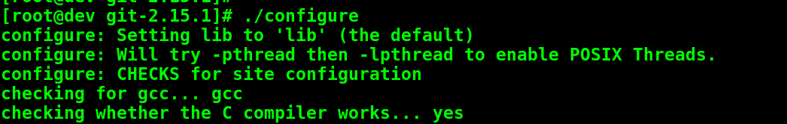

[root@dev git-2.15.1]# make



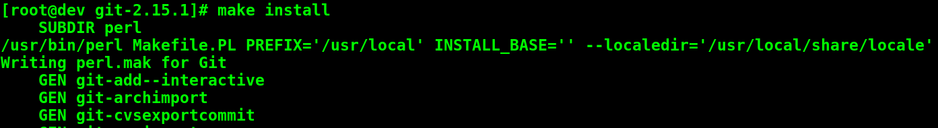[root@dev git-2.15.1]# make all

[root@dev ~]# git –version



[root@dev git-2.15.1]#

The first step is to specify your username and email address to your GIT repository using “git config” as shown below.

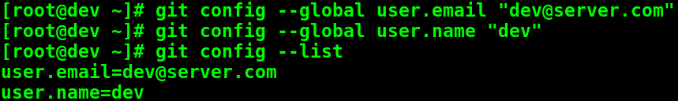

This information is stored in the .gitconfig file under your home directory.

## 1.4 Installing Git on Windows

Go to the following URL and download the git for windows.

<https://git-scm.com/download/>

1. Run the downloaded file and Select the default editor.

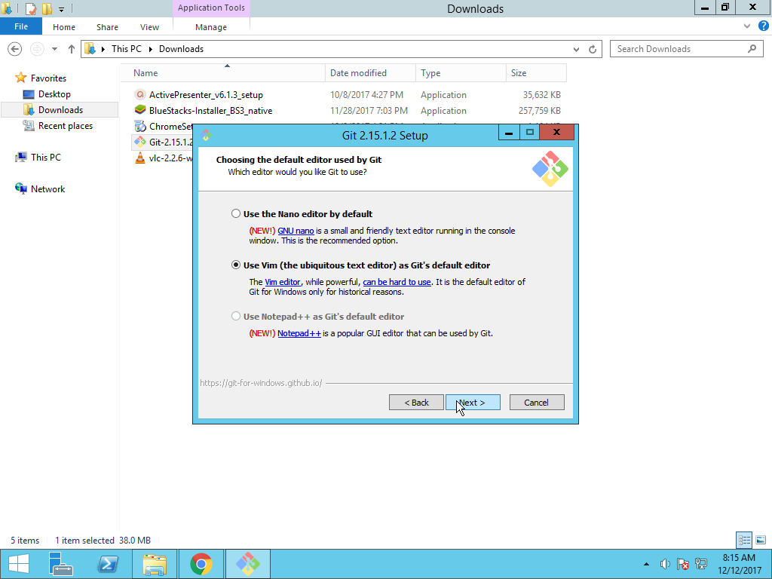

1. Adjusting your PATH environment:

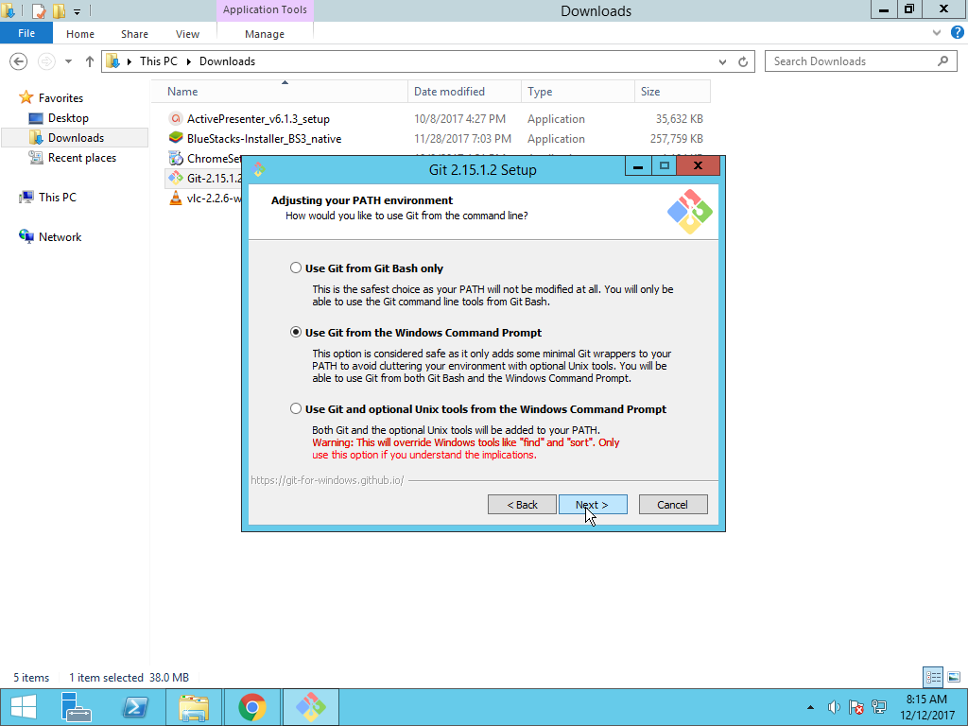

1. Select to use the OpenSSL library

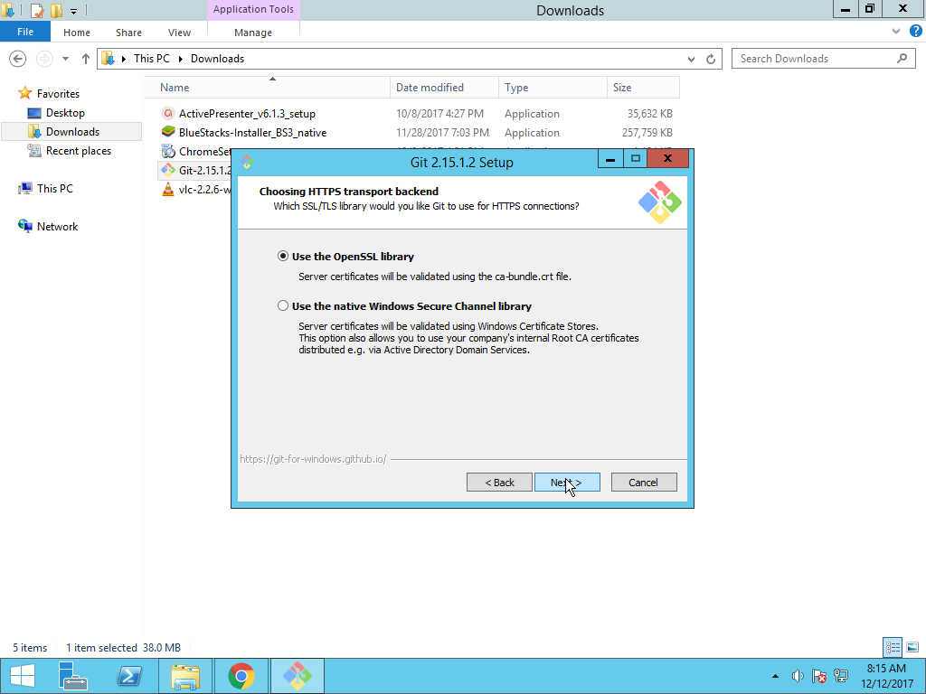

1. Configure the Git bash terminal.

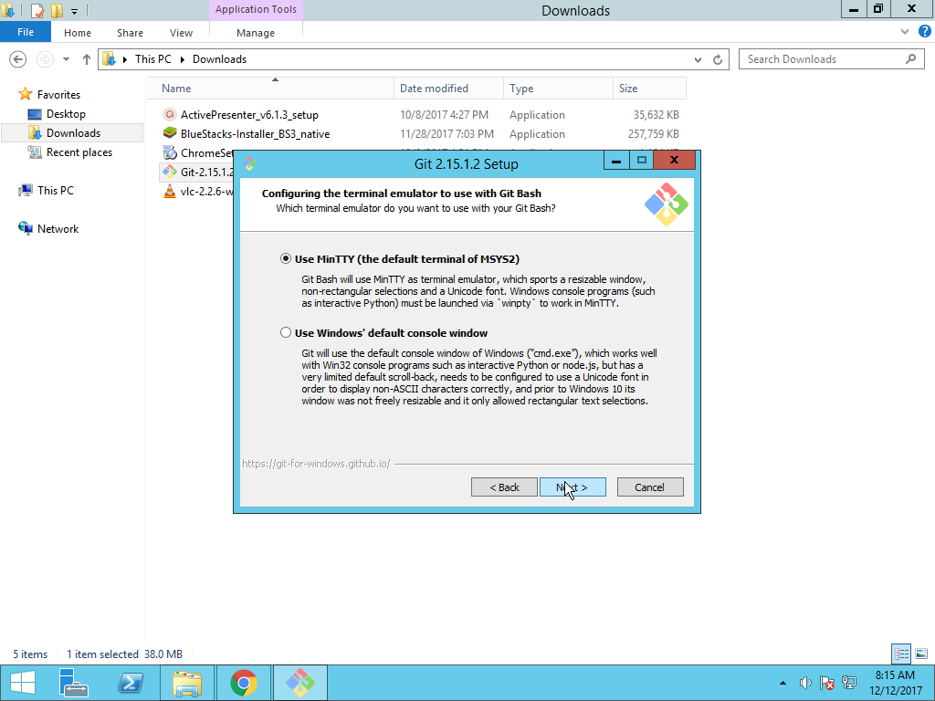

1. Configuring the line ending conversions

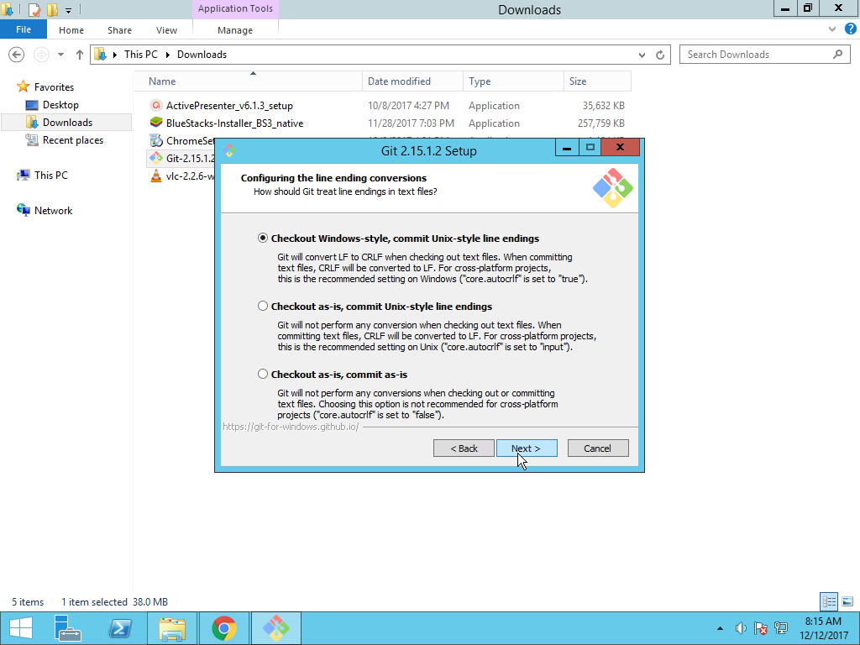

1. Click on next

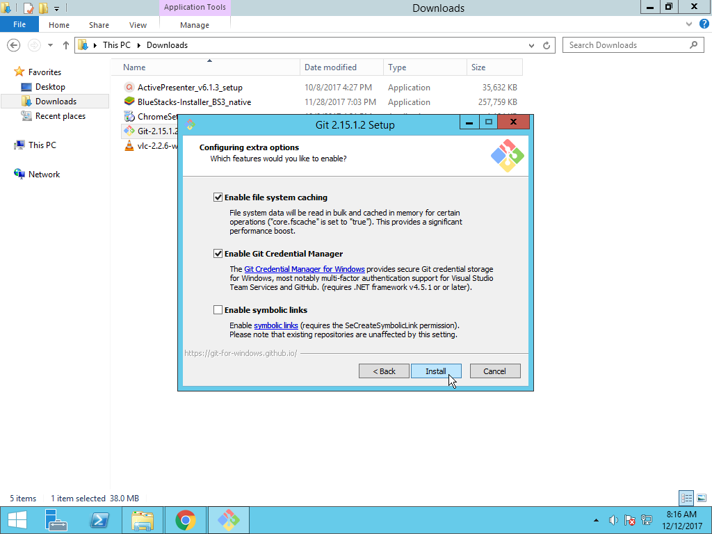

1. Click on Finish

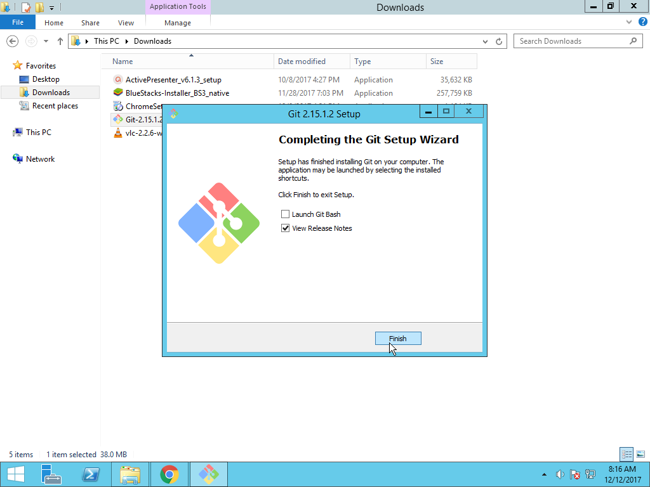

1. Create a Folder in the system and open the folder. Give a right click on the mouse and select Git Bash here.

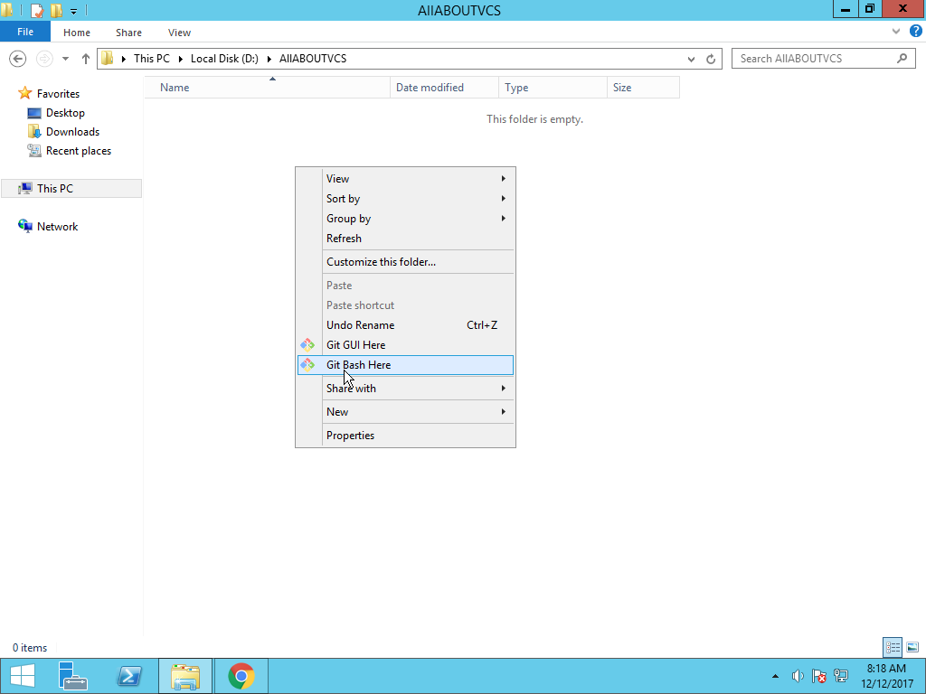

After this a terminal will appear on the screen.

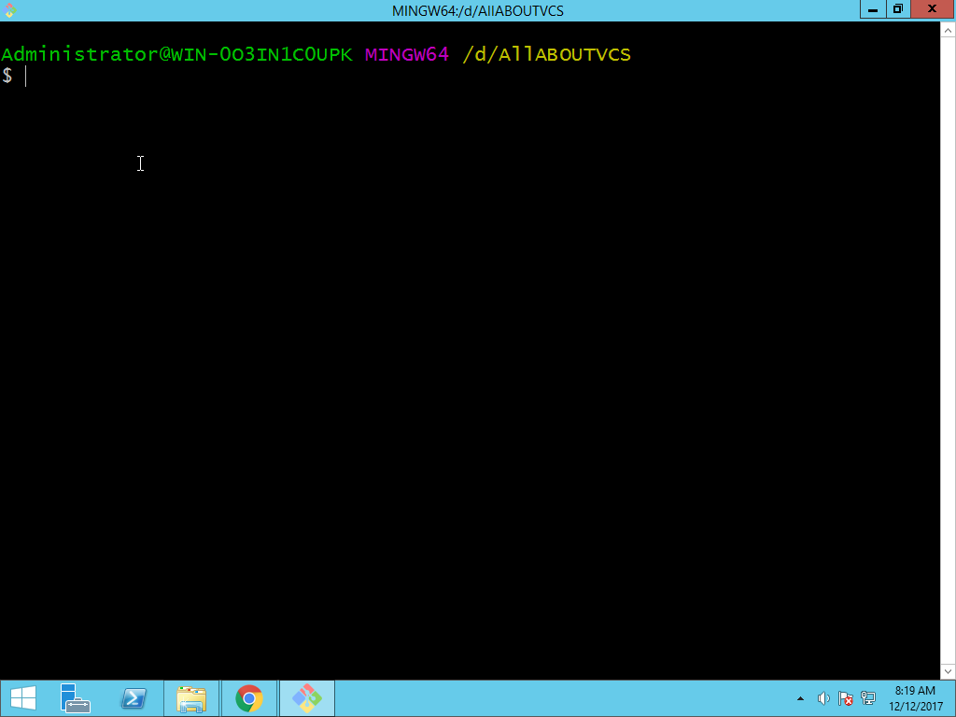

## 1.5 The Git Workflow

Git doesn’t track all of the files stored on your computer. You need to instruct Git to track certain files and directories. This process is called initialization. The parent directory containing your project—all the files and directories to be tracked by Git is called a repository. This repository might contain many files and directories, or even just a single file.

The following are three basic operations to be performed in Git after initializing local Repository.

**Track**

Once Git repository initialized, add files to the project. Any files that are added or modified initially untracked by Git. Git should be specified to track files for changes. Git monitors tracked files for changes and ignores untracked files.

**Stage:**

After making the required changes to your files, stage them. To stage a file is simply to prepare it finely for a commit. Git, with its index allows you to commit only certain parts of the changes you've done since the last commit.

**Commit:**

The next step is to create a commit. A commit is like a photograph that records the current state of your code. You can go back to a certain commit at a later time, view the status of the repository with respect to that commit, and check the changes that were made in the commit. The commit records the changes in a repository since the last commit. You can revert back to any commit at any point of time. Each commit contains a commit hash that uniquely identifies the commit, the author details, a commit message, and the list of changes in that commit. Once the commit has done, a file has to be pushed to remote locations. A push refers to the process of sending the changes you’ve made in your local repository to a remote location. A remote location is a copy of your repository stored on a remote server.

Git working can be defined in simply into three states.

* Current working directory
* Staging area
* Repository.

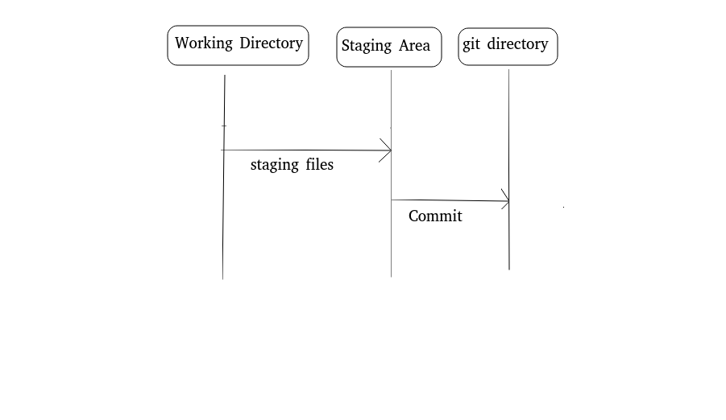

**The overall Work flow of Git.**

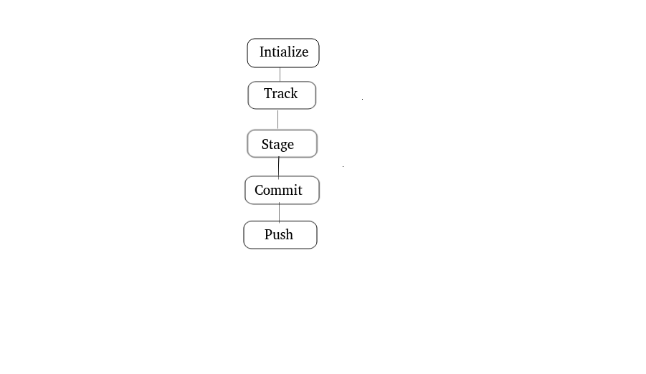

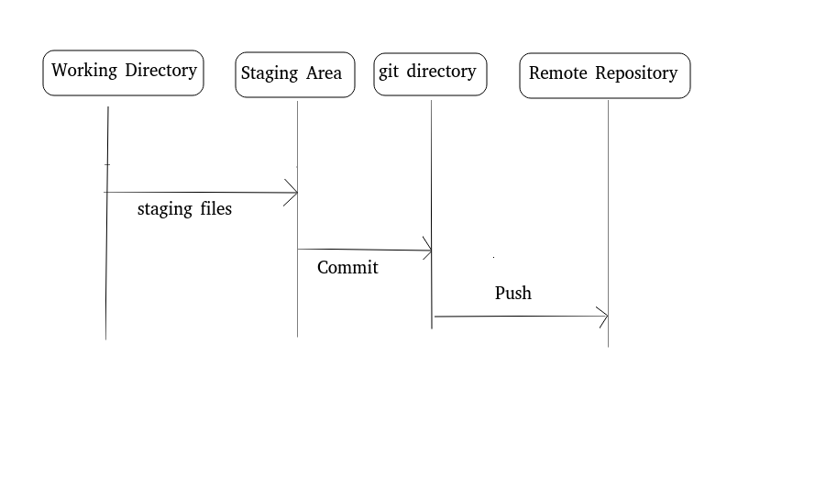

## 1.6 Basic Git Concepts

Repository

A Git repository is simply a database containing all the information needed to retain and manage the revisions and history of a project. The Git repository not only provides a complete working copy of all the files in the repository, but also a copy of the repository itself with which to work.

A repository can be a local folder on your computer, space on GitHub or any online Host, where you can keep code files, text files and image files inside repositories.

Types of Repositories

* Central Repository
* Local Repository

|  |  |
| --- | --- |
| **Central Repository** | **Local Repository** |
| Typically located on Server | Local repository on a system |
| Exclusively consist of .git  repository folder | Resides a git folder inside a project  root (project initial directory) |
| Meant for team to share and  exchange data | Only admin can have access |

Git maintains and inspects configuration and setup information on a per-site, per-user, and per-repository basis. Within a repository Git maintains two primary data structures object store and index. The repository data is stored in .git folder project root directory.

## 1.6 Getting a Repository

If you’re starting to track an existing project in Git, you need to go to the project’s directory and type.

The following command initialize a git repository, it creates a directory .git.

[root@dev projectx]# git init

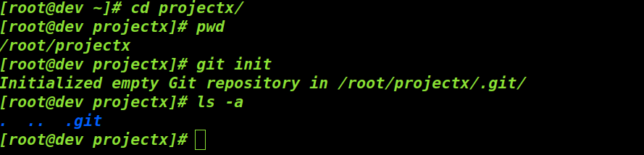

we will now create a file index.html file in the projectx directory, though we have git repository, we need to commit to the repository each time the project reaches a status which you want to records.

[[root@dev](mailto:root@dev) projectx] # cat index.html

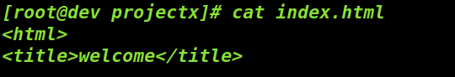

For now index.html is only part of current working directory. Each file in the directory can be one of the two states tracked or untracked. Tracked files are unmodified or modified or they can be staged(ready to commit).Git sees them as modified, because you’ve changed them since your last commit. You stage these modified files and then commit all your staged changes, and the cycle repeats.

The following command adds index.html to the staging area.

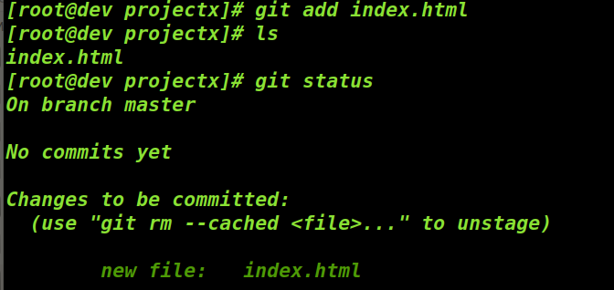

The following command shows the status of the tracked files and untracked files.

[root@dev projectx]# git status



Untracked basically means that Git sees a file you didn’t have in the previous commit Git won’t start including it in your commit until you explicitly tell it to do so.

For now Index.html file is a tracked file. Now modify index.html file

[root@dev projectx]# cat index.html

<html>

<title>welcome</title>

<body>My new page</body>

Run the command git status again, this time previously staged index.html file is modified

[root@dev projectx]# git status

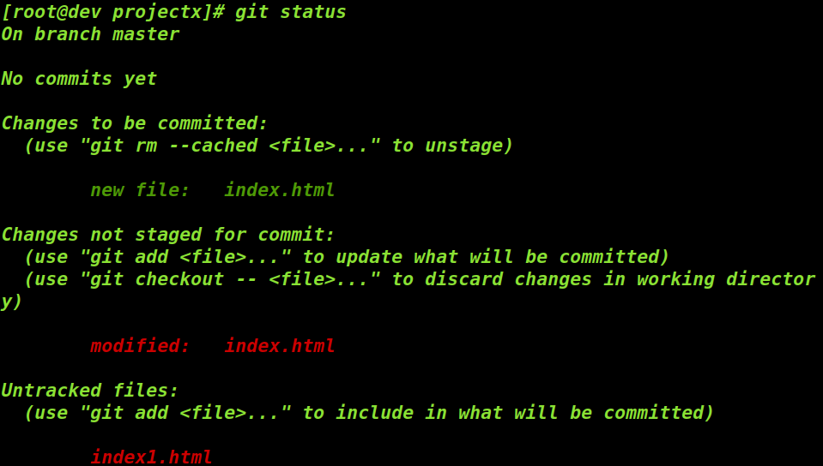

Add any new file and also the modified to staging area

The following command adds all the files to staging area.

[root@dev projectx]# git add .

[root@dev projectx]# git status

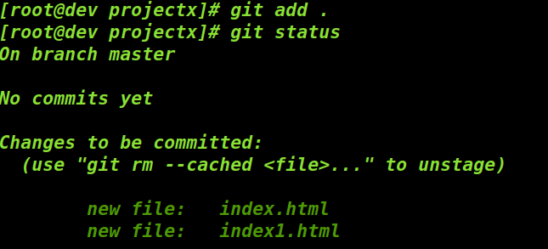

In the above output, we can observe that index. html is in staging area. Now when you run the command git commit, it will commit the index file in staging area not like what is there in the directory. Latest version of the file can be staged only if you run the command git add; now the latest version will be committed.

**Ignoring Files**

There are some automatically generated files such as log files or files produced by your build system, which you don't want to add to the git.

Create a file for example README.txt and this file should be ignored.

[root@dev projectx] # git status

Untracked files:

(use "git add <file>..." to include in what will be committed)

Now create file .gitignore and add a line *txt, which means files here, will not be tracked or added to staging area.

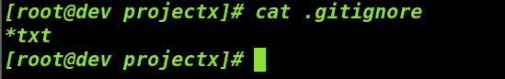

Now git status command will show you different output where you will not see file with txt extensions

[root@dev projectx]# git status

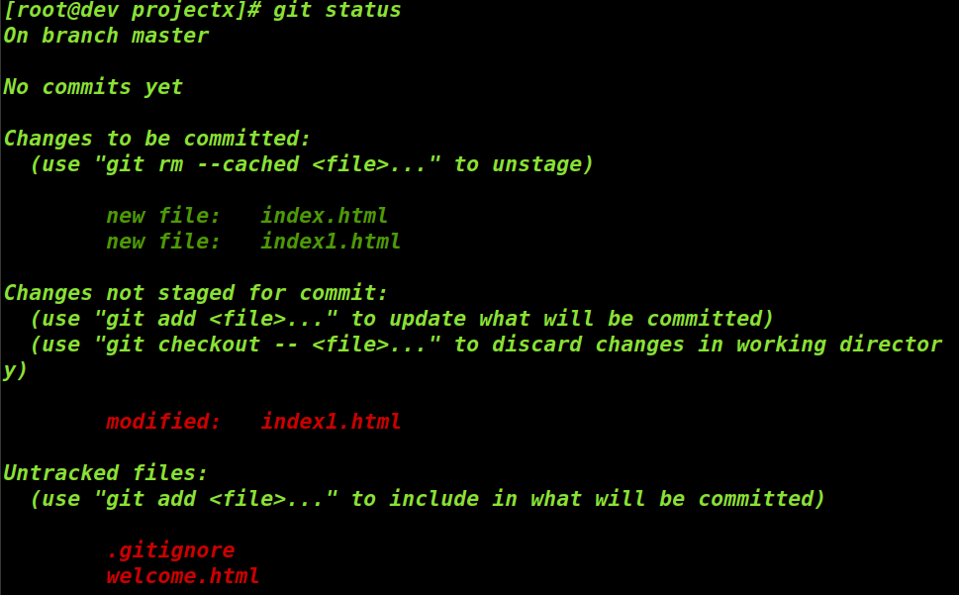

The file .gitignore is very much helpful, as it avoid accidental commit of the files. The rules for the patterns you can put in the file .gitignore.

1. Blank lines and lines starting with # are ignored
2. You can add patterns with slash to specify directory.
3. You can negate a pattern by starting it with an exclamation point (!)

Here is another example .gitignore file:

*.a # ignore all .a files

!lib.a # but do track lib.a, even though you're ignoring .a files above

/TODO # only ignore the TODO file in the current directory, not subdir/TODO

build/ # ignore all files in the build/ directory

doc/*.txt # ignore doc/notes.txt, but not doc/server/arch.txt

doc/**/*.pdf # ignore all .pdf files in the doc/ directory and any of its subdirectories

To see the differnce between the file in current directory and the staged file,run the following command.

[root@dev projectx]# git diff

diff --git a/index1.html b/index1.html

index bfb620c..18f299c 100644

--- a/index1.html

+++ b/index1.html

@@ -1,3 +1,4 @@

<html>

<title> NEW PAGE </title>

+<body> WELCOME </body>

The output below shows index.html is with an extra line (+) when compared to the file in current directory. In Git versions 1.6.1 and later, you can also use git diff --staged , which may be easier to remember.

It is important to remember that the command git diff only says between that last staged and unstaged file, once it is staged you will not see git diff command showing an output.

## 1.7 Committing the changes

If staging area ready with the content you want, then it’s time to commit your changes. Command git commit, commits the changes to repository. While doing commit we need to add a comment, a commit message.

Run the following command to commit the status

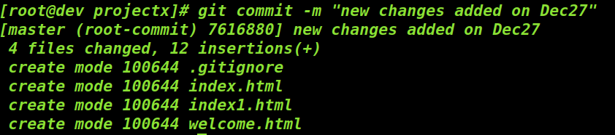

The above output shows which branch you committed to master, what SHA1-checksum the commit has lines added and removed from the file.

Every time you perform a commit, you’re recording a snapshot of your project that you can revert to or compare to later.

[root@dev projectx]# git status

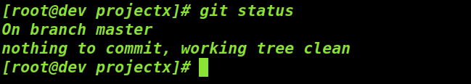

To commit without staging. Modify the index.html

[root@dev projectx]# vi index.html

[root@dev projectx]# git status

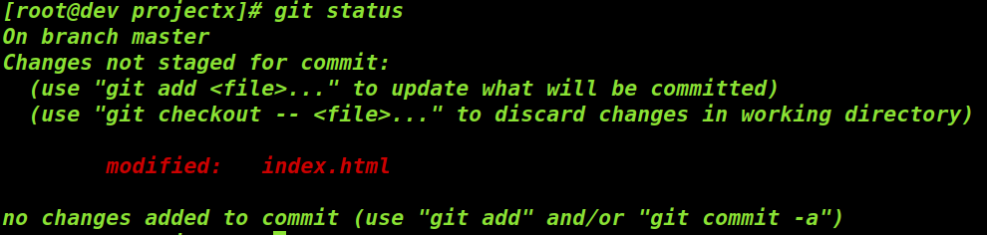

To commit changes without staging, run the following command.

[root@dev projectx]# git commit -a -m "skipping staging"

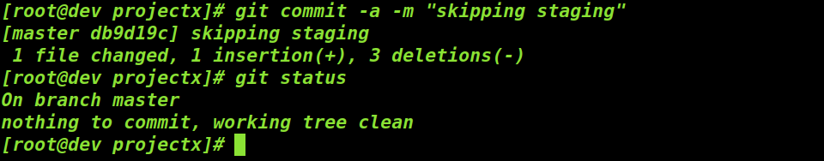

To remove the files from git, remove it from your tracked file in this case before you commit.

[root@dev projectx]# rm welcome.html

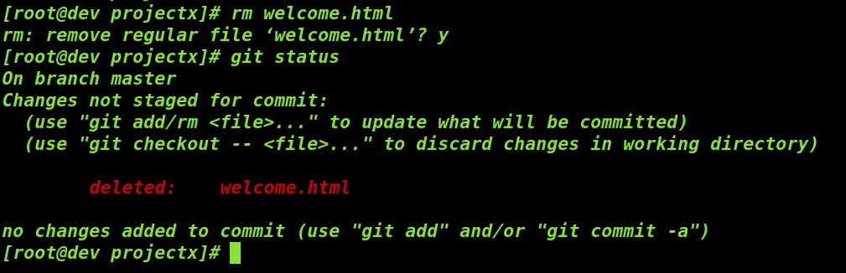

[root@dev projectx]# git rm welcome.html



[root@dev projectx]# git commit -m "deleted welcome.html"

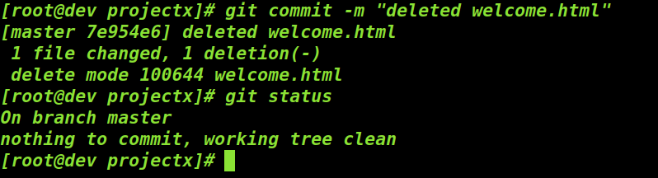

[[root@dev](mailto:root@dev) projectx]# git status

Unstage a staged family

To remove specifically from staging area only, then use the 'git rm --cached'. For example create a new file and add it to staging area. Now run the following command to remove only from staging area.

[root@dev projectx]# git rm --cached new.html

rm 'new.html'

To unstage a staged file run the command git reset HEAD

[root@dev projectx]# git reset HEAD

Unstaged changes after reset:

M index.html

[root@dev projectx]# git status

On branch master

Changes not staged for commit:

(use "git add <file>..." to update what will be committed)

(use "git checkout -- <file>..." to discard changes in working directory)

modified: index.html

Untracked files:

(use "git add <file>..." to include in what will be committed)

1

new.html

no changes added to commit (use "git add" and/or "git commit -a")

To unstage a specific file, pass the filename as argument.

[root@dev projectx]# git add index.html

Creating Local copy of existing Remote repository

To create clone of remote repository and start working with 'git clone' command is used. It will create local copy, with all the history of remote repository. After the clone, create files or modify the files and commit to the local repository.

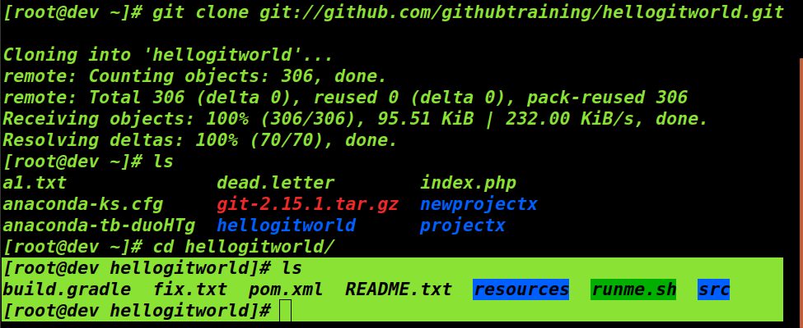

Alternatively you can pass a non-existent directory name to which repository has to be cloned and also to specify the number of last commits.

[root@dev ~]# git clone --depth 10 git://github.com/githubtraining/hellogitworld.git HELLO

## 1.8 Organizing your repository with Branches

**Branching**

Version Control Systems of yesterday had poor support for branches and even worse support for merging those branches back together. One of the most important features of Git is its ability to easily handle creating branches and gracefully merge them back together.

For example, you might be finishing up version 1.0 and already starting on new features for version 1.1.Using Branches and gracefully merge them together. Using branches version 1.0 can be isolated from from version 1.1 don’t accidentally slip into the version that is getting ready to release.

Create branch based on their names it easier to track them based on their name. Master is the name of default branch. Initially we will start work with master branch.

There are several different ways to approach branches. One approach is the topic branch. It can be used to work on specific feature, fix a bug, or deal with any other topic. Once it is completed then your merge the finished changes back into your master branch.

Another type of branch is the release branch; you create release branches as you approach a release in your project. They’re useful when you or other members on your team are working multiple versions of your project. Any changes from the final work on version 1.0 get merged back into master.

## 1.8.1 Creating and Switching Branches

Create a new branch from current place in the repository.

[root@dev projectx]# git branch version-1.1

To swith from current branch to new branch.

[root@dev projectx]# git checkout version-1.1

Switched to branch 'version-1.1'

[root@dev projectx]#

To view all branches

[root@dev projectx]# git branch

master

* version-1.1

[root@dev projectx]#

Note: * in the output indicates current branch

To commit changes only to the current branch

Create a new file in the directory and stage the file

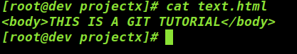

[root@dev projectx]# git add text.html

[root@dev projectx]# git status

On branch version-1.1

Changes to be committed:

(use "git reset HEAD <file>..." to unstage)

new file: text.html

[root@dev projectx]#

Commit the file to the repository.

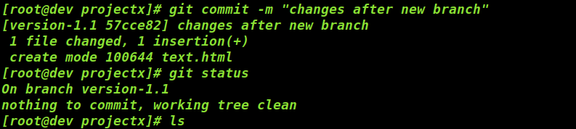

Run the command ‘git status’ and verify in the output that newly created file is added to the new branch, this happened as your currently in the new branch.



Switch to master branch and verify the files committed over there.

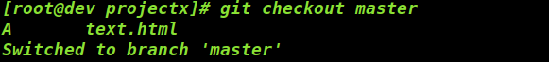

Check the files list in this directory.



Now switch back to the branch version-1.1 and verify the files listed.

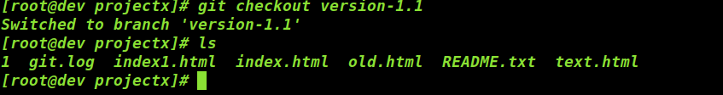

## 1.8.2 Merging branches

Verify the current branch, which are you are in,

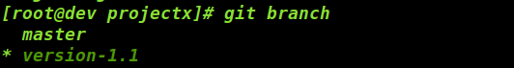

You should always in destination branch to merge the files,



Run the command git merge to merge the branches.

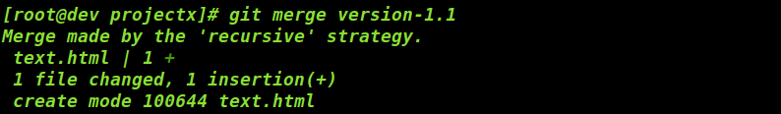

Note: while merging it will ask about a commit message, you can add -m to add comment.

By default git merge commits merged changes, to avoid these,run the following command, it only merges the branches will not commit.

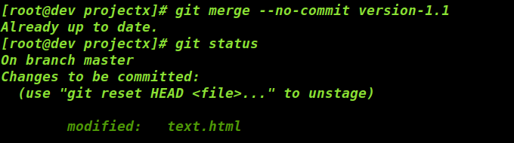

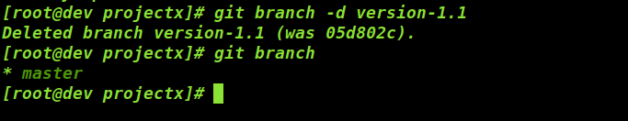To delete a branch run the command ‘git branch -d branchname’.

To delete a branch that hasn’t merged into the current branch run the command ‘git branch -D branch-name’.

## 1.9 Review History

The Git Log tool allows you to view information about previous commits that have occurred in a project.

[[root@dev](mailto:root@dev) projectx] # git log --all

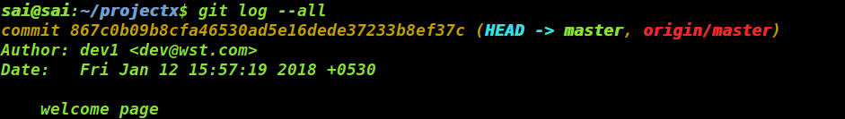

To View only most recent commits, run the following command.

[[root@dev](mailto:root@dev) projectx] #git log -3

To view commit based on the author

[[root@dev](mailto:root@dev) projectx ] # git log –author=dev1

The author option will limits results to commits in which the changes were written by name. The committer option on the other hand will limit results to commits that were committed by that individual.

[[root@dev](mailto:root@dev) projectx] # git log --committer=dev1

To view commits to those within a given date range.

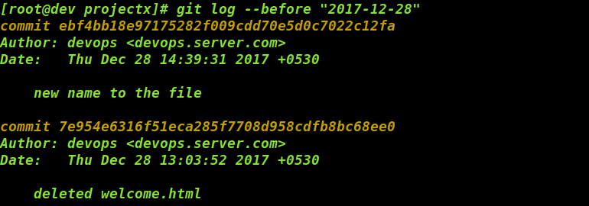[[root@dev](mailto:root@dev) projectx] # git log --before “2018-12-28”

[[root@dev](mailto:root@dev) projectx] # git log -- after “2018-12-28”

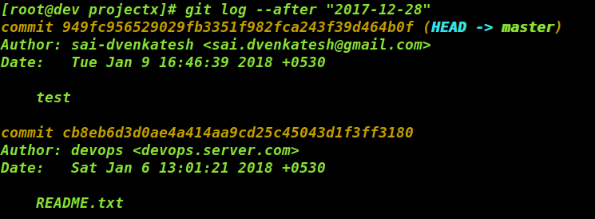

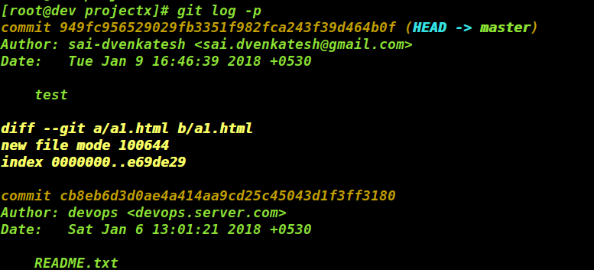To view the entire diff of changes for each commit found.

[root@projectx ~] git log -p

## 1.11 Roll back from previous commits

Run the command git log to list commit history of the target file which has to rolled back

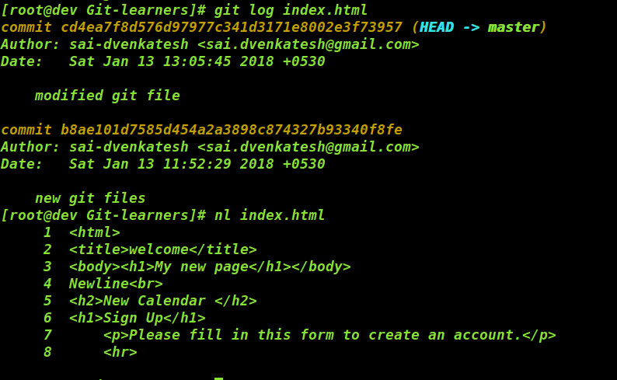

Copyt the first 8 digit commit from the inital commit of the modified file.

Run the command ‘git checkout <paste 8 digit commit hash> filename’



## 1.11 Remote repositories

Having a local repository as well as a remote (online) repository is the best way of keeping source code available to others and also a way back up for your local repository.

**GitHub** is a web-based Git version control repository hosting service. In order to use Git Hub, you need to create account and it is as simple as you create account in any other social networking sites. After creating account, a new repository has to be created.

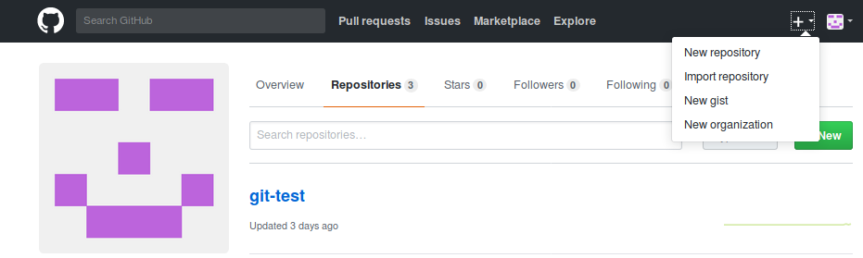

Click on new repository.

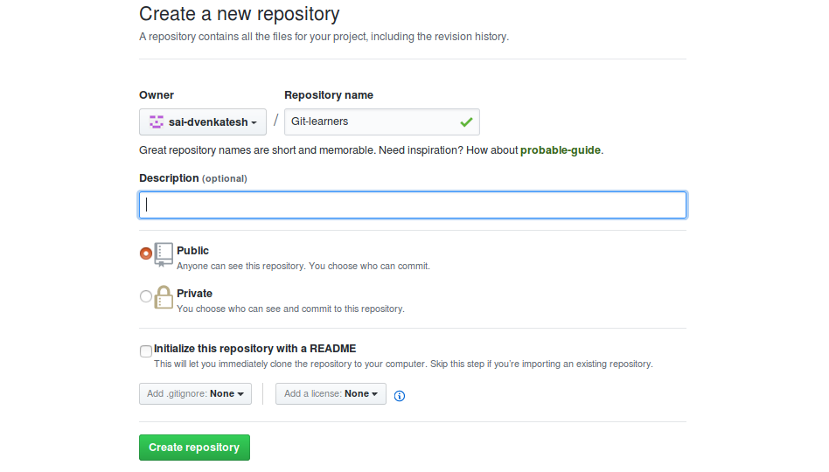

New repository in GitHub will be created.

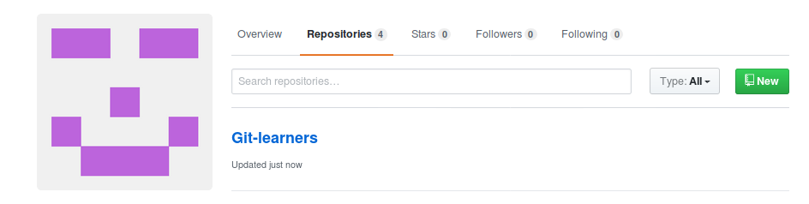

Now at the local machine, run the following command to push your code from the remote repository.

[root@dev projectx]# git remote add origin <https://github.com/sai-dvenkatesh/Git-learners.git>

[root@dev projectx]#git remote -v



Now to push code from the git local repository run the command, git push before that you need to provide the branch name to which the code has to be pushed.

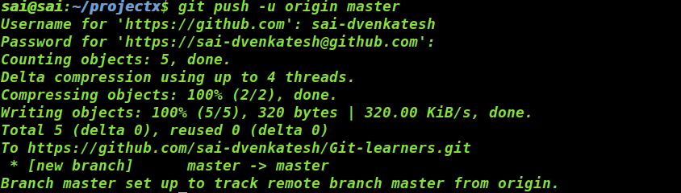[root@dev projectx]# git push -u origin master

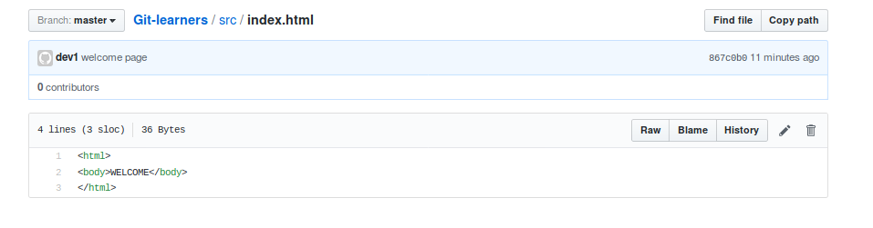Login into the Git.

To pull the content from Git repository run the command, git pull from your local repository.

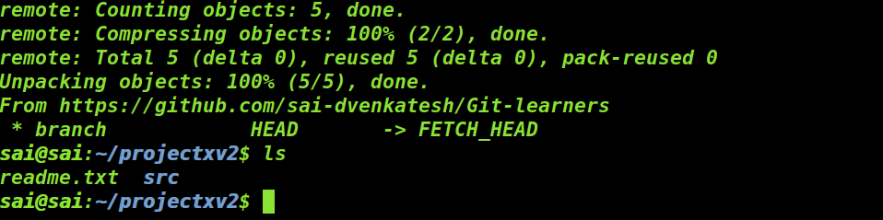[[root@dev](mailto:root@dev) projectxv2] git pull <https://github.com/sai-dvenkatesh/Git-learners.git>

## 1.12 Git Hub SSH login

Generate SSH keys

[root@dev **projectx] # ssh-keygen**

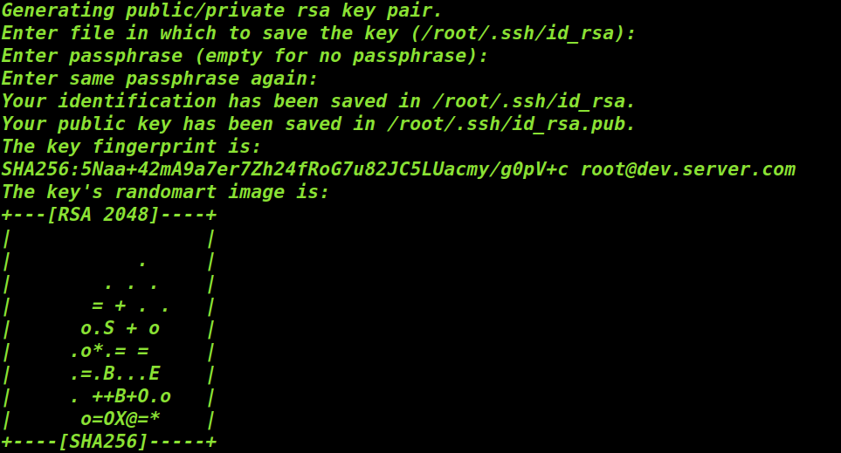

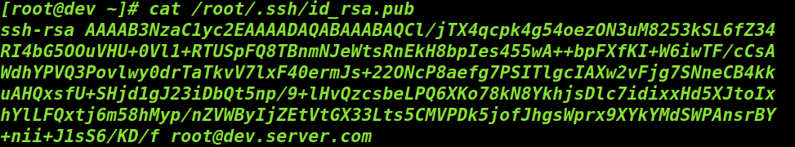Copy the public key which is store in the file ~/.ssh/id_rsa.pub.

Go to GitHub account --> settings > SSHkeys > NewSSH keys

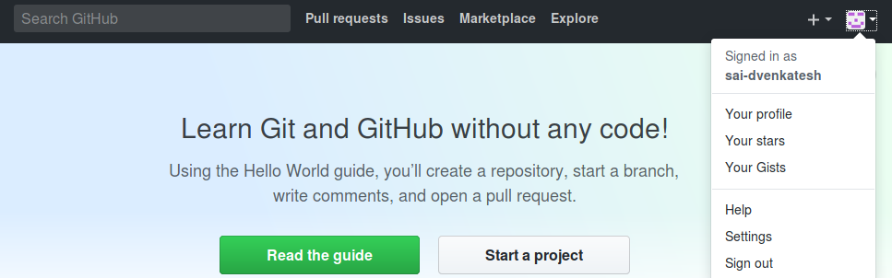

Click on new SSH keys and paste the key here.

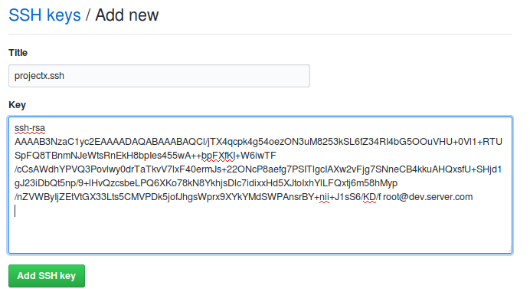

Click on add SSH key

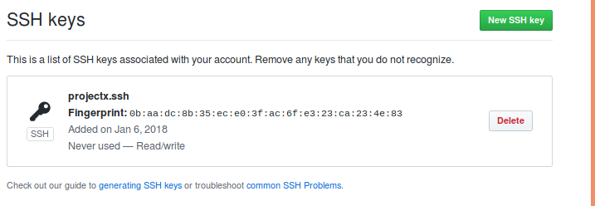

Log in to your account using ssh utility.



Push the code to remote GitHub repository.

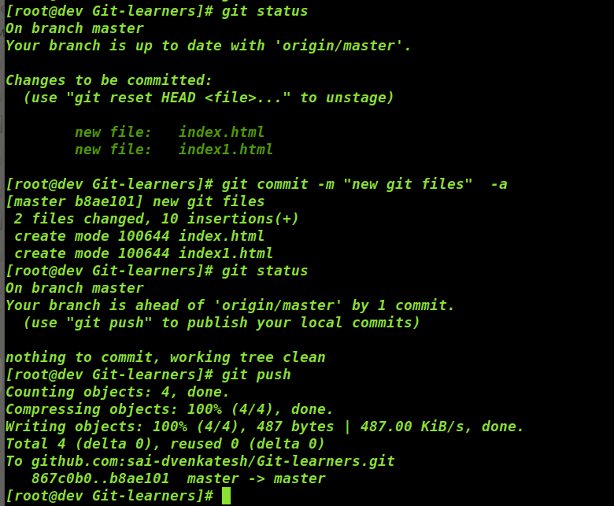

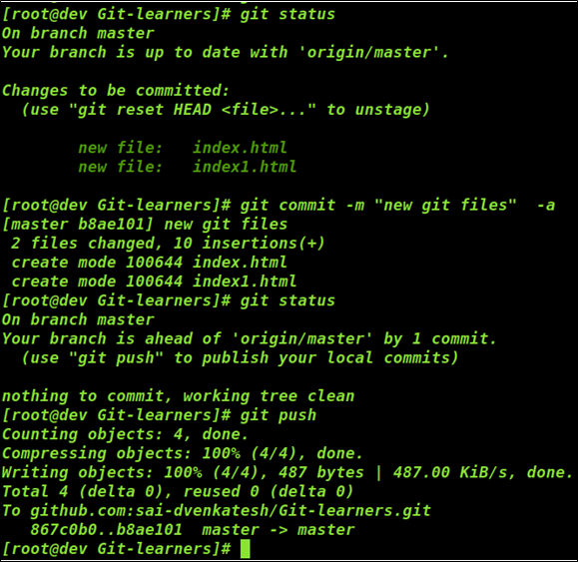

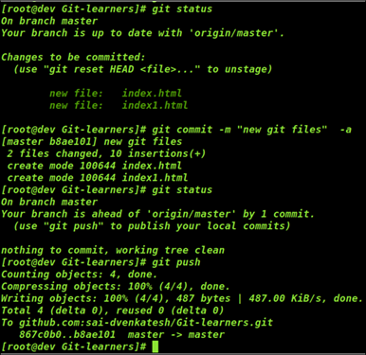

Add or modify a file in the github repository, select the target repository and create a new file.

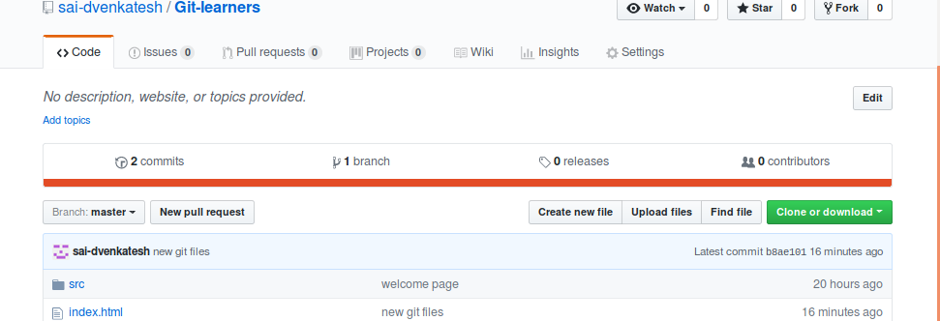

Edit the new file and commit that to the repository.

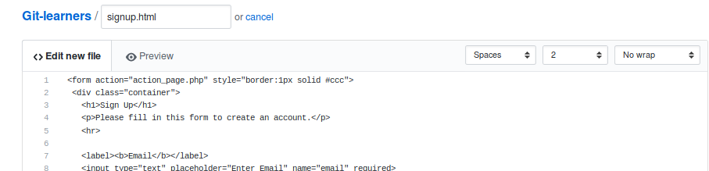

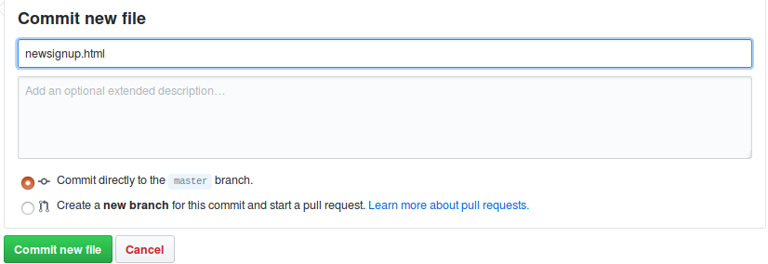

Now at the local repository run the command git pull to get the updates from the repository.

Pull the updates from the remote repositories.

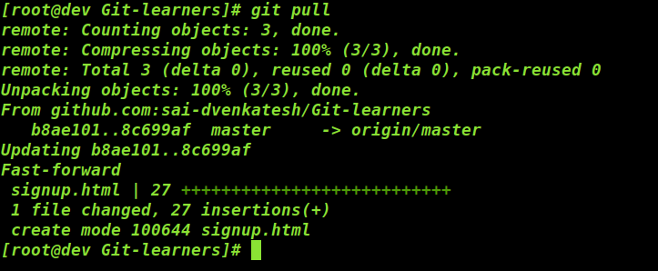

To remove a remote URL repository, run the command ‘git remote rm origin’

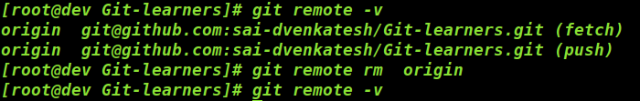

Note: git remote rm does not delete the remote repository from the server. It simply removes the remote and its references from your local repository.

# 2. Apache Maven

## 2.1 Build Process

Build process includes the following steps:

* Compiling source code in the source path of a module and placing results to the output path.
* Compiling source code in the test path of a module and placing results to the test output path.
* Creating copies of the resource files in the output path.
* Reporting problems in the Messages tool window

**Compilation and execution**

Compilation and execution of a Java program is two step processes. During compilation phase Java compiler compiles the source code and generates bytecode. This intermediate bytecode is saved in form of a .class file. In second phase, Java virtual machine (JVM) also called Java interpreter takes the .class as input and generates output by executing the bytecode.

Build Tool

A build tool takes care of everything for building a process. It does following:

* Generates source code (if auto-generated code is used)
* Generates documentation from source code
* Compiles source code
* Packages compiled code into JAR of ZIP file
* Installs the packaged code in local repository, server repository, or central repository.

## 2.1 Maven

An open source, project management and comprehension tool. Maven provides developers a complete build lifecycle framework. Development team can automate the project's build infrastructure in almost no time as Maven uses a standard directory layout and a default build lifecycle.

A build tool focused solely on pre-processing, compilation, packaging, testing and distribution. A project management tool, provides a superset of features found in a build tool. In addition to providing build capabilities, Maven can also run reports, generate a website, and facilitate communication among members of a working team.

**Apache Maven’s objectives are listed as**

* Making the build process easy
* providing a uniform build system
* providing quality project information
* providing guidelines for best practices in development

Most of the action in Maven happens in plugin goals which take care of things like compiling source, packaging bytecode, publishing sites, and any other task which need to happen in a build.

**What is POM?**

A Project Object Model or POM is the fundamental unit of work in Maven. It is an XML file that contains information about the project and configuration details used by Maven to build the project. It contains default values for most projects. Examples for this are the build directory, which is target; the source directory, which is src/main/java; the test source directory, which is src/test/java; and so on. The pom.xml file should be in the base directory. Following is the sample pom.xml file

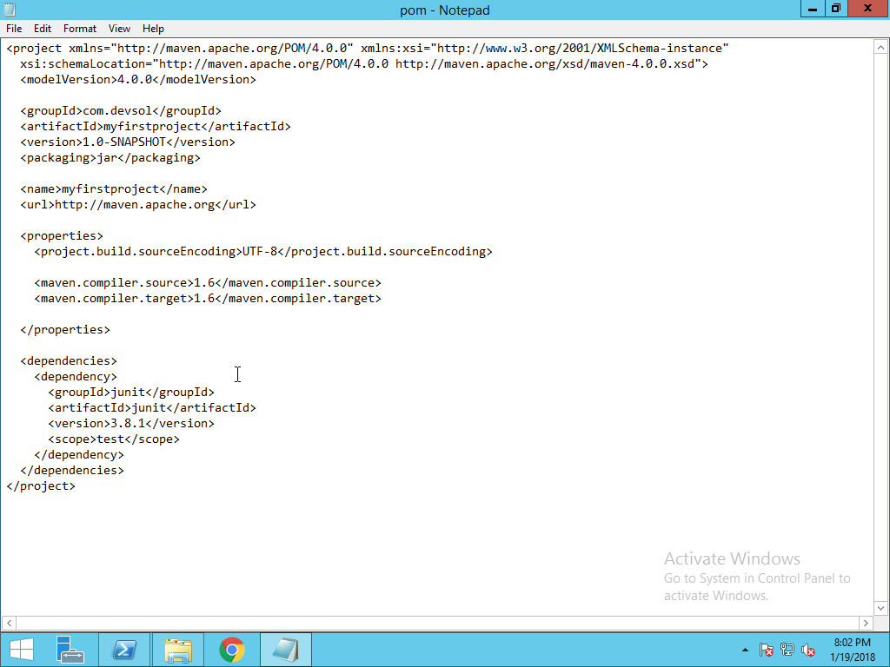

## 2.2 Setting up Apache Maven on Windows

To Download and Install Apache Maven, First we need to identify system requirements and the best way to know about this is mave.apache.org.

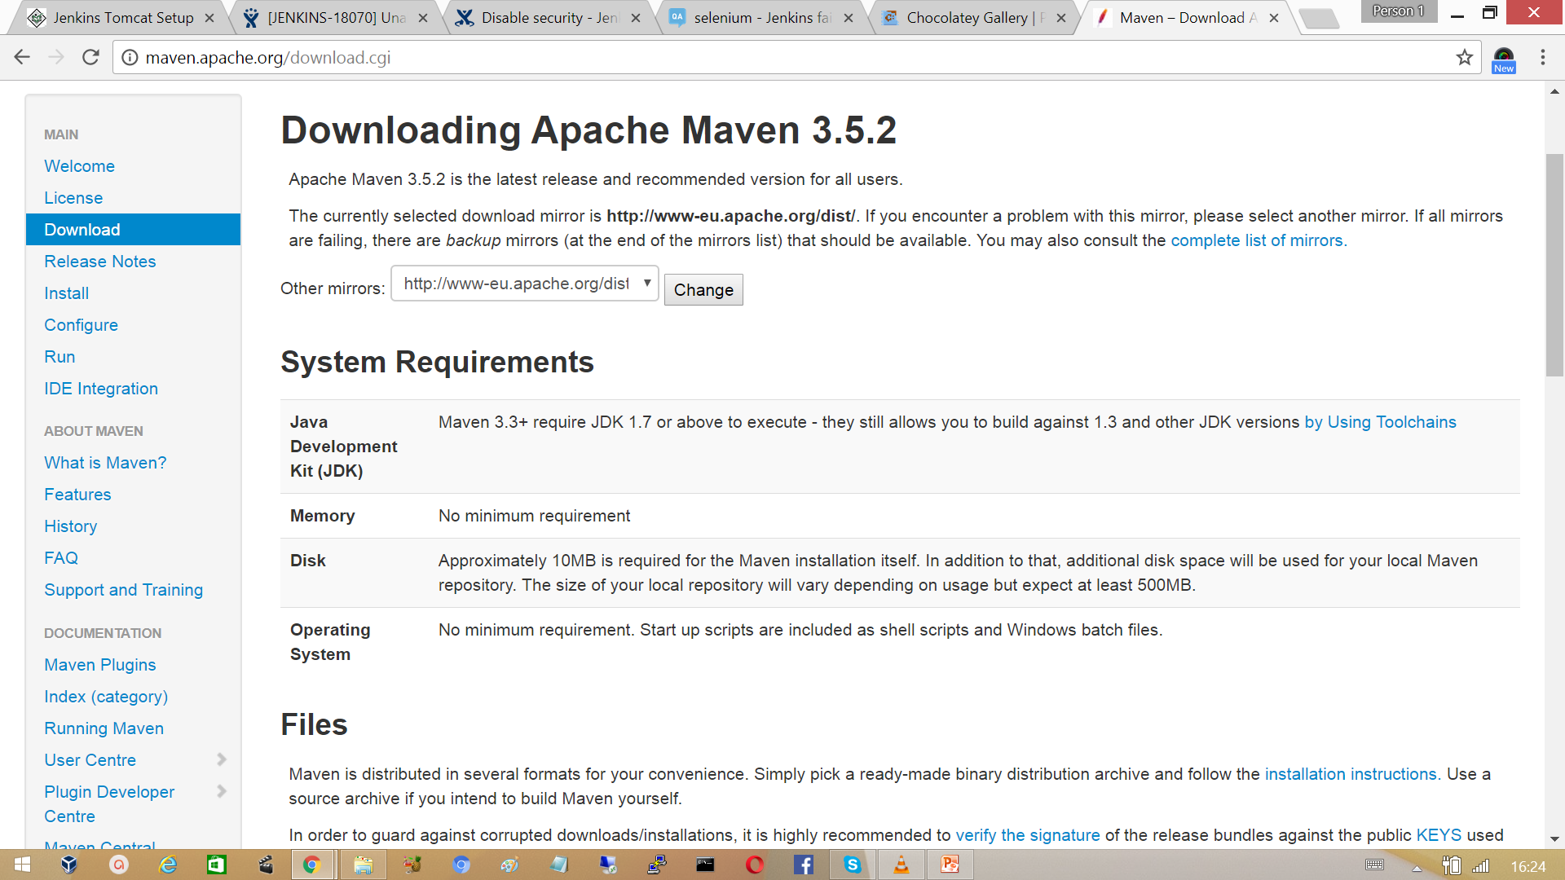

To install and run maven, Java Development Kit must be installed already, Instructions below tells us how to install JDK on Windows.

Download JDK from Oracle website.



Run the installer file. Click on next to continue choose the path to install and complete the java in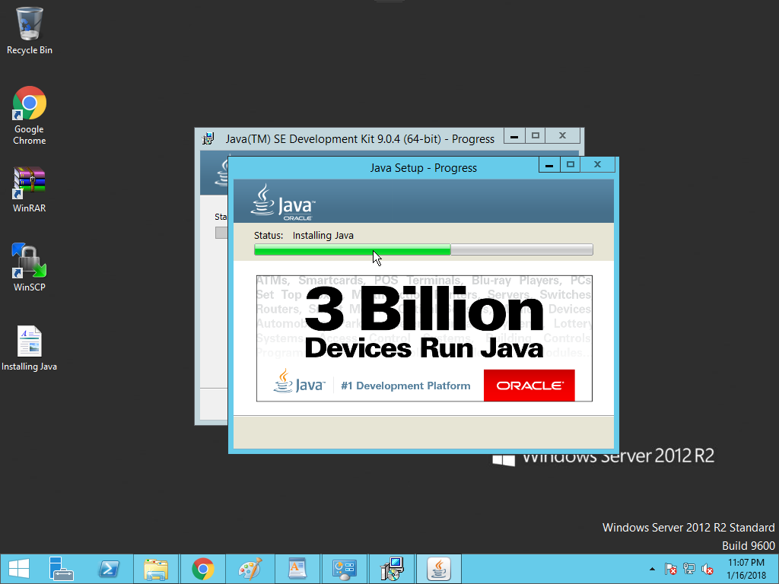stallation. Complete the java Installation.

**Setting Up Java Path**

To set up Java path Right click on My computer (This PC) > properties > Advanced System Settings > System Properties > Environment Variables.

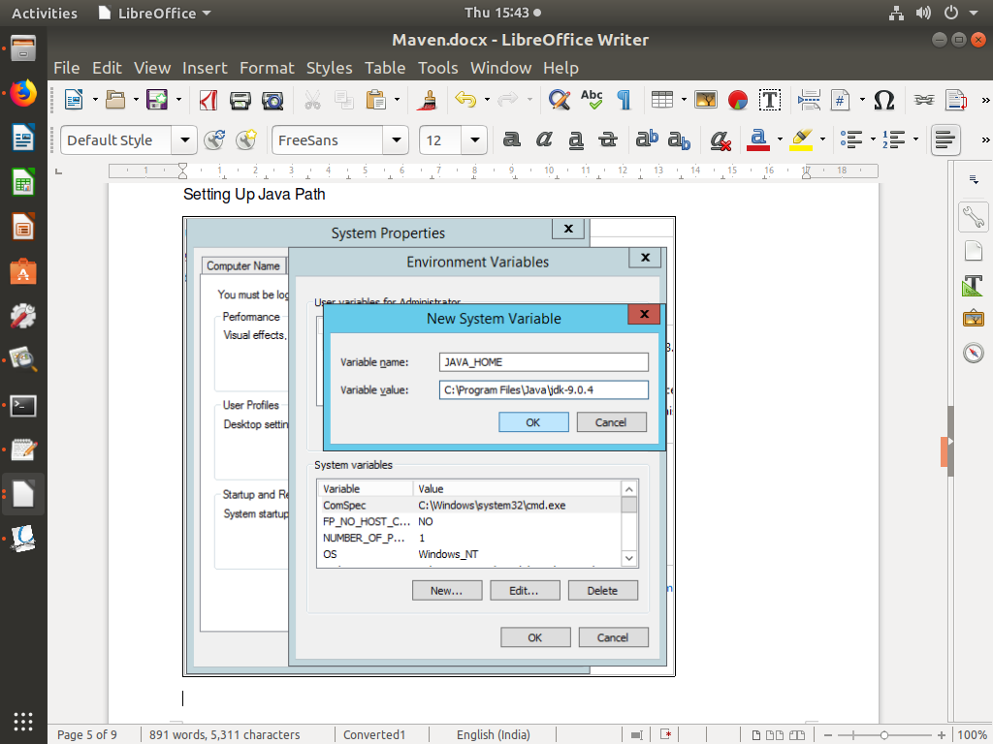

As we mentioned prerequisite for working with maven is the availability of the java Development Kit. Make Sure Java is installed before proceeding. Run the command ‘java -version’ to verify it.

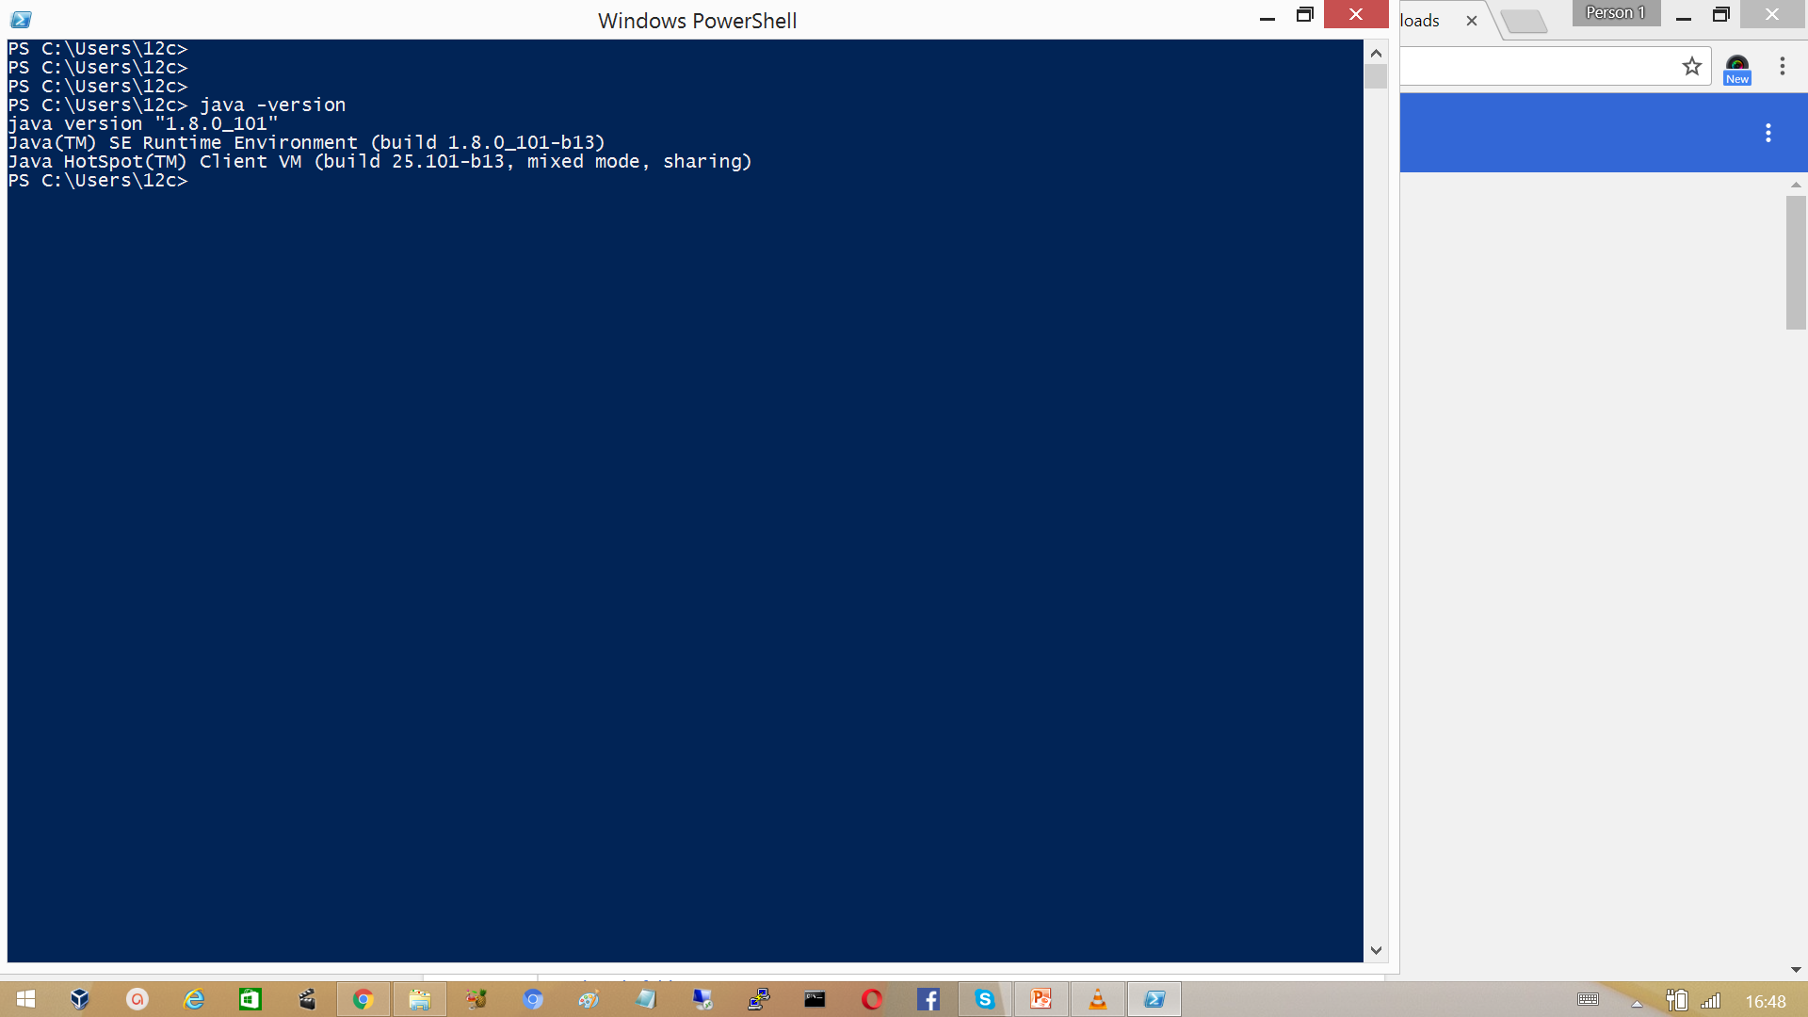

Now download the maven binary zip file from maven.apache.org

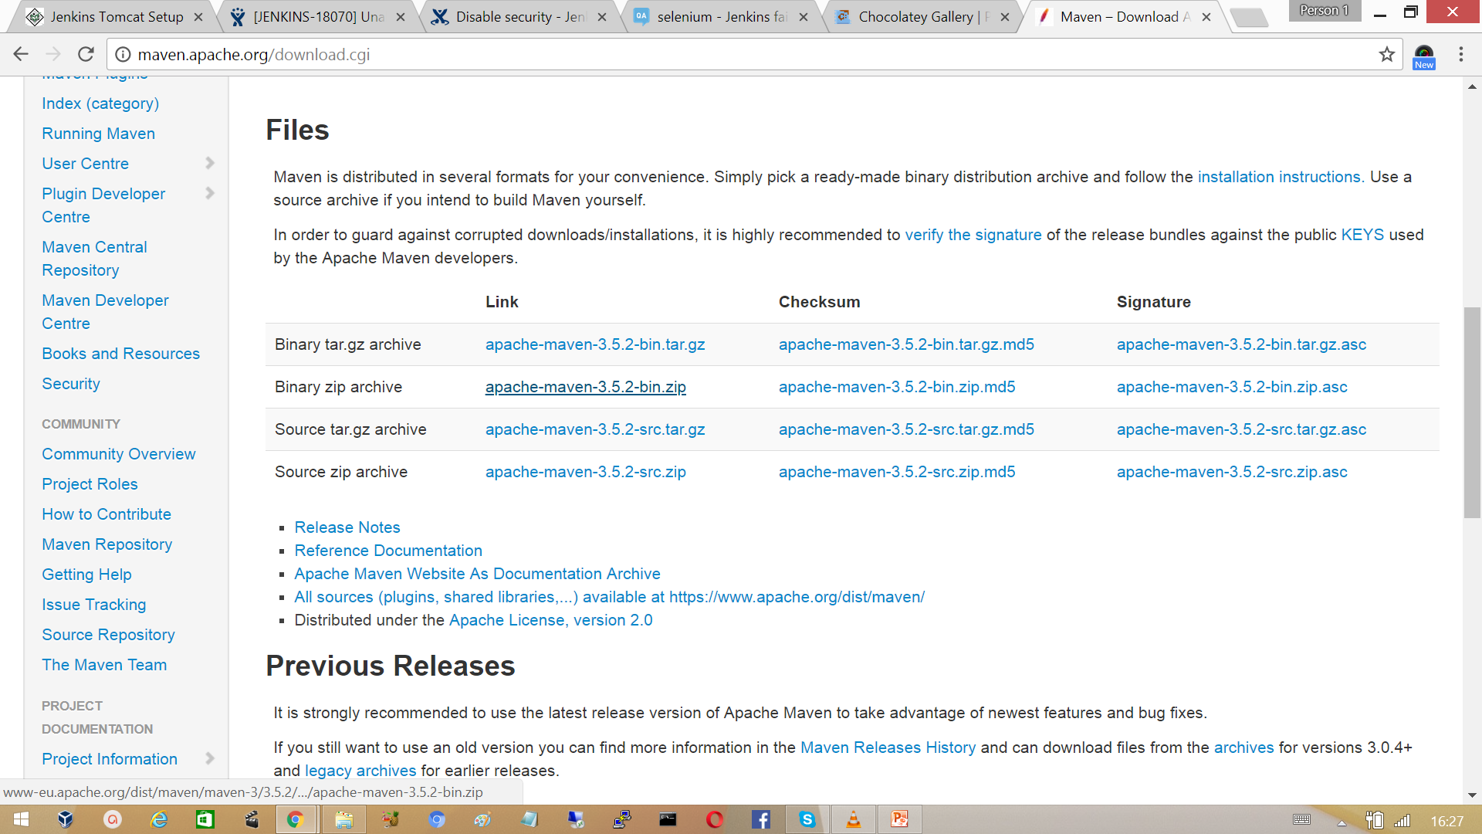

Extract the files to the location program files. To start using Maven, we need to configure Windows environment variables. The M2_HOME Variable needs to be set and the PATH variable needs to be modified to include the Maven binaries folder.



Verify maven is recognized from the command line.



## 2.3 Setting Up Maven on Linux

Install the prerequisite the JDK on Linux

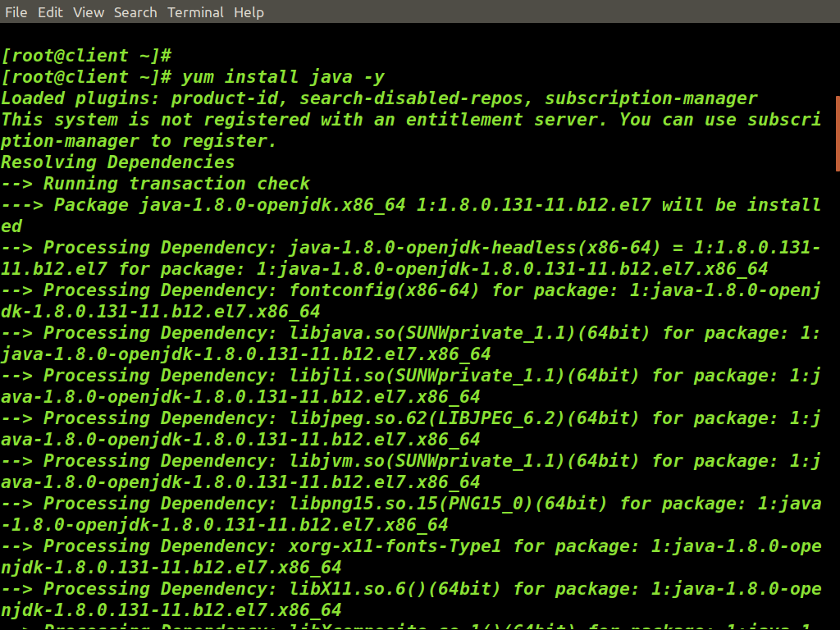

Setting up Java path in Linux



To set path permanently add the same to /etc/profile

[root@client ~]# vi /etc/profile



Download the Maven from <http://maven.apache.org> website.

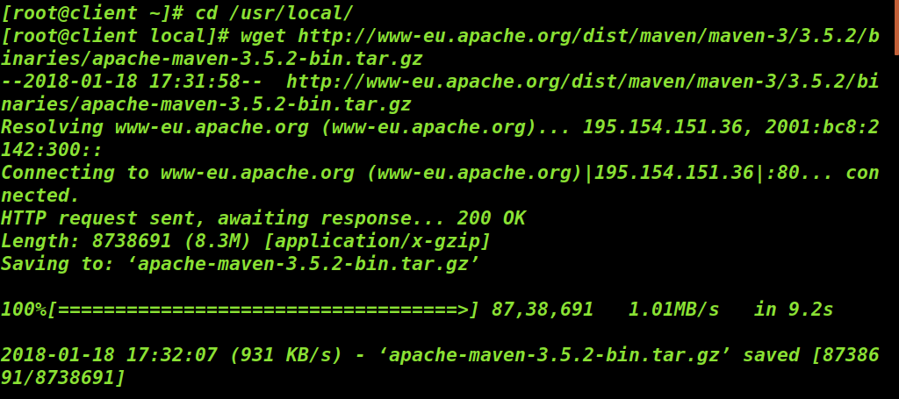

Now set the environments variables.

To set path permanently add the same to  */etc/profile*

[root@client ~]# vi /etc/profile



Verify the apache maven installation

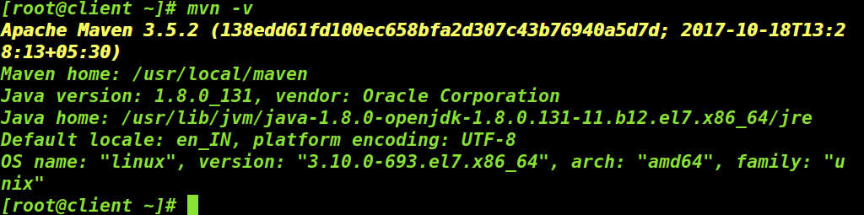

## 2.4 Create a new project.

In this exercise we create our first maven project.

Run the command ‘mvn archetype: generate’, which generates a project directory structure. Archetype is a maven plugin, here it generates a project structure from available templates by default it uses a template quick start to create simple maven project while doing so it list different archetype available it has number for each archetype, you can choose any one of them.

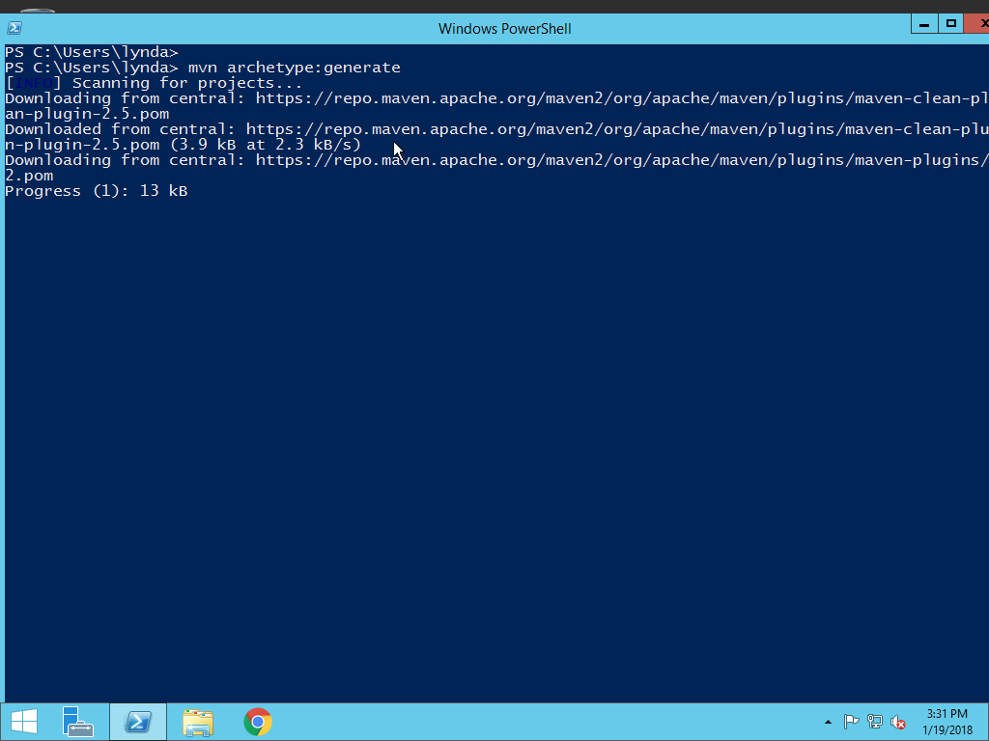

Maven searches for plugins at a local repository, for the first time it will not find any local repository; it downloads the plugins required from a central repository. Maven will ask for the project detail. Enter project detail as asked. Press Enter if the default value is provided. You can override them by entering your own value.

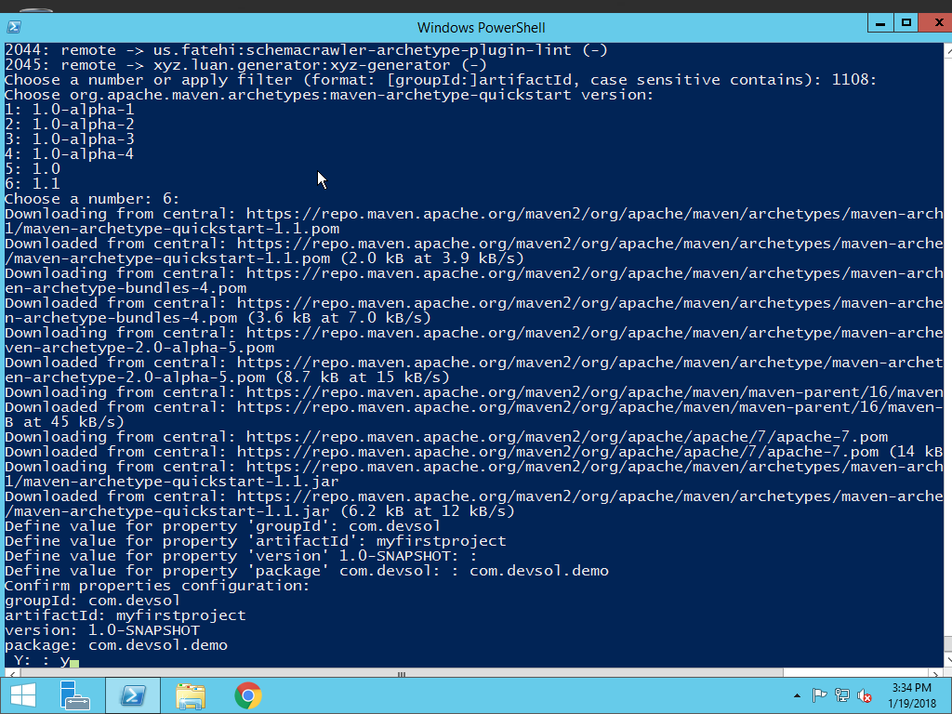

What is GroupID?

An ID of the project group, unique among organizations for example an organization DevSol and website of them is DevSol.com then it is convention to give a domain name in reverse way ‘com. DevSol’

What is artifactID?

An artifact in maven is a resource generated by a maven project. Each maven project can have exactly one artifact like a jar, war, ear, etc. Along with the groupId, the artifactId defines the artifacts location within the repository. In generally your project is known by artifactid.

What is Version?

This is the version of the project. Along with the groupId, It is used within an artifact's repository to separate versions from each other. Keyword snapshot indicates as it is in development state

What is Package?

Package defines the folder to store class directory (Class file) and test (test file) directory.

Now verify the folder location myfirstproject, a template class file and a template file will be created here.

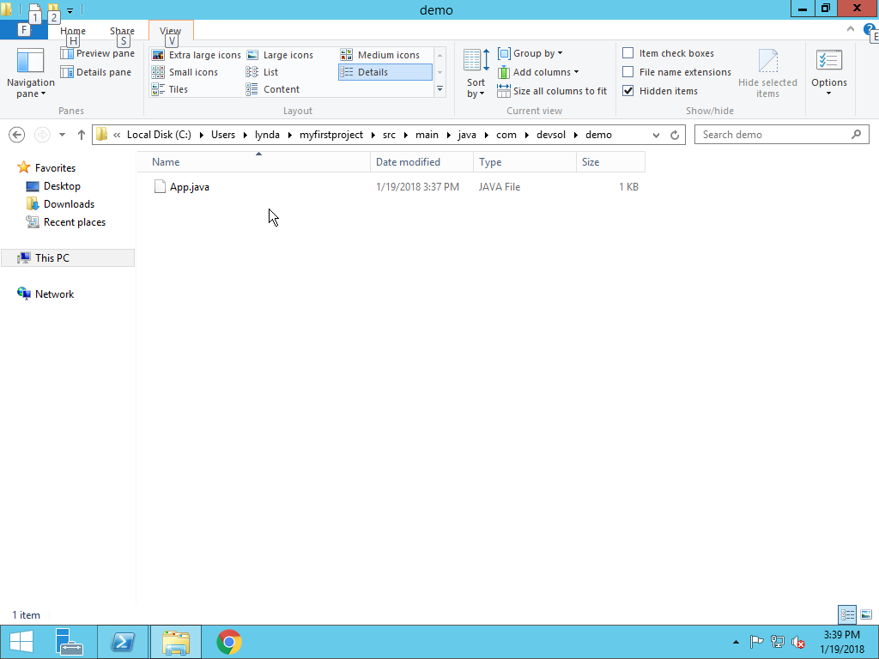

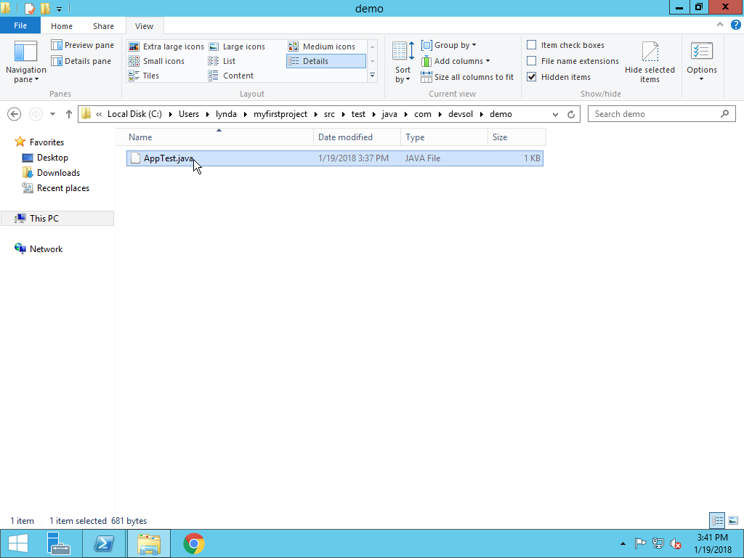

How to build a Jar file?

To build a jar file, first we need to run compile and whenever you compile a source file a .class file is created, then we need to compile a test file which also creates ‘.class file’ then we need to run the test.

Run mvn clean command to clean your project this command cleans all the previous build files from the project directory.

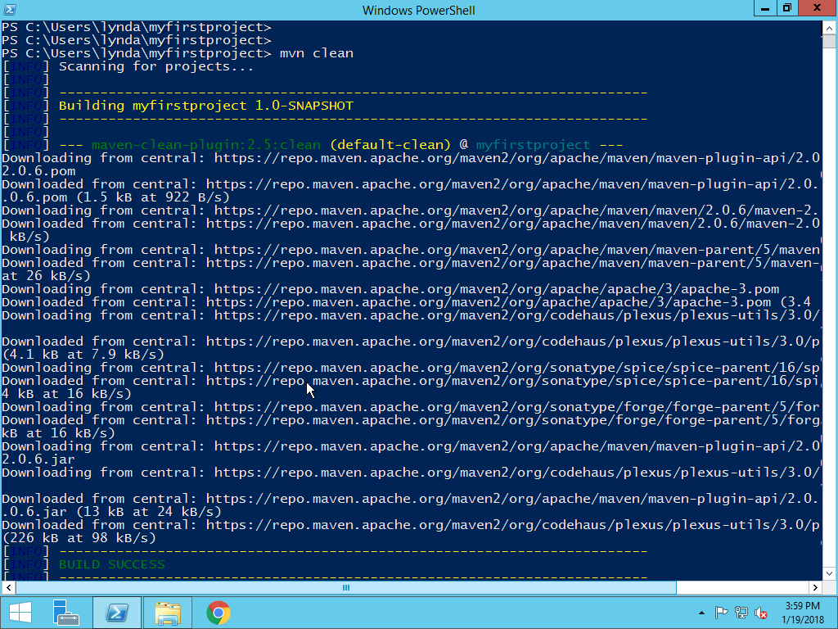

Now run the command mvn compile to create a source file.

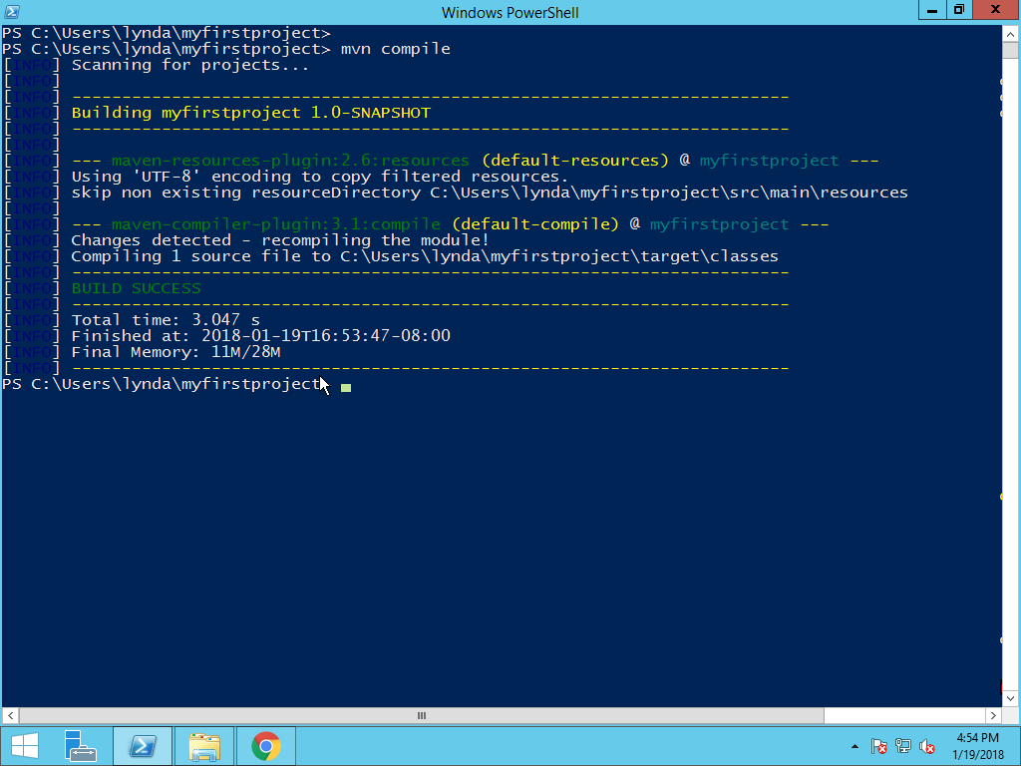

Once the command runs successfully a target folder is created where class file is placed.

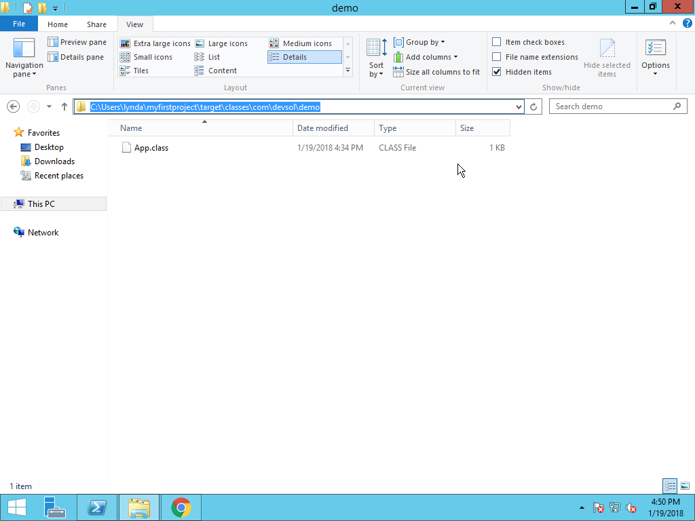

Now run the command maven test-compile to compile all the test files.

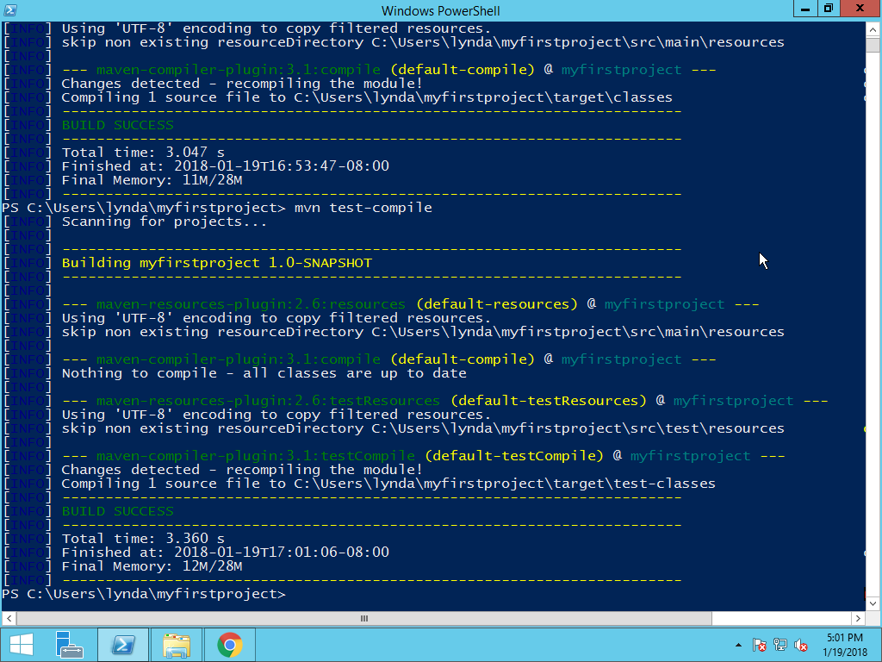

It creates a test class file in target folder.

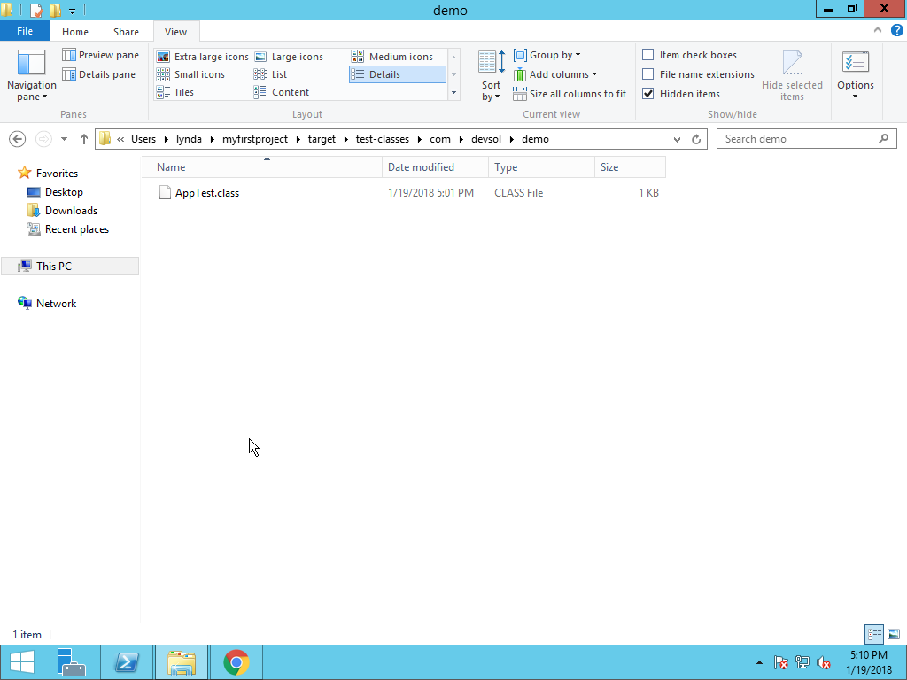

Now run the mvn test command, if successfully it shows build success and failures as zero.

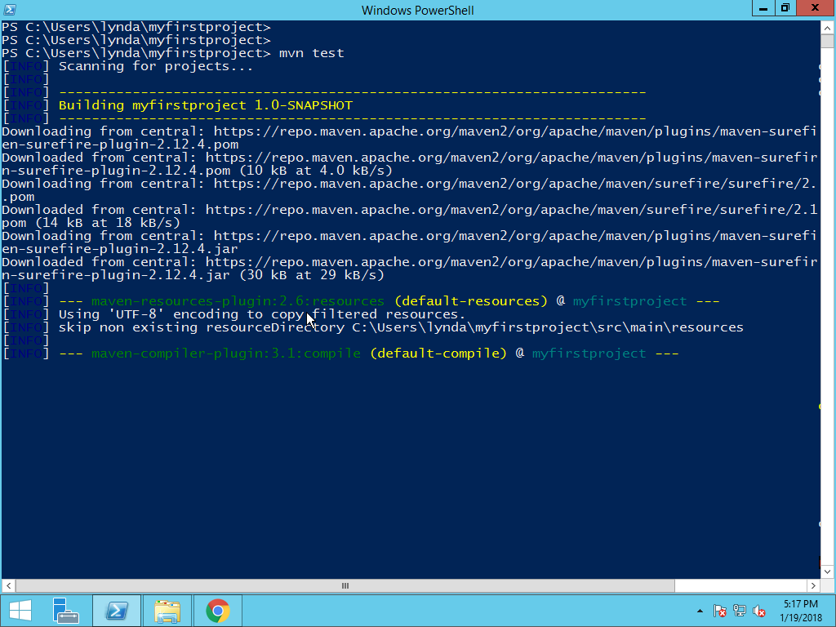

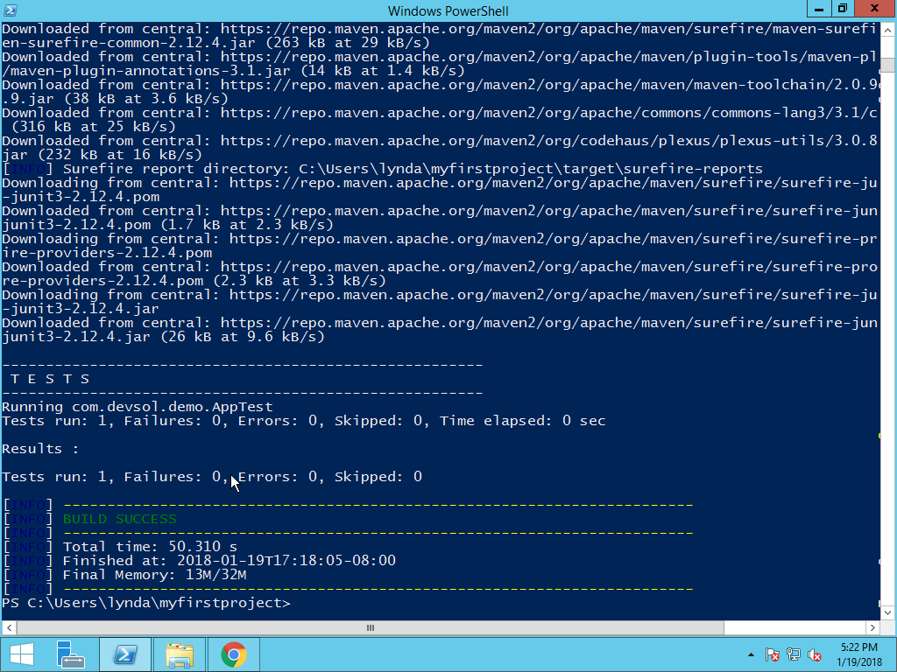

The test report is stored in the form of text file in the subfolder surefire-reports of the folder target.

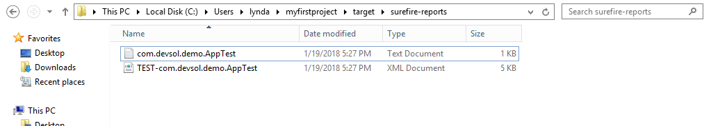

Finally run the command mvn install to build the jar file.

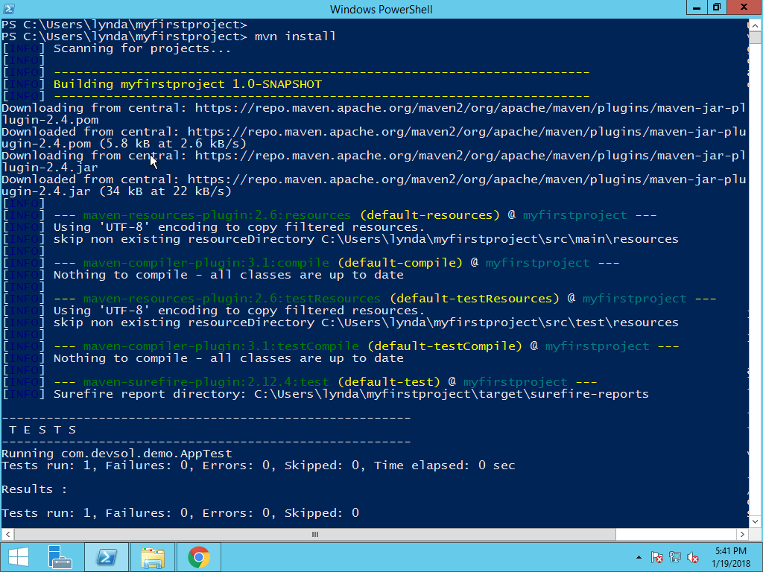

If the command runs successfully it shows build success.

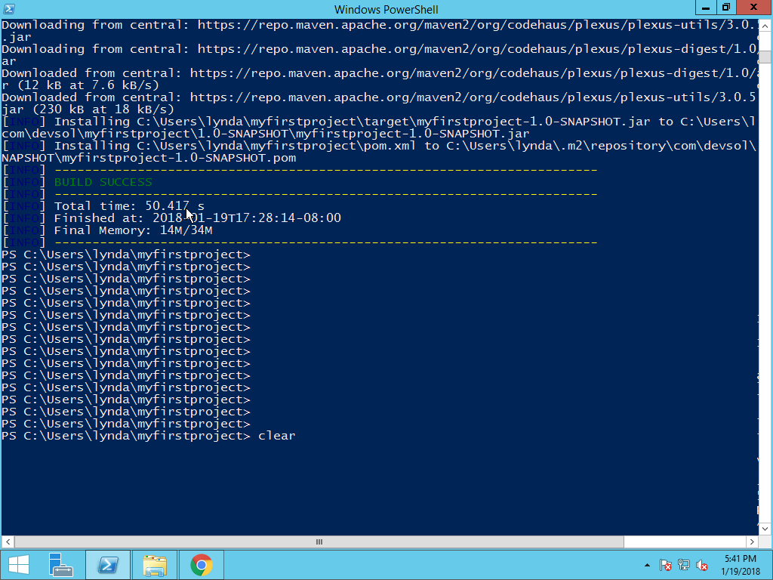

Observe that jar file is create under the folder target, you can identified the name of the jar file is like artifactid-version. Extension.

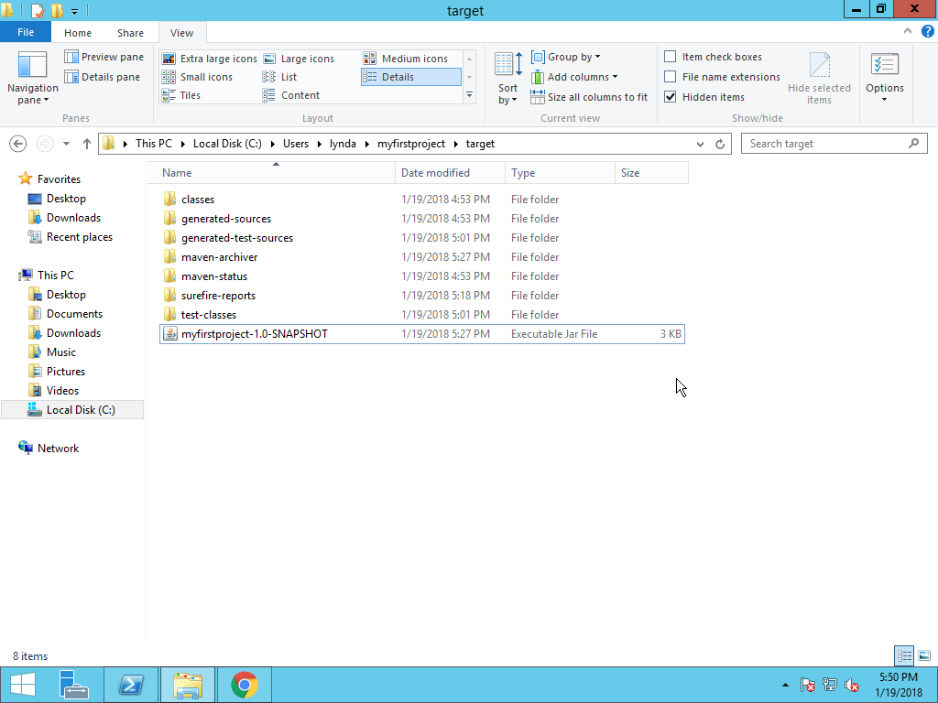

2.5 Maven Build Life Cycle

When maven builds software it follows a build life cycle. It explicitly defines the process of building, testing, distributing an artifact and it is the heart of every maven project.

There are three input build lifecycles.

* Default
* Clean
* Site

Default life cycle handles the project compilation, test, build and deployment; the following are the most important phase in the default life cycle.

**Validate**

Validate that all project information correct and all necessary information is available. This also makes sure that dependencies are downloaded.

**Compile**

Compile the source code of project.

**Test**

Runs the test against the compiled source code using a suitable unit testing frame work.

**Package**

Package the compiled code in a distributed format like jar, war, ear etc.

**Integration Test**

Deploy the package into an environment to run where integration test can be run

**Verify**

Run any checks to verify the package is valid

**Install**

Install the package into local repository.

Given the lifecycle phases above, this means that when the default lifecycle is used, Maven will first validate the project, then will try to compile the sources, run those against the tests, package the binaries (e.g. jar, war), run integration tests against that package, verify the integration tests, install the verified package to the local repository, then deploy the installed package to a remote repository.

The clean lifecycle handles the project cleaning and contains the following build phases:

**Pre-clean**

Executes processes required before project cleaning

Clean: removes all files generated by previous builds

**Post-clean**

Executes processes required to finalize project cleaning.

The site lifecycle handles the generation and deployment of the project’s site documentation:

**Pre-site**

Executes processes required before generation of the site

**Site**

Generates the project’s site documentation

**Post-site**

Executes processes required to finalize the site generation and prepares the site for deployment

Site-deploy: deploys the site documentation to the specified web server.

Maven Repositories

**Central Repository**

It contains open source components that will be download when you run the commands like mvn compile etc., from the maven central repository.

**Local Repository**

Maven create a Local repository ~/.m2 contains maven repository. It contains a copy of maven repository a copy of jar file, copy of pom file.

## 2.6 Maven Alternatives

**Ant Vs Maven**

There are many differences between ant and maven that are given below:

|  |  |
| --- | --- |
| Ant | Maven |
| Ant doesn't have formal conventions, so we need to provide information of the project structure in build.xml file. | Maven has a convention to place source code, compiled code etc. So we don't need to provide information about the project structure in pom.xml file. |
|  |  |
| Ant is procedural; you need to provide information about what to do and when to do through code. You need to provide order. | Maven is declarative, everything you define in the pom.xml file. |
| There is no life cycle in Ant. | There is life cycle in Maven. |
| It is a tool box. | It is a framework. |
| It is mainly a build tool. | It is mainly a project management tool. |
| The ant scripts are not reusable. | The maven plugins arereusable. |
|  |  |
| It is less preferred than Maven. | It is more preferred than Ant. |
|  | |

**Gradle**

Gradle is an advanced general purpose build management system based on Groovy and Kotlin. Gradle supports the automatic download and configuration of dependencies or other libraries. It supports Maven and Ivy repositories for retrieving these dependencies.

Now the interest for DSLs (Domain Specific Languages) continued increasing. The idea is to have languages designed to solve problems belonging to a specific domain. In case of builds, one of the results of applying DSL is Gradle and for e.g. Gradle is used in Android for build and packaging. Gradle aims to help organizations ship better software, faster. Faster builds is one of the most direct ways of achieving this; Gradle combines good parts of both tools and builds on top of them with DSL and other improvements. It has Ant’s power and flexibility with Maven’s life-cycle and ease of use. For example, Google adopted Gradle as the default build tool for the Android OS. Gradle does not use XML. Instead, it had its own DSL based on Groovy (one of JVM languages). As a result, Gradle build scripts tend to be much shorter and clearer than those written for Ant or Maven.

# Jenkins

## 3.1 Introduction

Jenkins is an open source automation tool and continuous delivery tool used by software and DevOps Engineers. With Jenkins Organizations can accelerate the software development process through automation. Jenkins integrates development life cycle process of all kinds including build, document, test, package, stage, deploy, static analysis.

The basic functionality of Jenkins is to execute a predefined to compile source code and build a JAR from the resulting classes. The trigger for this execution can be time or event based. For every 20 minutes or after a new commit in a Git repository.

Jenkins continuously integrates all development work as early as possible achieving continuous integration.

**Continuous Integration**

Back in days of waterfall model, group of developers are changing the source code in the repository. When the entire application is written, it is build by using Ant and Maven build tools and the build application is deployed in the test server for testing. Any bug in the code developers are notified with a feedback notification, if there are no bugs then the application is finally deployed on production server.

**Problems of the above procedure**

As group of developers involved writing the code, integration of this code was very hard sometimes involving the integration of month of conflicting changes, it could involve reworking that had been written weeks or months before.

Developers have to wait till the complete software is developed for test results. If test fails then locating and fixing bugs is very difficult. Developers have to check the entire source code of the software which takes lot of time.

Overall all this problems lead to significant delivery delays, unplanned costs and as a result, unhappy clients.

**Continuous Integration addresses the above problems**

Continuous Integration, in its simplest form, involves a tool that monitors your version control system that detects the changes in the version i system, compiles the code and test the application if something goes wrong it immediately notifies the developer.

Multiple developers commit code to the source code repository, the code is pulled from the repository and build and test are performed for each commit, this process allows developers to identify which part of the code is having bugs as locating and fixing bugs take less time developers can focus more on application code and delivery rather than fixing bugs.

**Continuous Integration Tools**

To achieve Continuous Integration different tools are available few of them list below. Any continuous integration tool help to keep tab on health of the source code and maintains code quality and fasten the build, test, and deploy process.

* Buildbot
* Bamboo
* Travis CI
* CircleCI
* Jenkins
* Codeship

## 3.2 Jenkins

**Jenkins** is one such open source automation tool written in Java with plugins built for continuous integration purpose of plugins allows integration of various stages like version control systems, Build tools, Continuous testing, configuration management, continuous deployment, continuous monitoring**.** List of few plugins

|  |  |
| --- | --- |
| Test | JUnit |
| Reports | HTML publisher |
| Notification | Jenkins Build |
| Compile | Maven |

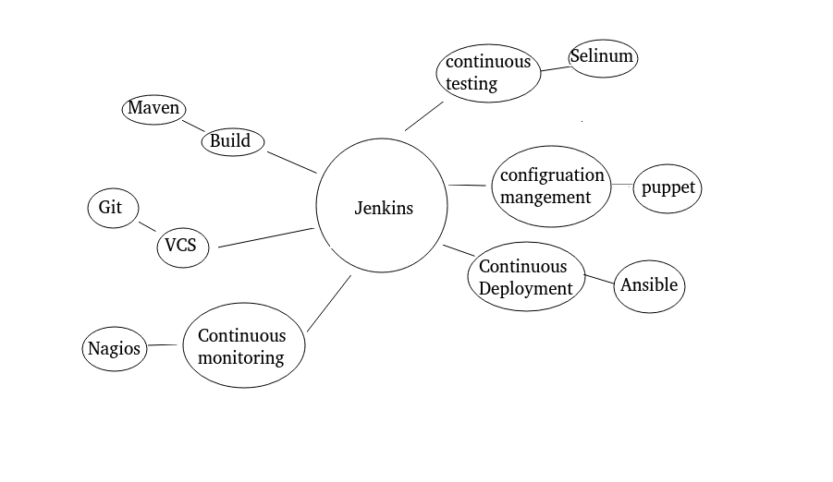

**Jenkins Work flow**

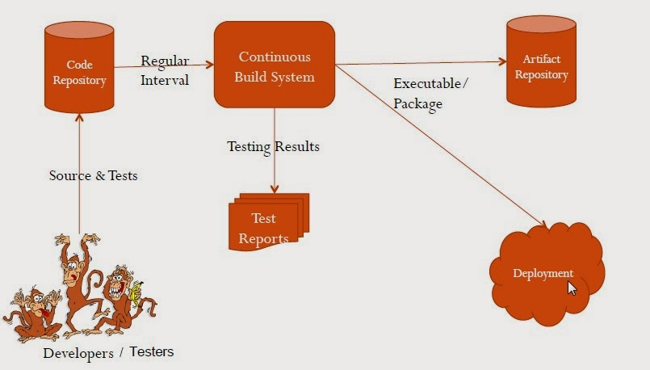

**Advantages of using Jenkins include**

1. It’s an open source tool with great community support.
2. Easy to install.
3. It has 1000+ inbuilt plugins are available and new plugins can be written and shared with community.
4. It is built with Java and hence, it is portable to all major platforms.
5. Easily extensible with the use of third-party plugins—over 400 plugins.
6. Easy to configure the setup environment in the user interface. It is also possible to customize the user interface based on likings.
7. The master slave architecture supports distributed builds to reduce loads on the CI server.
8. Jenkins is available with test harness built around JUnit; test results are available in graphical and tabular forms.
9. Build scheduling based on the Cron
10. Notification support related to the build status

## 3.3 History of Jenkins

Hudson was started in 2004 at Sun Micro Systems by Kohsuke Kawaguchi as a hobby project.

First release was in the year 2005; it was adopted by the Sun Micro’s for their own projects.

From early 2008 Hudson professional services are made available, it then became leading Continuous Integration solution with a market share over 70% in 2010. Hudson was renamed to Jenkins 2011.

## 3.4 Setting Up Jenkins on Windows

To install and run Jenkins, Java Development Kit must be installed already, Instructions below tells us how to install JDK on Windows.

Download JDK from Oracle website.



Run the installer file. Click on next to continue choose the path to install.



Complete the java Installation.



Setting Up Java Path

To set up Java path Right click on My Computer > Properties > Advanced System Settings > System properties > Environment variables.



Jenkins supports wide variety of Operating System, download the Jenkins long term support version for windows. Select the Operating System as Windows in the list shown.

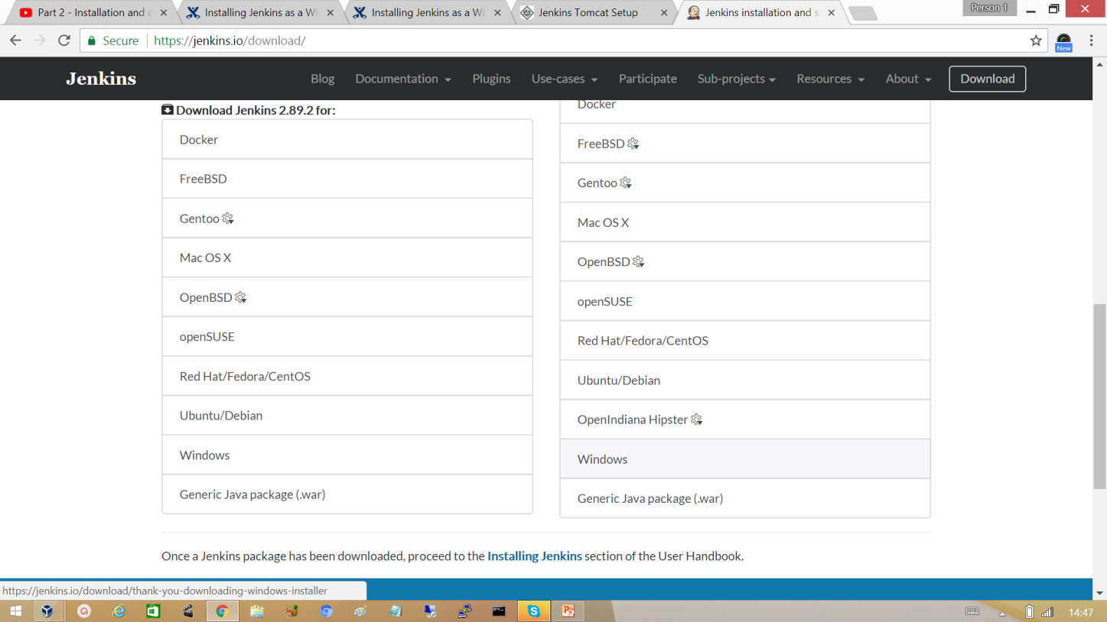

Extract the file to a specific folder and open the folder in the command prompt. From the command prompt run the war file with the command , ‘java –jar Jenkins.war’

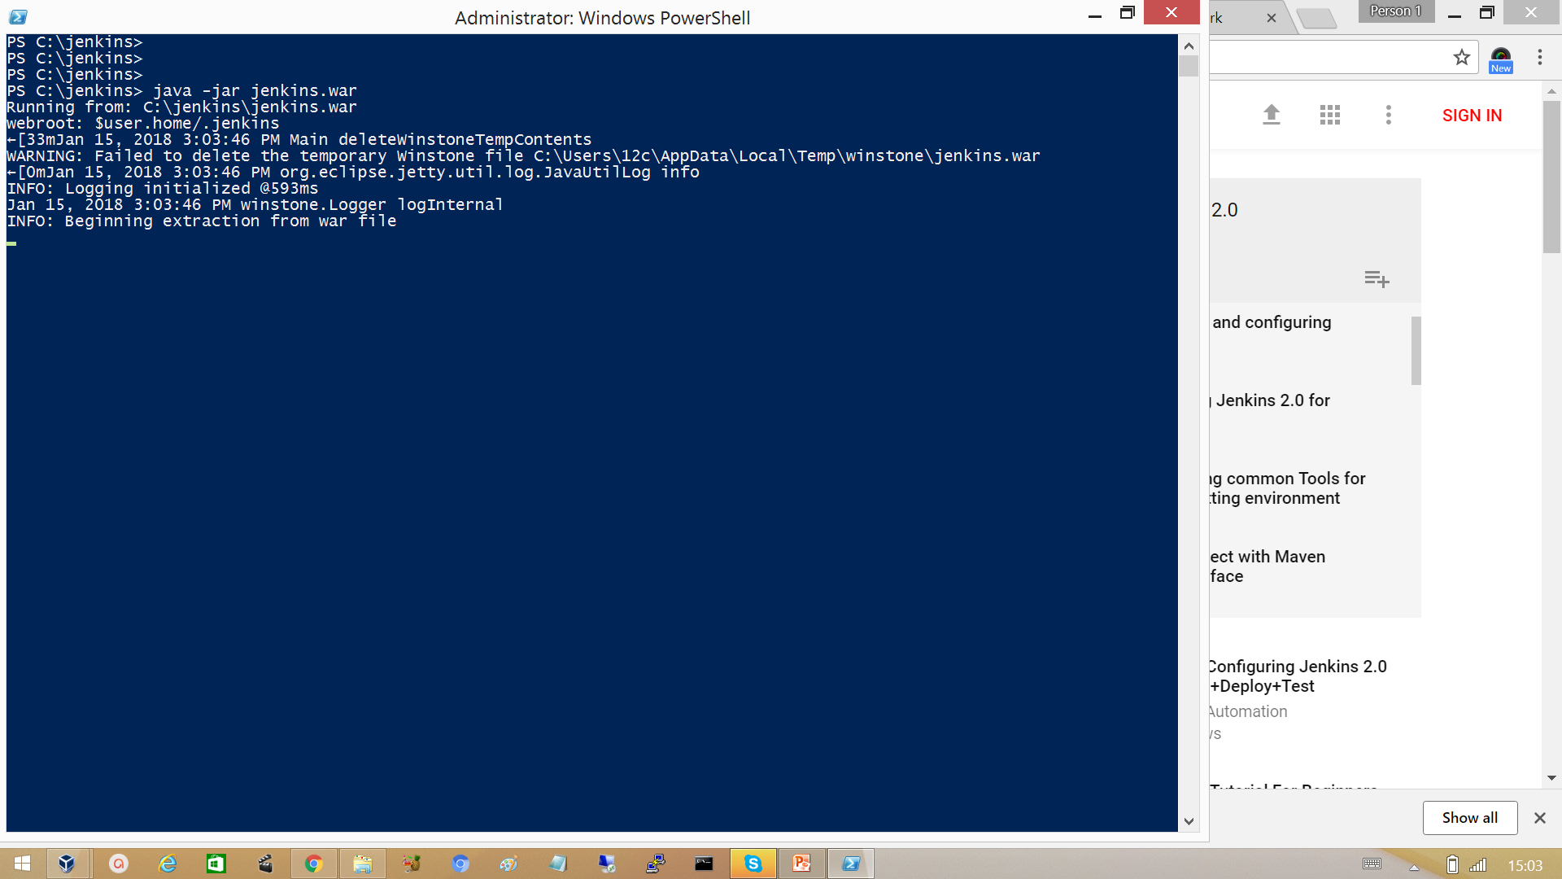

After Successful Installation, hit the URL <http://localhost:8080> on you browser. Copy the admin password from the file.

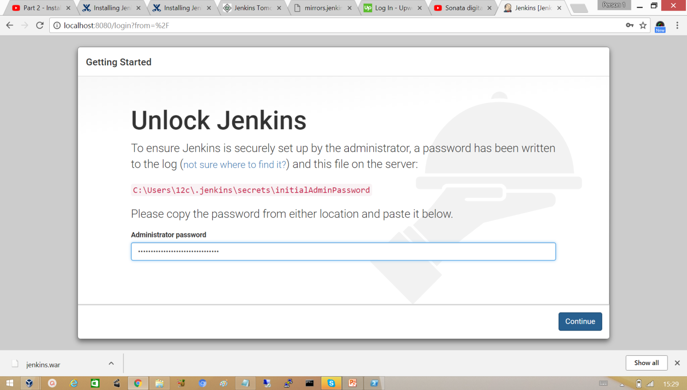

Install the suggested Jenkin plugins. It’s not mandatory to install them.

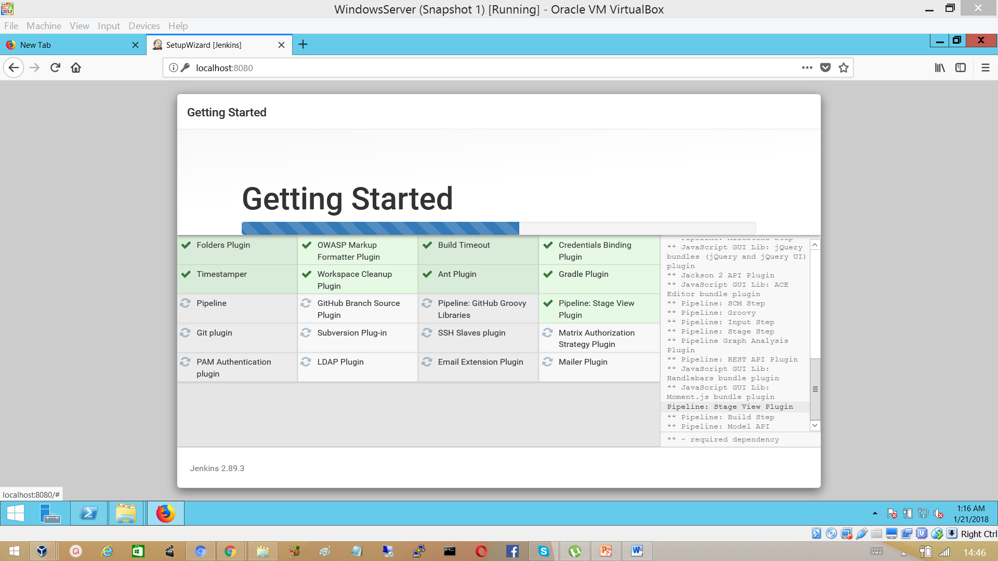

Create a Jenkin User or continue as admin.

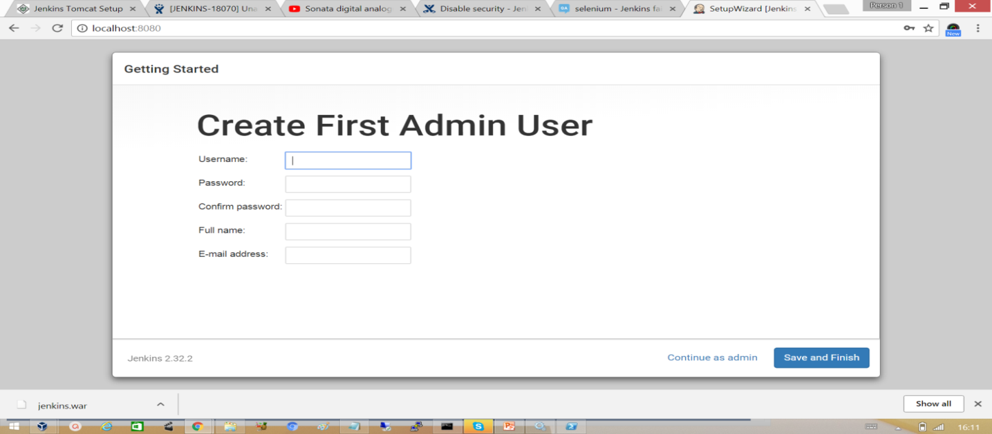

Login into the Jenkins Web UI with admin account.

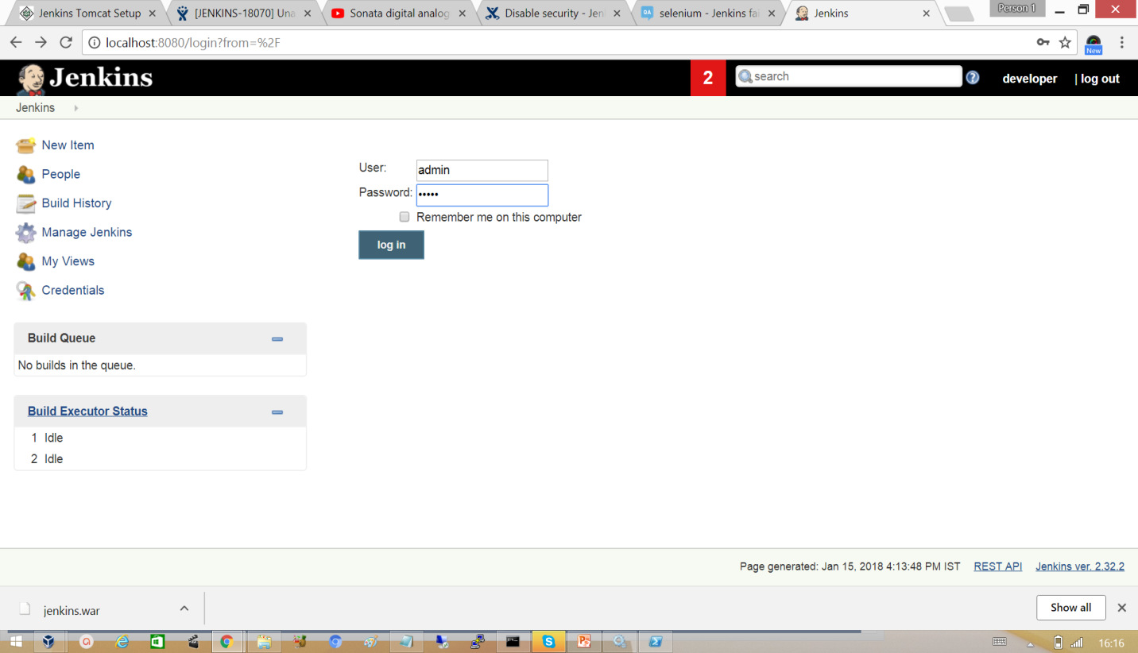

## 3.5 Setting Up Jenkins On Linux

Install Java and set Java path variable



**Setting up Java path in Linux**



To set path permanently add the same to */etc/profile*

[root@client ~]# vi /etc/profile



Configure the Jenkins repository and also the local RHEL repository.

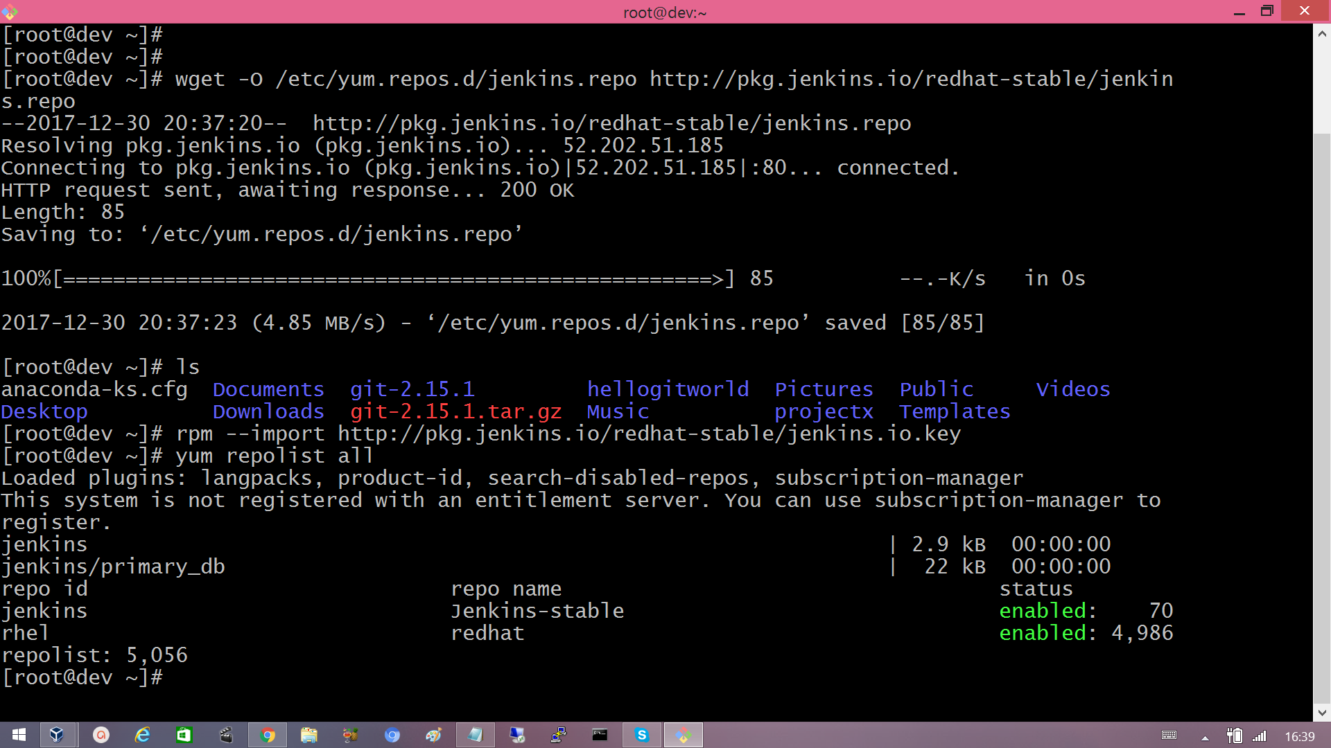

Verify whether the repository is configured and enabled or not with ‘yum repolist all’ command.

Install Jenkins with the command ‘yum install jenkins’

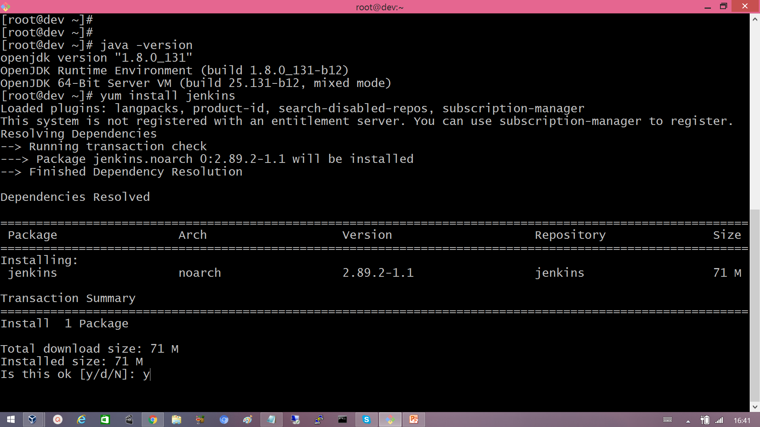

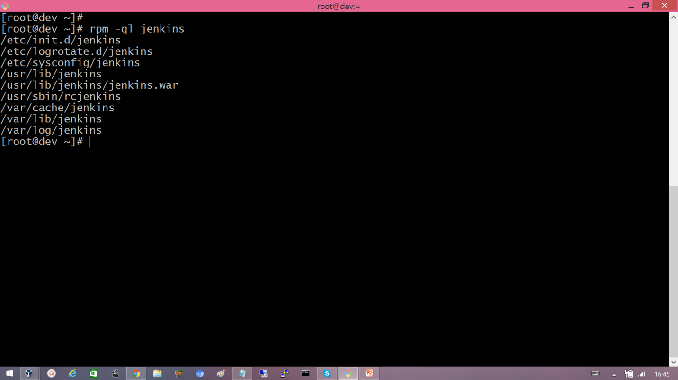

Start the Jenkins service and enable it start automatically at the boot time.

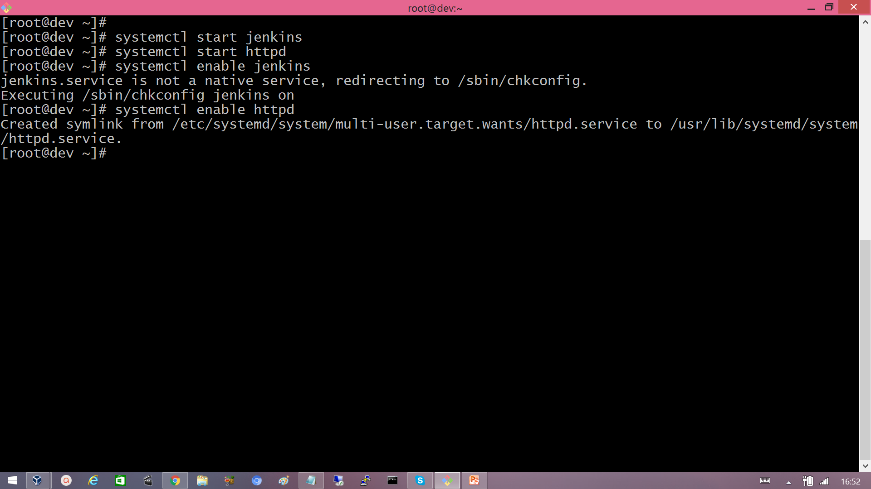

Configure the firewall to allow Jenkins to run.

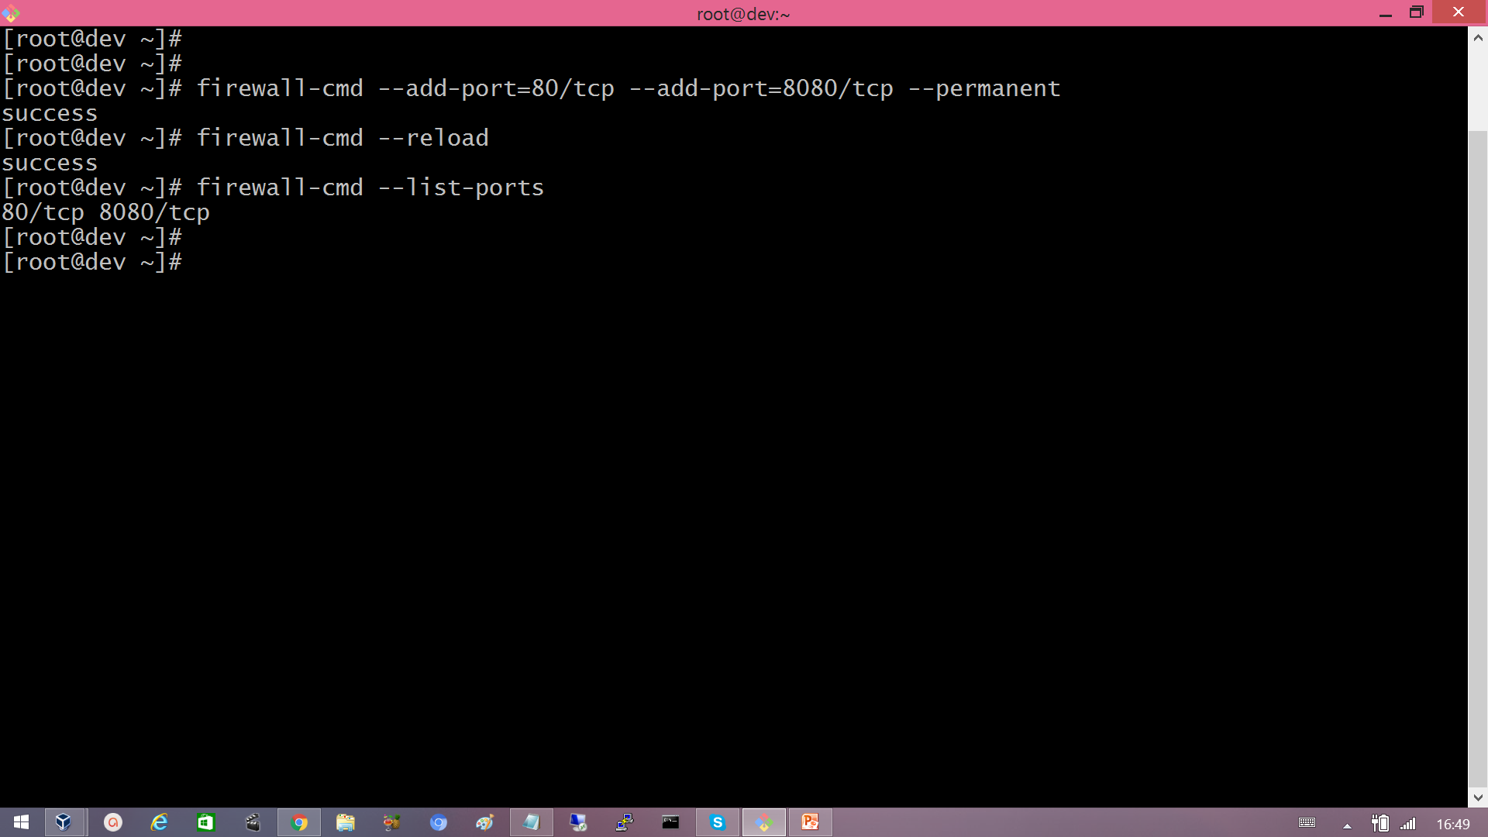

Jenkins initial admin password stored in a file.

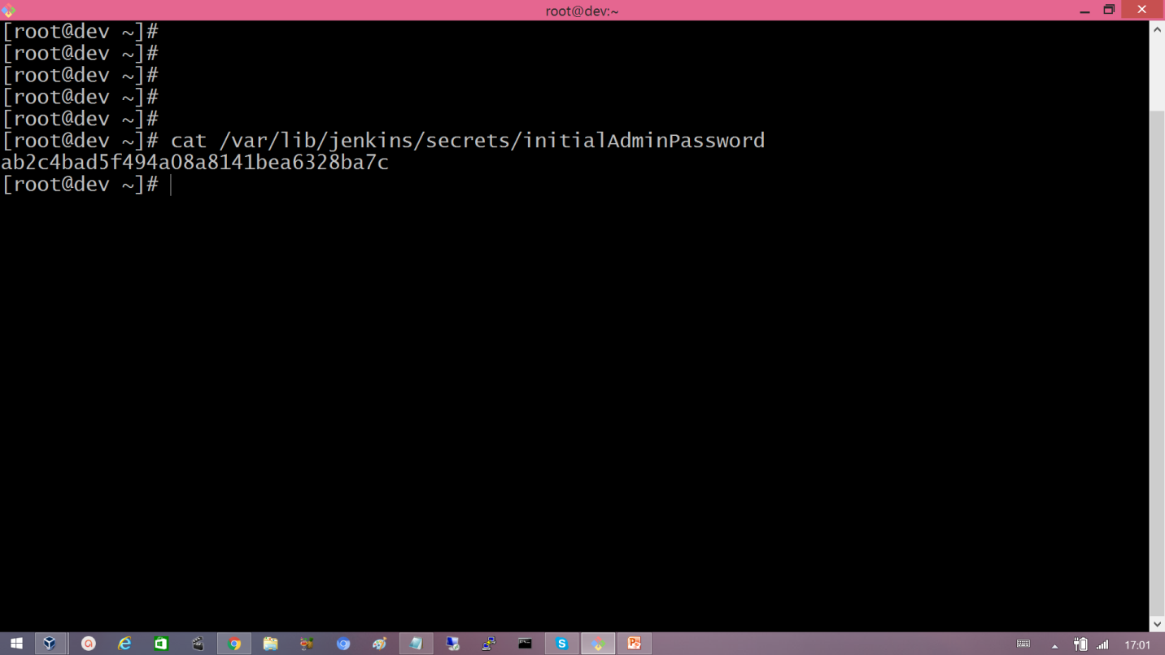

Login into Jenkins Web UI Admin User account and initial password.



## 3.6 Creating and running first Jenkins Job

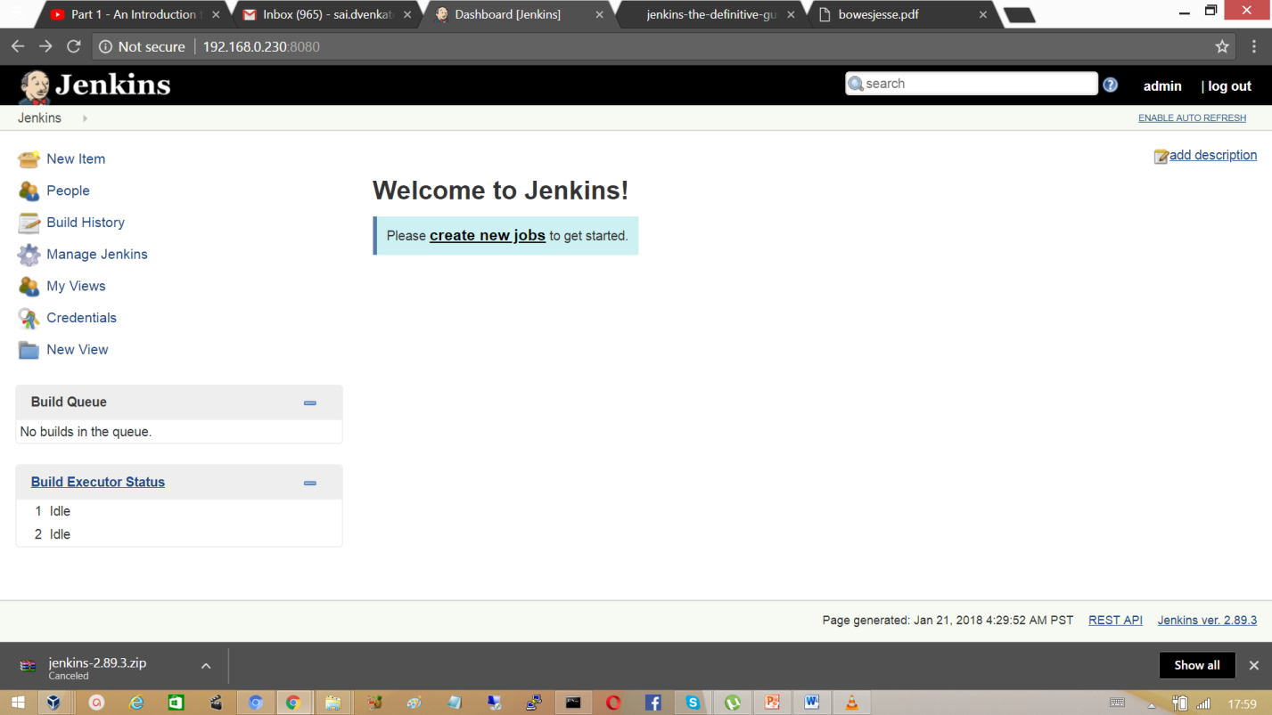Click on create new jobs, enter the project name usually that can be project base directory and choose the free style project which is more flexible and allows you to execute shell scripts, dos scripts.

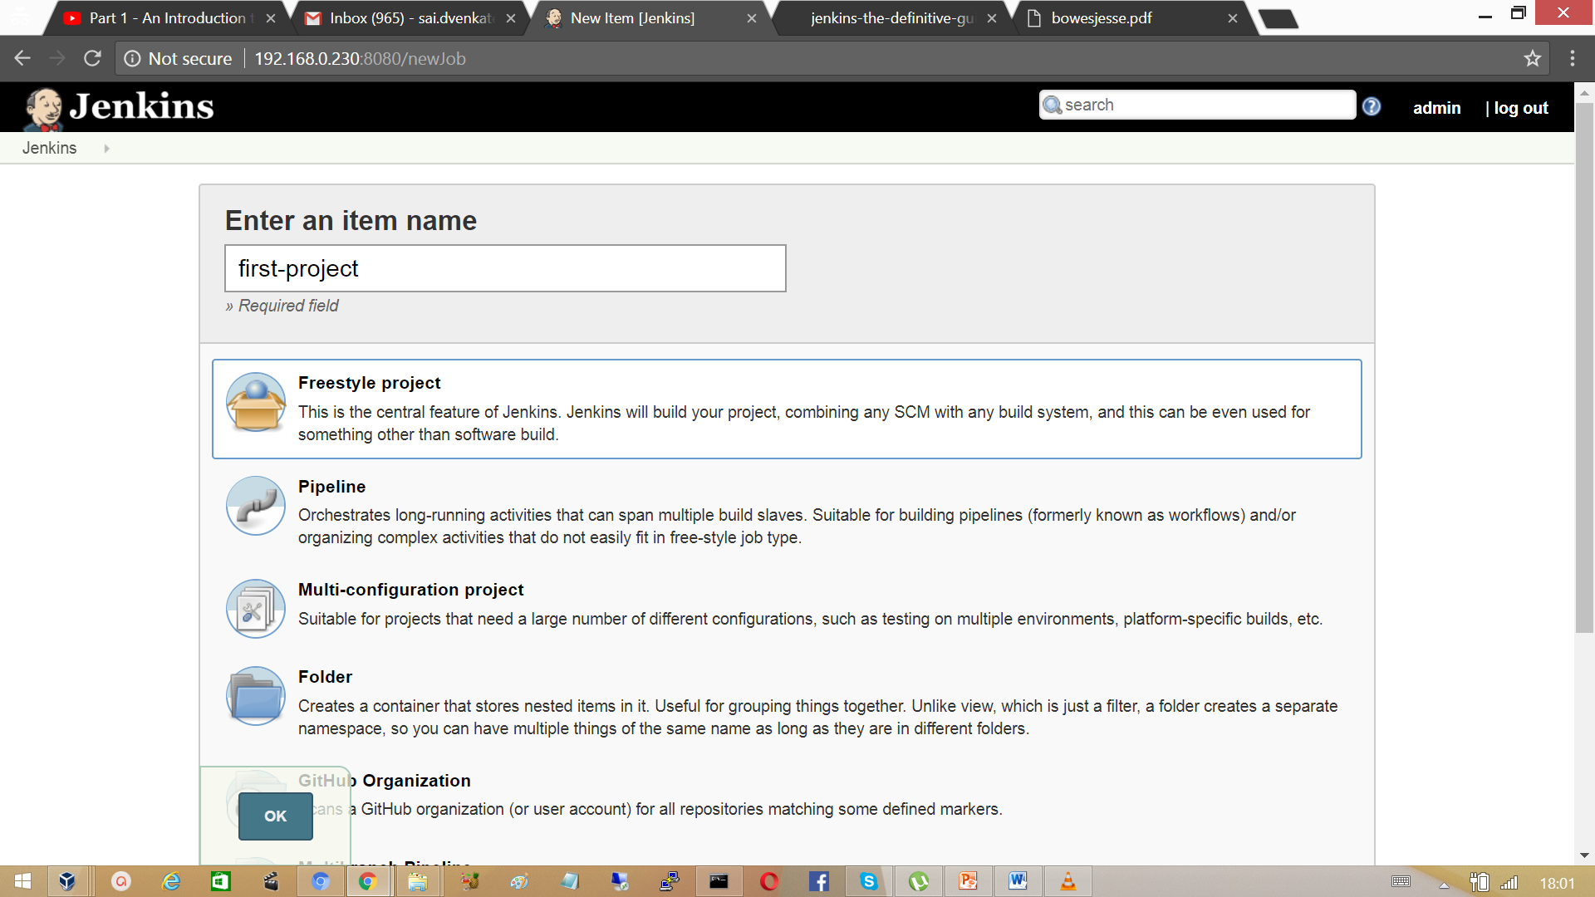

Click on ok. In the next step configure the job with details where to get the source code and what to do with that for example it can be a compile, test etc.

Add a job description which provides an overview about the project.

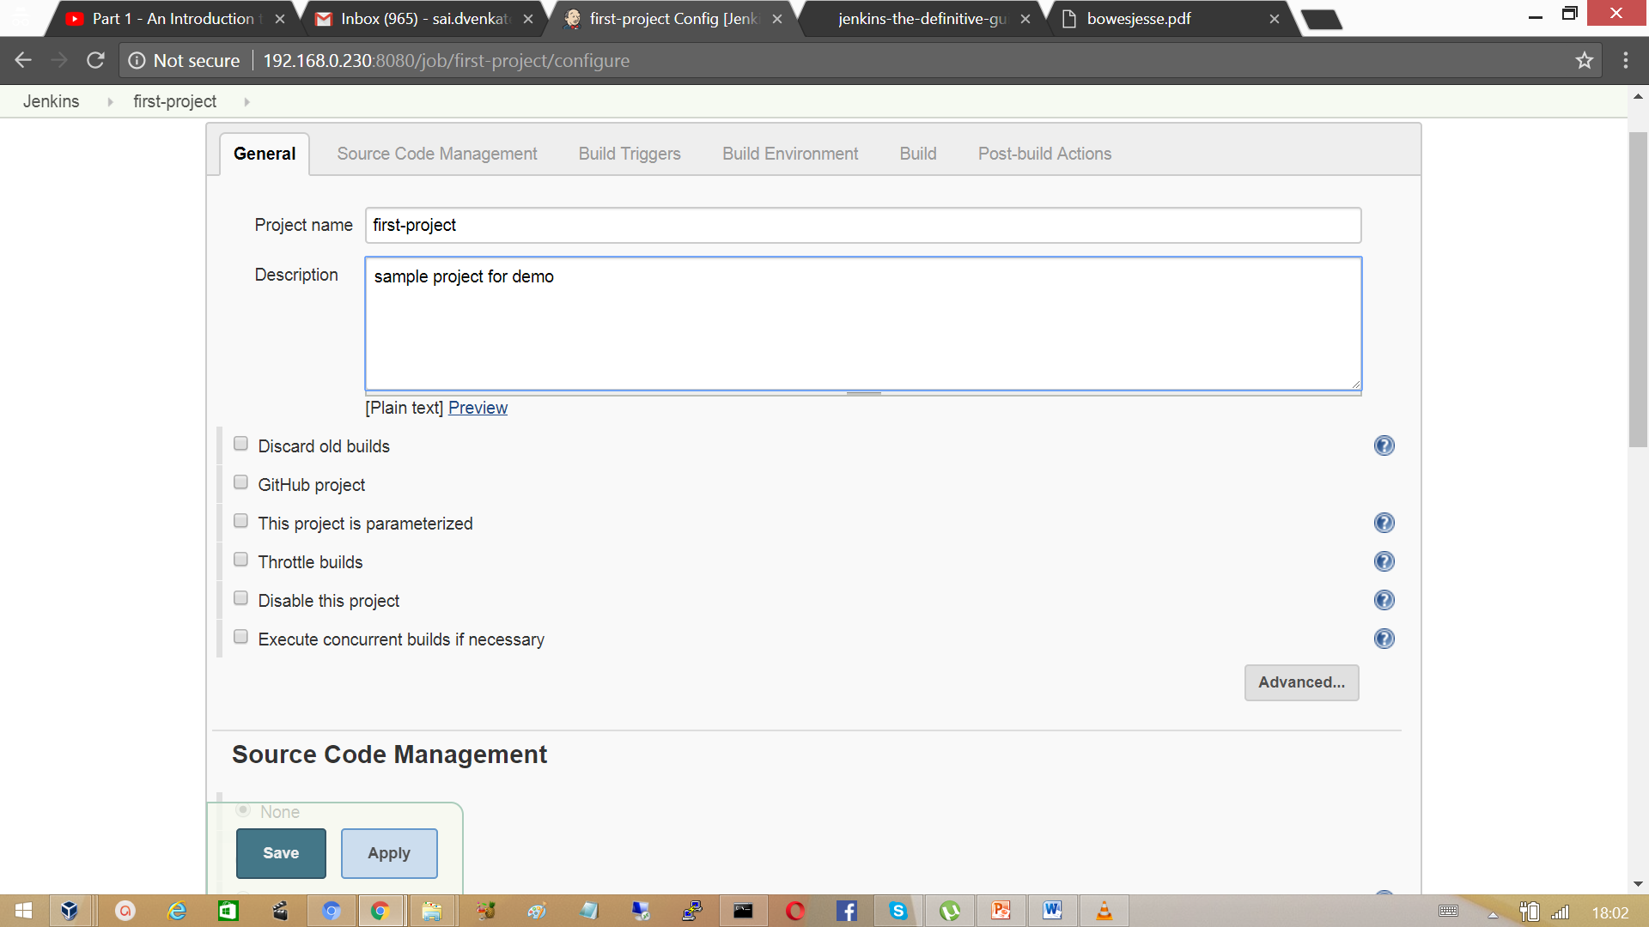

In the first Jenkins we did not used any code. Select the Build option as Execute shell. Type the command echo “hello” and click on save.

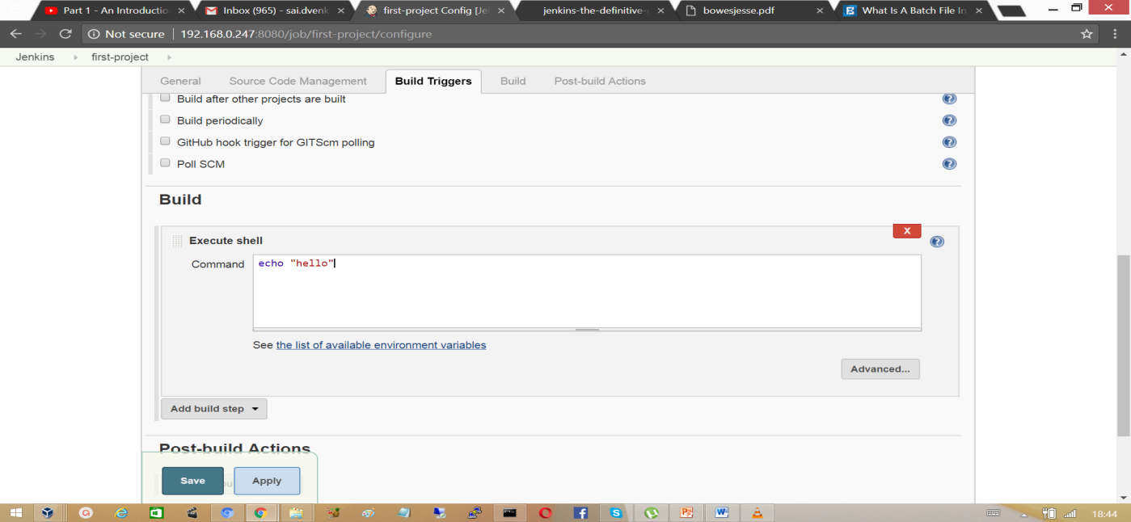

Go back to dashboard and click on the clock icon to schedule a build and then click on project name.

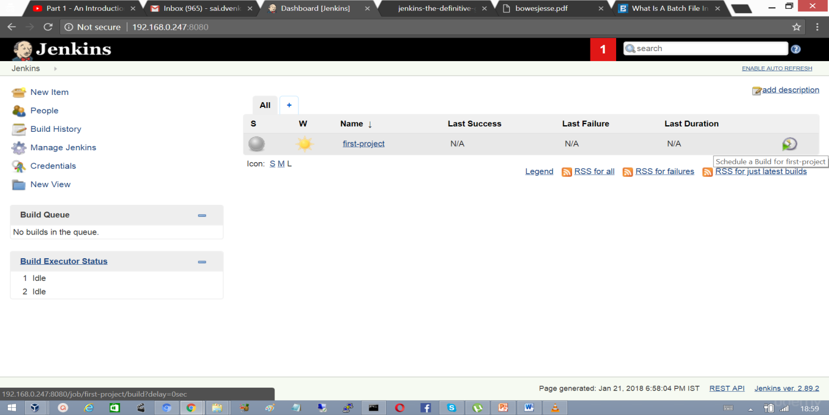

At the Left corner of the User Interface find a section Build Executor, a blue ball appears that indicates that build status is successful click on the #1 which brings up the details of build.

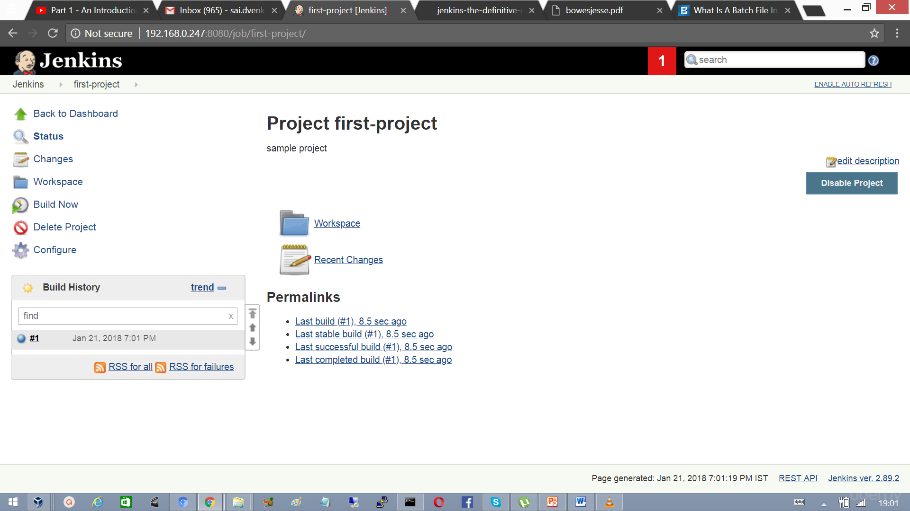

 The following output lists the status of the build.

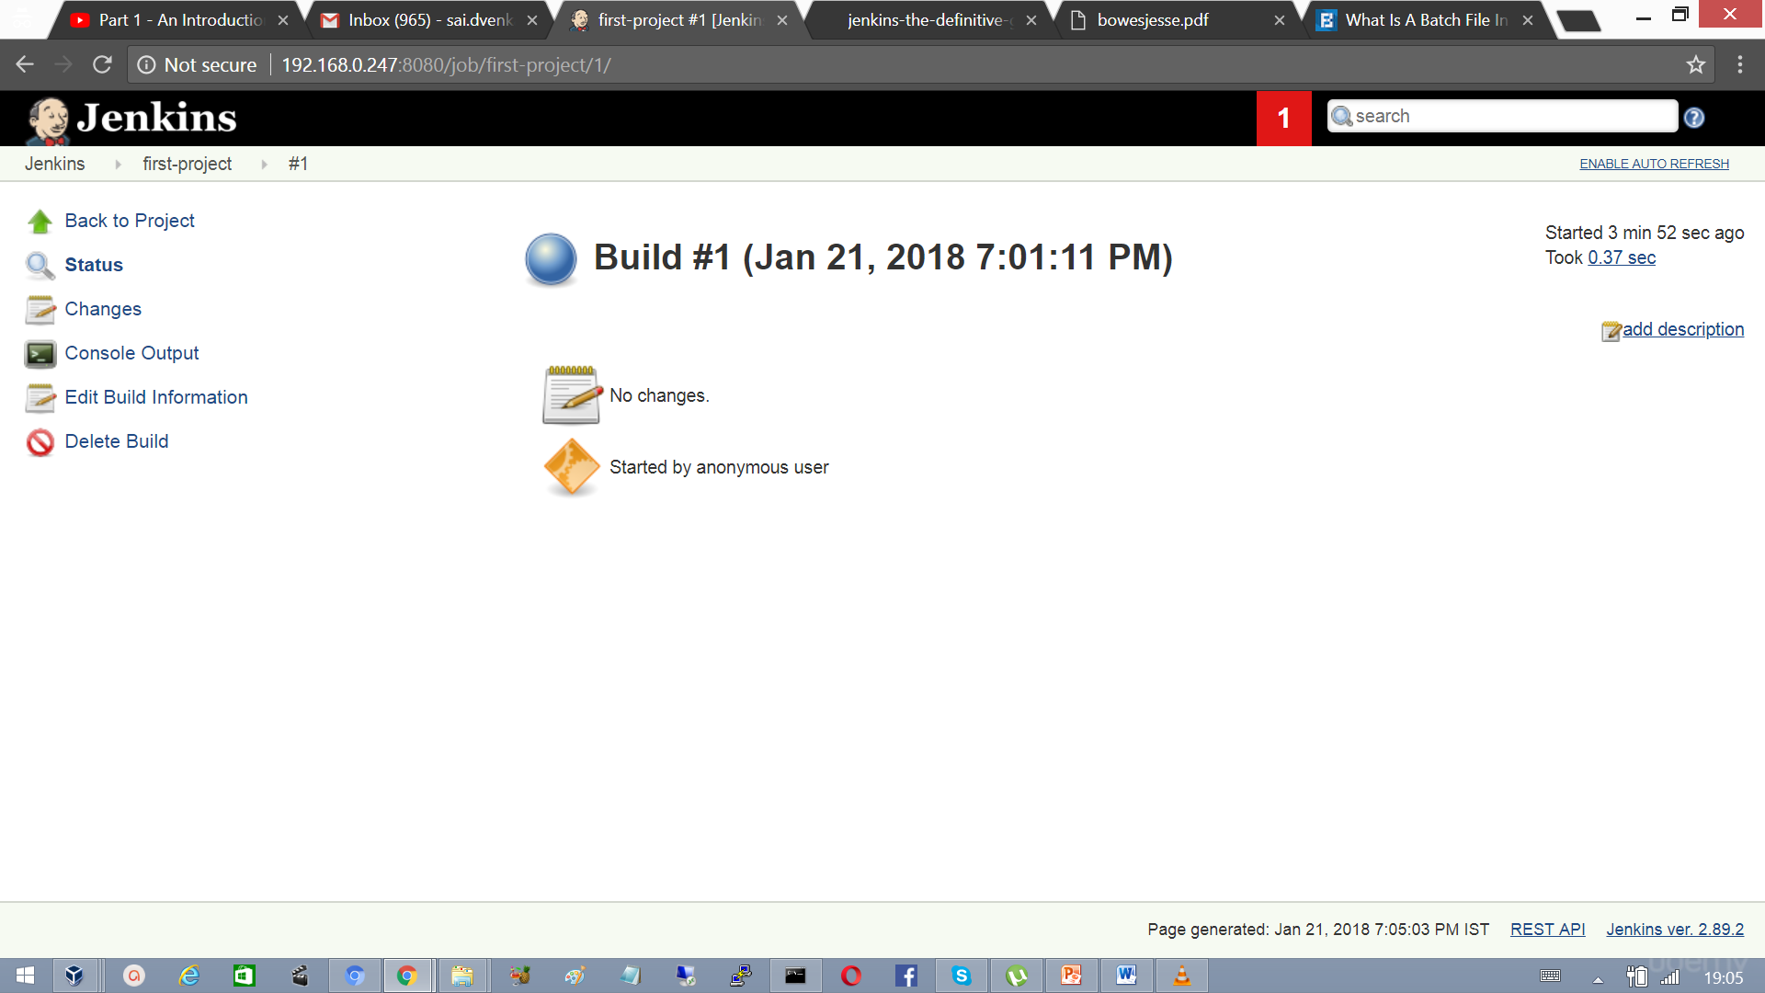

Click on the Console Output link to see the details of the build.

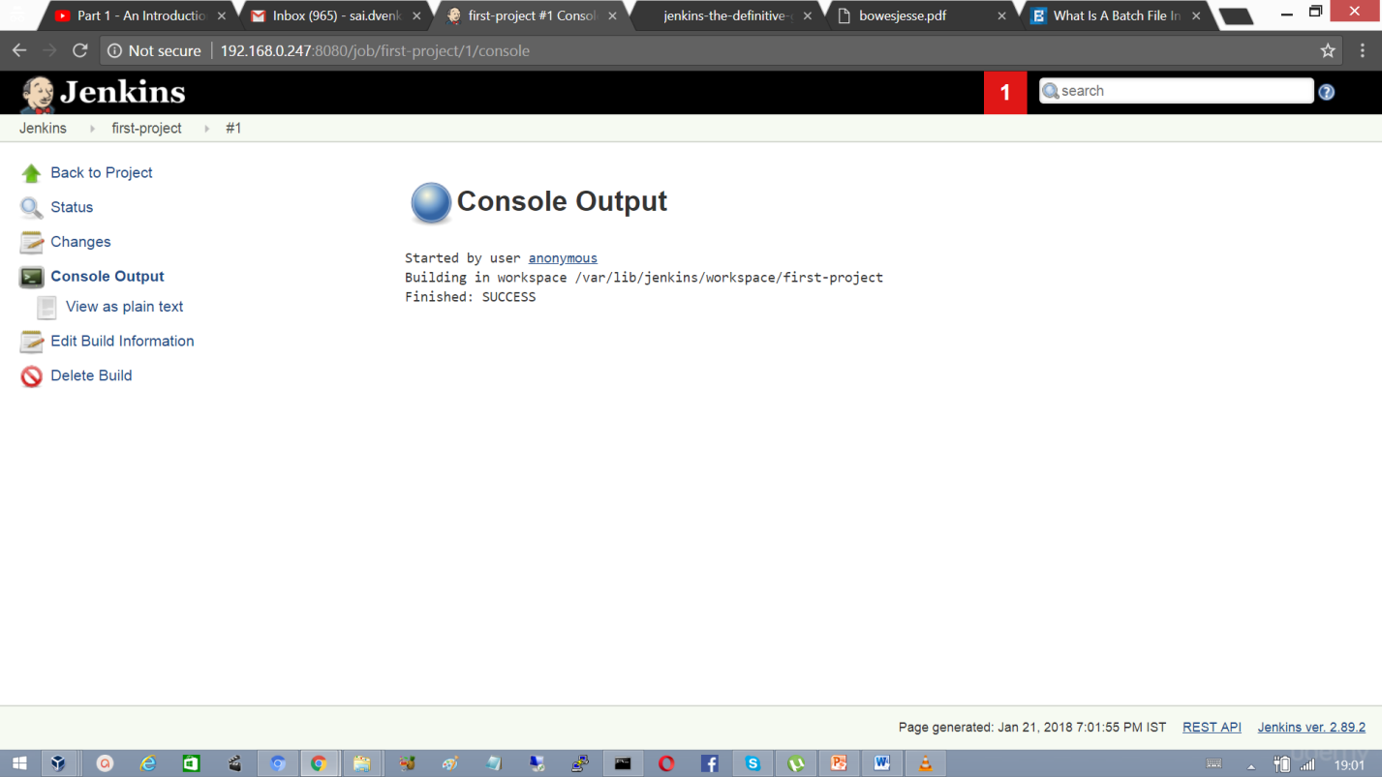

On the Jenkins dashboard we can find the status of the projects, success or failure of the project last successful build and also the last failure.

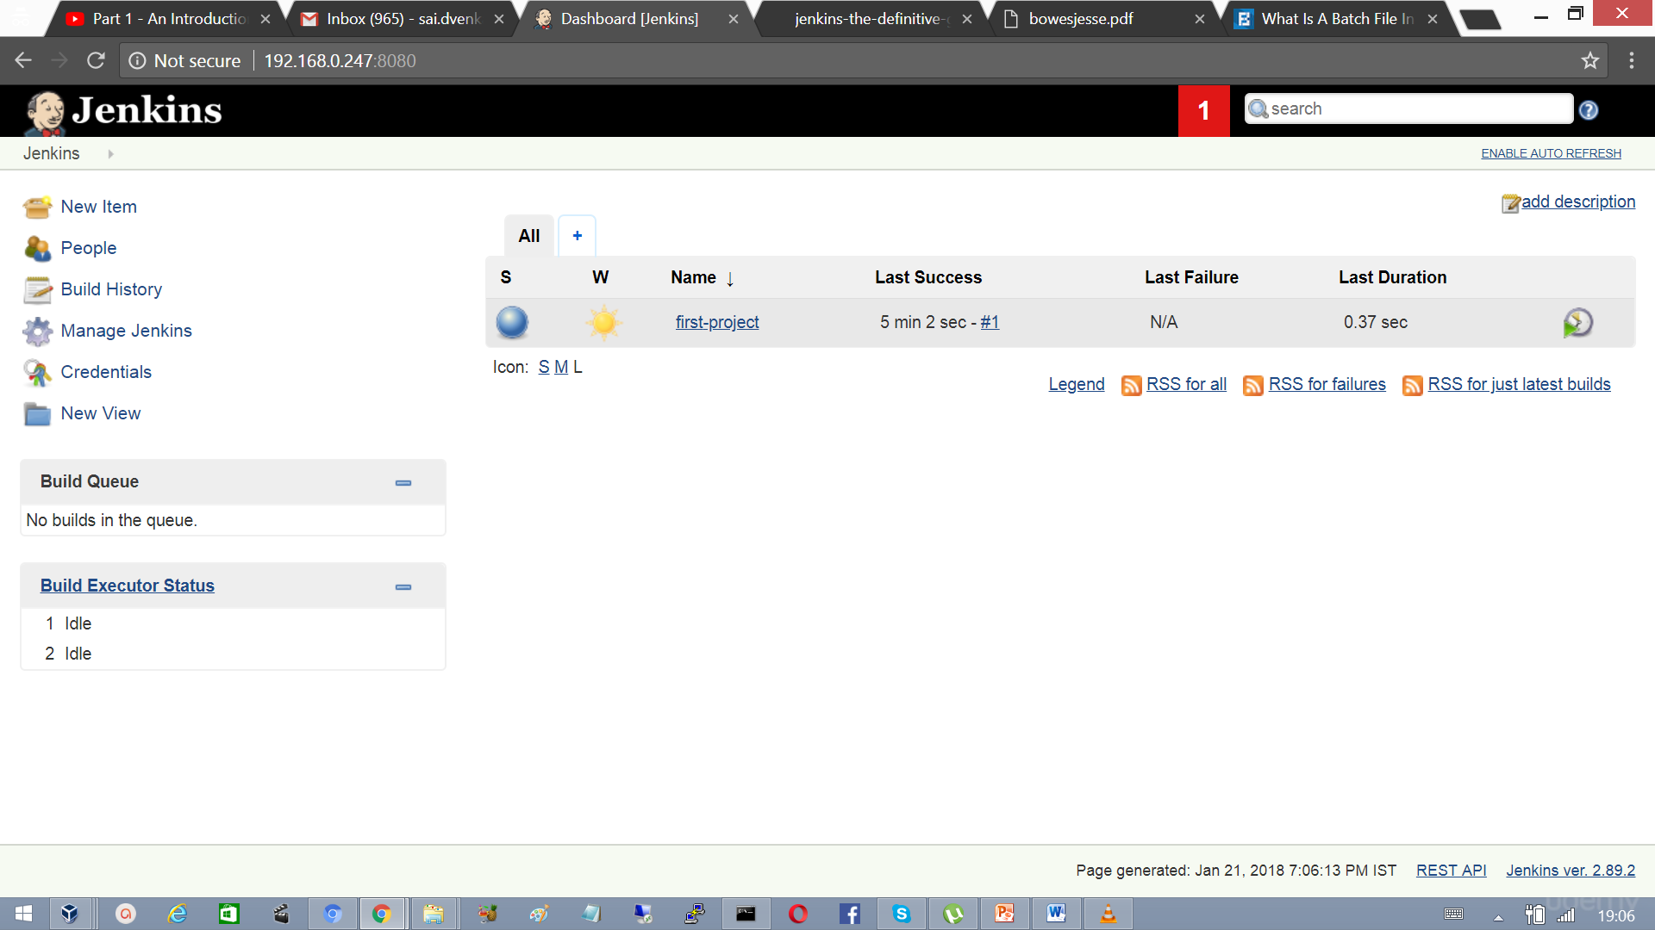

## 3.7 Deployment pipeline

The application development life cycle is a traditionally lengthy and a manual process. In addition, it requires effective collaboration between development and operations teams. The deployment pipeline is a demonstration of automation involved in the application development life cycle containing the automated build execution and test execution, notification to the stakeholder, and deployment in different runtime environments. Effectively, the deployment pipeline is a combination of CI and continuous delivery, and hence is a part of DevOps practices. The following diagram depicts the deployment pipeline process.

Members of the development team check code into a source code repository. CI products such as Jenkins are configured to poll changes from the code repository. Changes in the repository are downloaded to the local workspace and Jenkins triggers an automated build process, which is assisted by Ant or Maven. Automated test execution or unit testing, static code analysis, reporting, and notification of successful or failed build process are also part of the CI process.

**Deployment Pipeline**



Once the build is successful, it can be deployed to different runtime environments such as testing, preproduction, production, and so on. Deploying a war file in terms of the JEE application is normally the final stage in the deployment pipeline.

One of the biggest benefits of the deployment pipeline is the faster feedback cycle. Identification of issues in the application at early stages and no dependencies on manual efforts make this entire end-to-end process more effective.

**Continuous Integration Vs Continuous Delivery Vs Continuous Deployment.**

**Continuous Integration**

Continuous integration is a practice that puts the integration phase earlier in the development cycle so that building, testing and integrating code happens on a more regular basis.

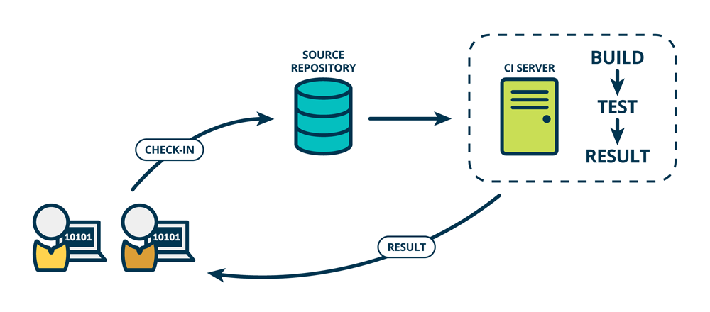

**Continuous Delivery**

Continual Delivery of code to an environment once the code is ready to ship. This could be staging environment similar to the production environment. The idea is the product is delivered to a user base, which can be QAs or customers for review and inspection.

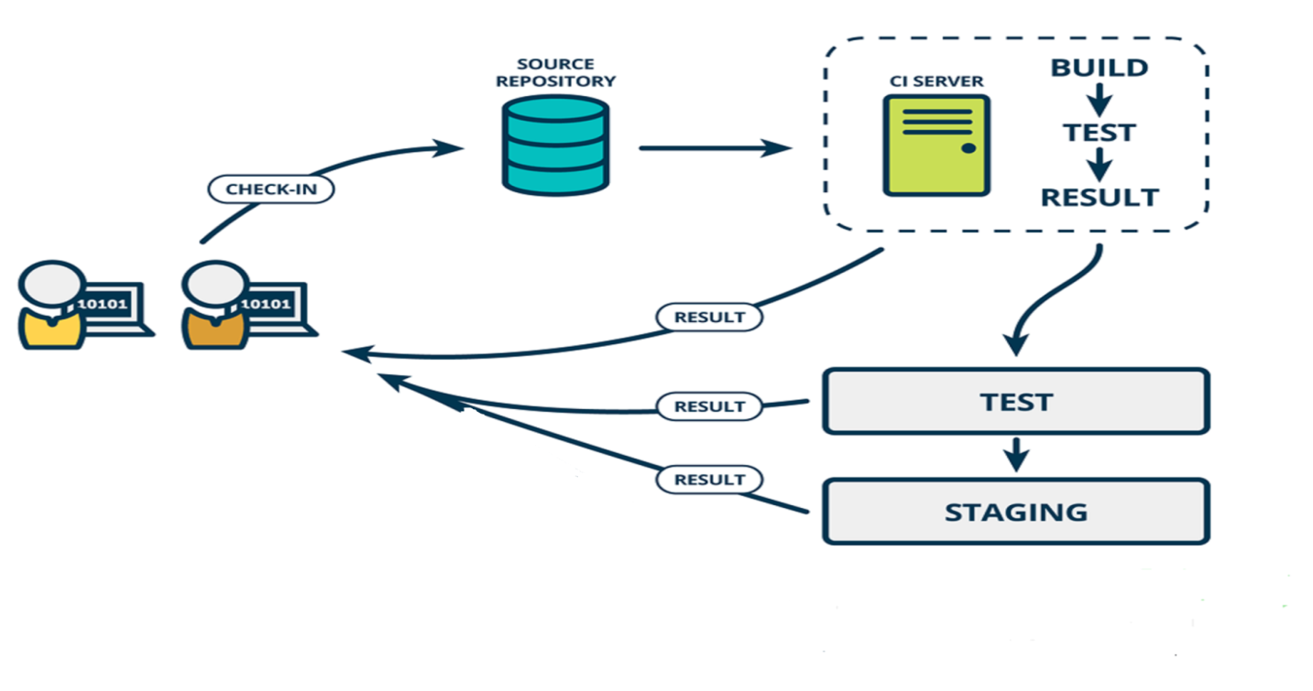

**Continuous Deployment**

The release of code to production as soon as it is ready.

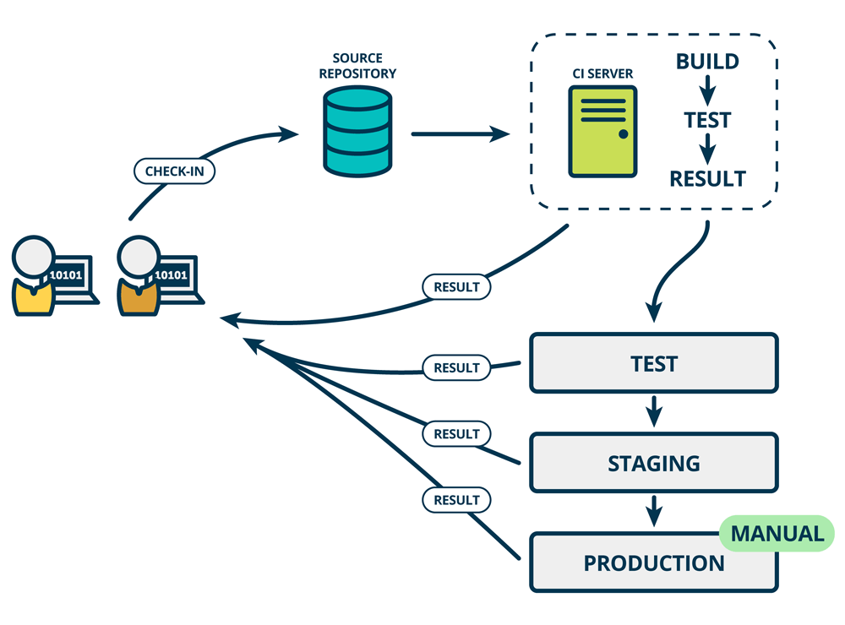

**Staging Environment**

A stage or staging environment is an environment for testing that exactly resembles the production environment. When starting a new project development will begin on a development server, or in some other closed environment. Once the work enters all stable state will be transferred to the staging environment where the client gets a preview.

**Production Environment**

The production environment is also known as live, particularly for servers, as it is the environment that users directly interact with.

## 3.8 Working With Jenkins

**Basic Work Flow of Jenkins**

* Get the code from version control system (git)
* Execute the build to compile, test, package

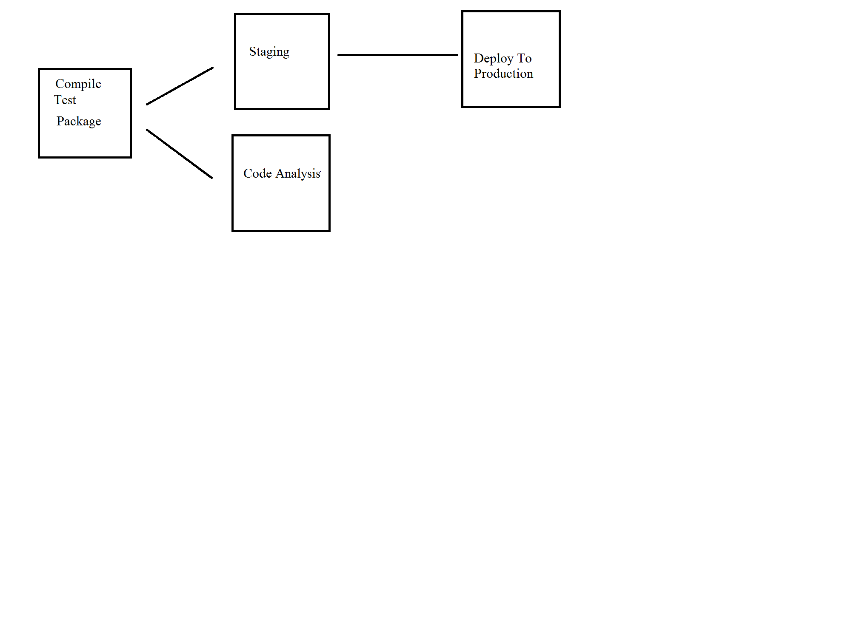

* Execute the source code analysis
* Deliver the build also called artifact to staging environment.
* Finally deploy the build to production environment

**Plugins**

Jenkins is built and used around plugins. Its core is the Jenkins tool and there are 100’s of plugins available to enhance its power and usability. To integrate Jenkins with Source Code repository, build tools and for deploying the artifacts.

## 3.9 Installing Git and Jenkins GitHub plugins

Click on Manage Plugins.

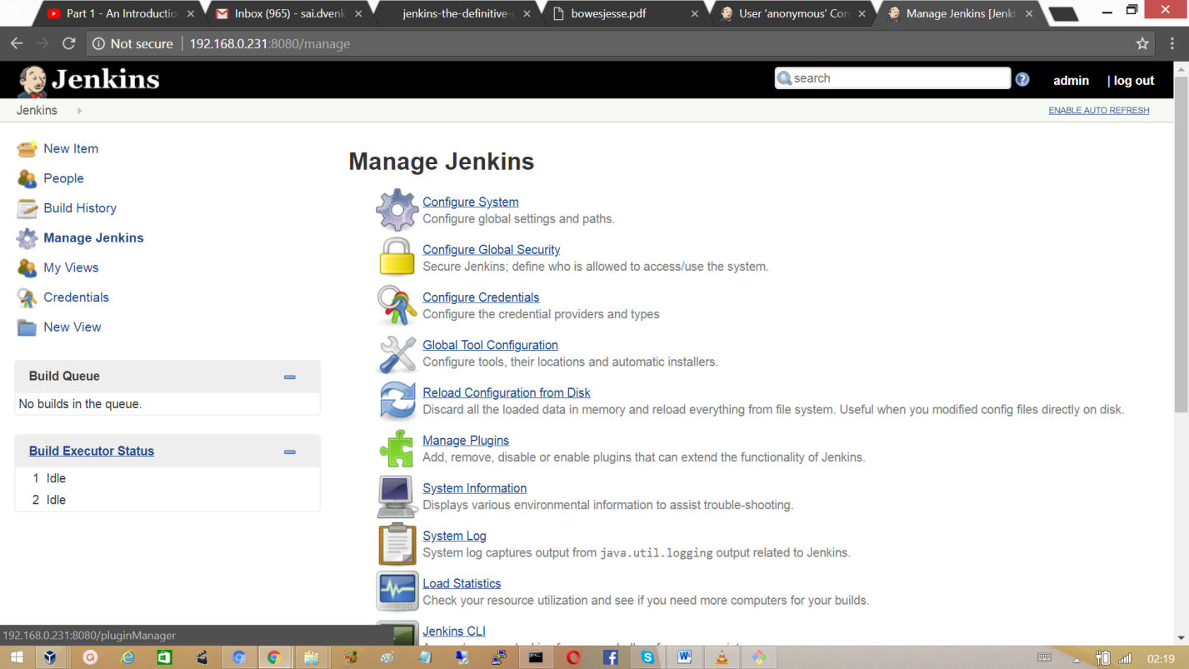

Install GitHub plugin without restart, during this process Jenkins will try to install GitHub plugin along with the dependencies.

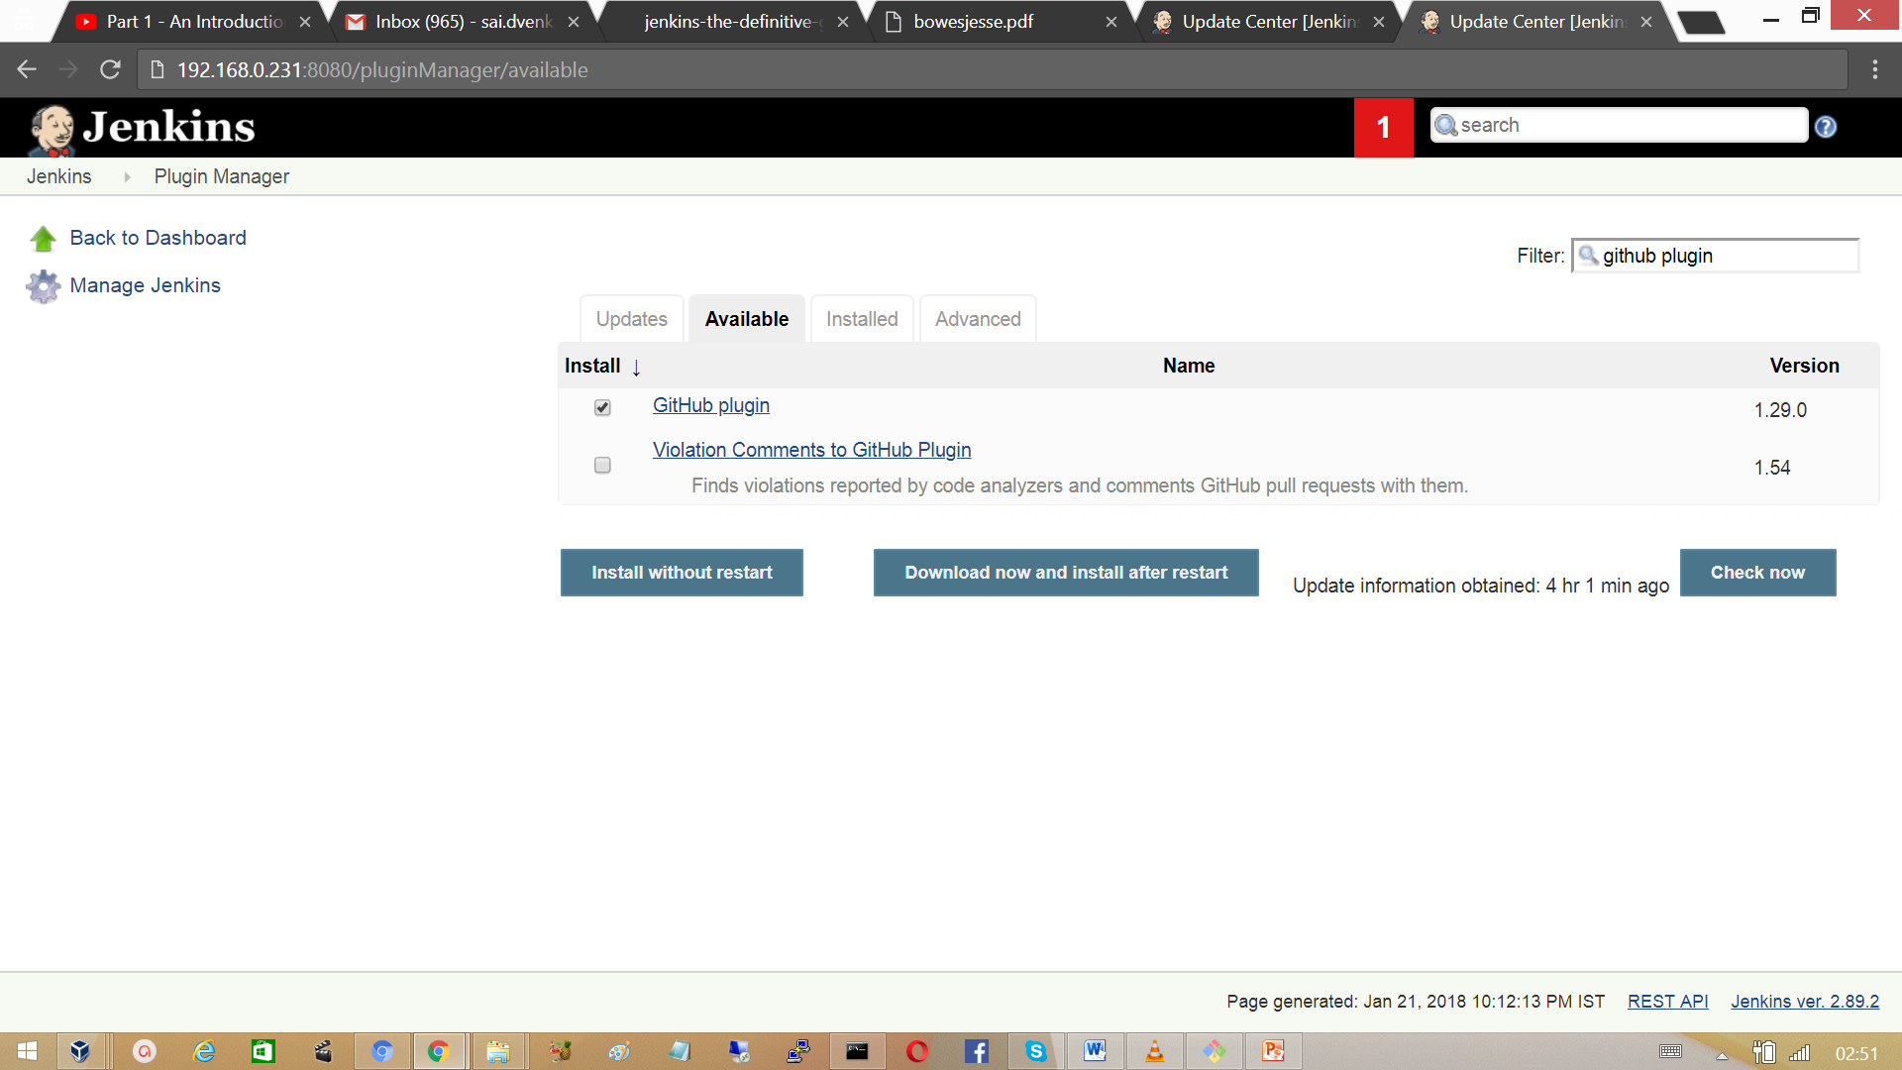

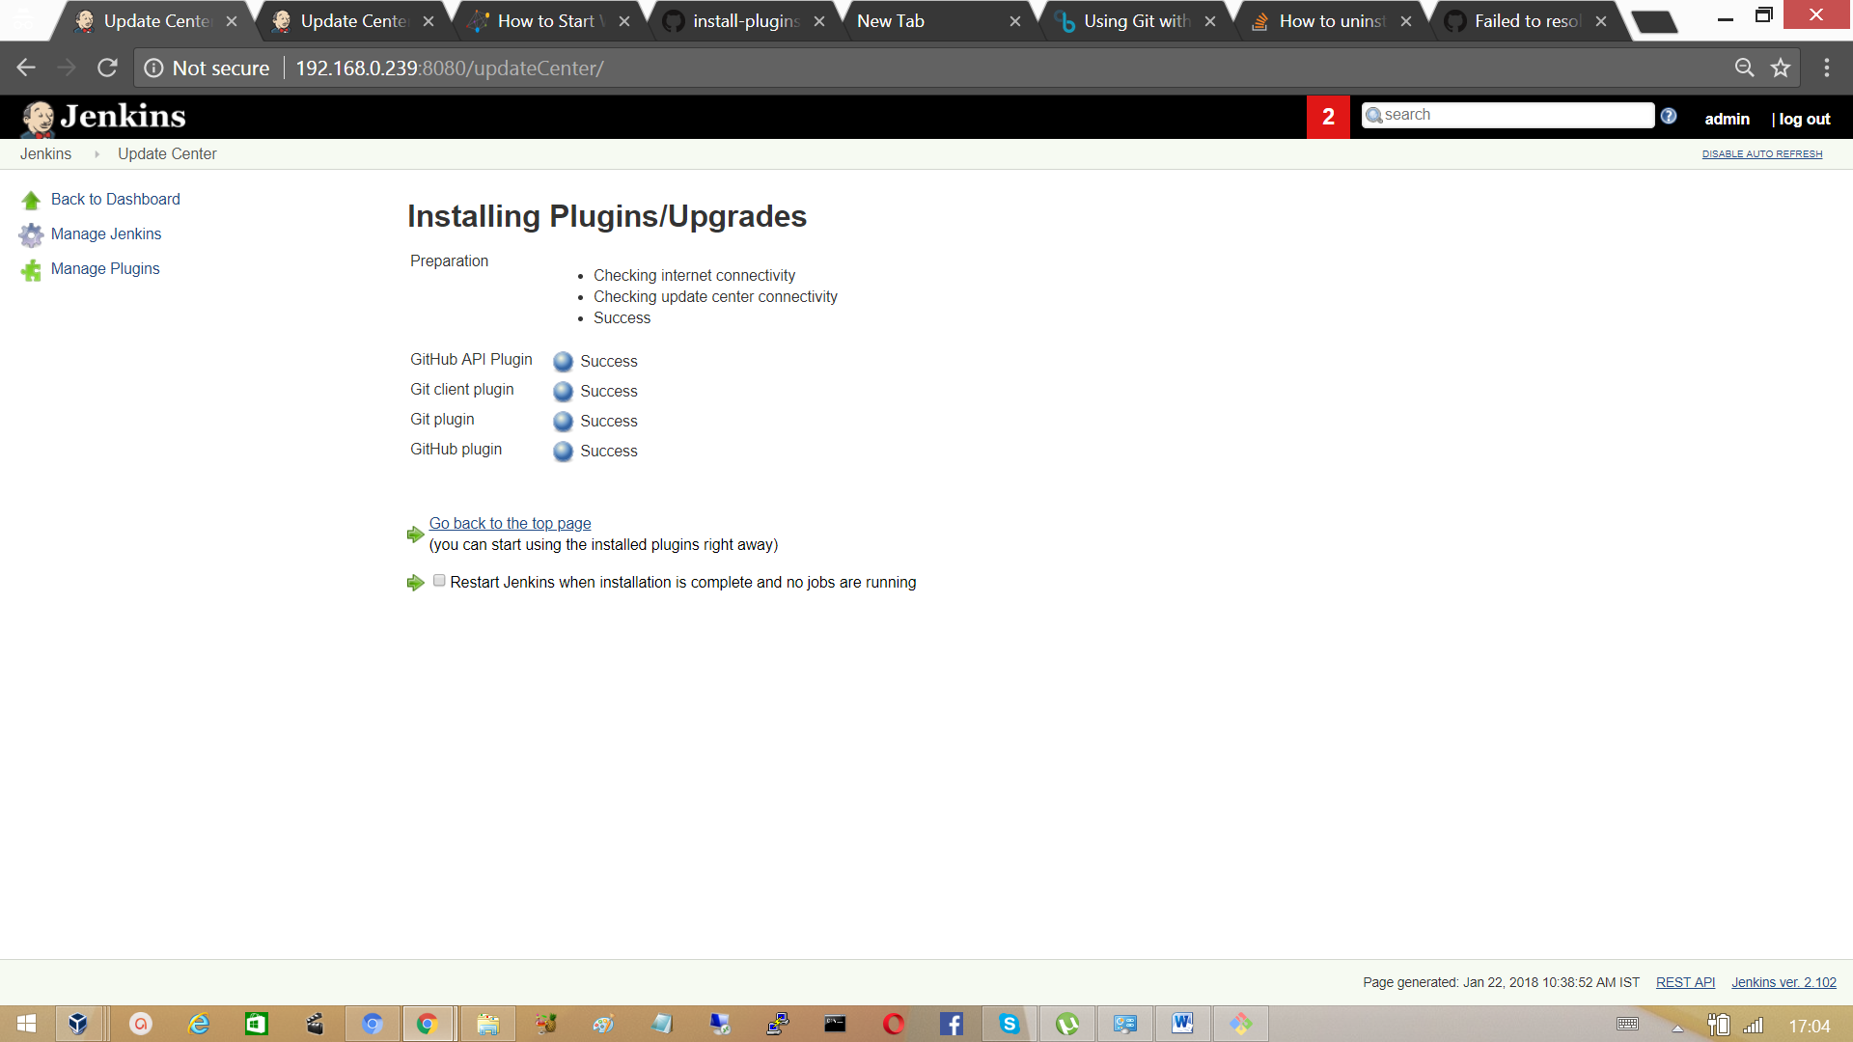

Verify whether the plugin installed or not in installed section.

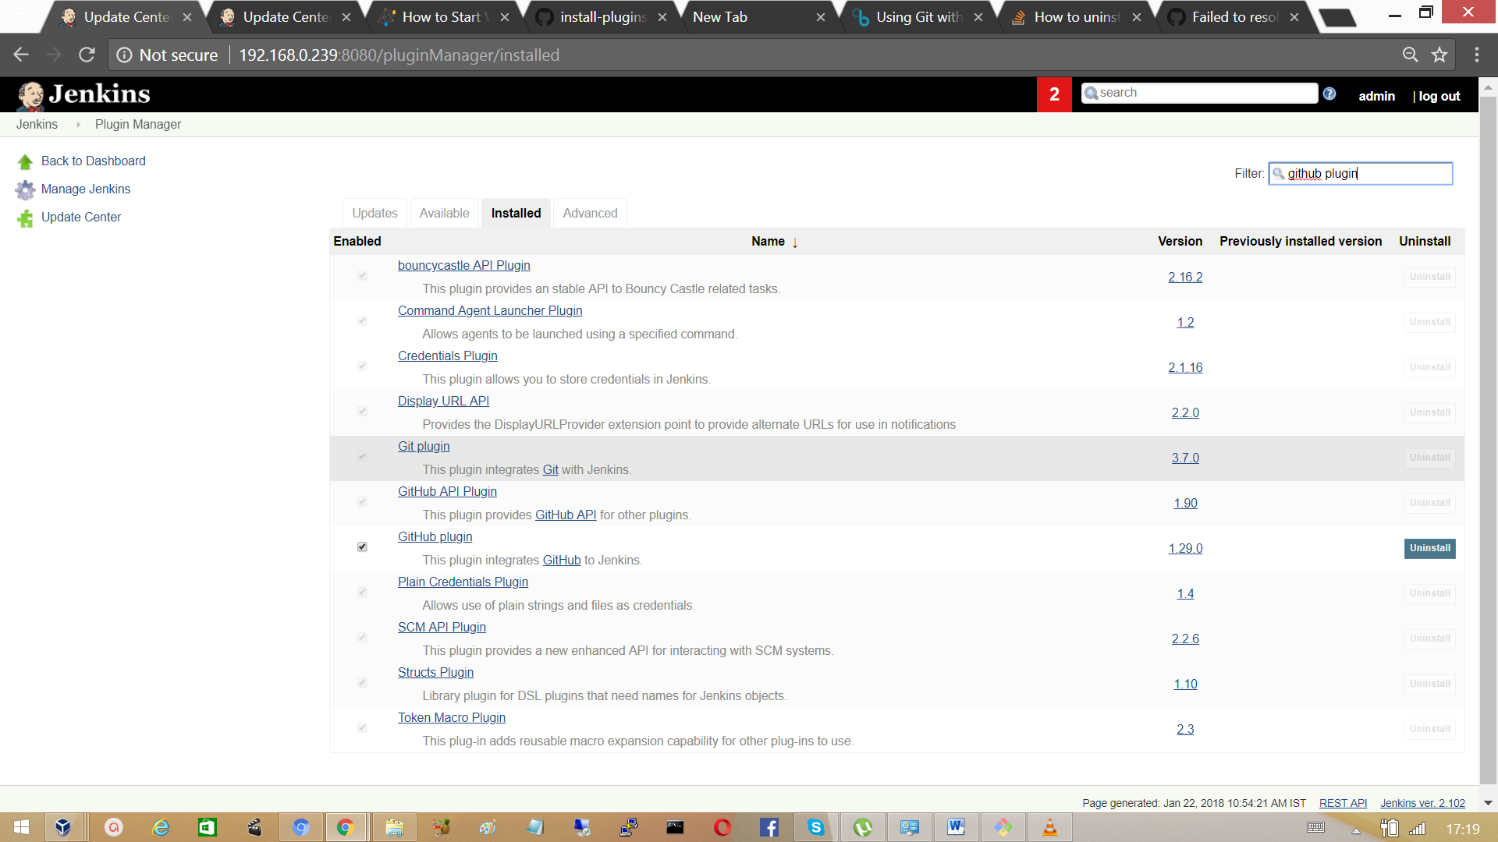

## 3.10 Configure Jenkins to work with Git and Maven

Make Sure Java is installed before proceeding. Run the command ‘java -version’ to verify it. Then, download the maven binary zip file from maven.apache.org. Extract the files to the location program files as shown below. Extract the files to the location program files.

To start using Maven, we need to configure Windows environment variables. The M2_HOME variable needs to be set and the PATH variable needs to be modified to include the Maven binaries folder.

Note: MAVEN_HOME is for Maven 1, M2_HOME is for Maven 2 and later.



Verify maven is recognized from the command line.



**Setting Up Maven in Linux**

Download Maven and set the environments variables.



To set path permanently add the same to  */etc/profile*

[root@client ~]# vi /etc/profile



Verify the installation from the command line with the command ‘mvn –version’

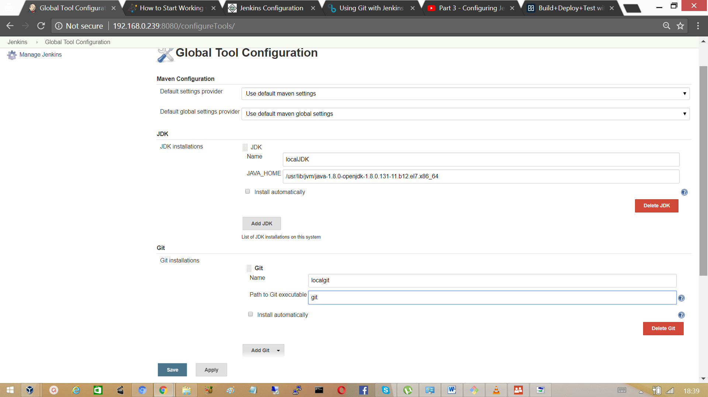

Uncheck the box to avoid maven installation and provide the name and path for the Jenkins

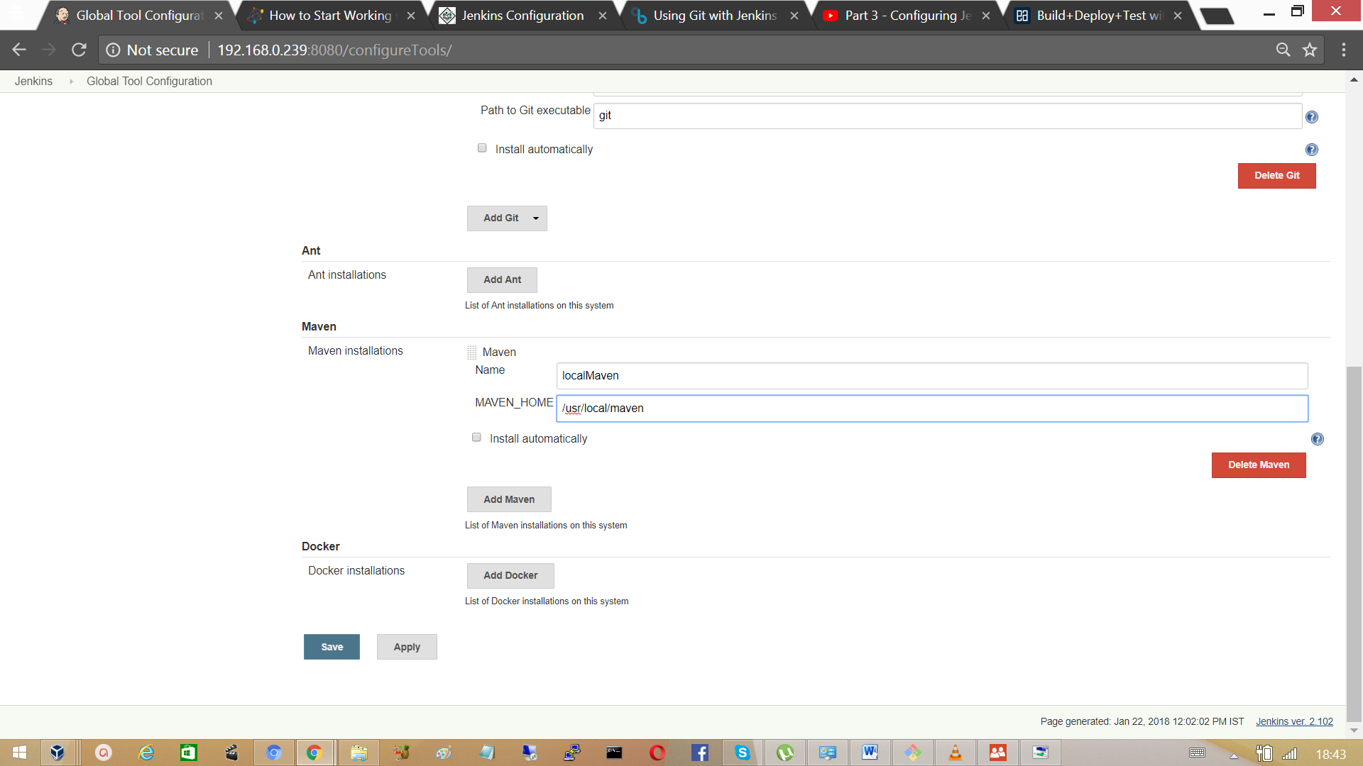

Note: configure the maven path, should be configured according to the variable name listed in the

Jenkins configuration.

**Create Our First Maven based Jenkins project.**

The project we are going to build is hosted on GitHub, a simple web application that displays ‘Hello world’ on the browser. To create new project click on new Item.

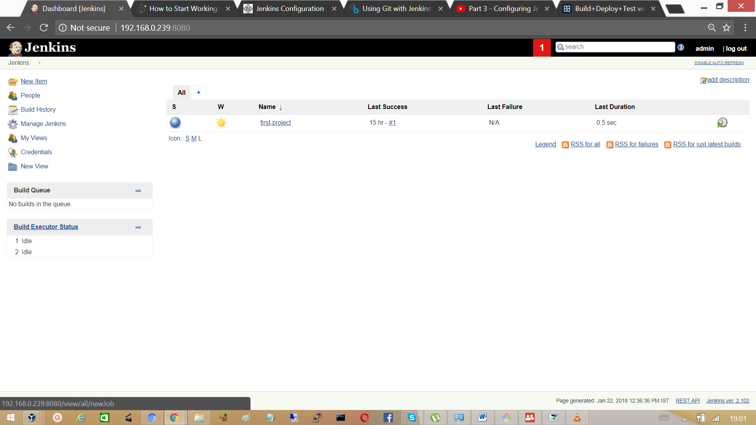

Provide the name for the project, and select project type as free style project.

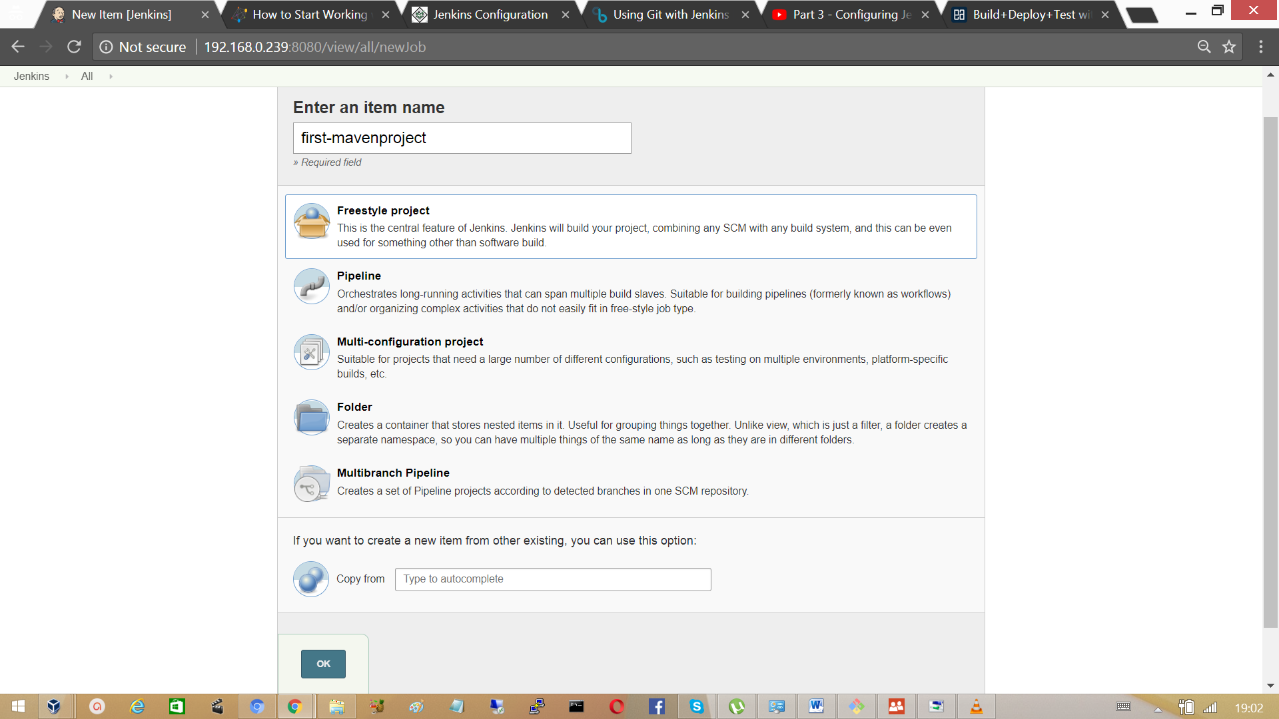

Configure the project with a description for the project.

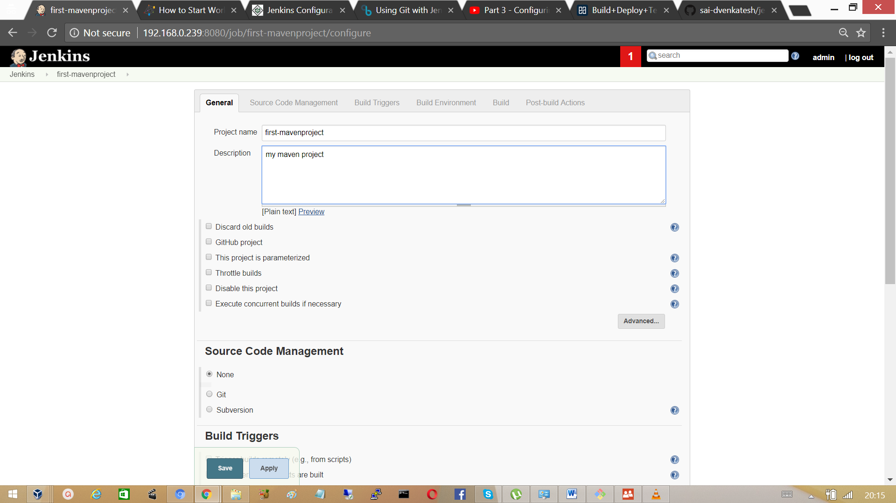

In the Source Code Management section, select the version control system and provide the repository URL.

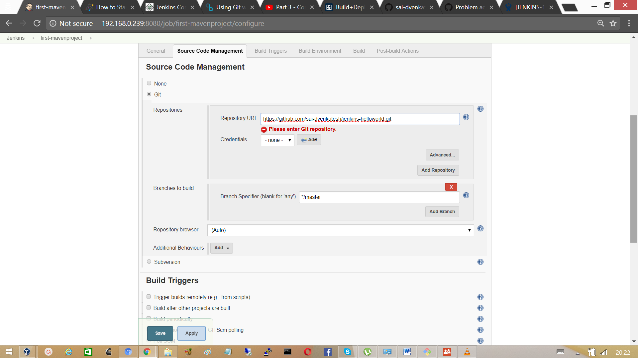

Select the build step to invoke top-level Maven targets.

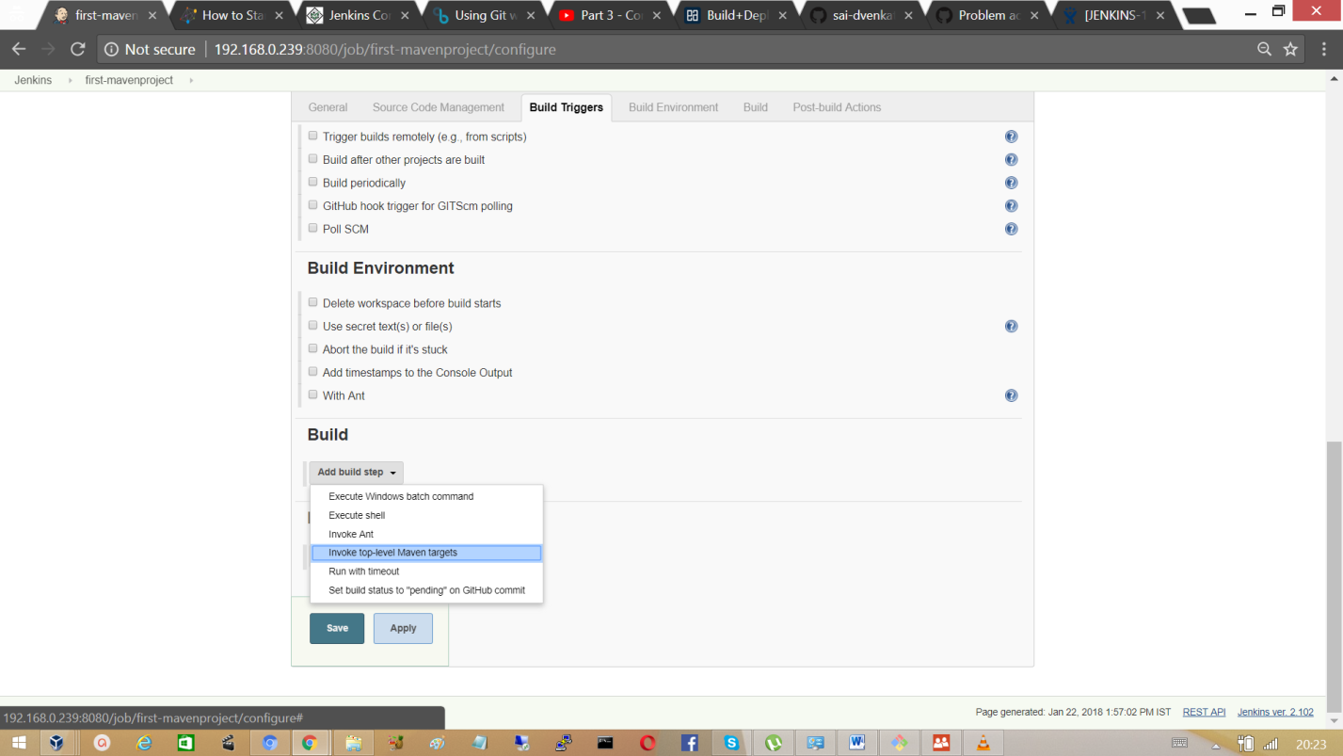

Invoke the local maven, to build package. In the current project, the entry clean package will clean the existing builds in target folder and performs a new build. It is one of the phases in maven life cycle.

Click on Save.

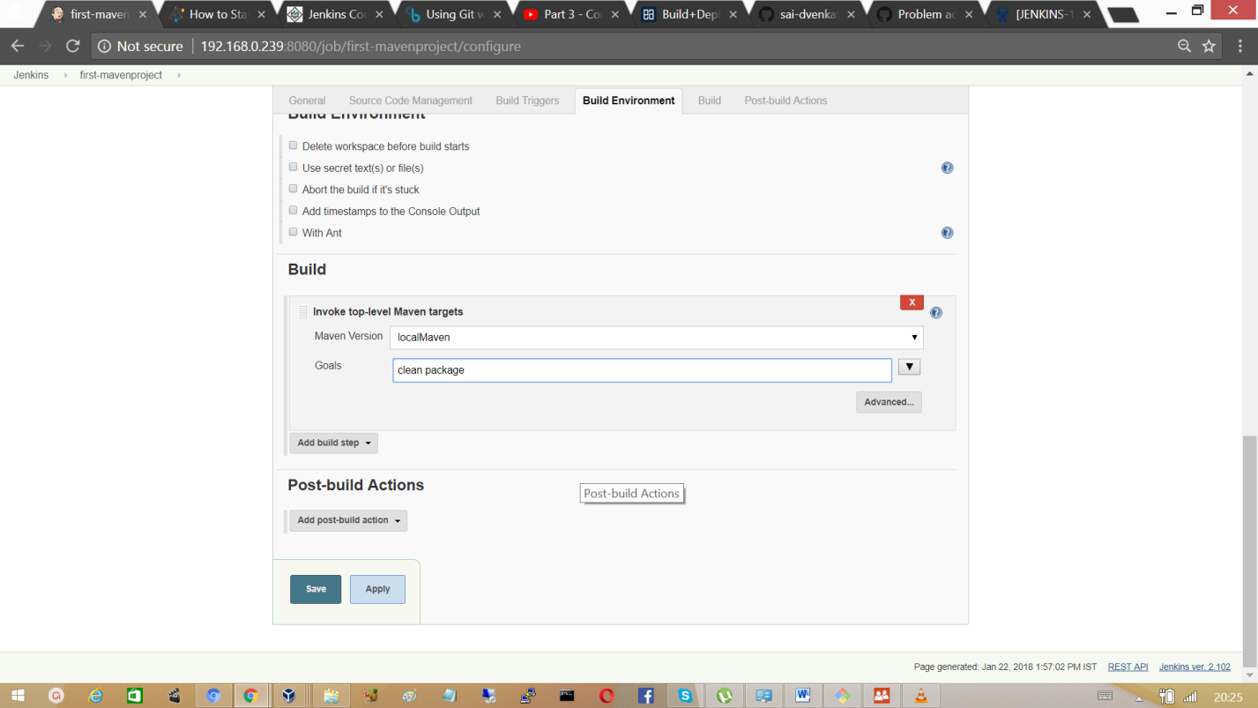

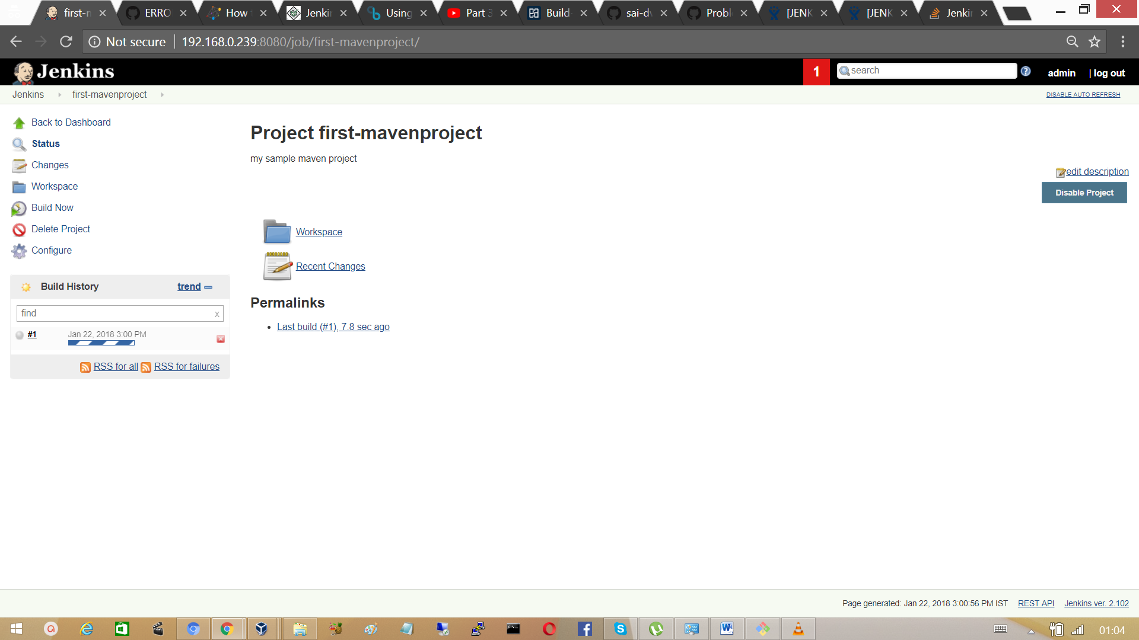

Click on #1 count and you should observer the blue colour ball, which defines that the build is successful.

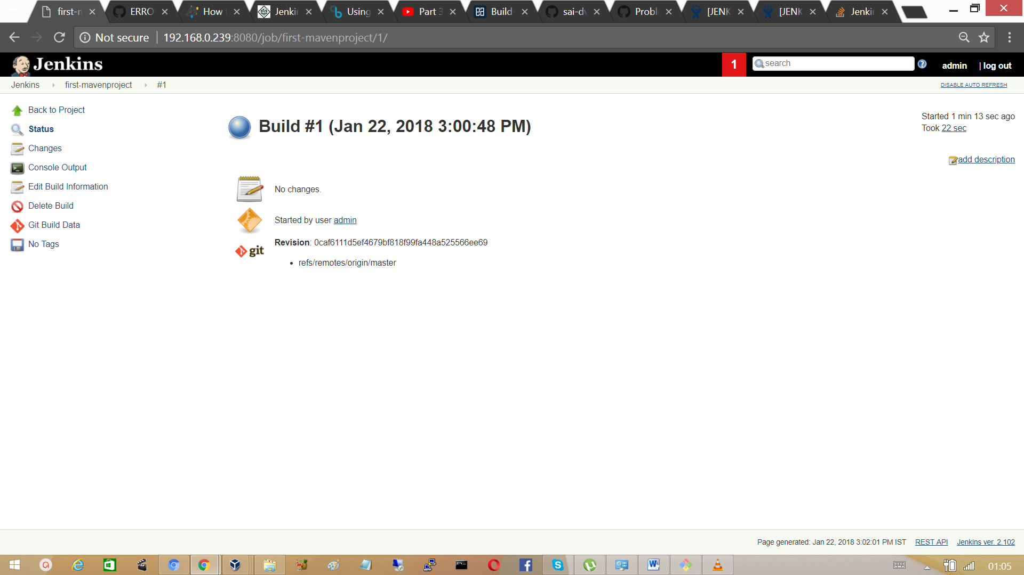

Click on Console output to know how Jenkins performed the build. Jenkins builds the project in a work space /var/lib/Jenkins/first-mavenproject, then it checks out the code from github repository.

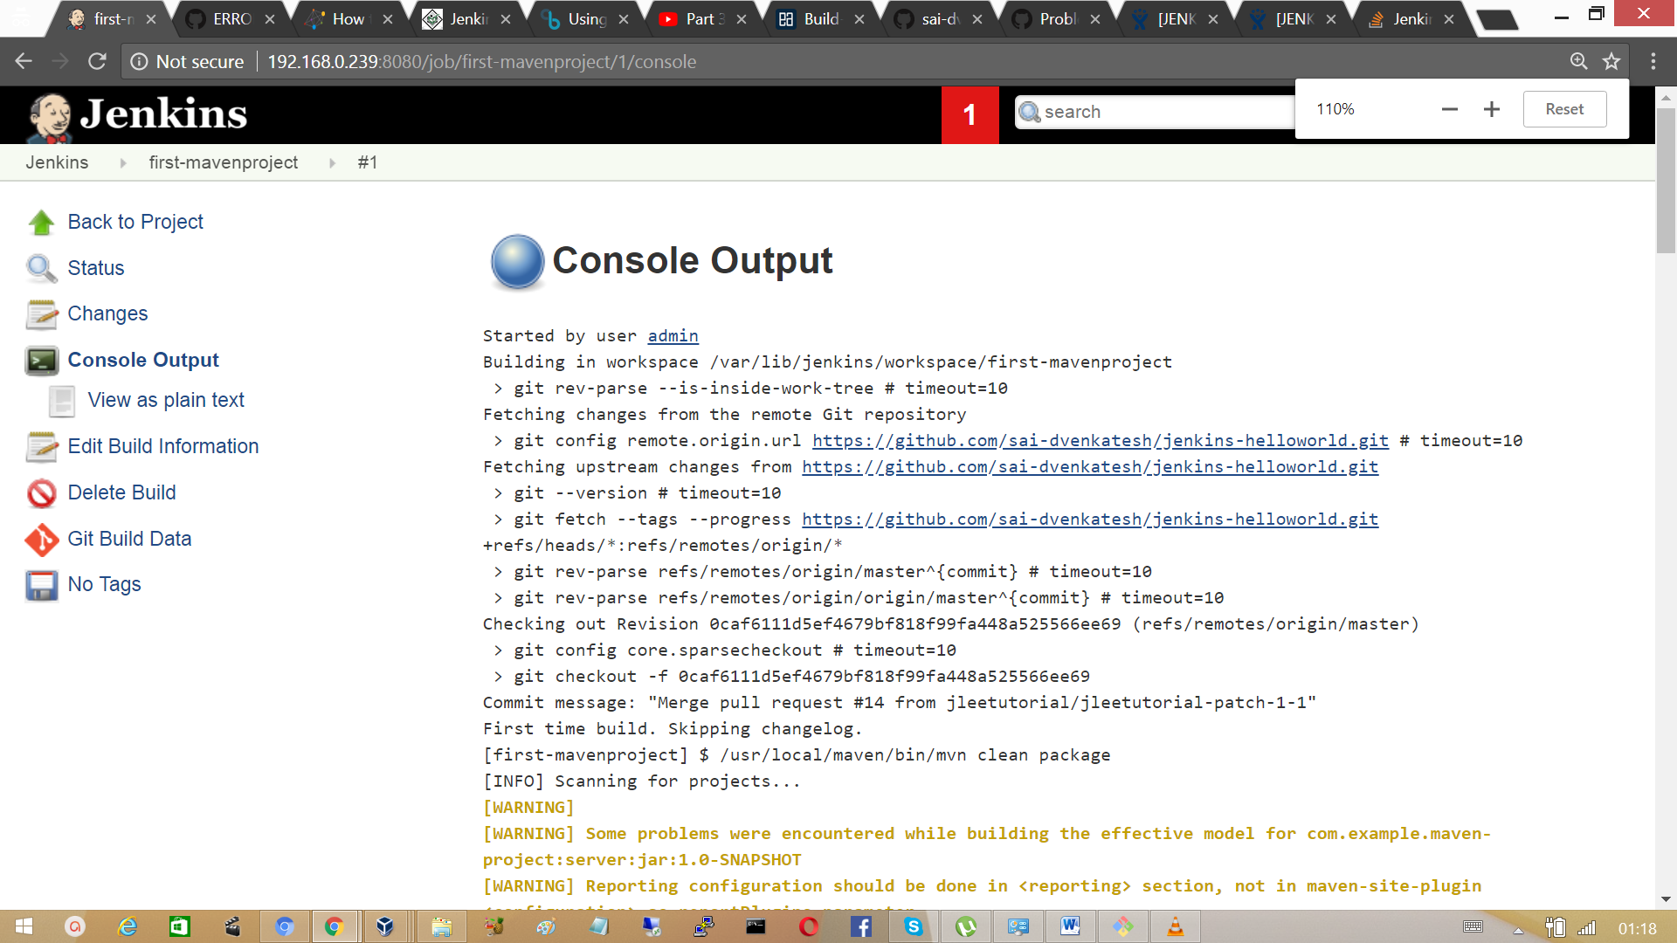

Jenkins then executes the maven ‘mvn clean package’ command as per the maven life cycle such as compile, test and lastly it build the jar or war file under the target directory of server module. Jenkins perform this actions for the three modules i.e mavenproject base directory, server modules and then to webapps directory of the project. Jar or War file created can be deployed in tomcat.

## 3.11 Jenkins Work Space

The workspace directory is where Jenkins builds your project: it contains the source code **J**enkin**s** checks out, plus any files generated by the build itself.

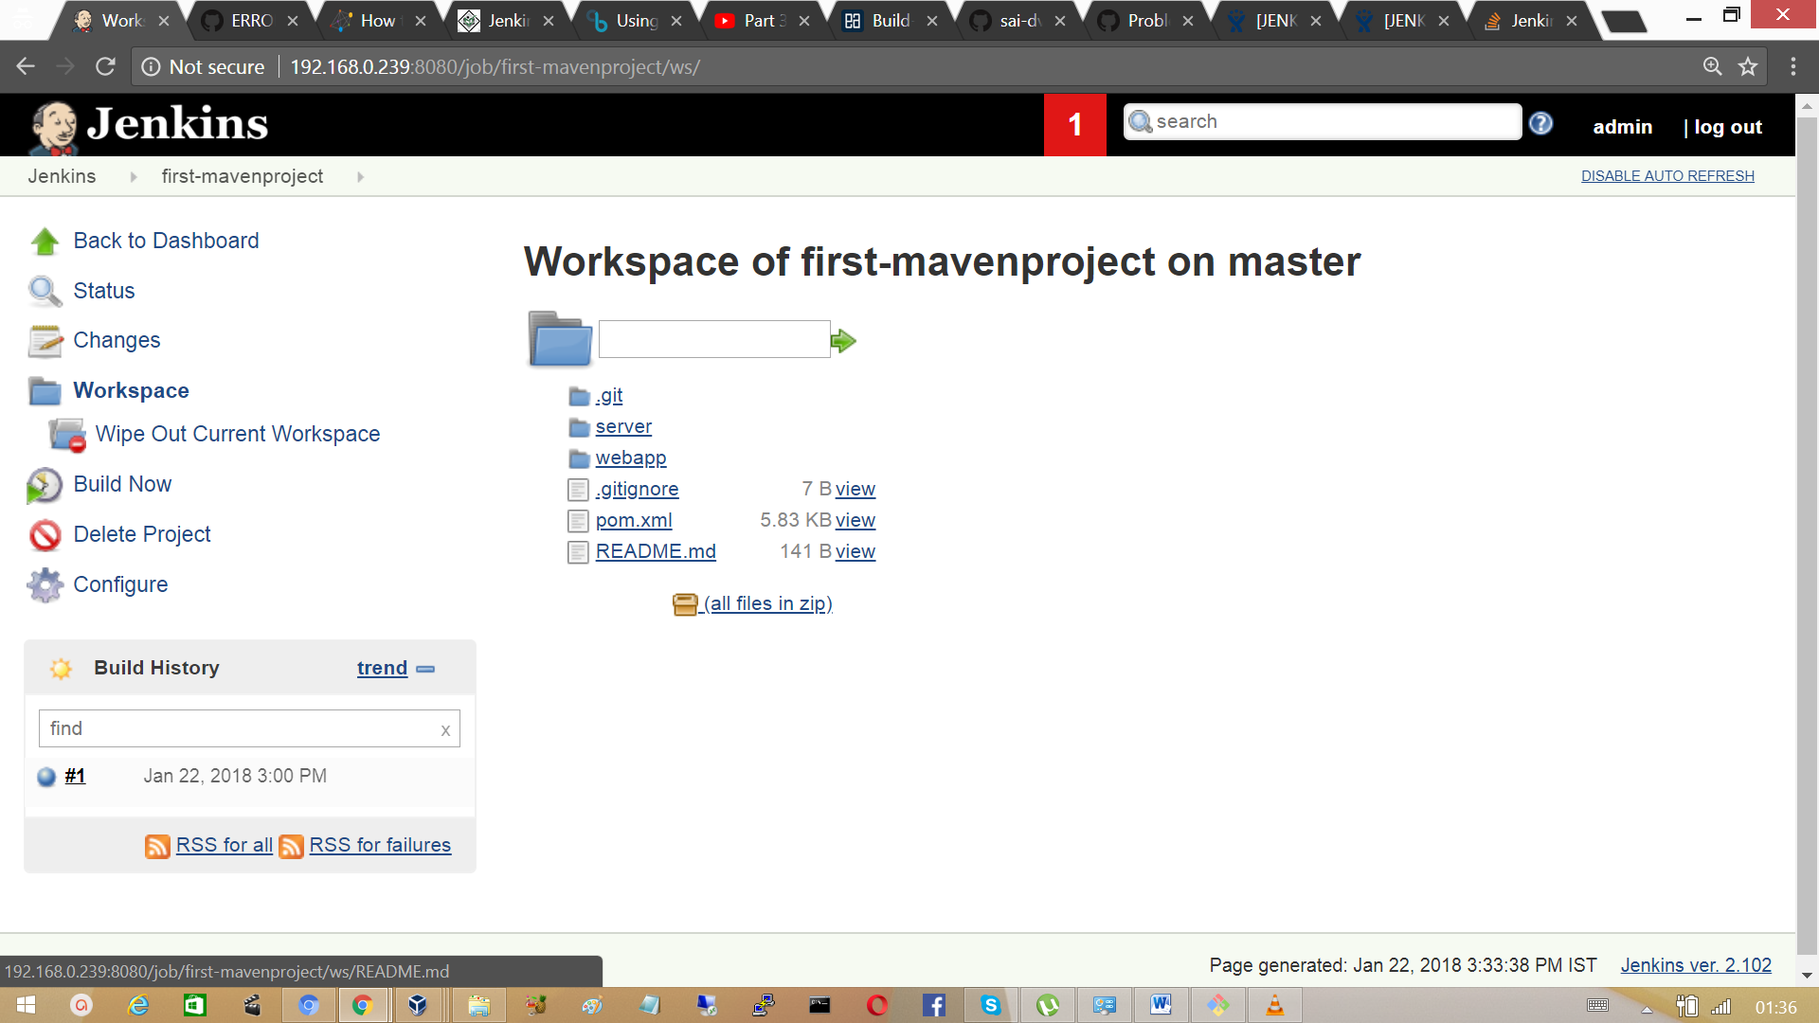

## 3.12 Configure Jenkins to poll source code changes periodically.

Whole point of continuous integration is that whenever a commit move to the central repository the system would automatically build and test your applications the easiest way to achieve this is to let Jenkins poll the source on github periodically, if Jenkins detects the change in code repository based on polling it would trigger a build.

Click on the first-maven project. On the left side of the page find a section ‘configure’, click on it.

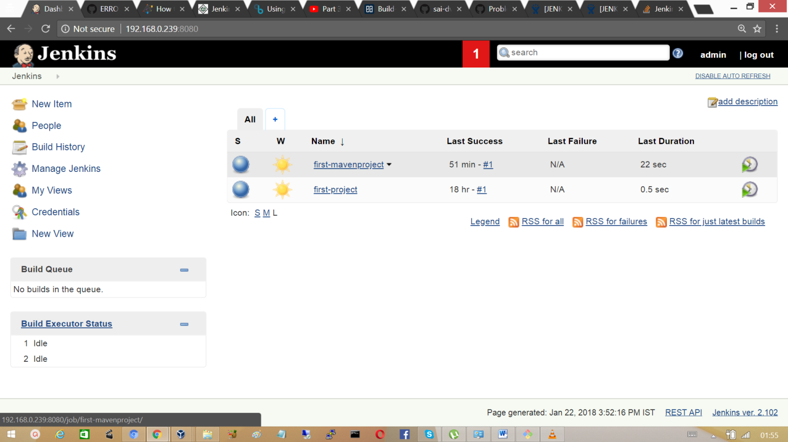

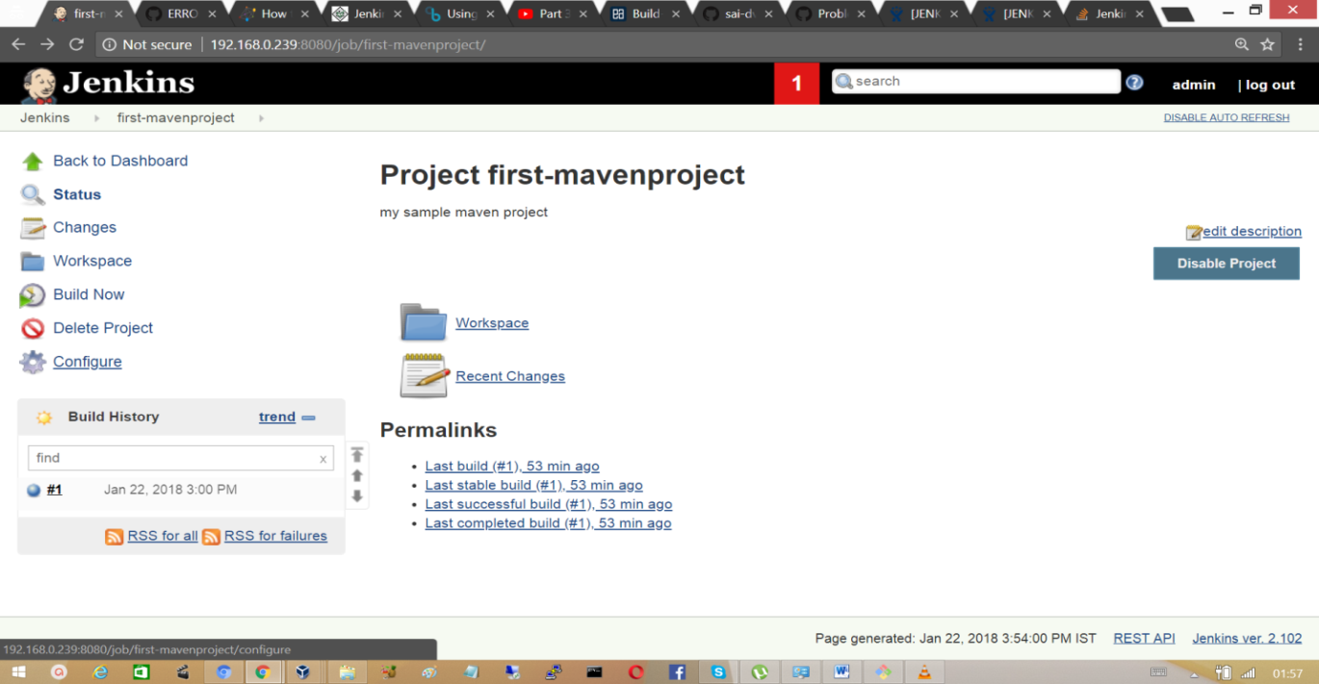

At Build Triggers check the box ‘poll SCM’ and run a schedule which is similar to maven project.

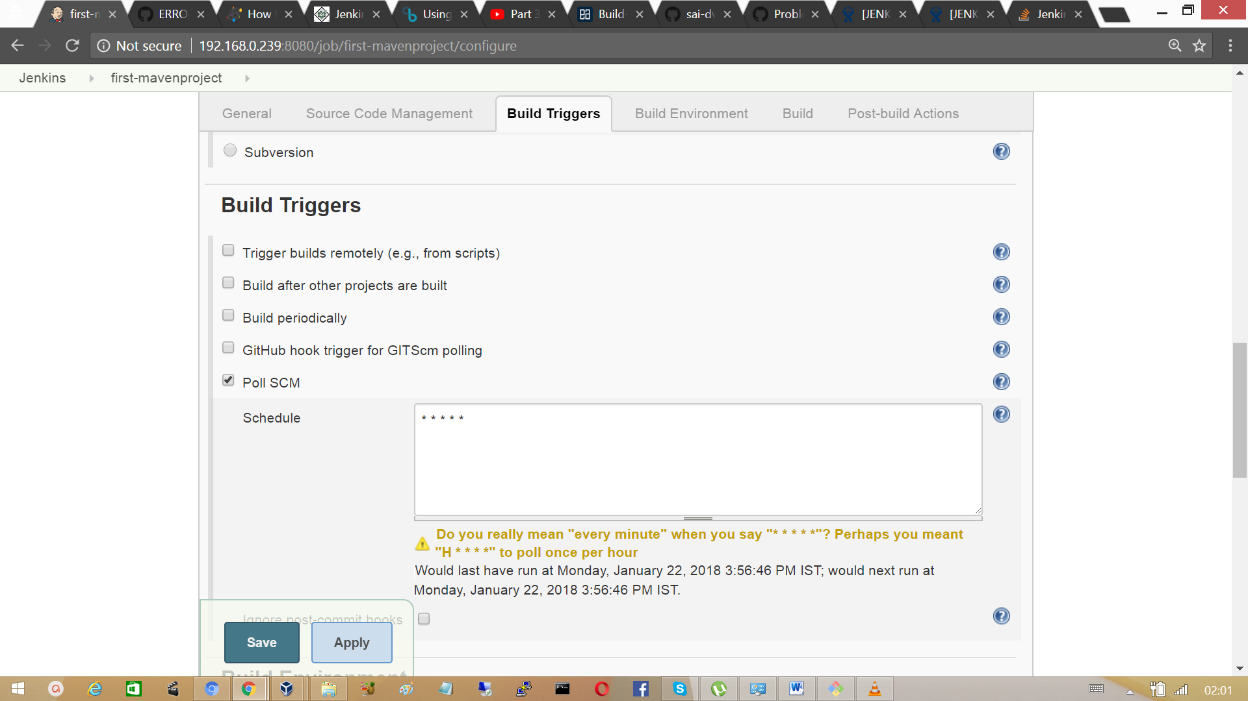

Click on save. Once you save the configuration, a new item git Polling Log appears on the User Interface.

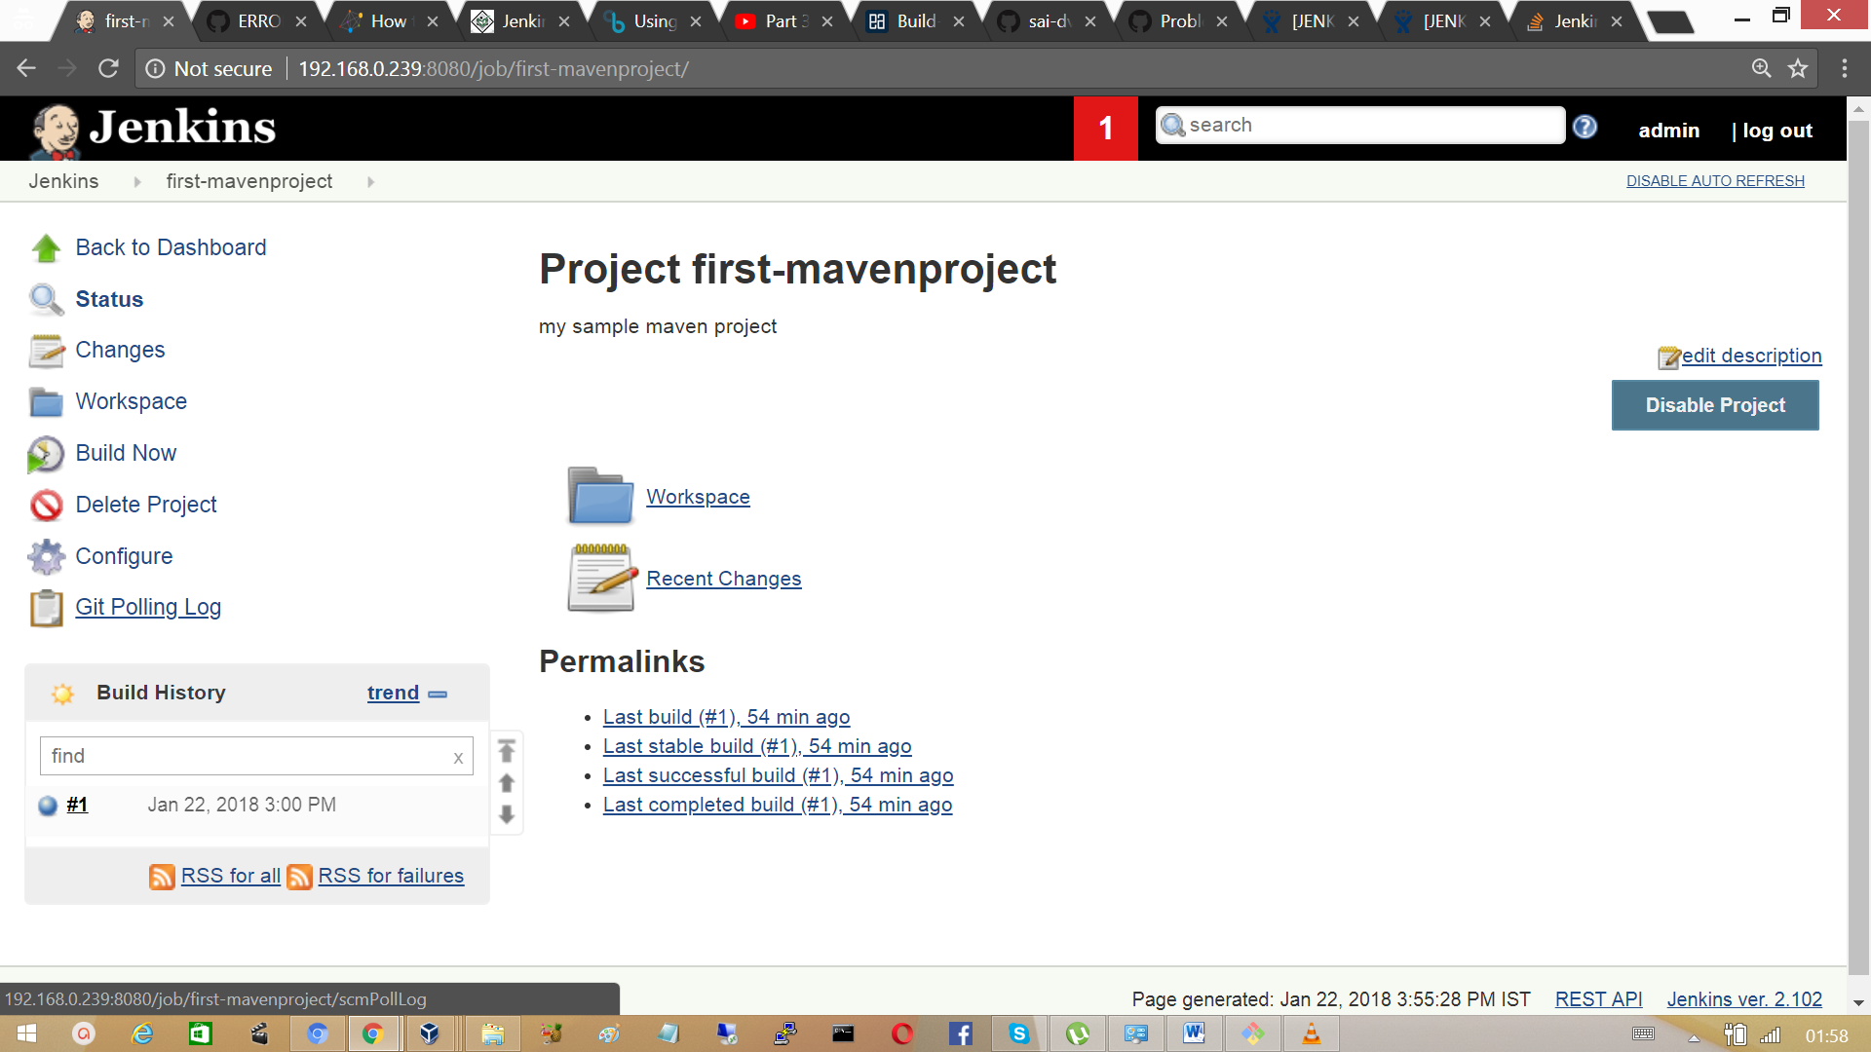

Click on Git Polling Log, it shows us that the Jenkins checked out source code for any changes. Jenkins does this for every minute.

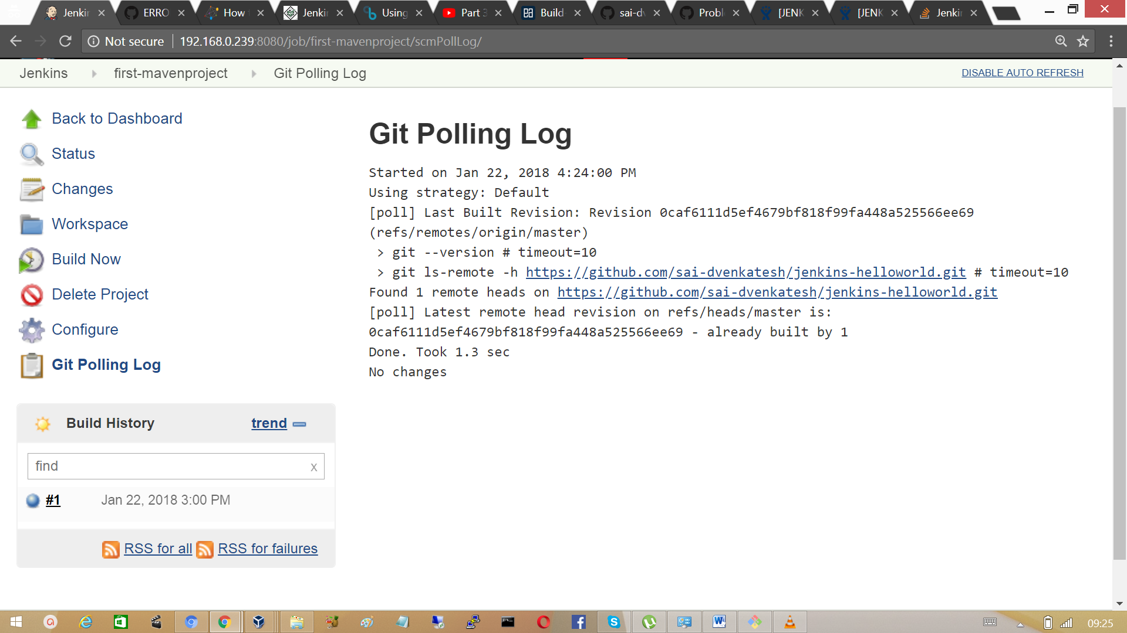

Modify the git repository and check whether Jenkins able to detect changes and perform the build process as it is already schedule to check the changes and perform build periodically. Try out empty commit to the local git repository.

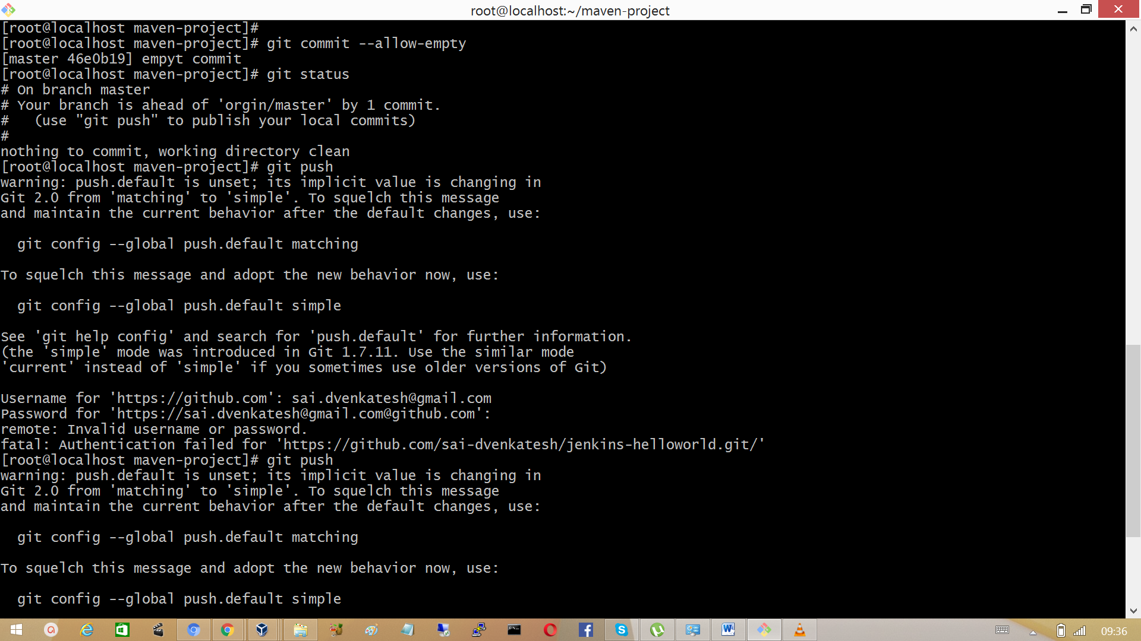

Push the changes to GitHub repository.

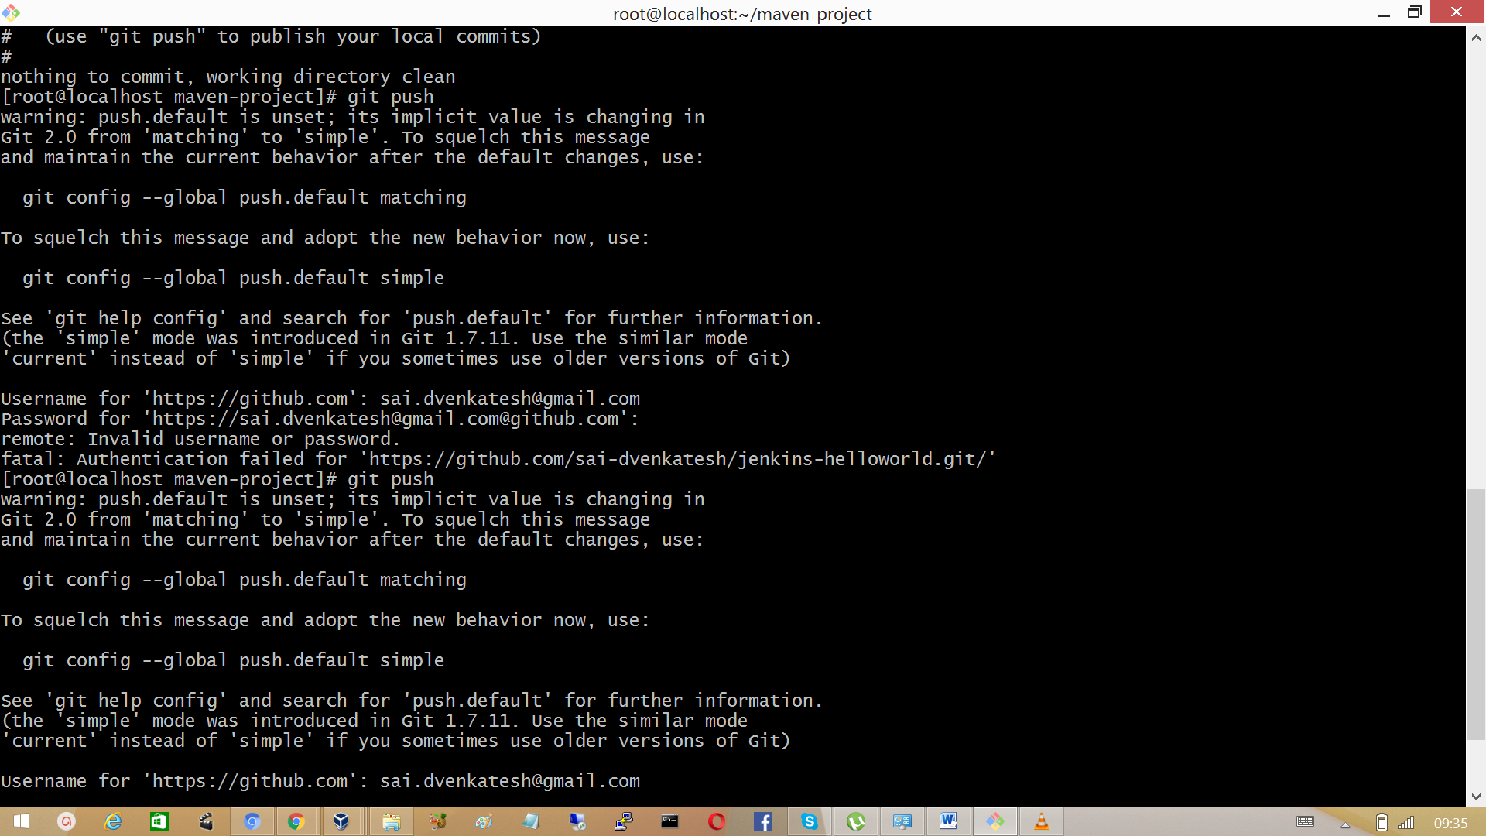

Now verify at the Jenkins UI, console output.

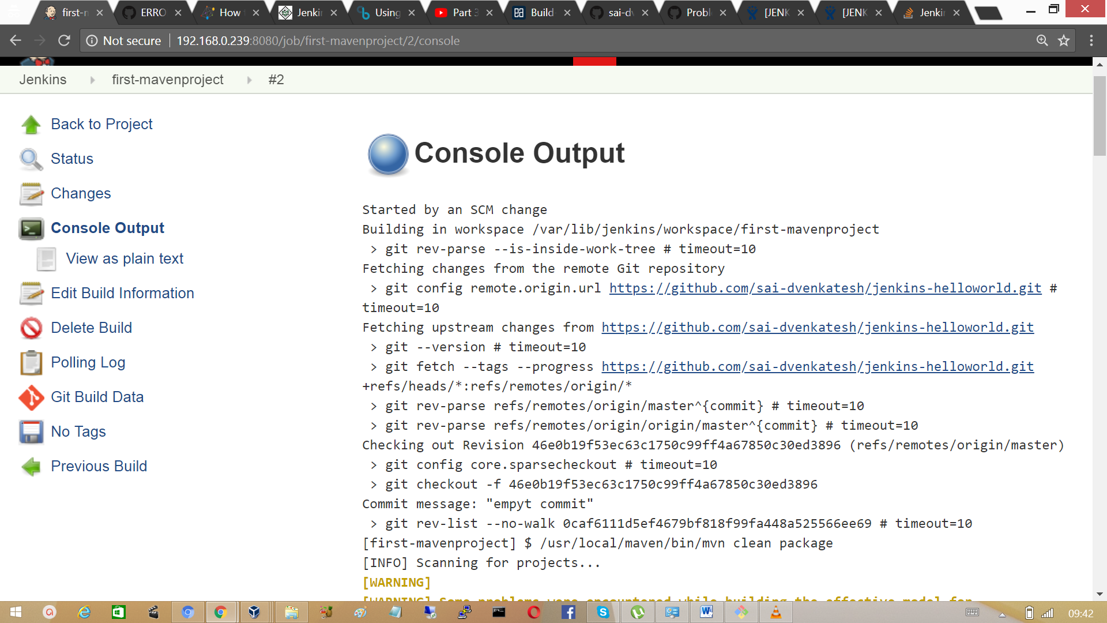

It indicates blue ball saying build is successful and started an SCM change.

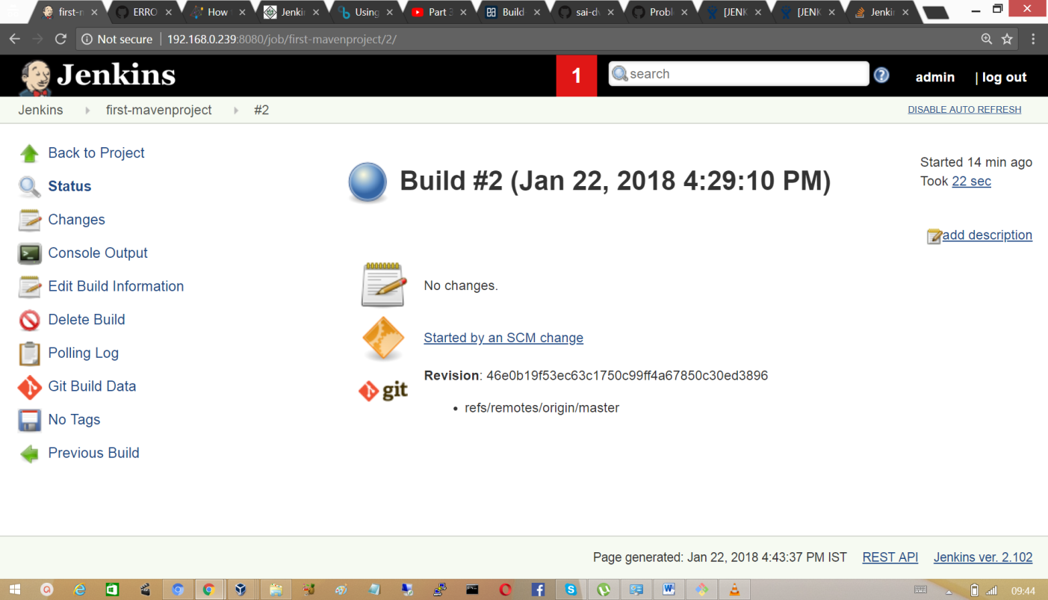

## 3.13 Using build triggers

Click on the first maven project and go to section ‘configure’.

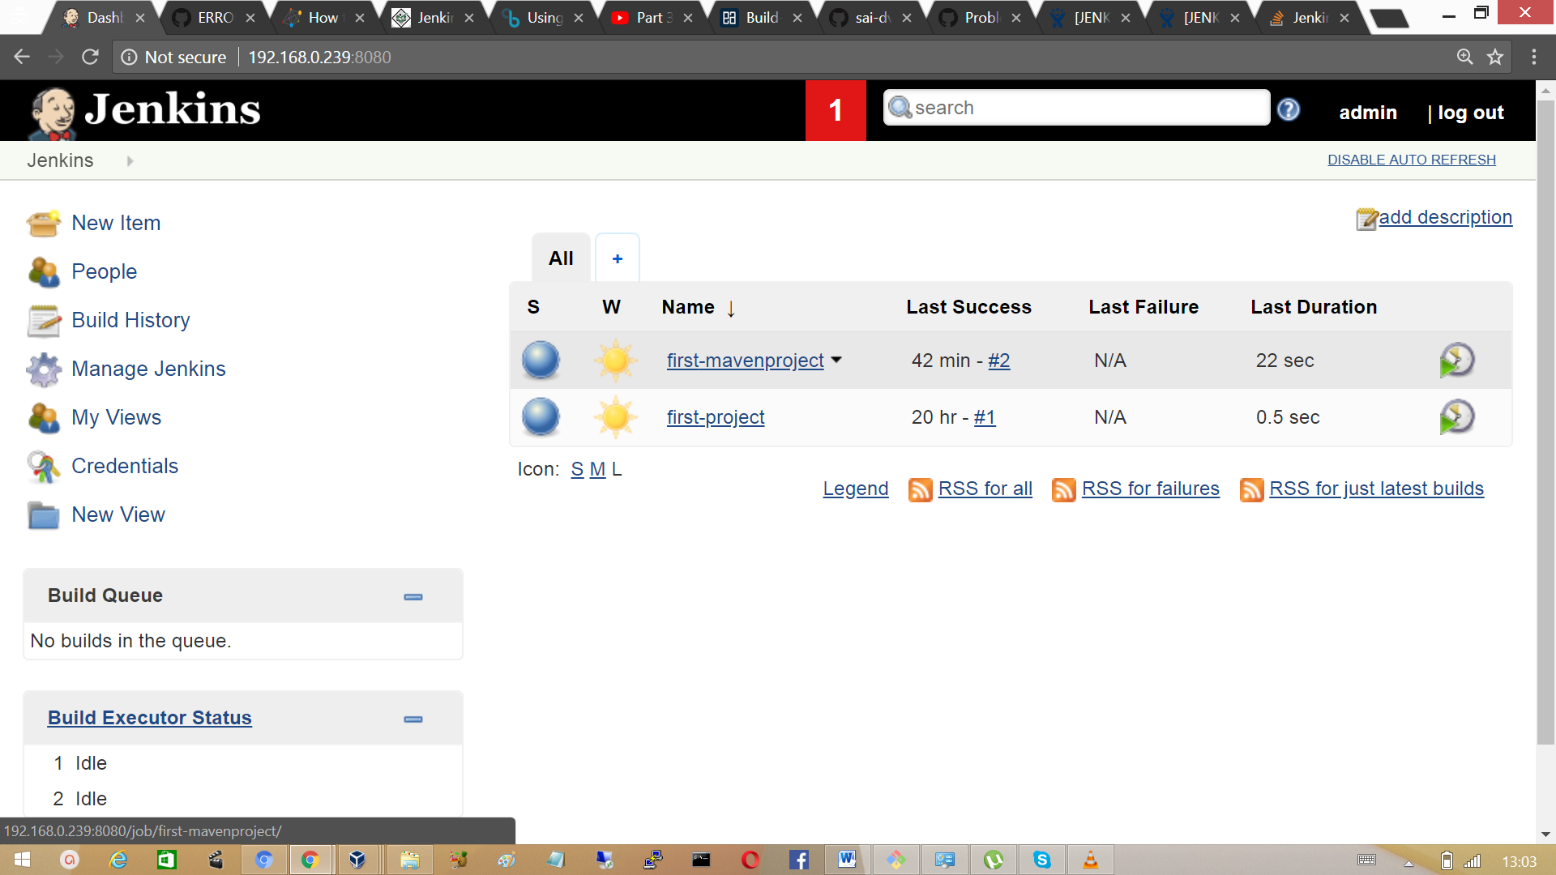

In the Build Triggers section provide the authentication token

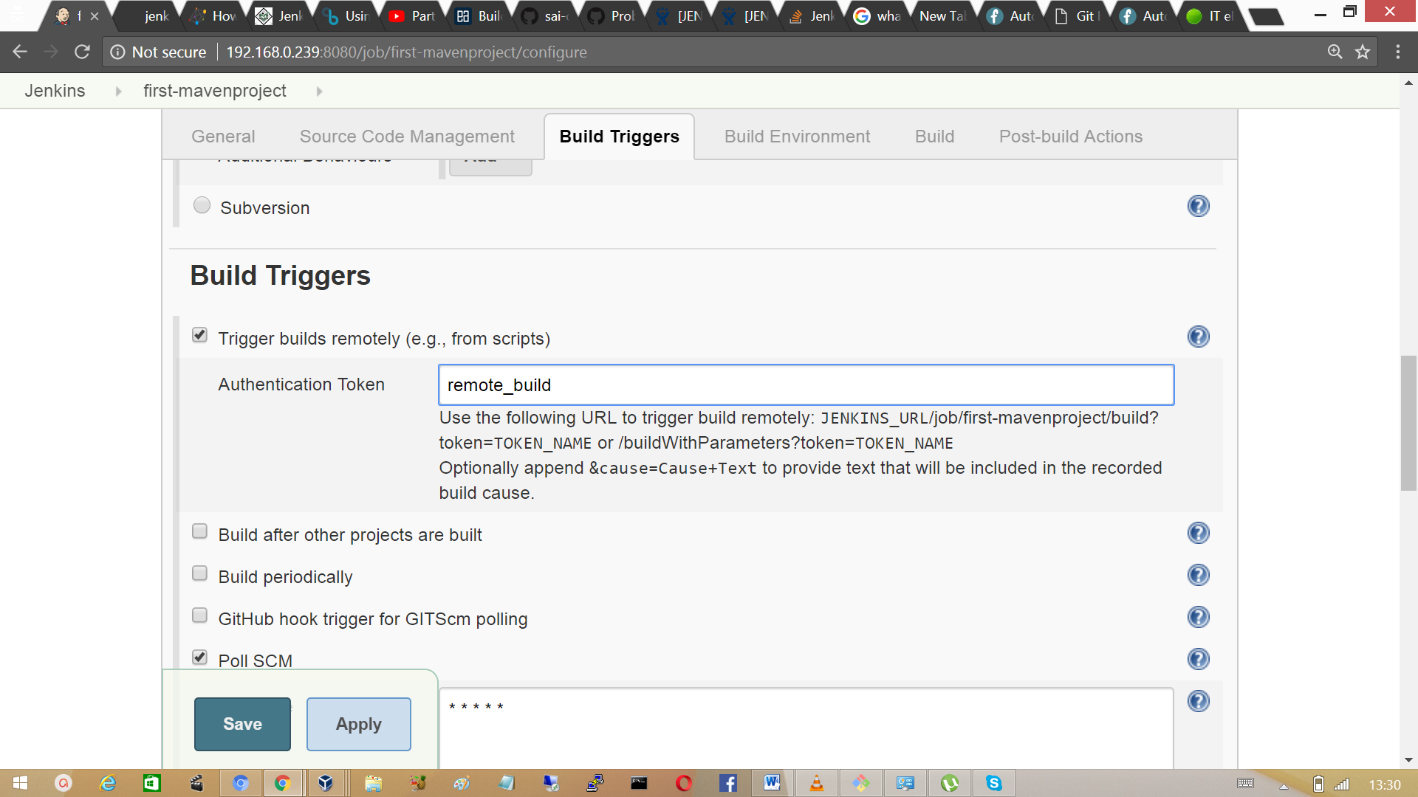

Run the URL from the browser to trigger a build remotely

## 3.11 Jenkins Code quality metrics report

An Important aspect of Continuous Integration is to report about code quality and code coverage metrics reports this should run along with continuous testing to evaluate the code quality.

Checkstyle is a code static analysis tool to help programmers to write java code that adheres to coding standard such as

* Avoid multiples blank lines
* Removing unused variables
* Enforcing correct indentations

It automates this process of checking code which boring but an important task. Checkstyle can be used with Jenkins by installing a plugin, Checkstyle scans the code and reports the warnings found after each build.

Go to Manage Jenkins > Manage plugins, search checkstyle plugin and install it without restart.

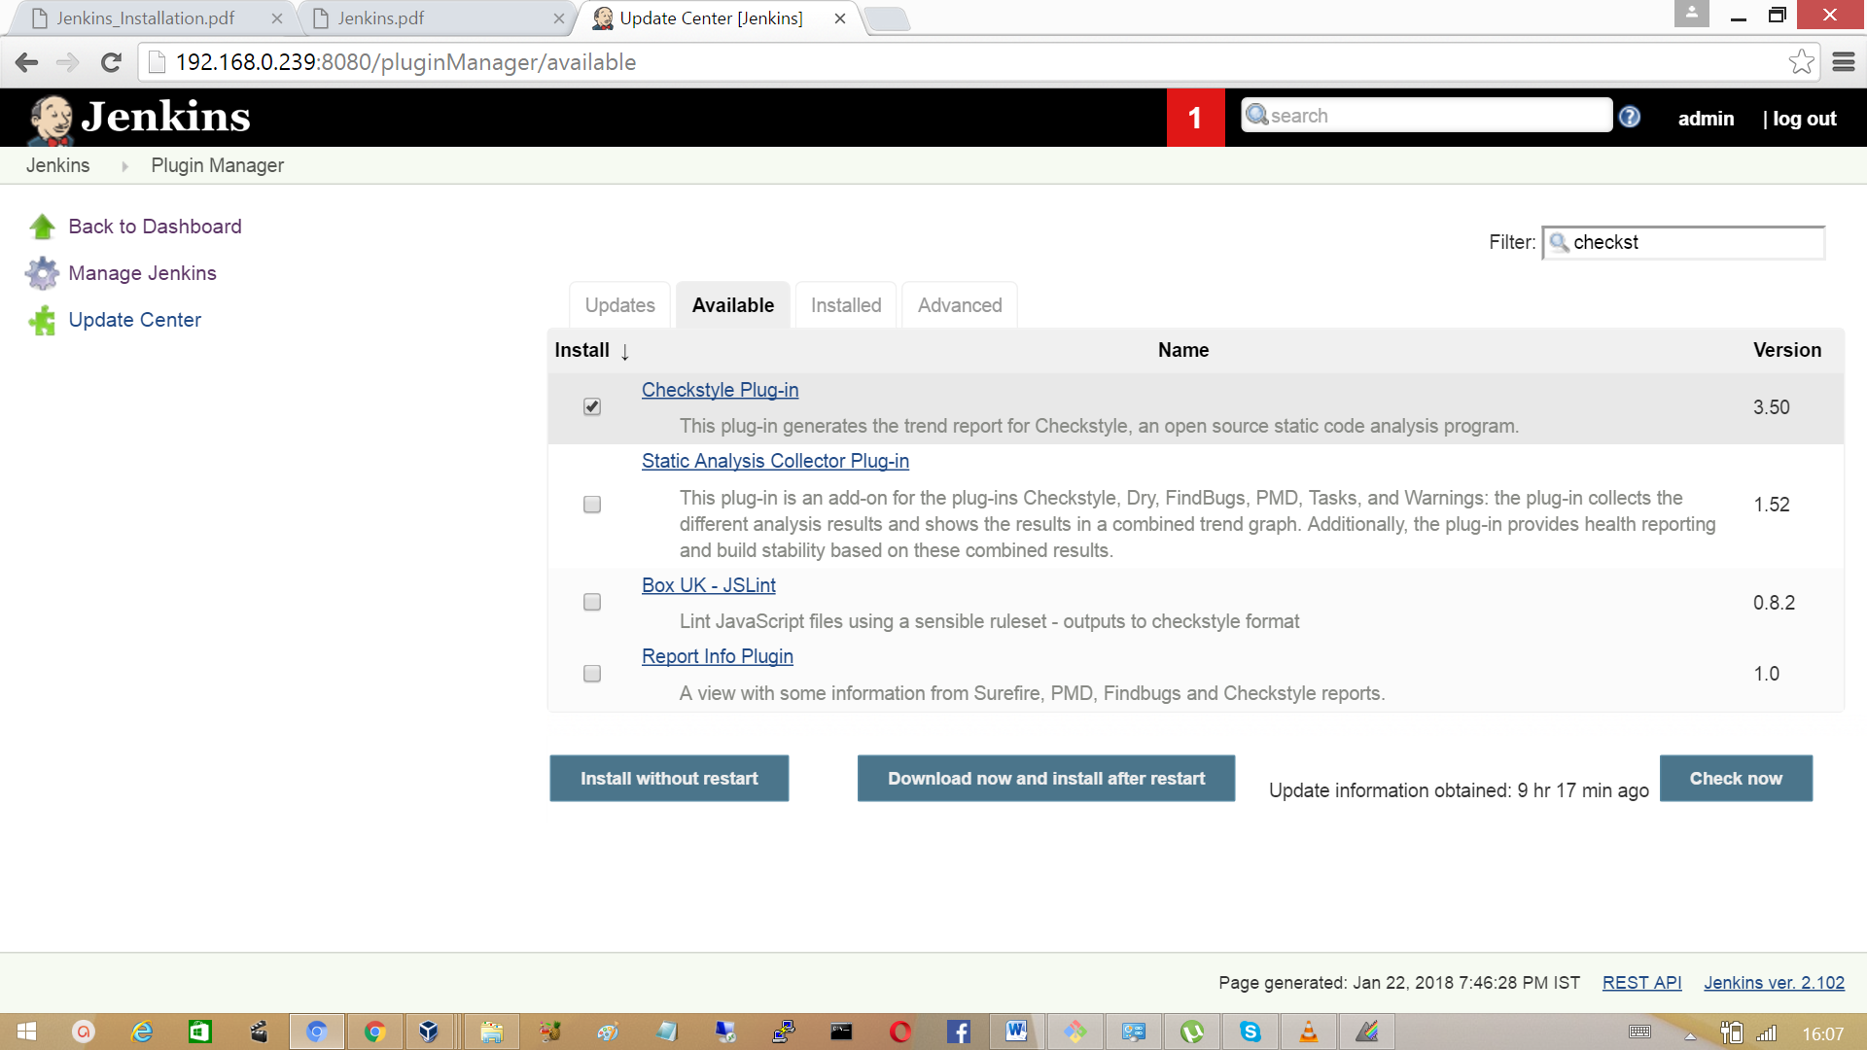

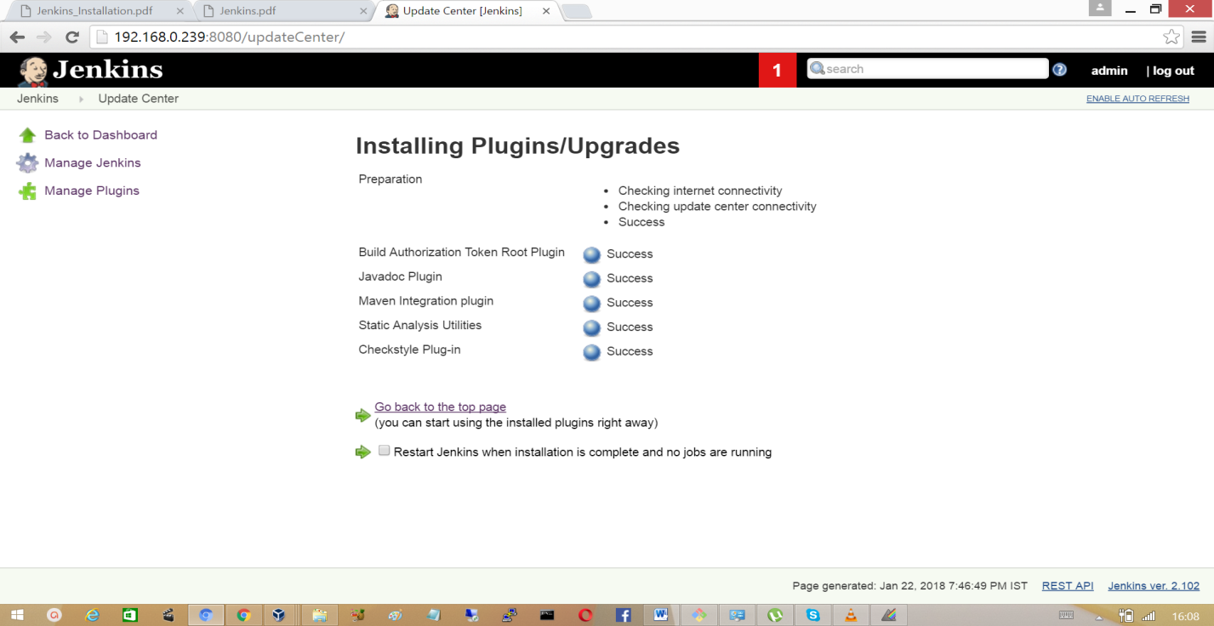

Click on the first-maven project and go to ‘configure’ section, in the build environment invoke the build with maven with a checkstyle plugin goal as checkstyle.

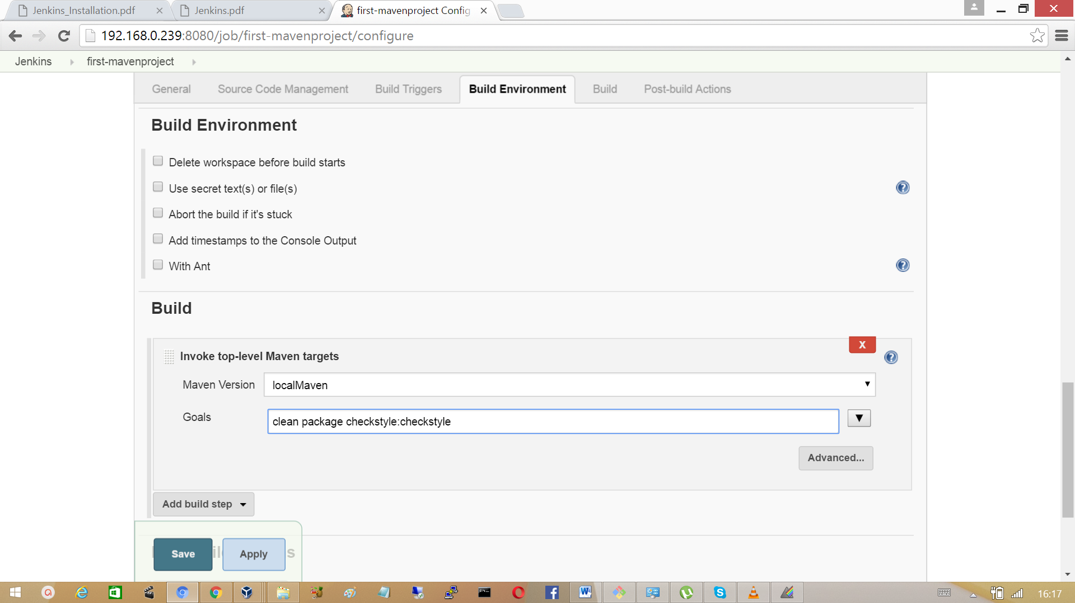

Now select the post build action to publish check analysis with check style results.

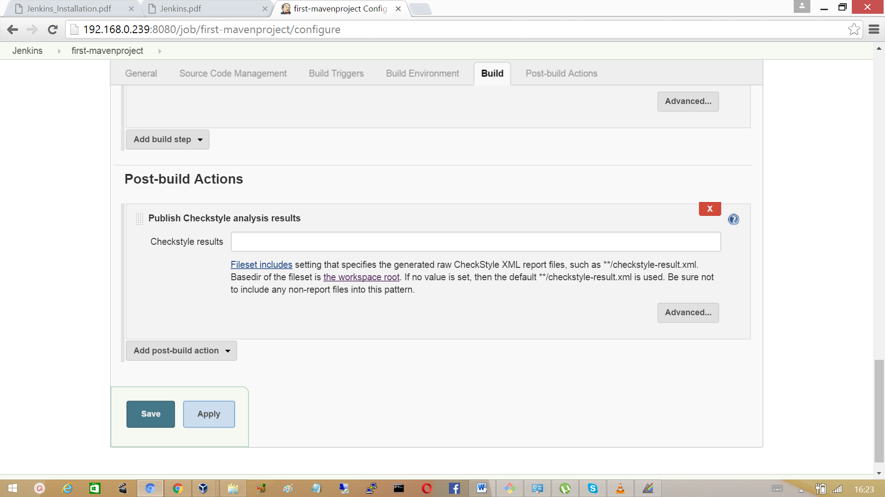

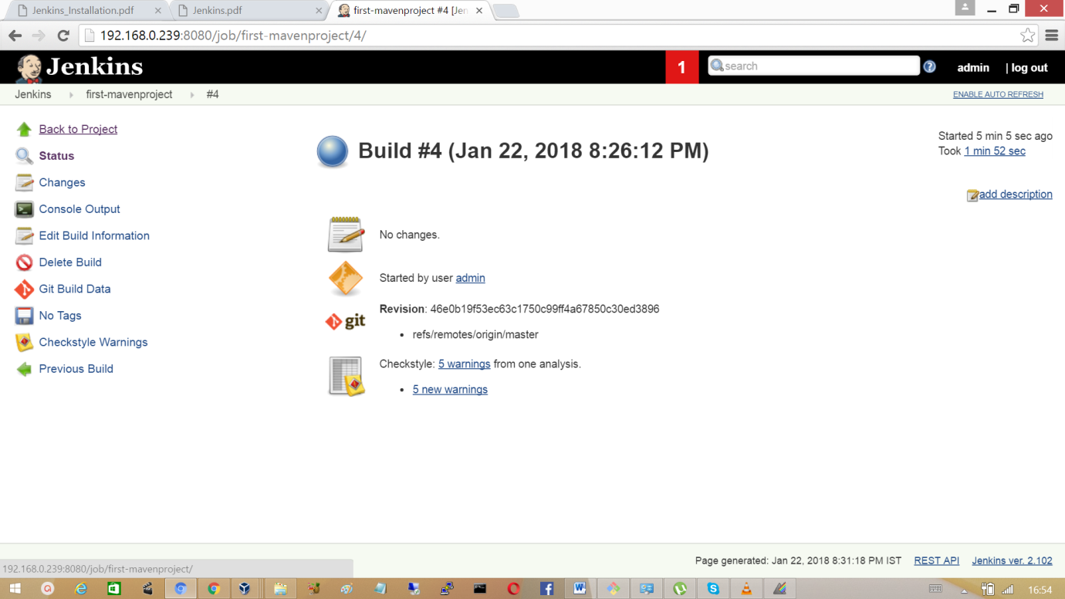Click on save and scheduled build, after the successful build attempt a new item check style warning added to the list.

Click on checkstyle warnings to find the warnings generated.

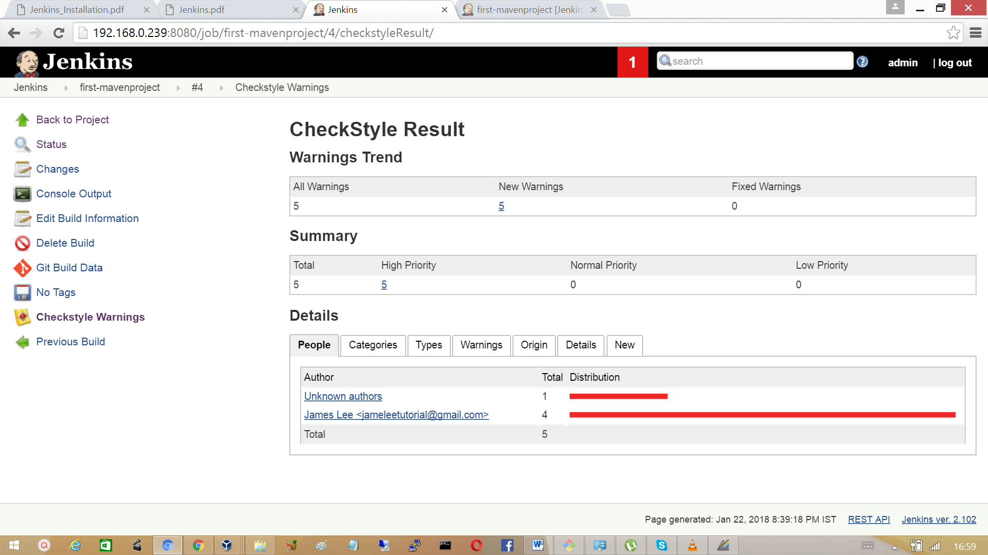

To fix the generated warnings, click on categories and click on a specific category to fix waring generated in that. For example in the category Checks, shows a warning at line no 16 of a file. Click on the file which shows code in the Jenkins UI.

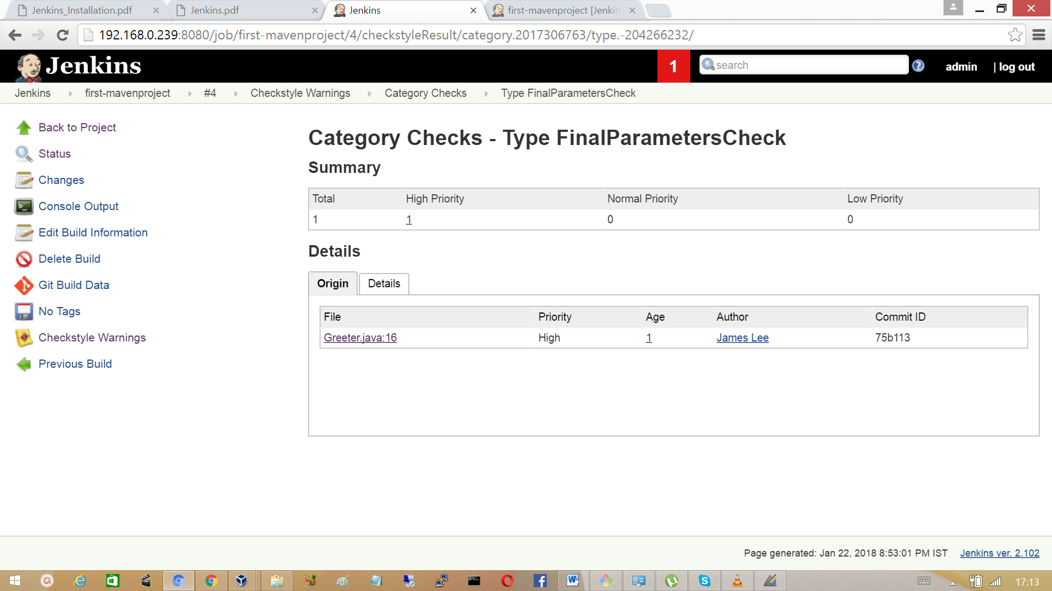

As shown in the screen shot, the line 16 is highlighted.

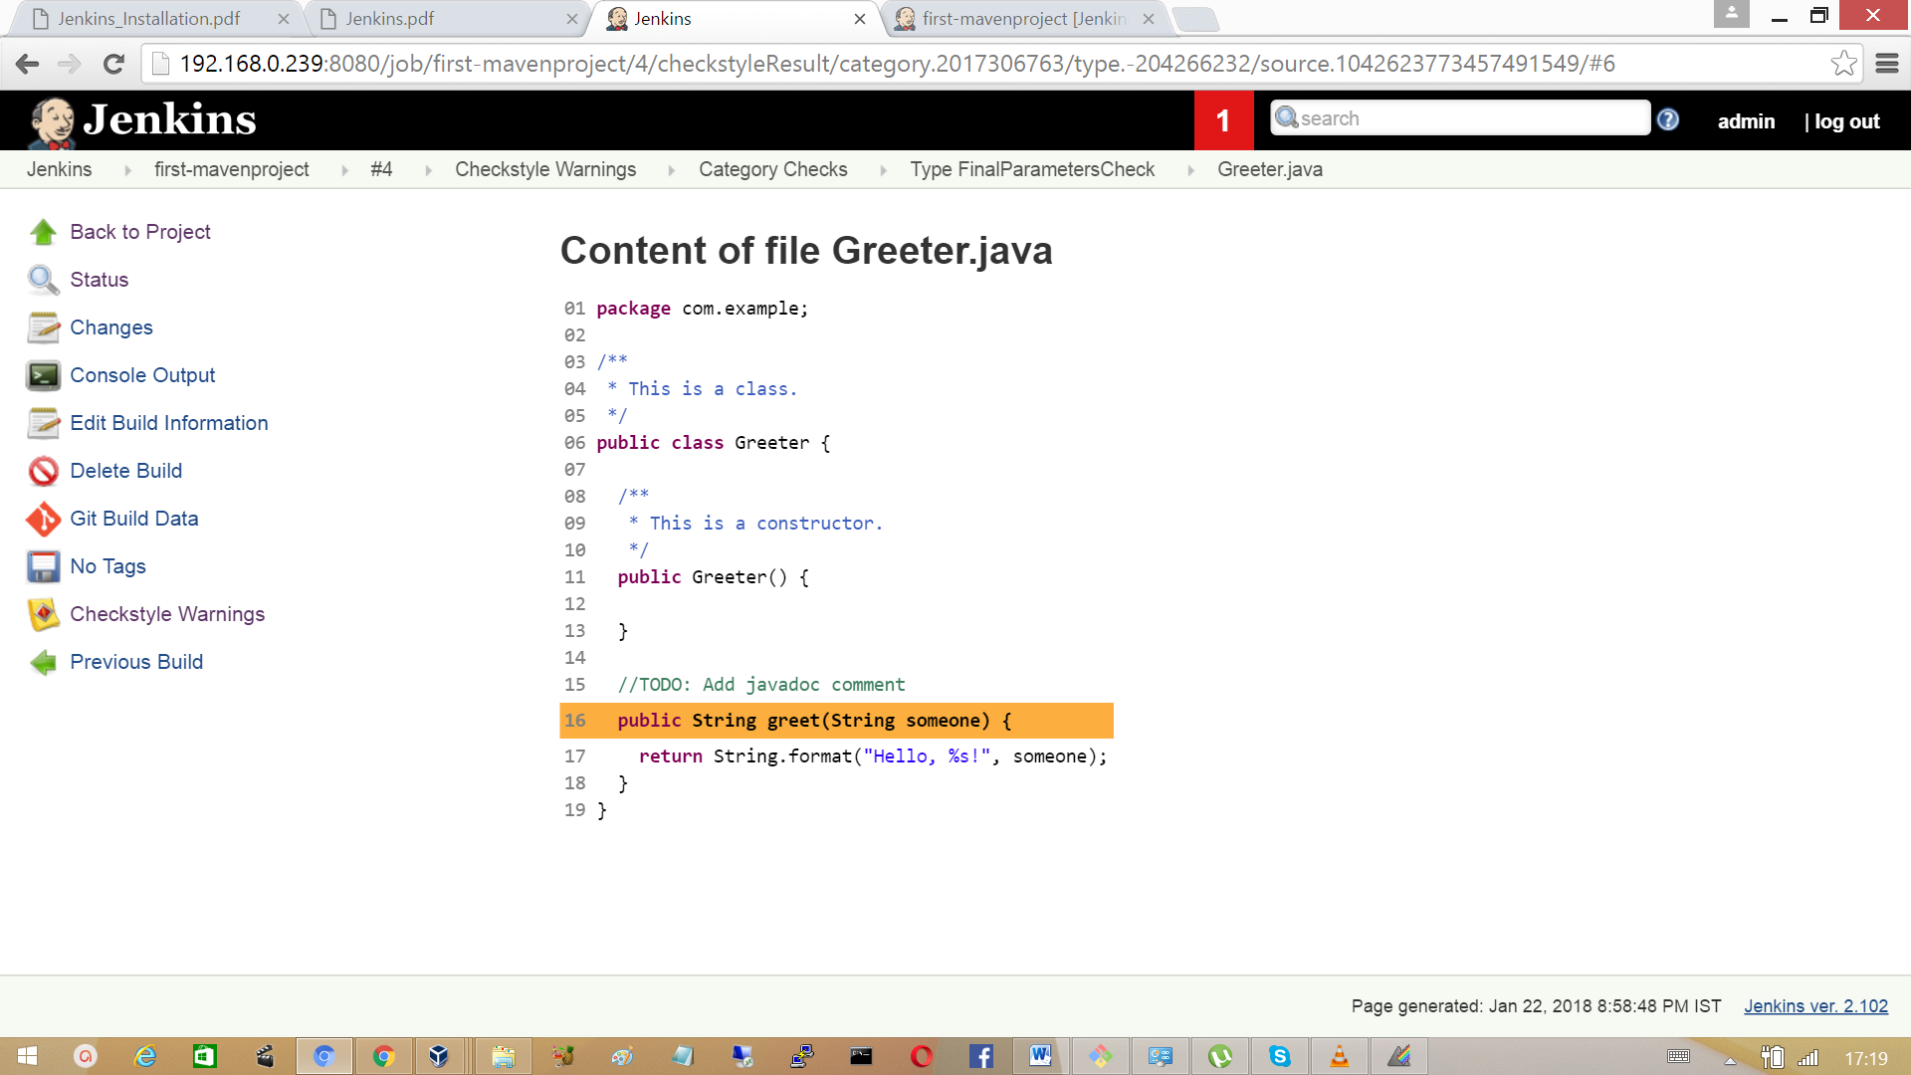

Go to the repository and modify the parameter as specified in the checkstyle warning and

push the changes to the central repository. After new build observe the Checkstyle warning has decreased in number.

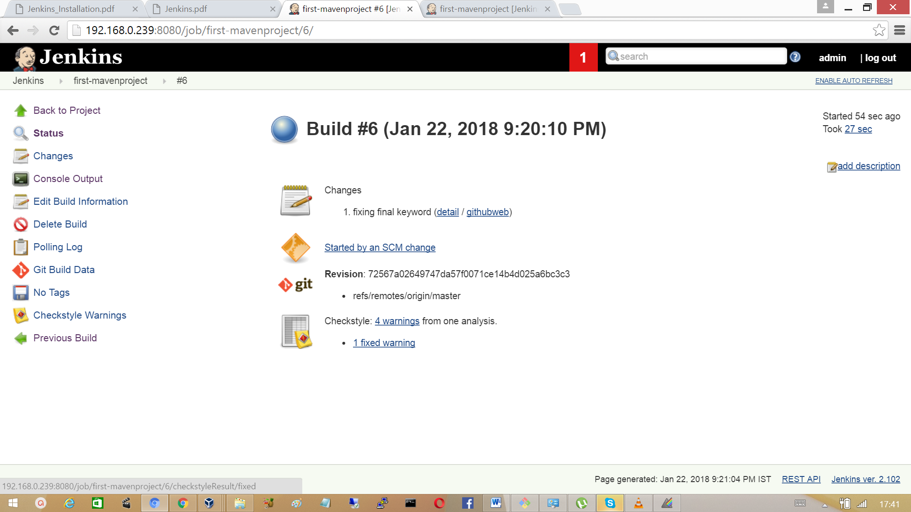

Similarly we need to fix the other 4 warnings. So, click on checkstyle warnings

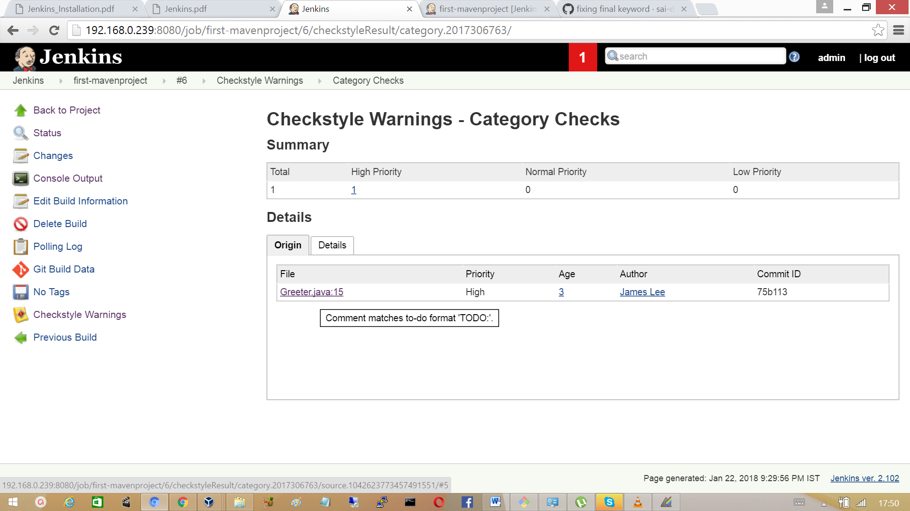

Again in the file line no 15 throws a warning, the comment was not specified properly.

Now fix the warning by removing the comment at line 15 from source in git repository.

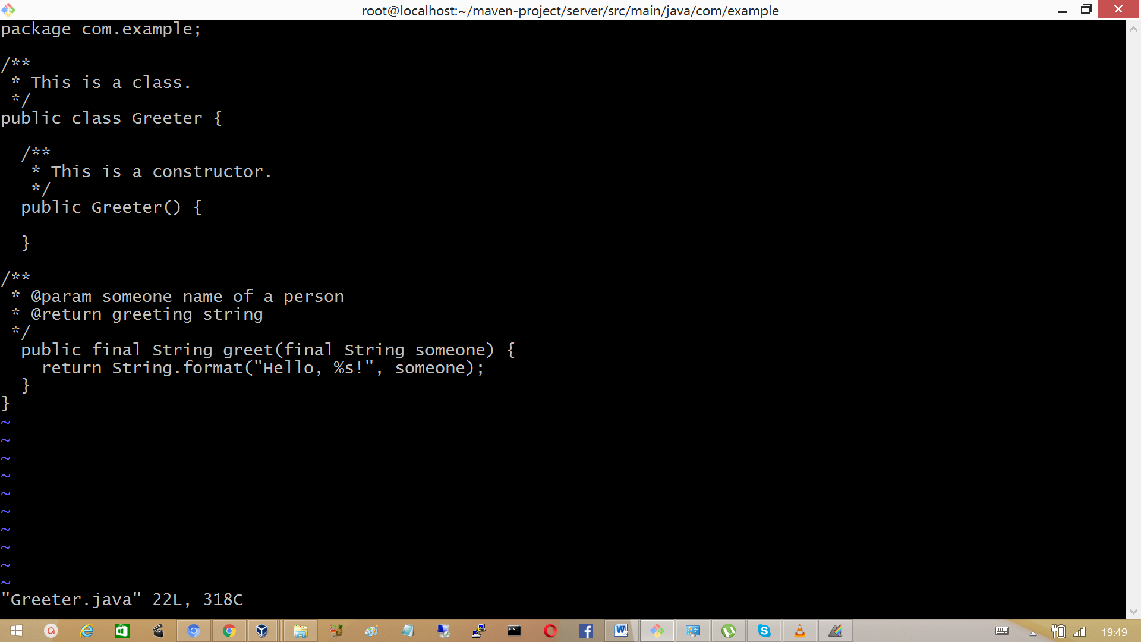

Select the next category design, the issues here is a warning is raised as method is not designed properly. Fix with the help of hint.

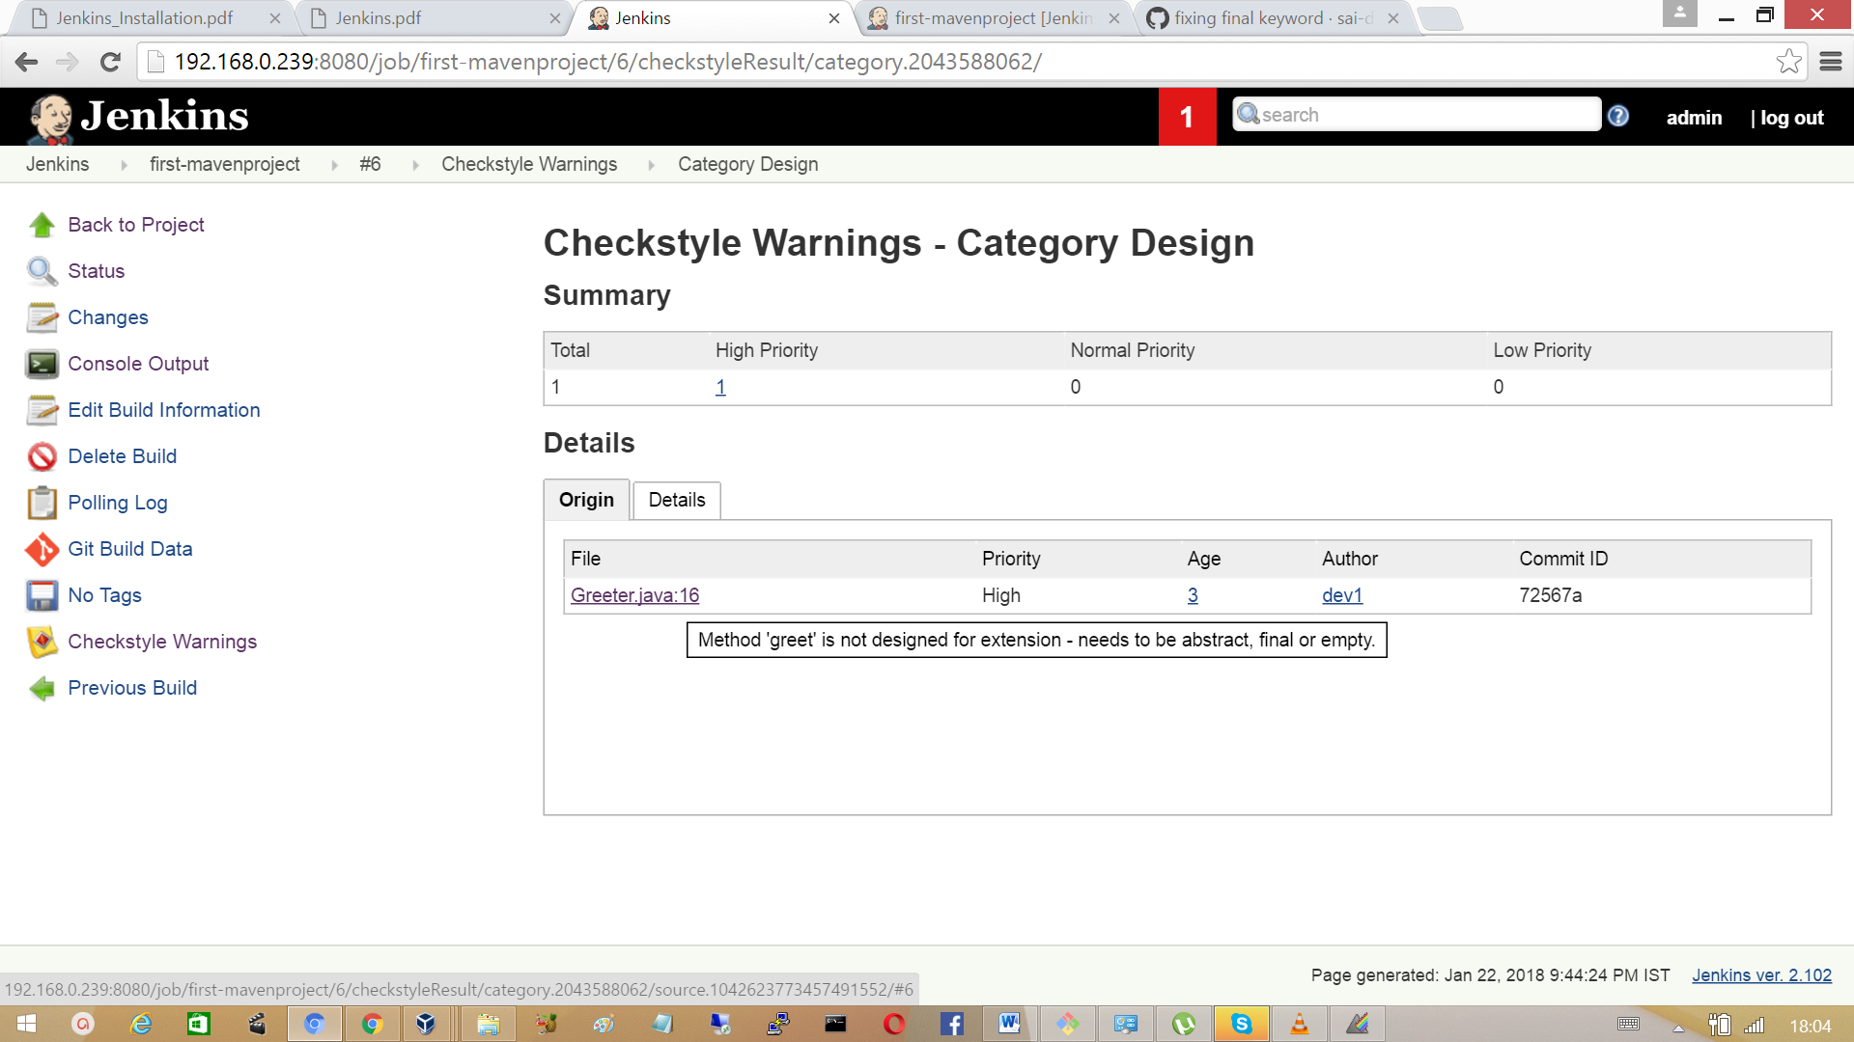

Declare the greet method as final method.



Next move the Category Javadoc and look for the warnings, fixing the warning with comment at line 16.

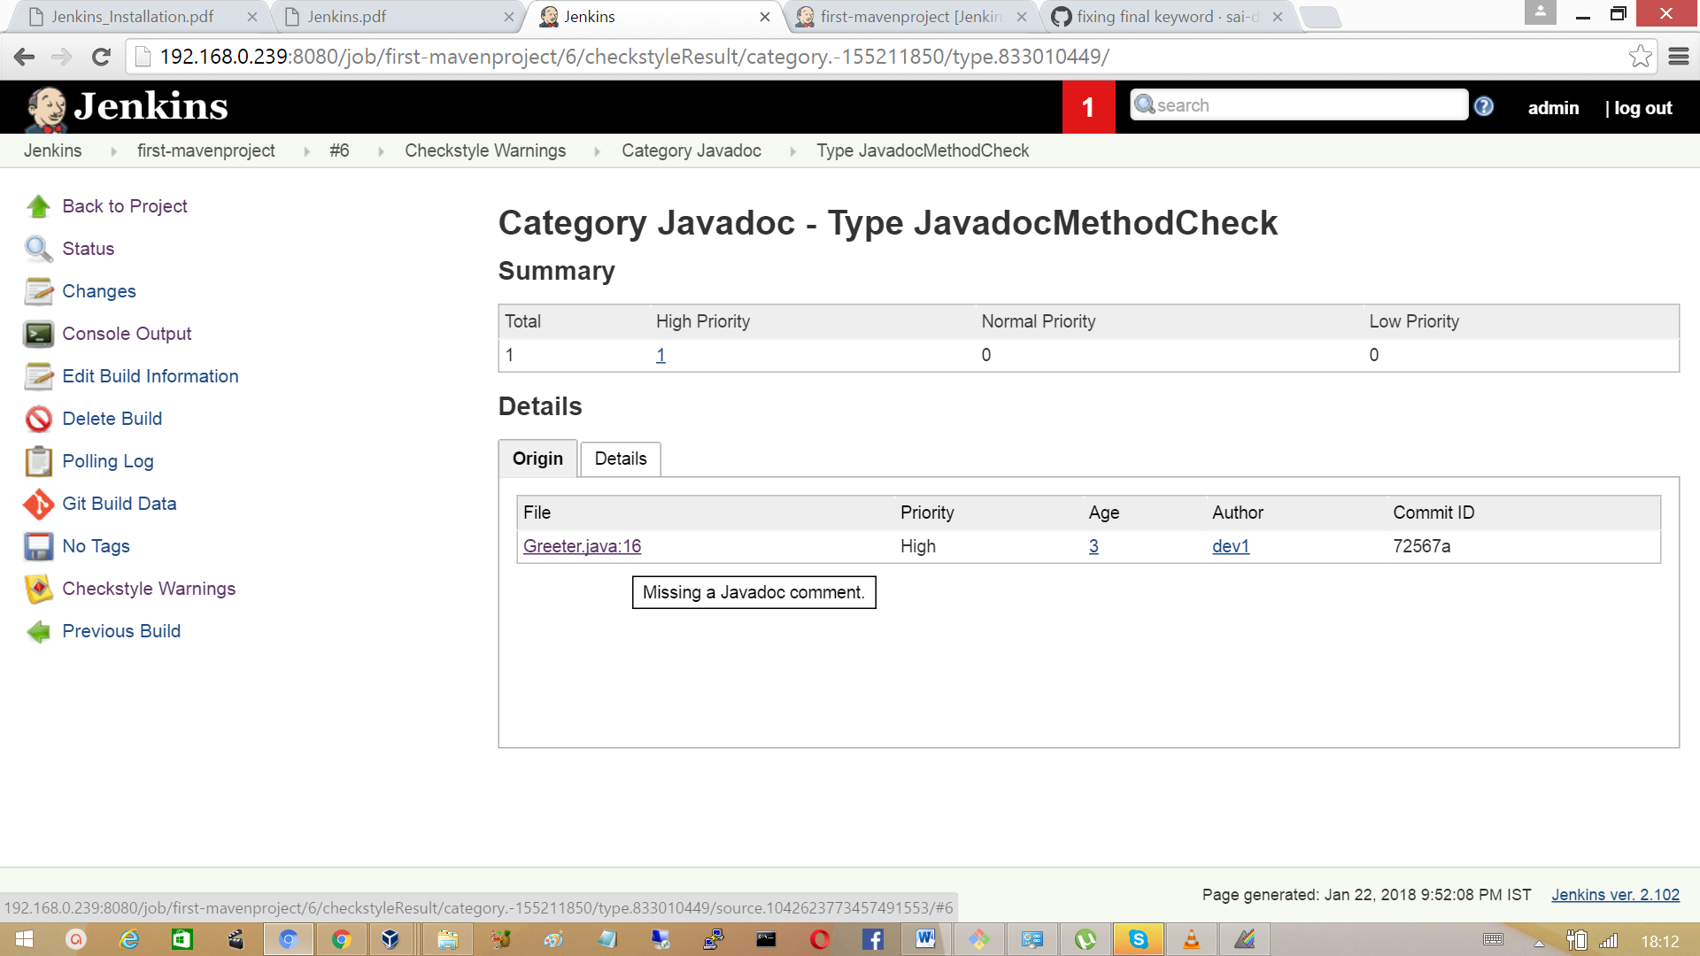

Fix the Javadoc warnings by modifying the file as shown.



Now checkout the last warning in category Javadoc shows a warning package-info file is missing.

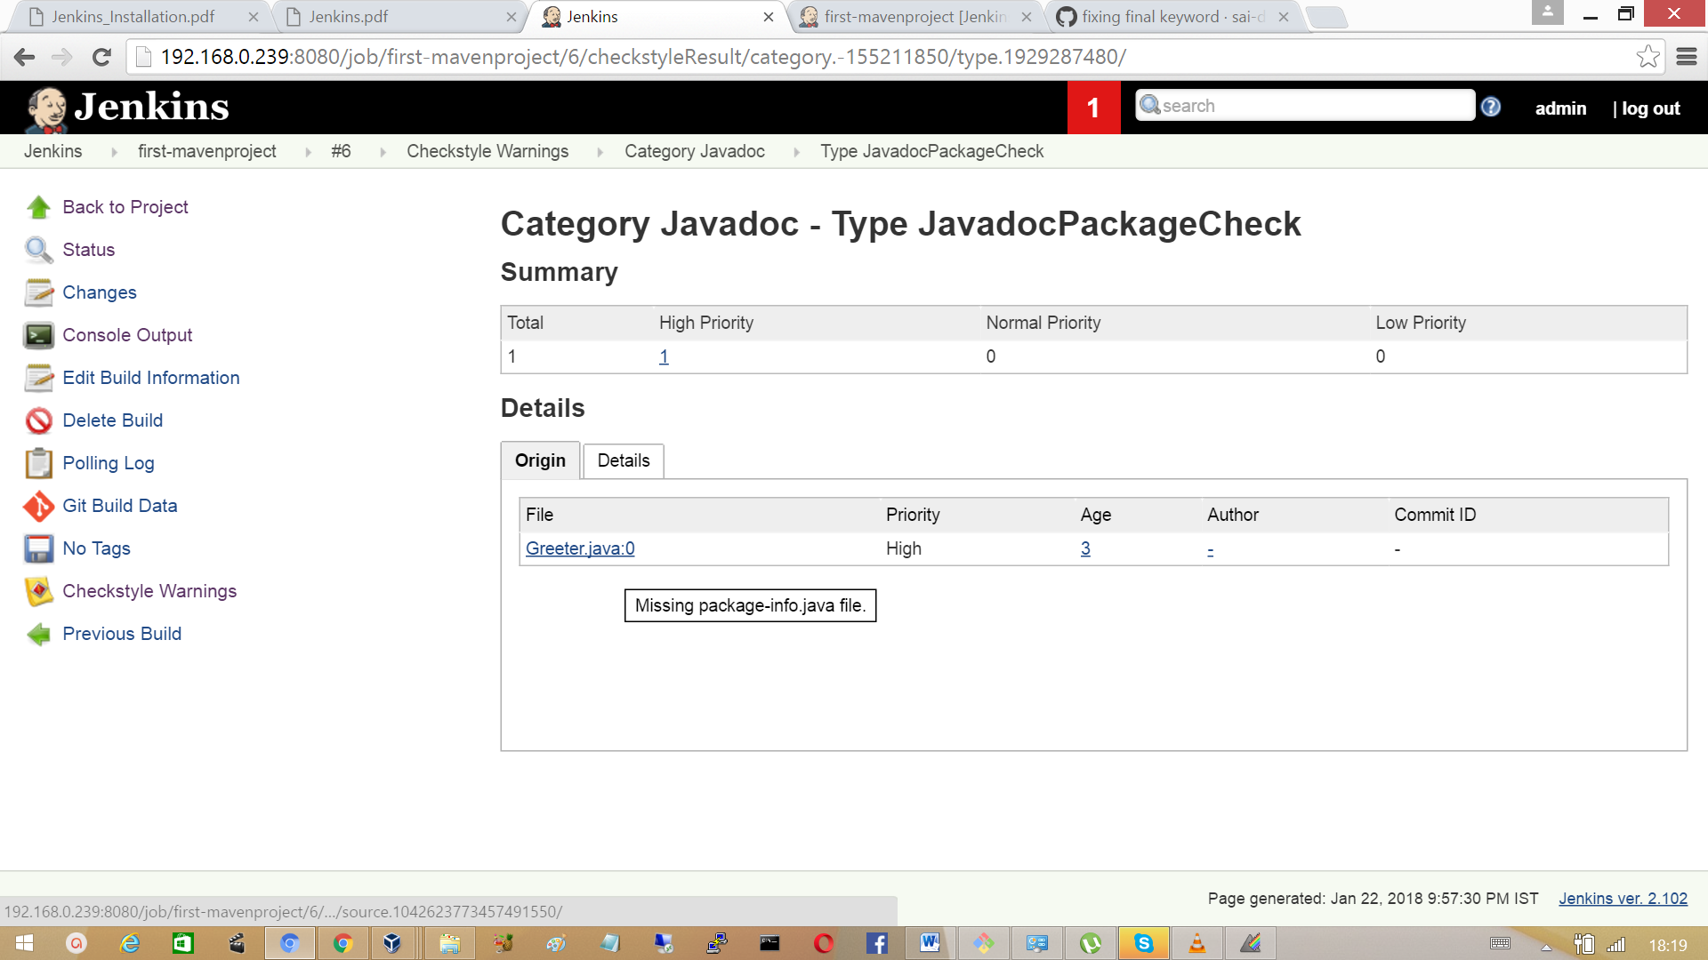

Create the file package-info.java. Push the changes to source code. Schedule the build process again.

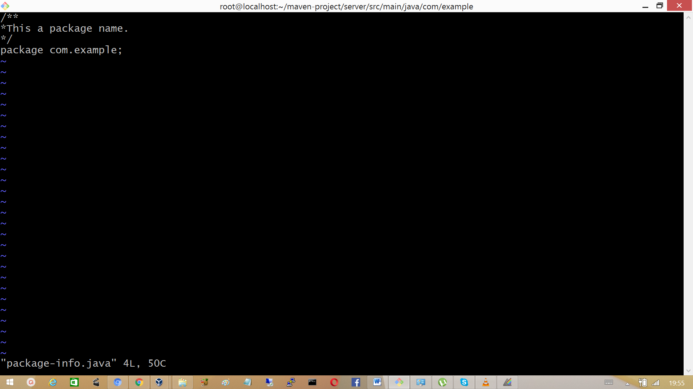

After fixing the warnings the checkstyle warning will come down to ‘zero’ in number.

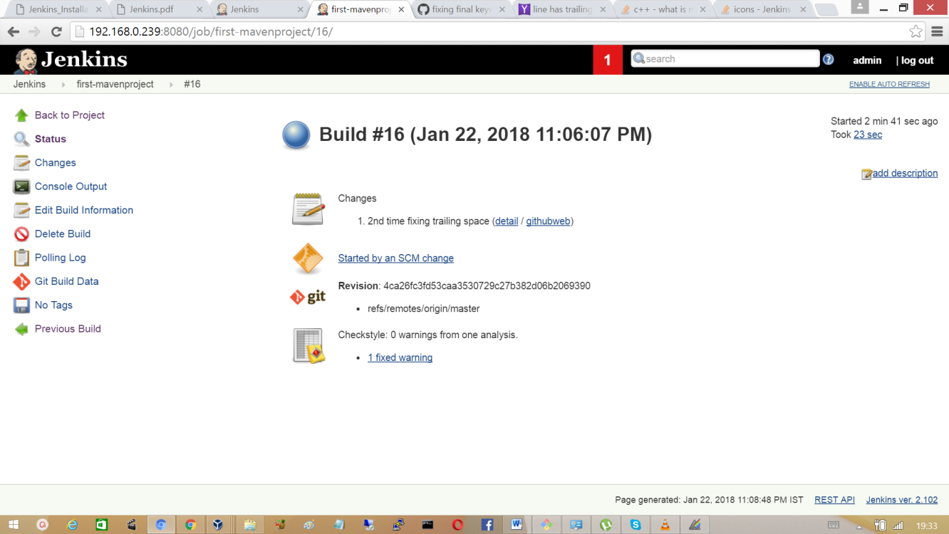

Click on Checkstyle Trend and analyse how we fixed warning over the different builds.

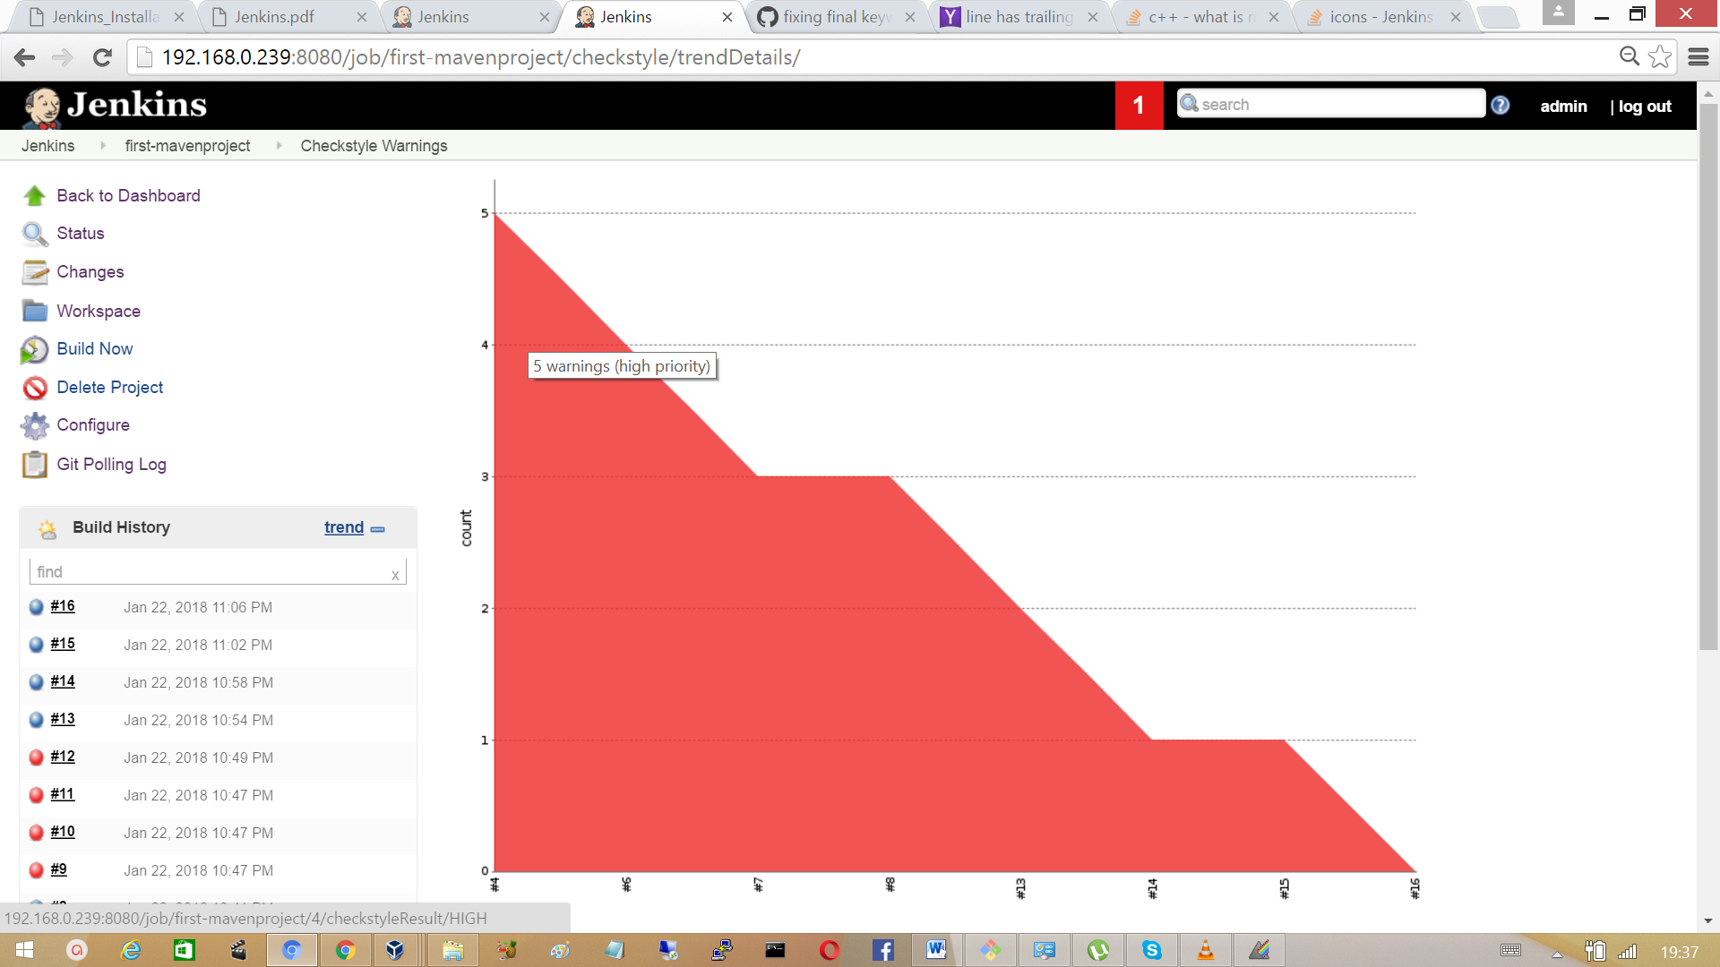

**Here are some of the Java Static Analysis tools you should know about**

PMD Java

PMD scans Java source code and looks for potential problems. Problems range from breaking naming conventions and unused code or variables to performance and complexity of code, not forgetting lots of possible.

The PMD project also supports JavaScript, PLSQL, Apache Velocity, XML and XSL. It also ships with a CPD, a tool to detect duplicated code in several languages.

**FindBugs**

FindBugs looks for bugs in Java Code, and this means over 400 different bugs. Patterns are separated into several categories: bad practice, correctness, malicious code vulnerability, multithreaded correctness, performance, security and dodgy code (two additional categories exist, with just a couple of patterns each: experimental and internationalization).

**SonarQube**

SonarQube is an open source platform for continuous inspection of code quality to perform automatic reviews with static analysis of code to detect bugs, code smells and security vulnerabilities on 20+ programing languages including java, c, C++, C#, PHP, Java Script, C, C++, python, XML etc. SonarQube offers reports on duplicated code, coding standards, unit tests, code coverage, code complexity, comments, bugs and security vulnerabilities. SonarQube can record metrics history and provides evolution graphs.

SonarQube can be integrated with build tools Maven, Ant, Gradle.

## 3.12 Archiving the Artifcats

An artifact is a file, usually a JAR that gets deployed to a Maven repository. A Maven build produces one or more artifacts, such as a compiled JAR and a "sources" JAR.

Go to configure section of the project ‘first-mavenproject’ and specifies the files to archive.

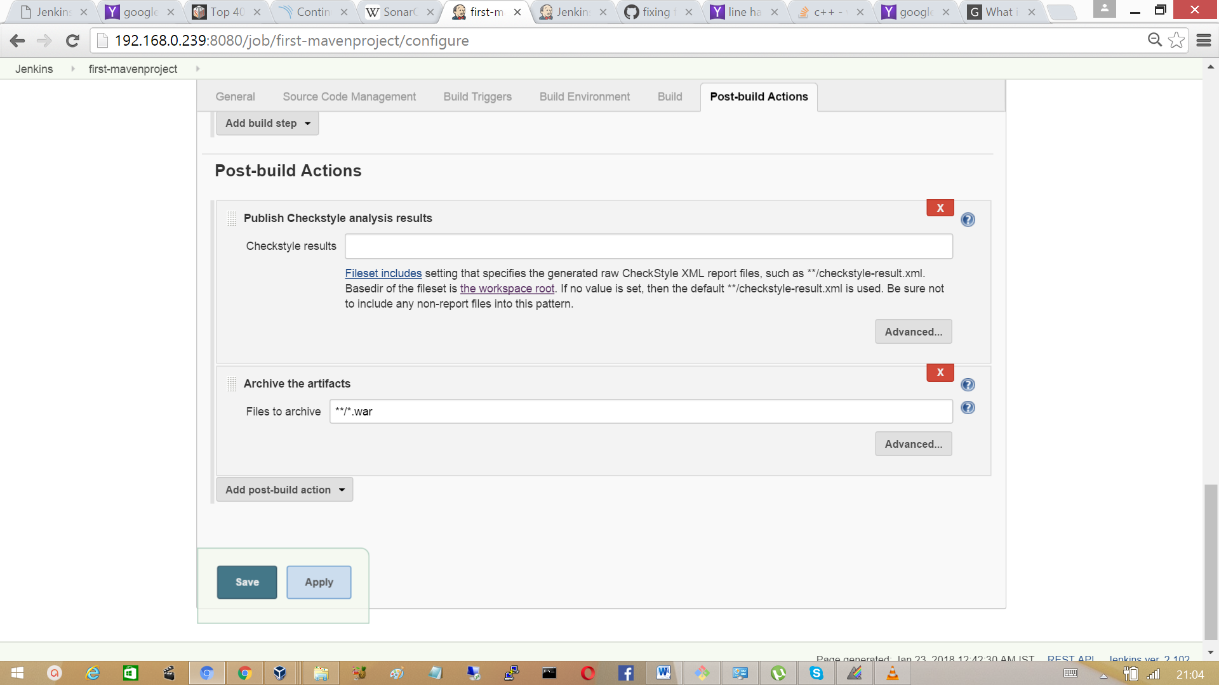

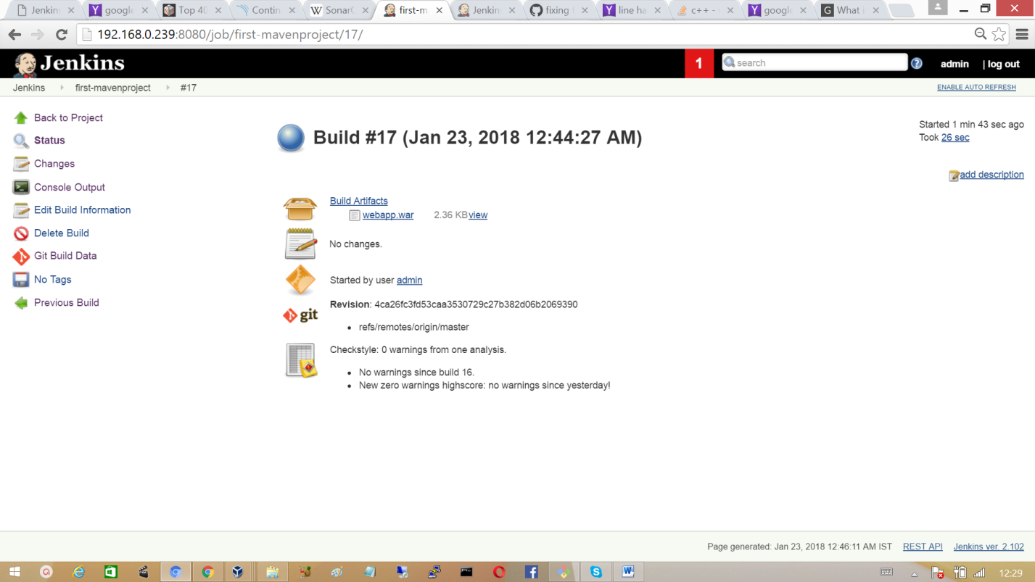Click on Save and scheduled a build, after a successful build a war file will be created.

3.12 Install and configure Tomcat as staging environment

Using the package manager ‘yum’ install the package tomcat.

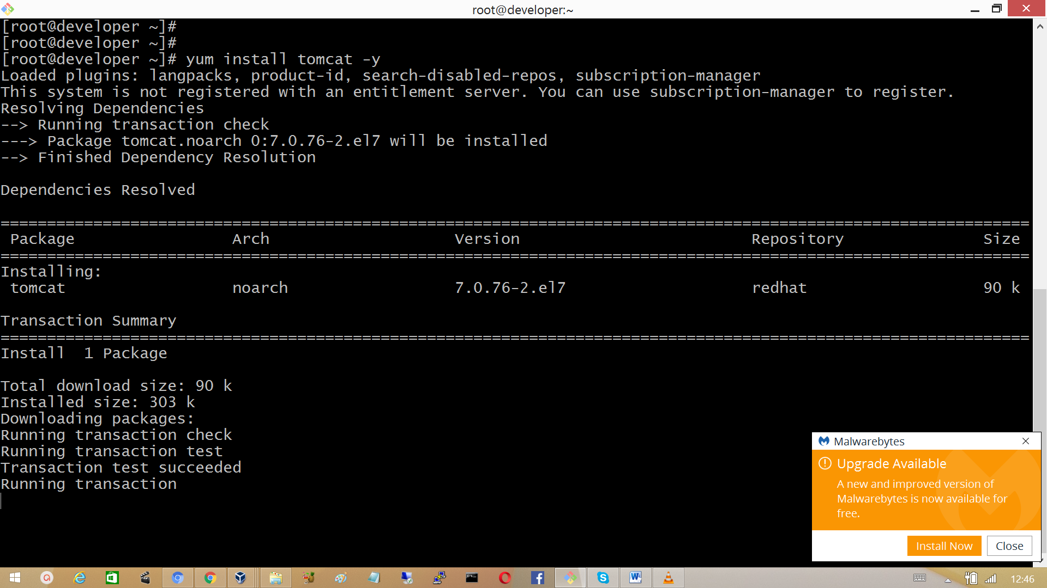

The default port for tomcat is 808. Since Jenkins already running on port 8080, we need to change the port for example to port 8090 (port cannot be used for other purpose). To dis this modify the configuration file **‘/etc/tomcat/server.xml’** as shown below.

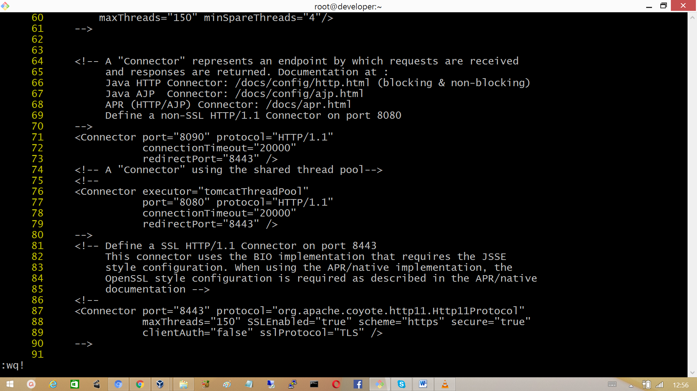

Note: Usually string ‘Connector is around line no:70 in the configuration file.Configure the roles for the user, add the roles manager-script, admin-gui by modify the configuration file ‘/etc/tomcat/tomcat-users.xml’.

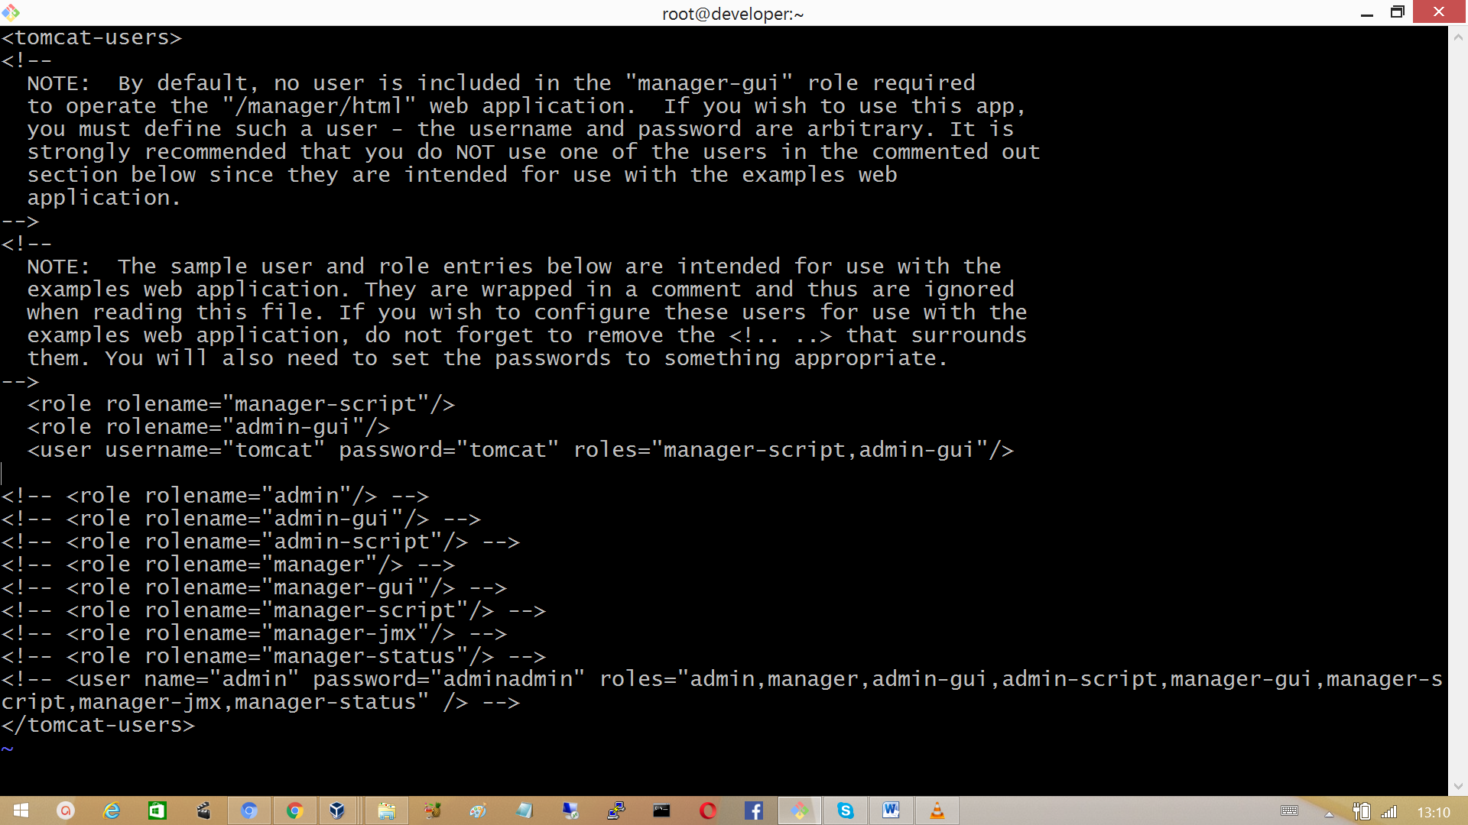

Start the service ‘tomcat’ and enable it to start automatically at boot time.

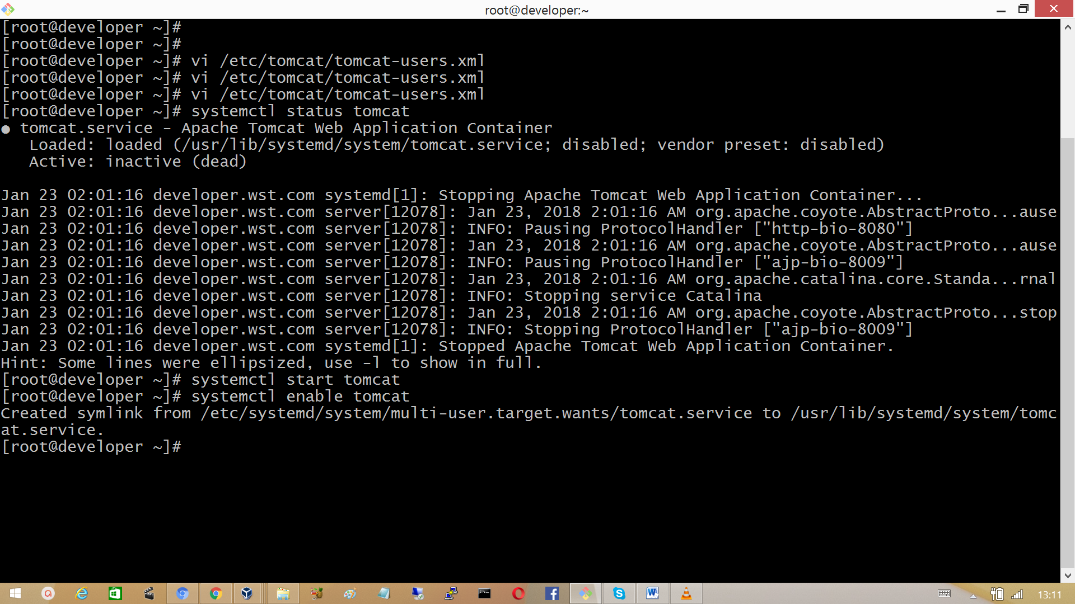

Go to browser and hit the URL, http://<tomcat-server>:8090

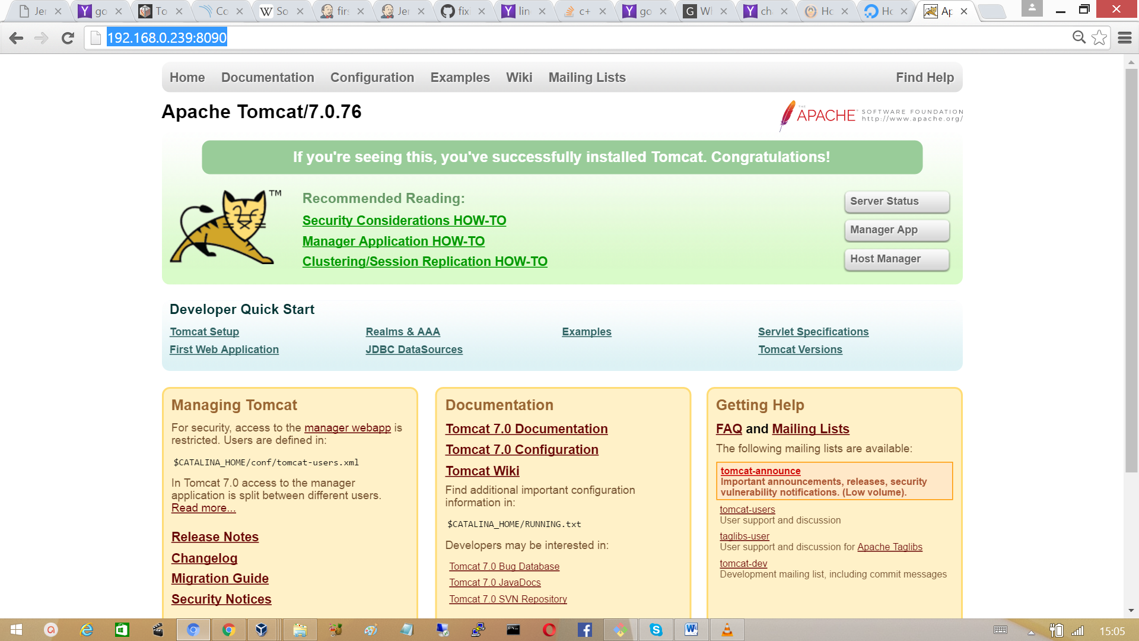

**Note:** Make sure SElinux is disabled**.** To disable modify the configuration file **/etc/sysconfig/selinux** as shown belowand reboot the system.

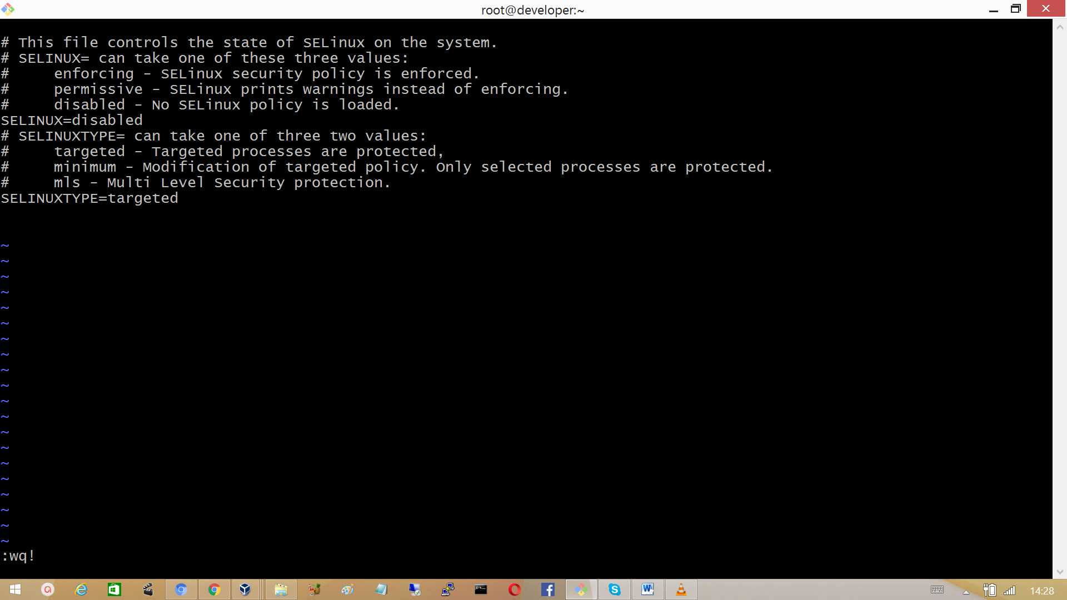

## 3.13 Install copy artifact plugin and deploy to container plugins

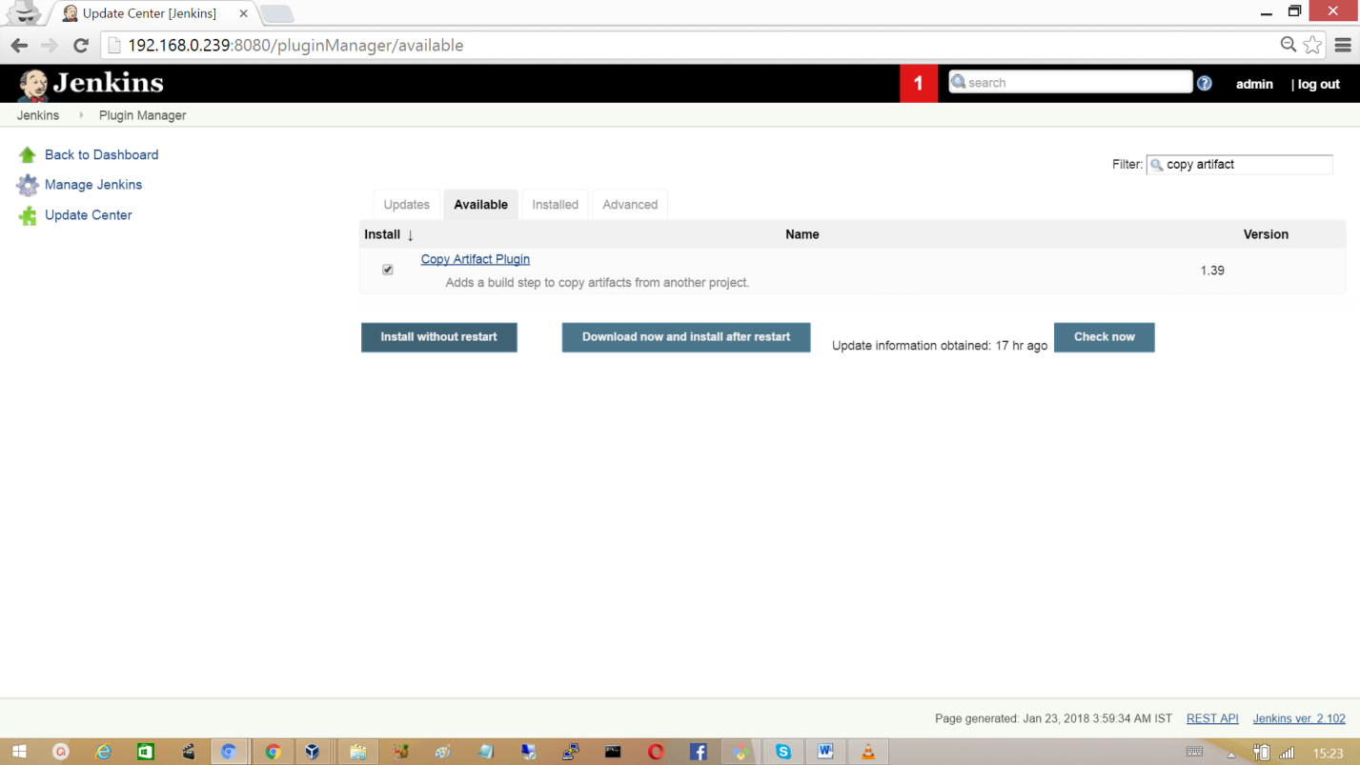Go to manage Jenkins > manage plugins and search for the ‘copy artifact plugin’ and install the plugin without restart.

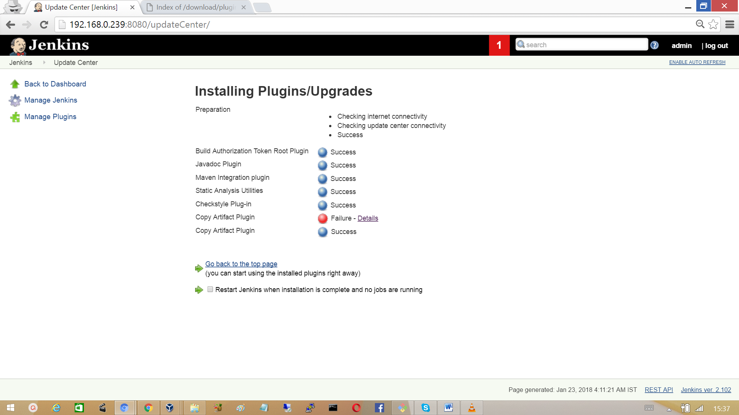

Similarly install the Deploy to container plugin

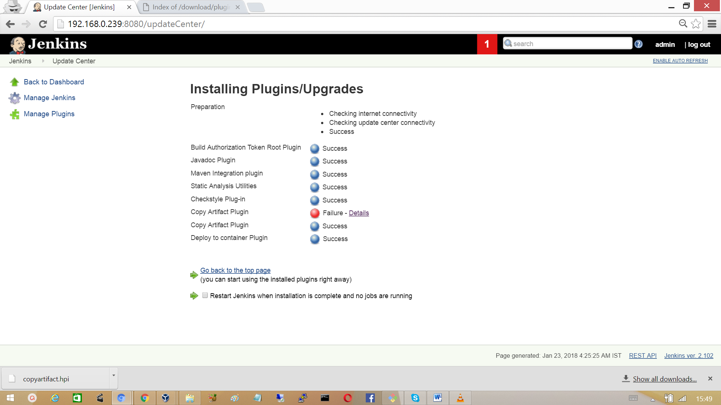

Now create another Jenkins job, to deploy the package.

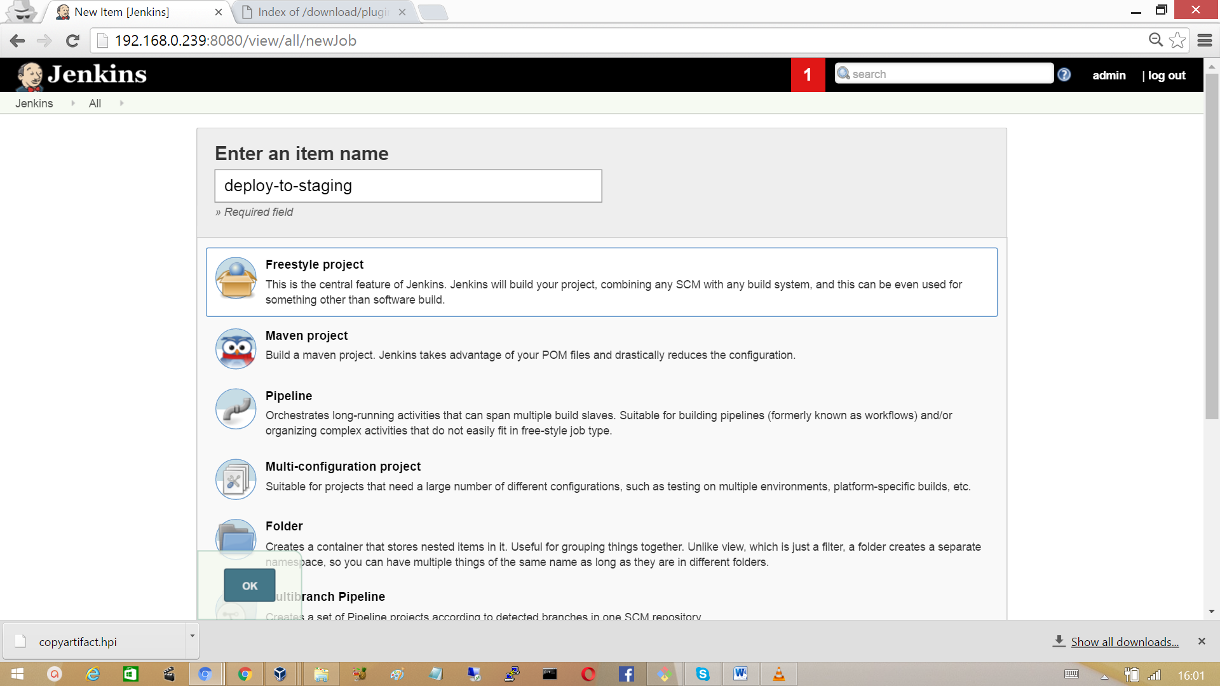

In the build section provide the project name in which artifact exists and provide the name of the artifact.

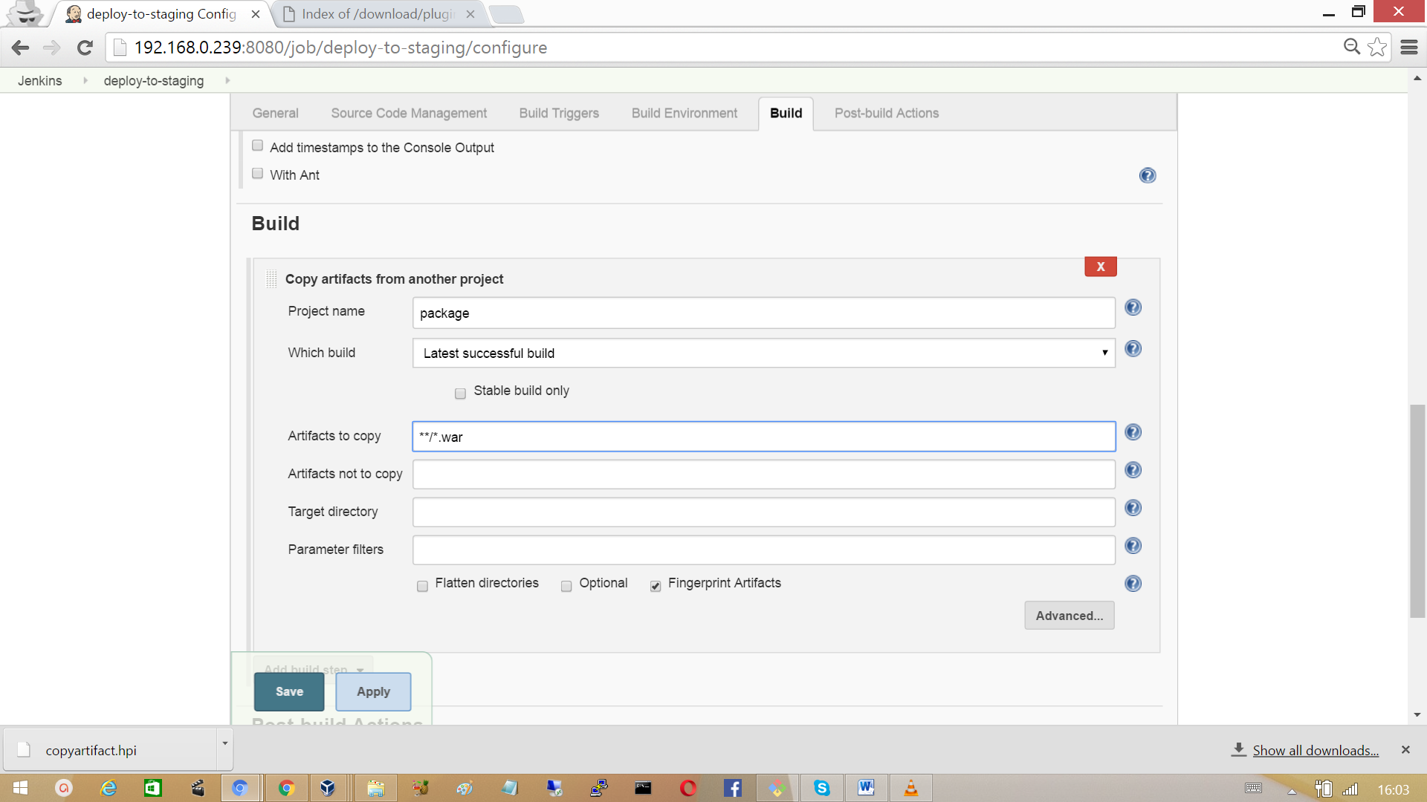

In the Post-build Actions, add tomcat credentials to deploy the artifact.

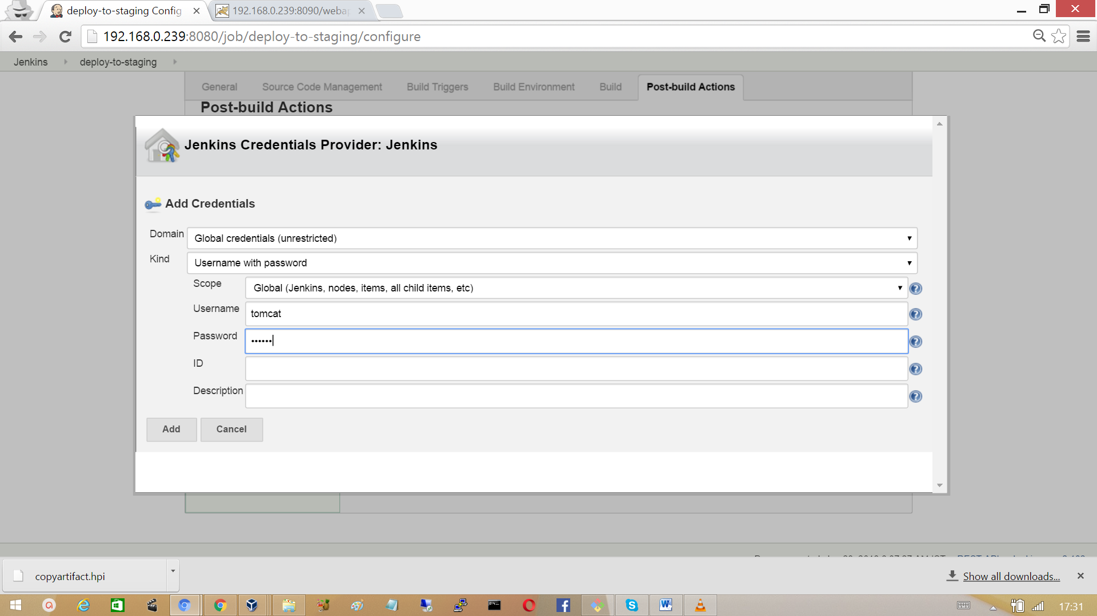

Specify the credentials and tomcat URL to run the artifact**.**

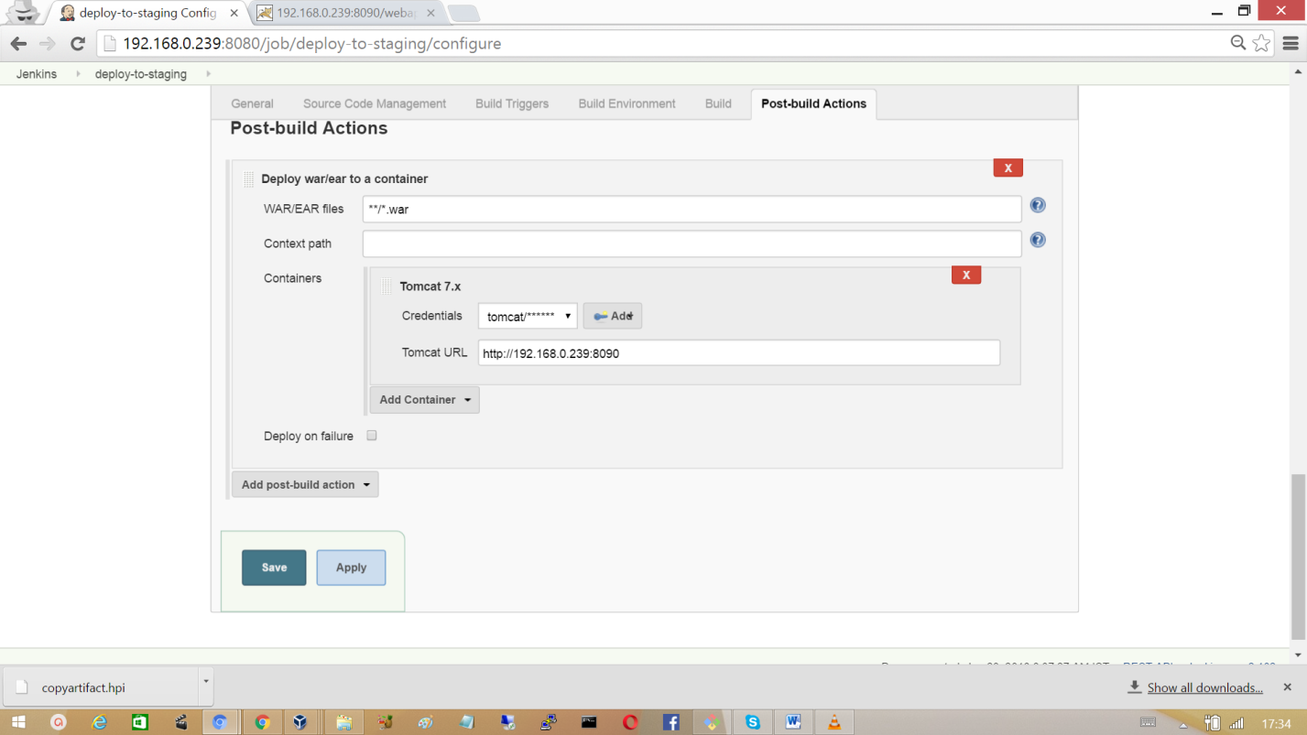

Click on Save.

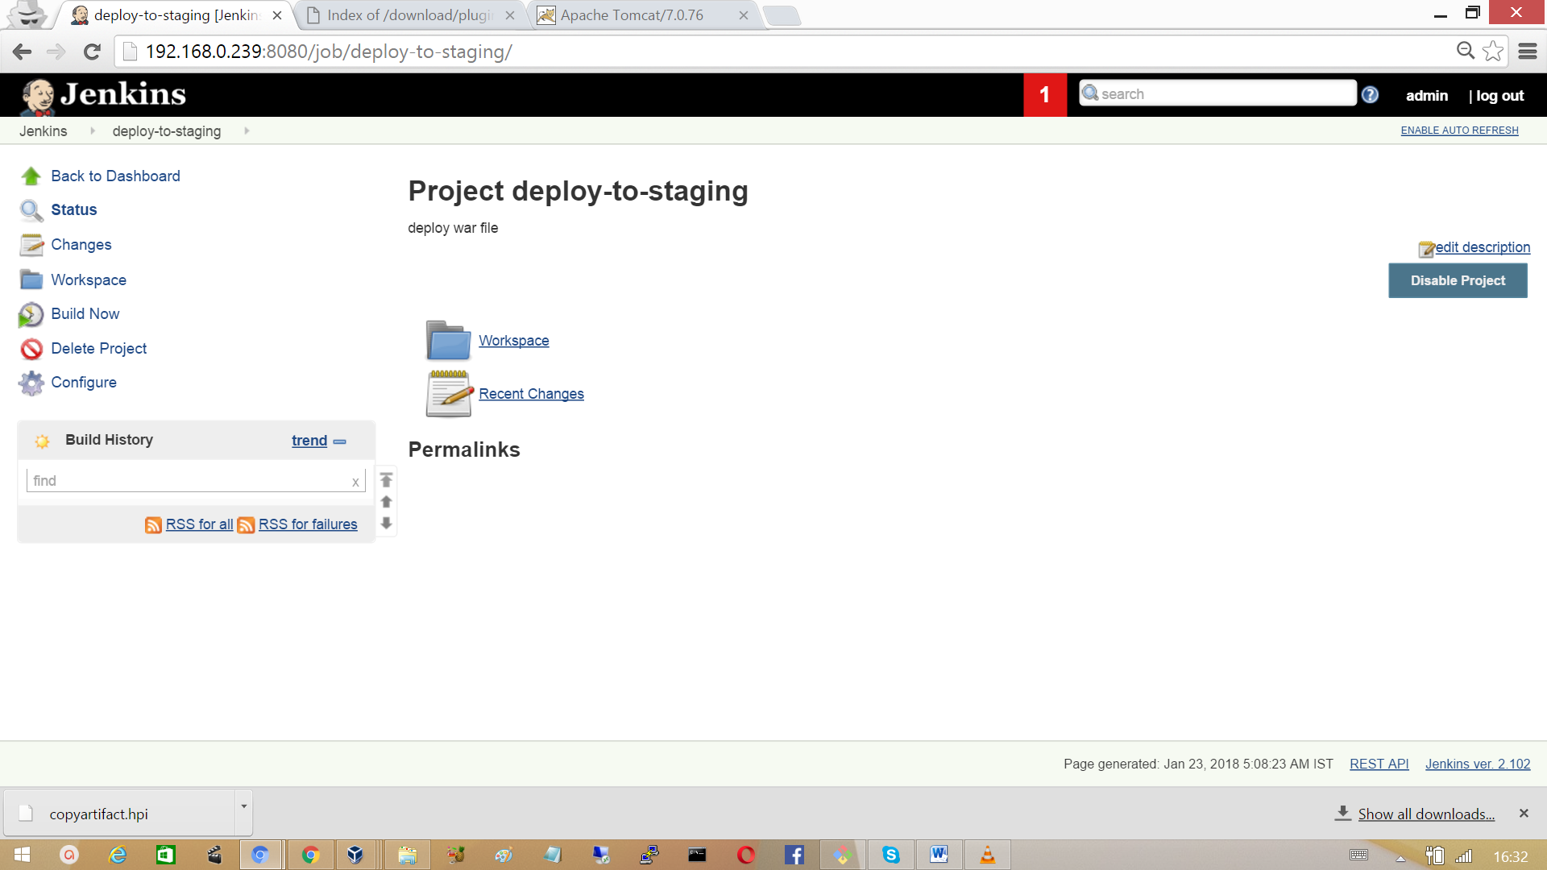

Setup post build action for the job ‘package’ to trigger the job ‘deploy-to-staging’ so that if upstream job is successful and then the build move to the staging environment.

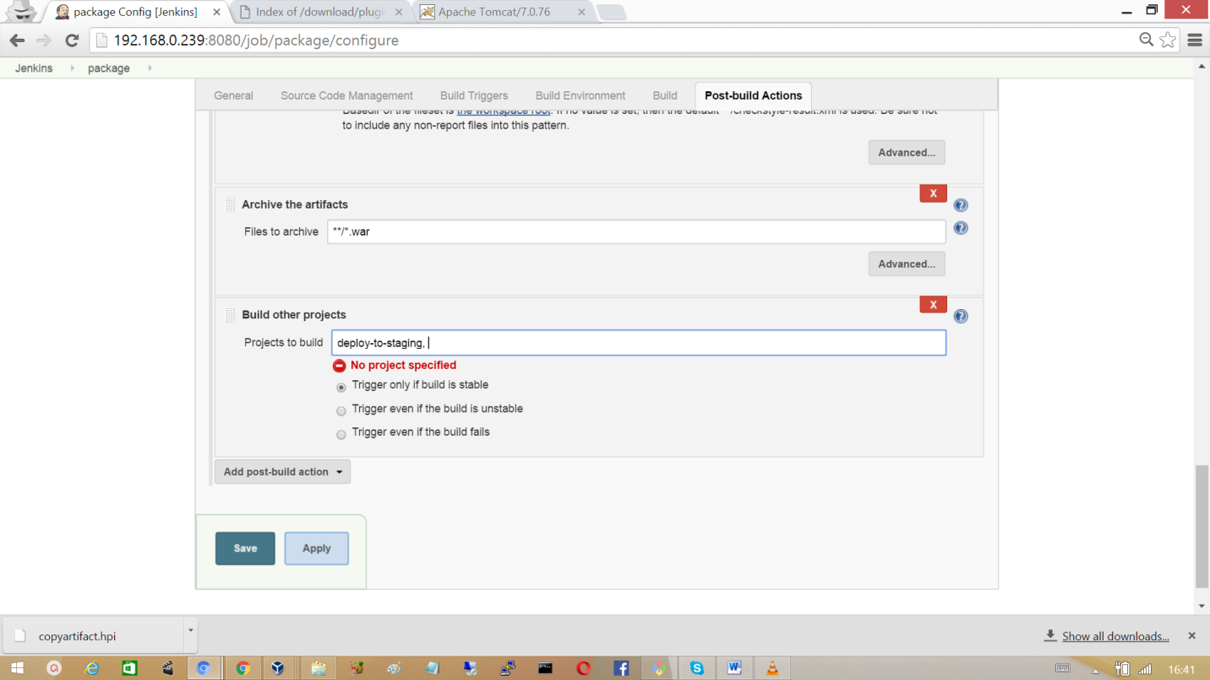

Click on Save and scheduled the build. Jenkins first runs the job ‘package’ and only after successful build it triggers the ‘deploy-to-stage’.  
After the successful build Jenkins deploy the artifact to tomcat server.

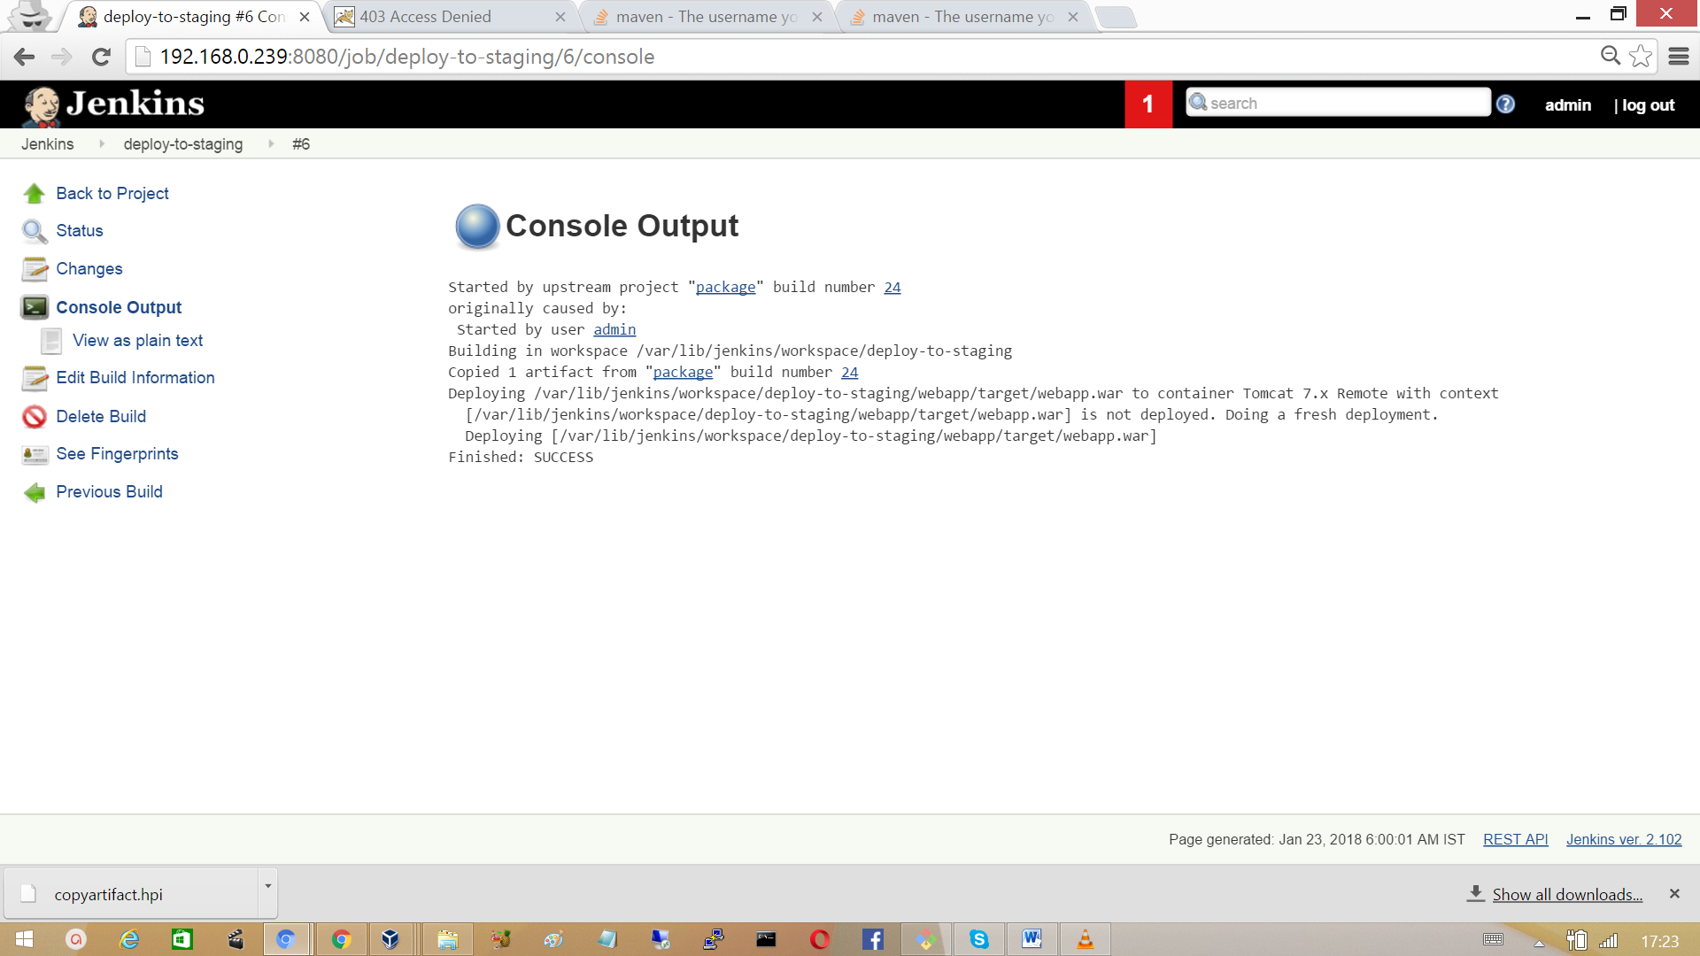

Hit the URL http://<tomcat-server>:8090/webapp in the browser and verify whether the war file deployed successfully.

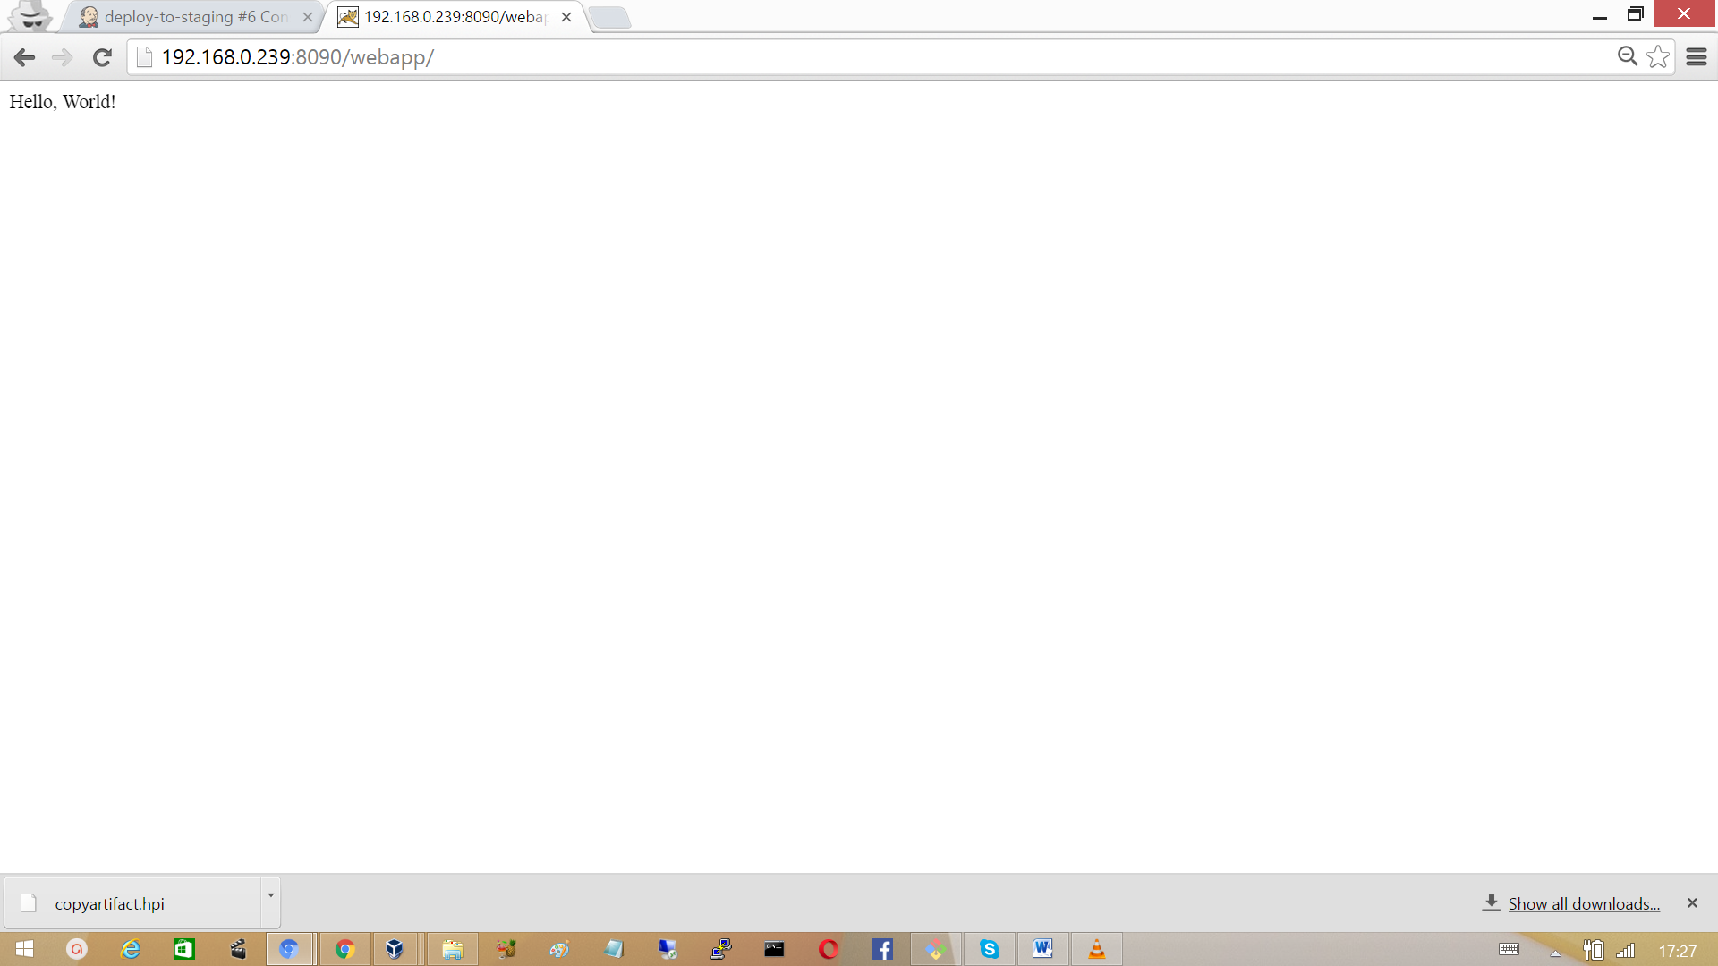

## 3.14 Jenkins Build Pipeline

Build Pipeline plugin provides Build Pipeline View of upstream and downstream connected jobs that typically form a build pipeline. In addition, it offers the ability to define manual triggers for jobs that require.

Install the plugin ‘Build Pipeline’

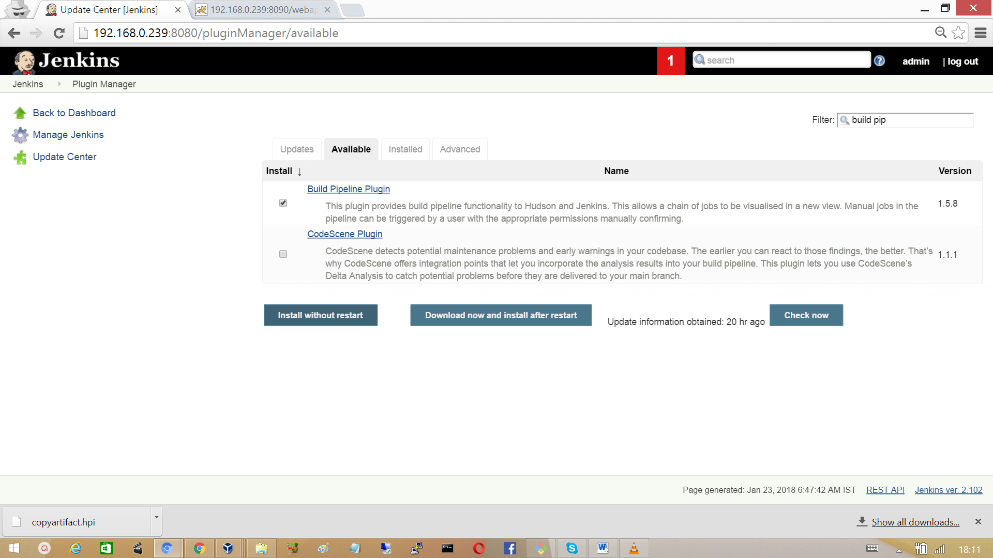

Go back to dashboard and click on ‘+’ to provide the view name for the build pipeline

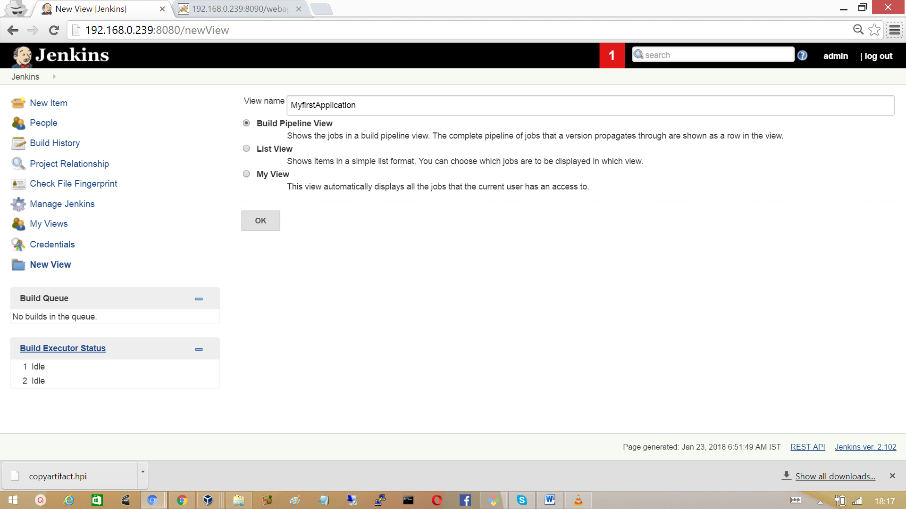

Select the initial job in the build pipe line.

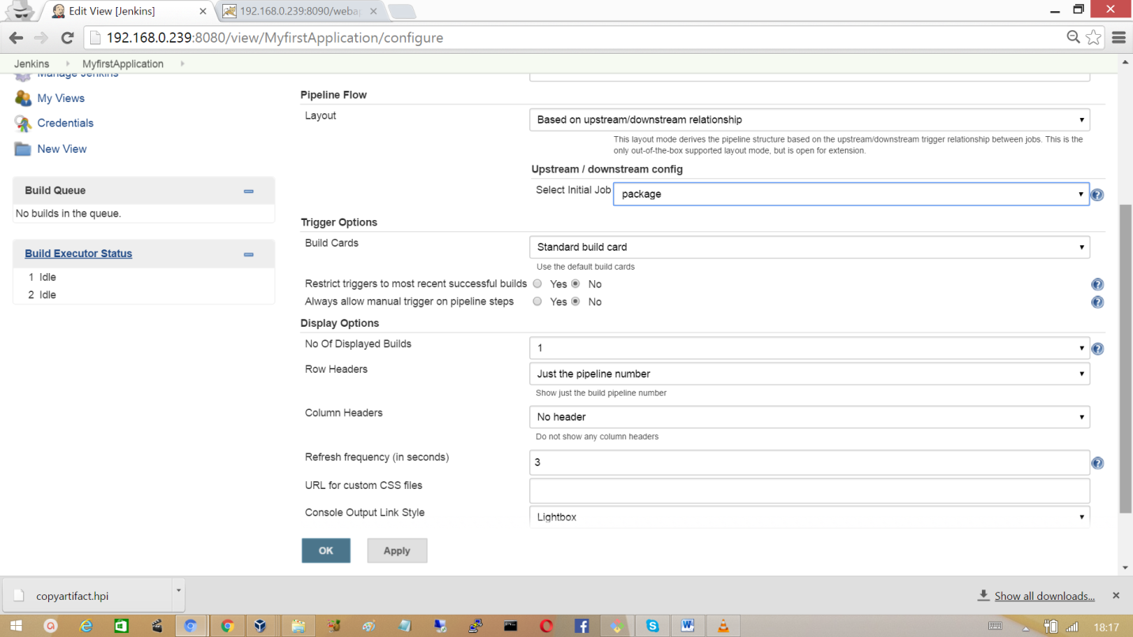

**Go back to Jenkins dashboard and click on the ‘MyfirstApplicaton’ to view the pipeline**

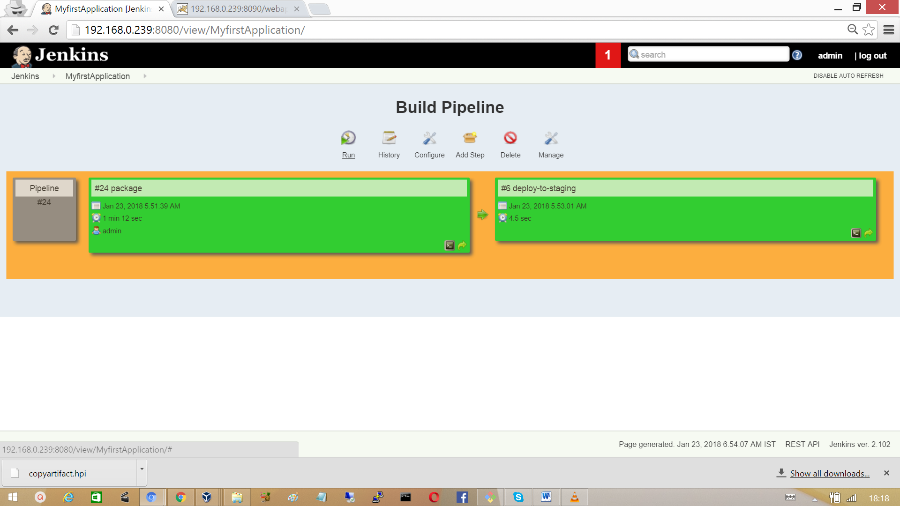

The following is the build pipeline of the project

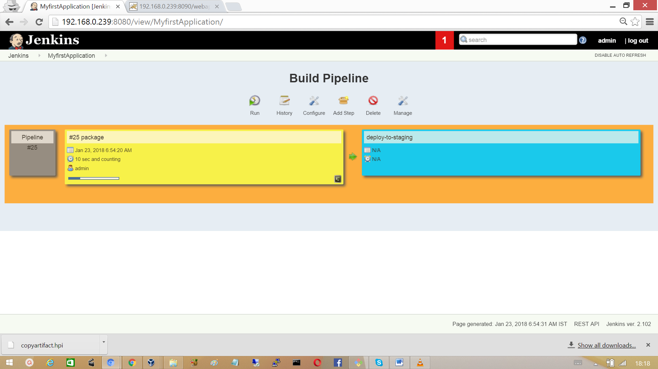

**Parallel Jenkins Build**

In this example we trigger the job static analysis of source code in parallel with the staging of the project.

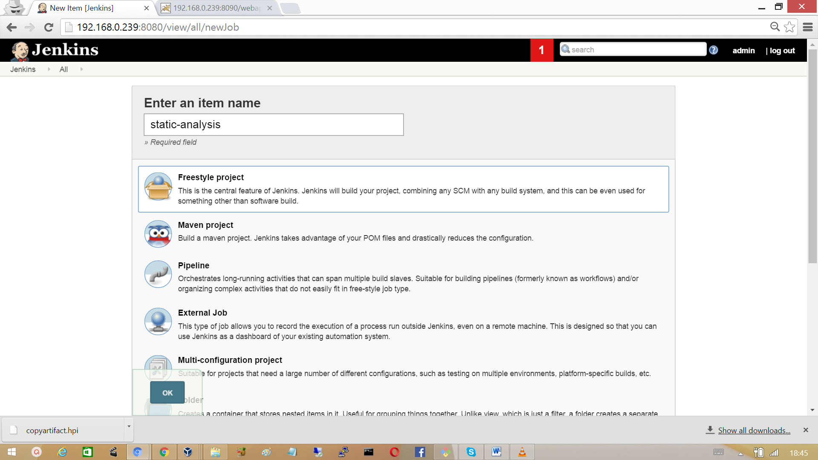

Provide the URL of git repository in Source Code Management section.

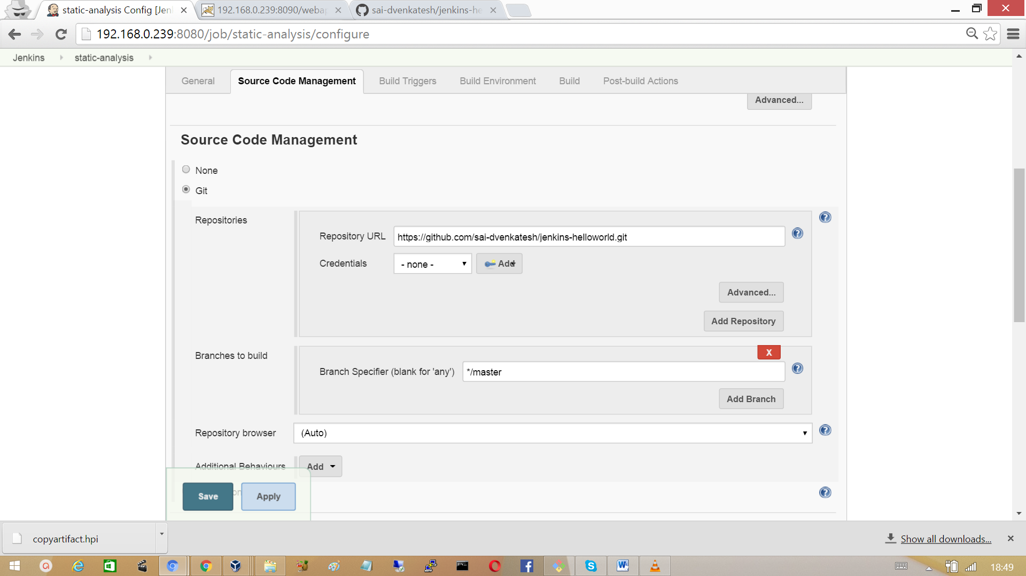

In the Build section invoke top-level Maven targets and the goal to checkstyle.

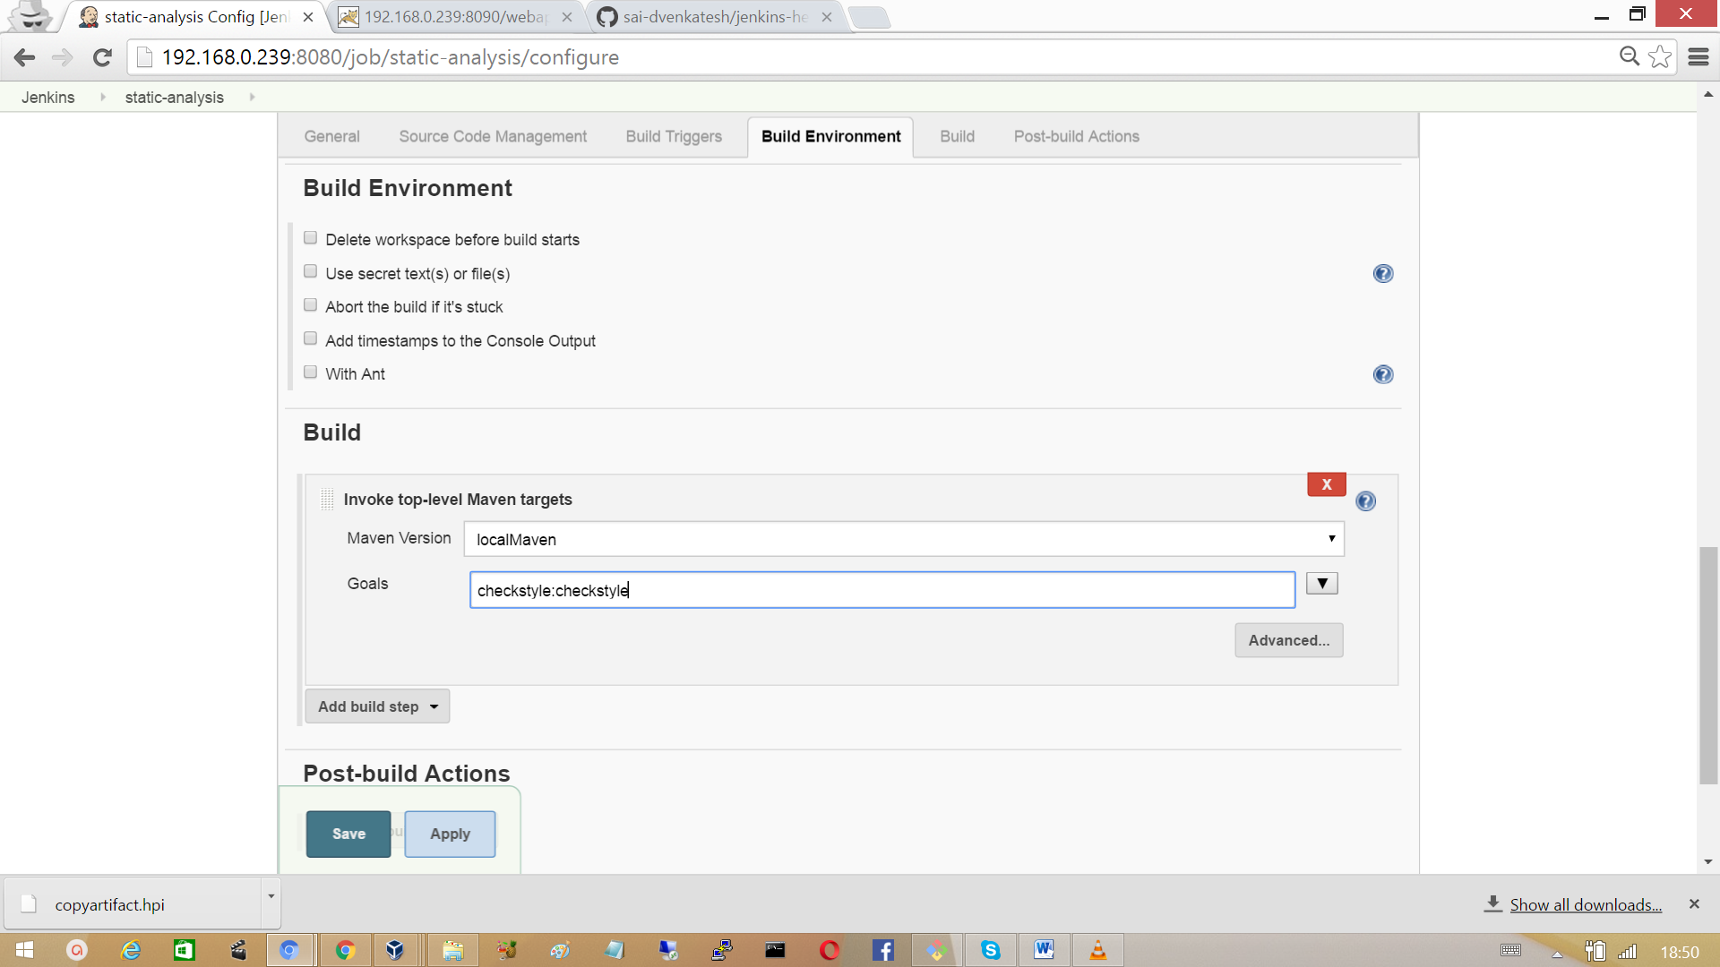

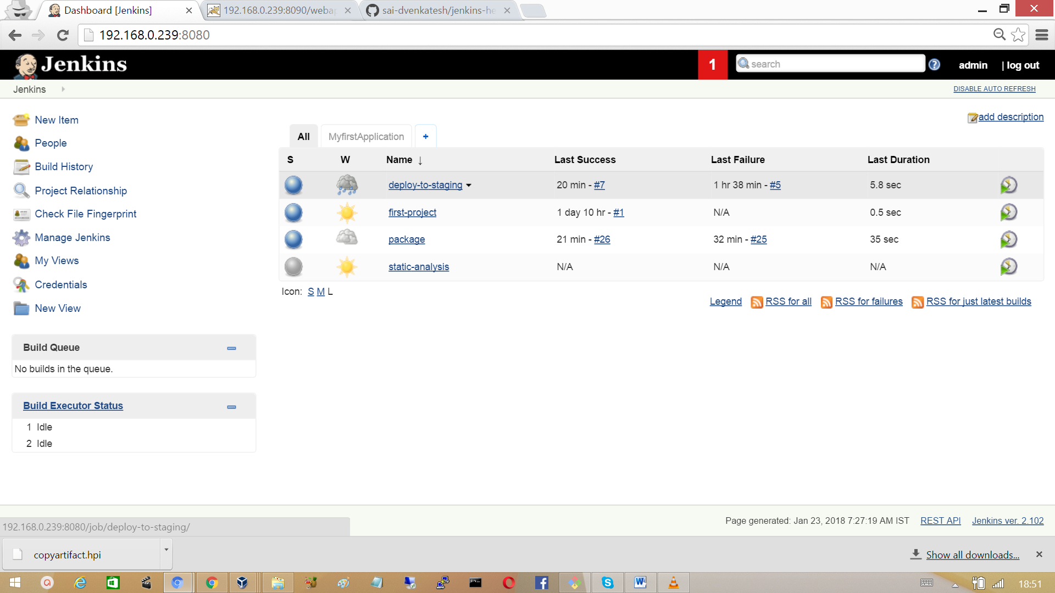

In the build pipeline view ‘MyfirstApplication’, run the build pipeline and observe that the jobs are staging and static analysis are running in parallel.

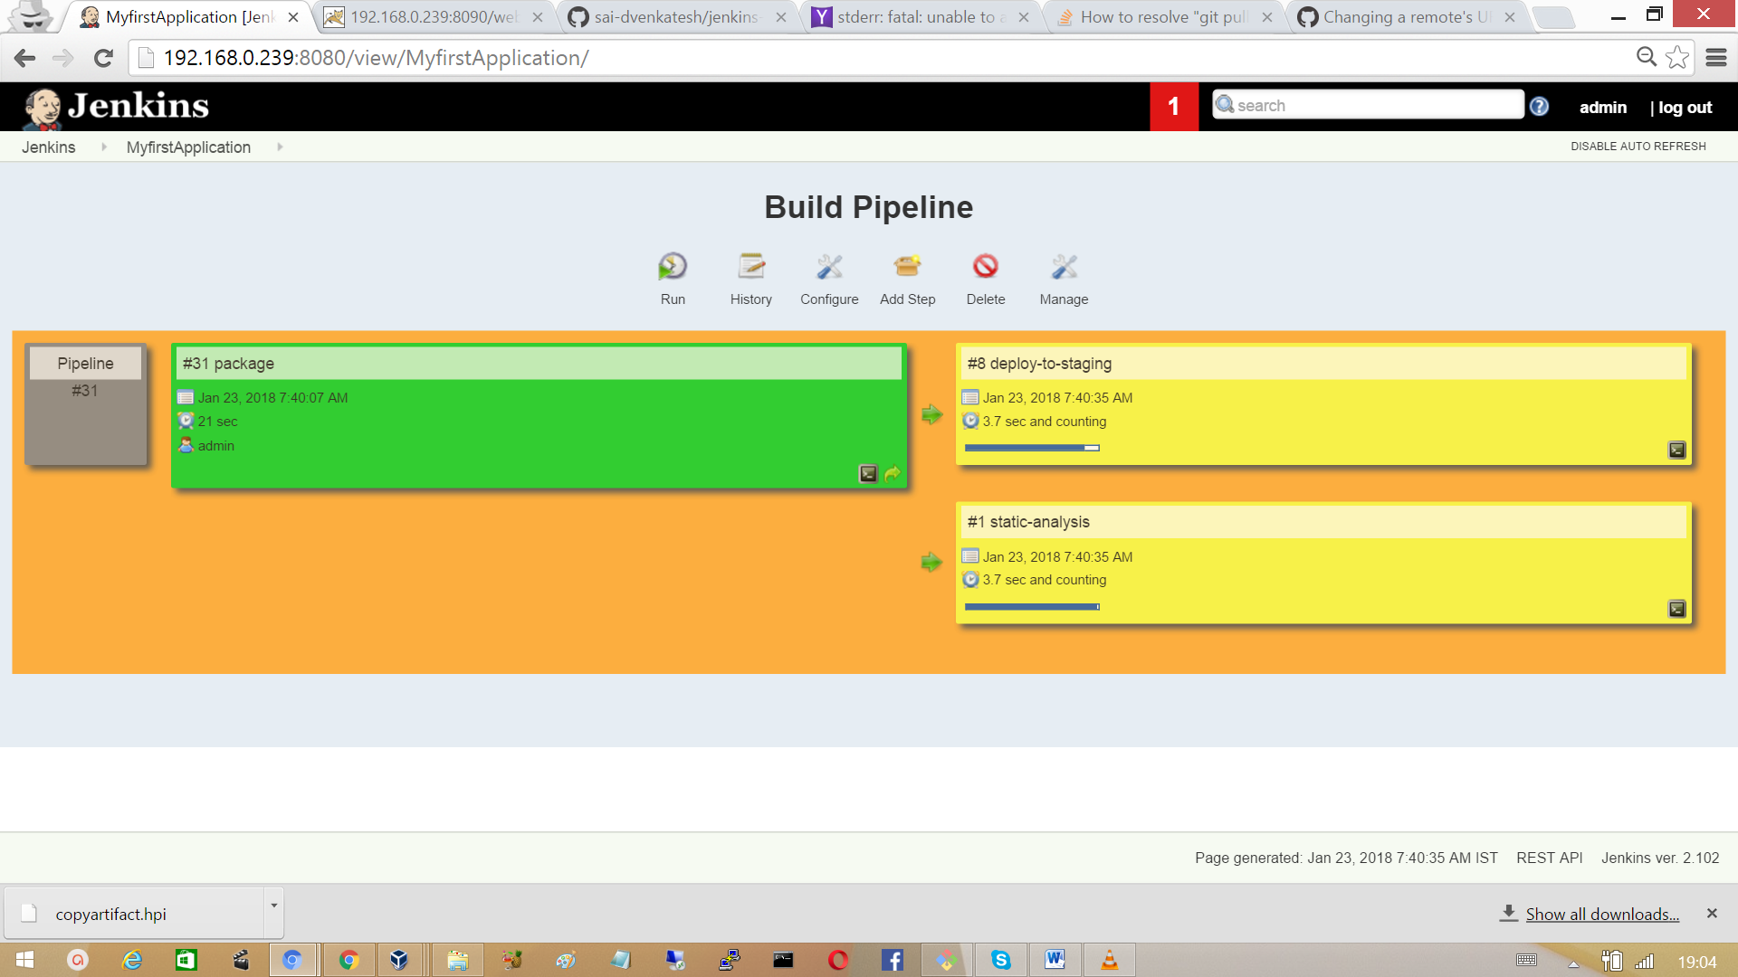

## 3.15 Deploy To Production

Create a Job with a name ‘deploy-to-prod’ as free style project.

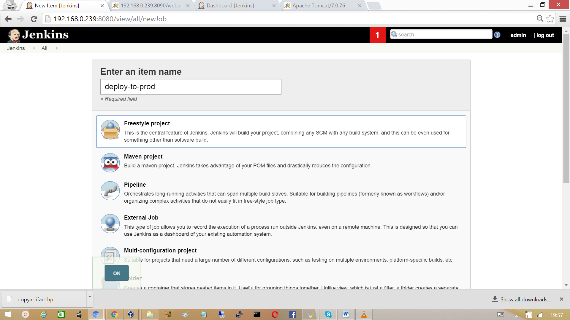

Provide the git URL.

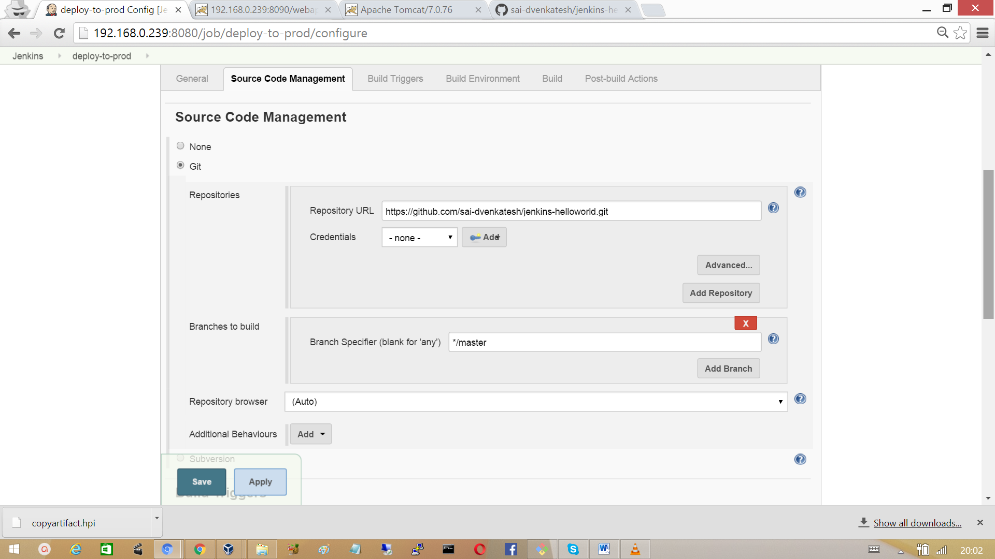

Provide the project name as ‘package’, which generated the artifact. Provide the artifact to copy.

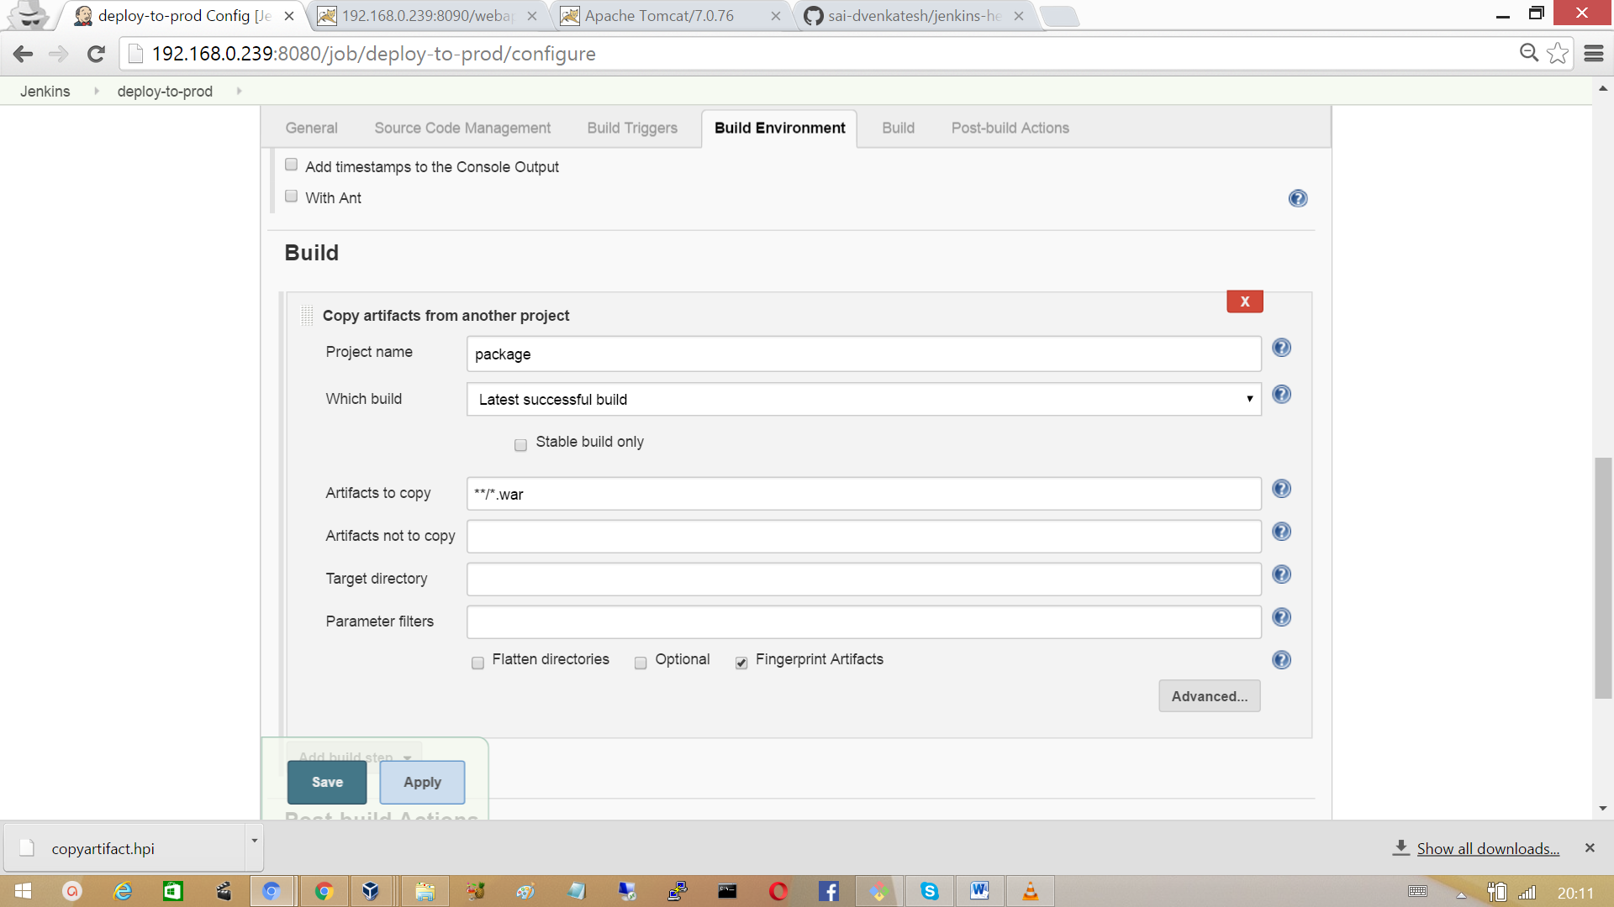

In the Post-build Actions, provide the file to be deployed in the tomcat server. We must tomcat user credential which we have defined in the tomcat server. So that file can be deployed.

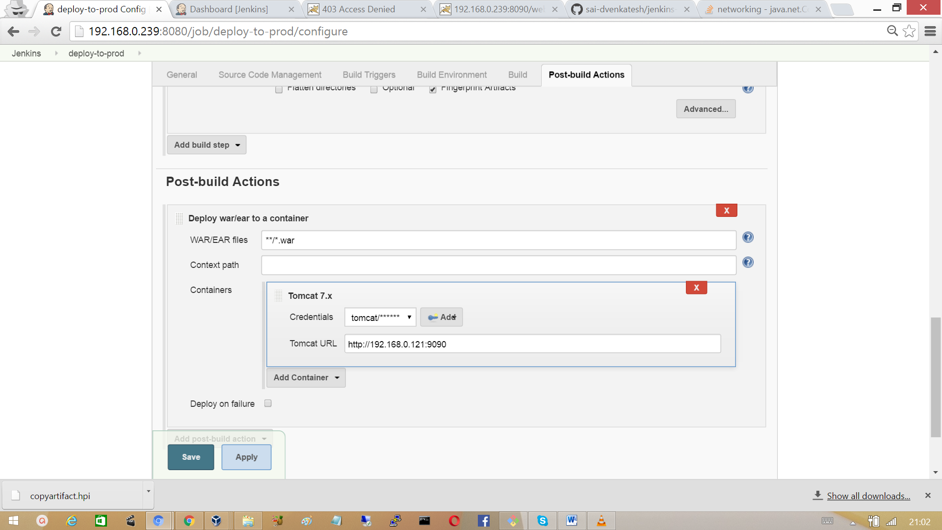

Click on add to define tomcat credentials, and select that credentials from drop down box.

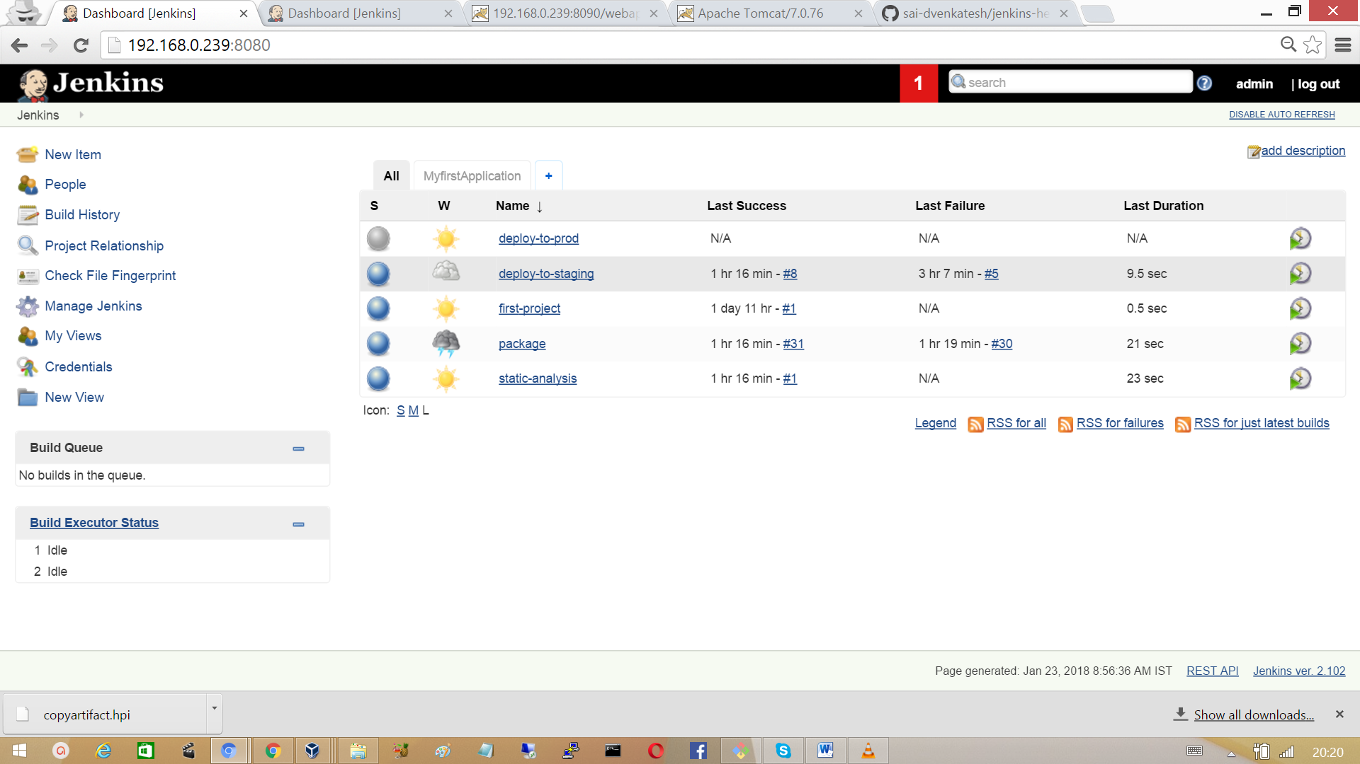

Trigger the Job from the build pipeline ‘MyfirstApplication’ and wait for successful build.

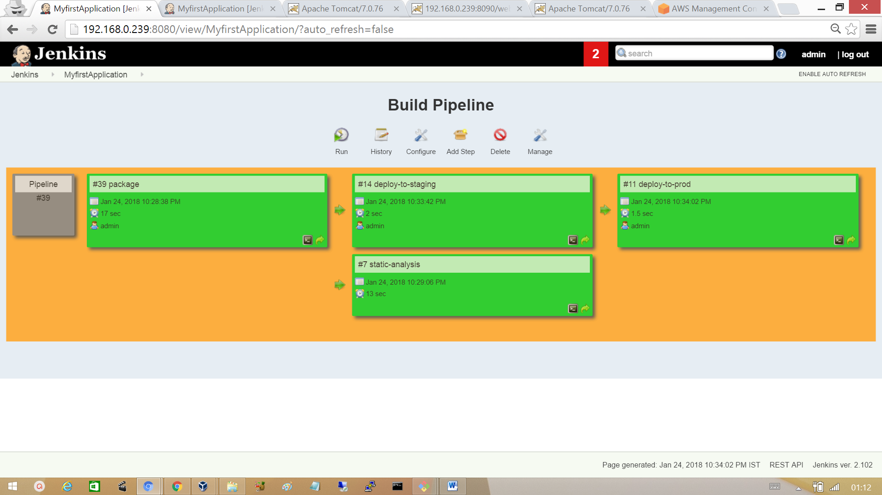

After the Build completed, go to browser and hit the URL http://<tomcat-server-ip>:port.

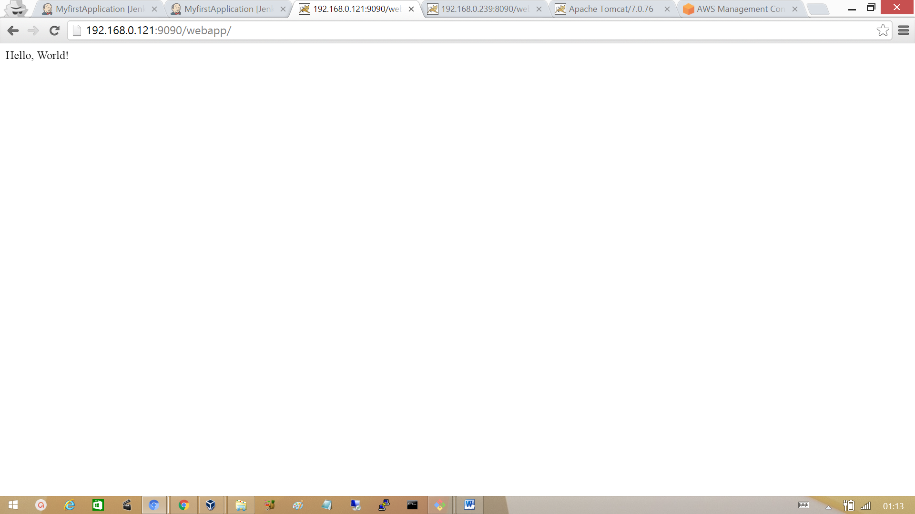

## 3.16 Jenkins Master Slave Architecture

Jenkins uses master and slave architecture to manage distributed builds.

Master:

* Schedule Build jobs.
* Dispatch builds to slaves for the actual job execution.
* Monitor the slaves and record the build results.

Slave:

Execute build jobs dispatched by the master.

Slave runs a java program to listen for request from the master.

**Installing Jenkins Master node in the cloud**

Login into your into AWS account and in the compute section select EC2.

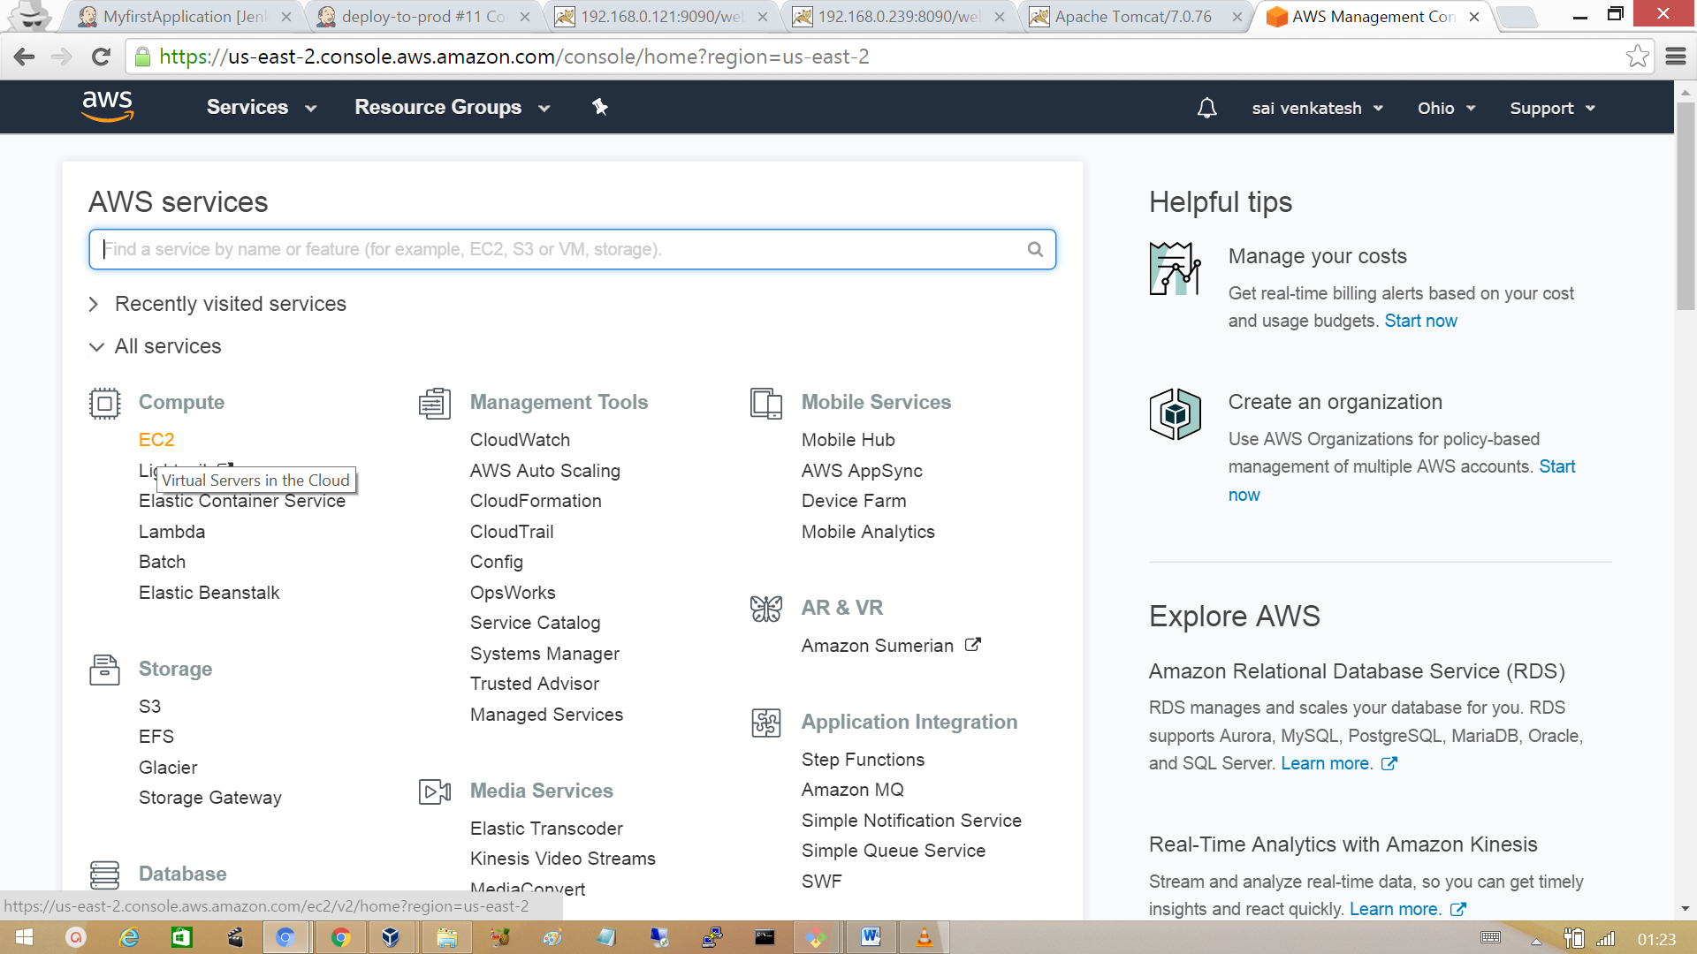

Click on launch instance

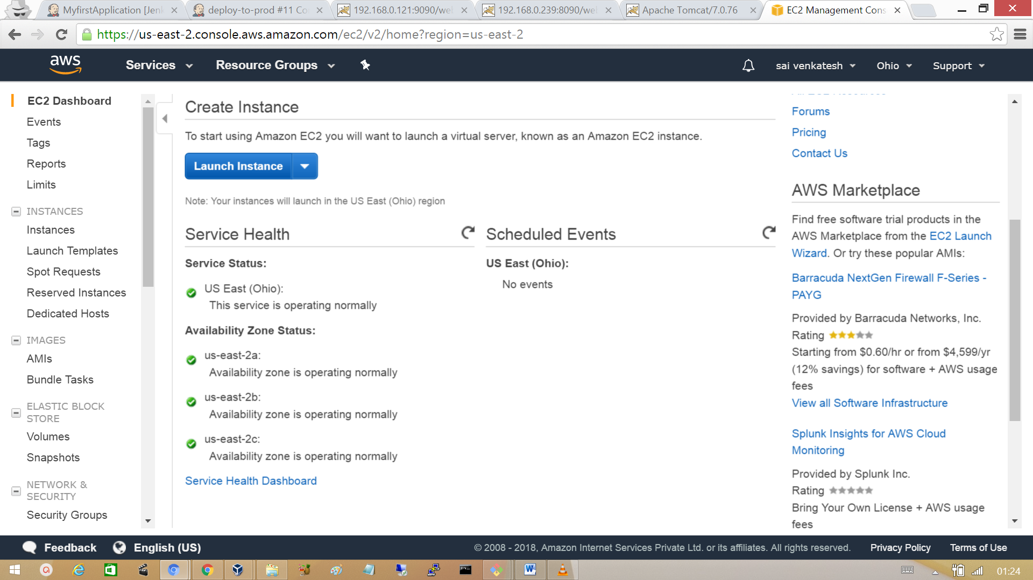

Select the instance as RHEL v7

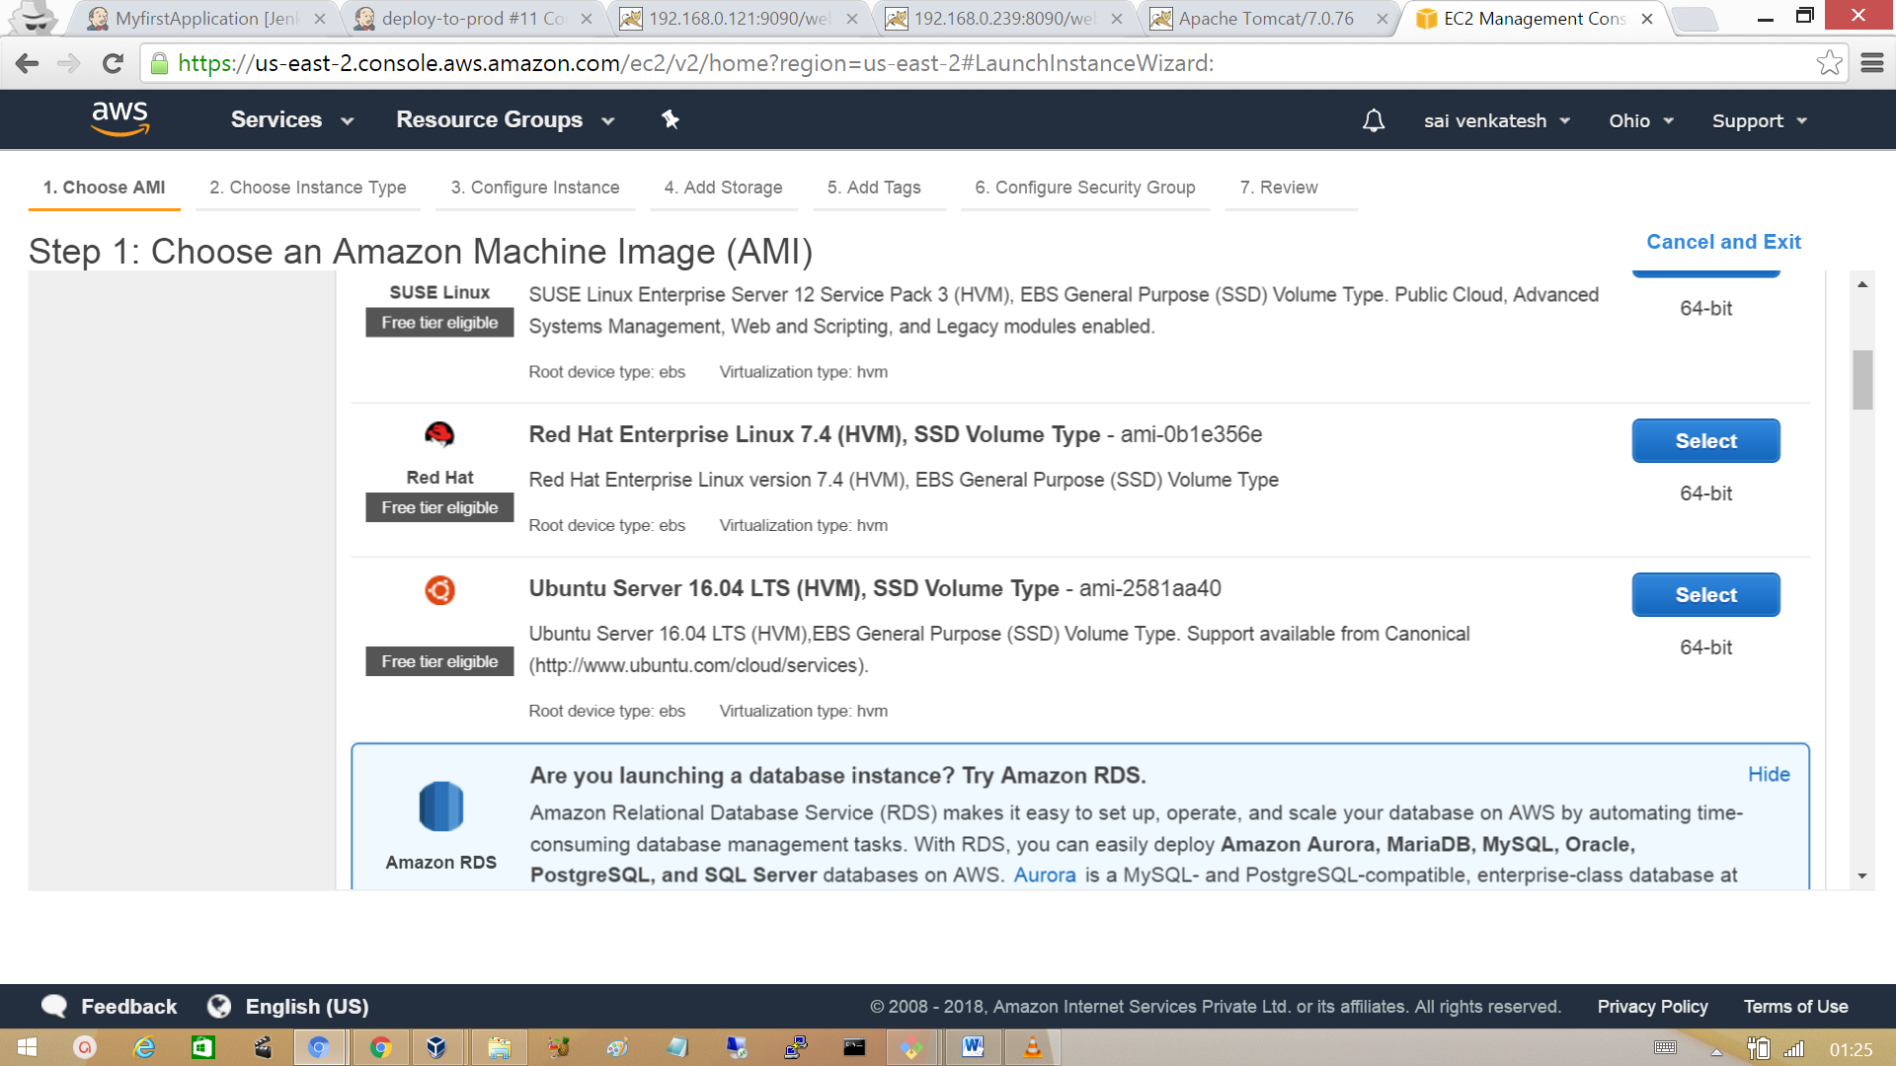

Choose an Instance type as t2.micro and then click on review and launch.

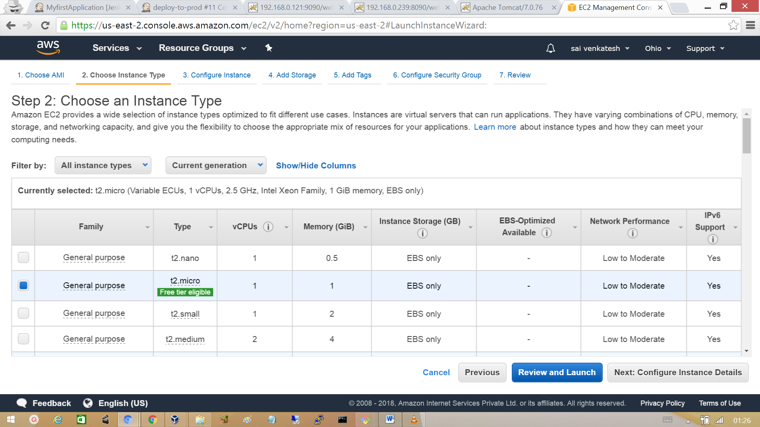

Finally click on launch to start your AWS instance.

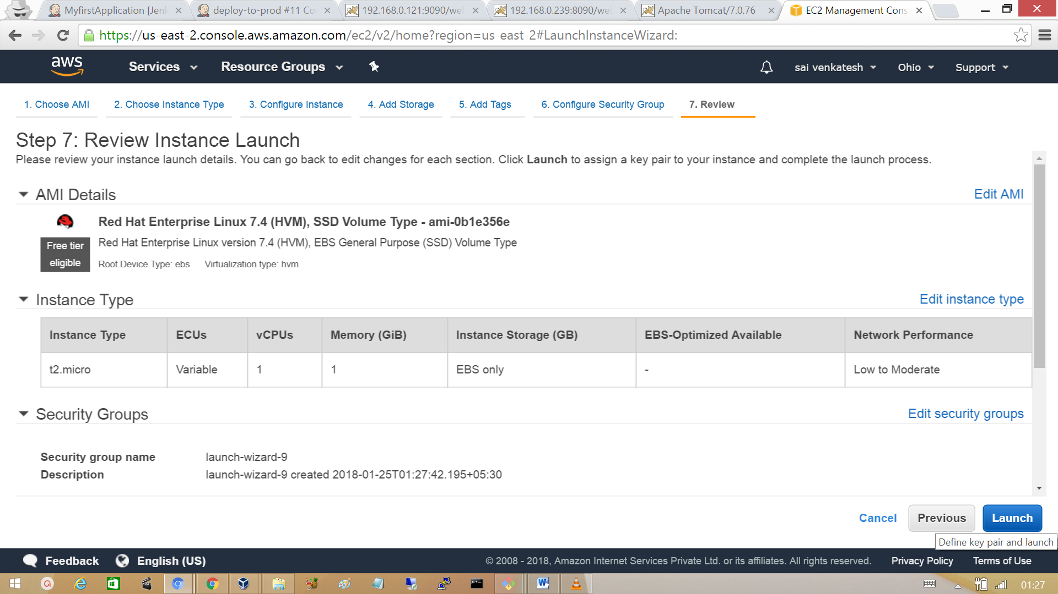

We need to download SSH key pair, which is only to login into your cloud instance over SSH.

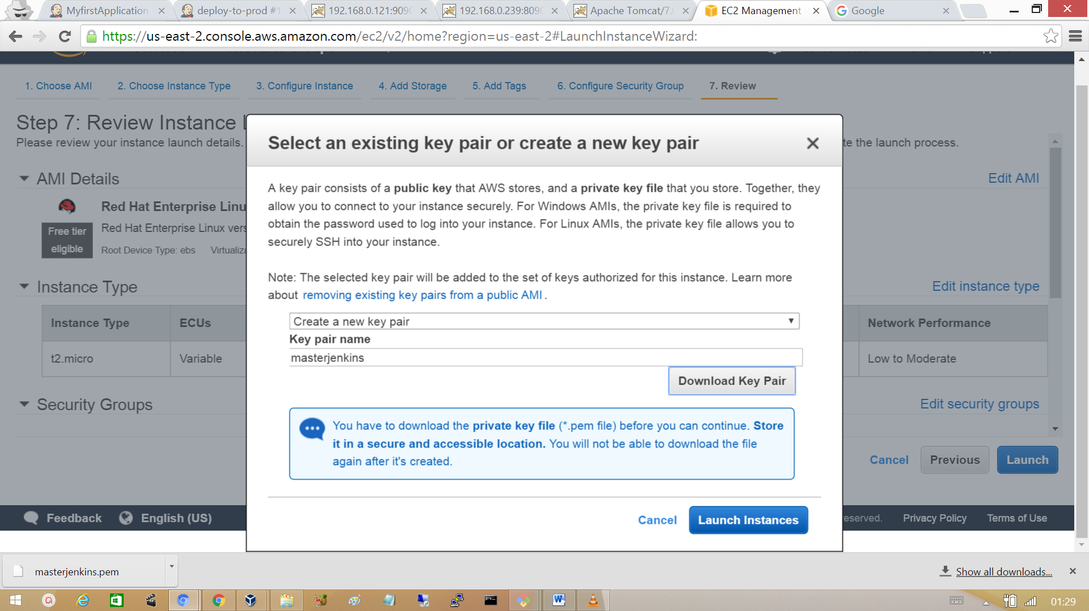

After the instance is launched successfully. Click on connect and copy the ssh command shown to login into your instance.

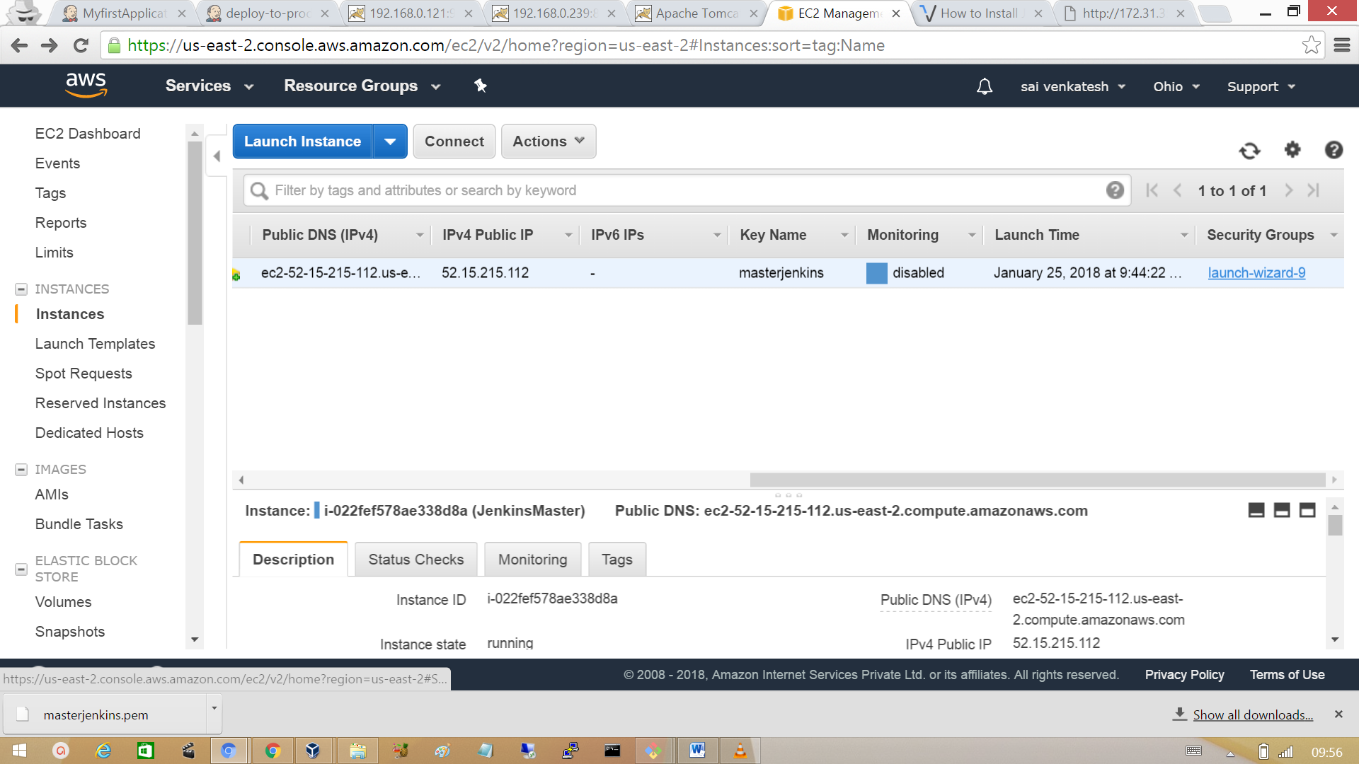

In order to run Jenkins on the port 8080, click on security groups and edit the inbound rules. Add the type as Custom TCP port and provide the port 8080 and define the source address either with specific IP address. In General the network id ‘0.0.0.0/0’ allows inbound traffic from any the outside network. Click on save.

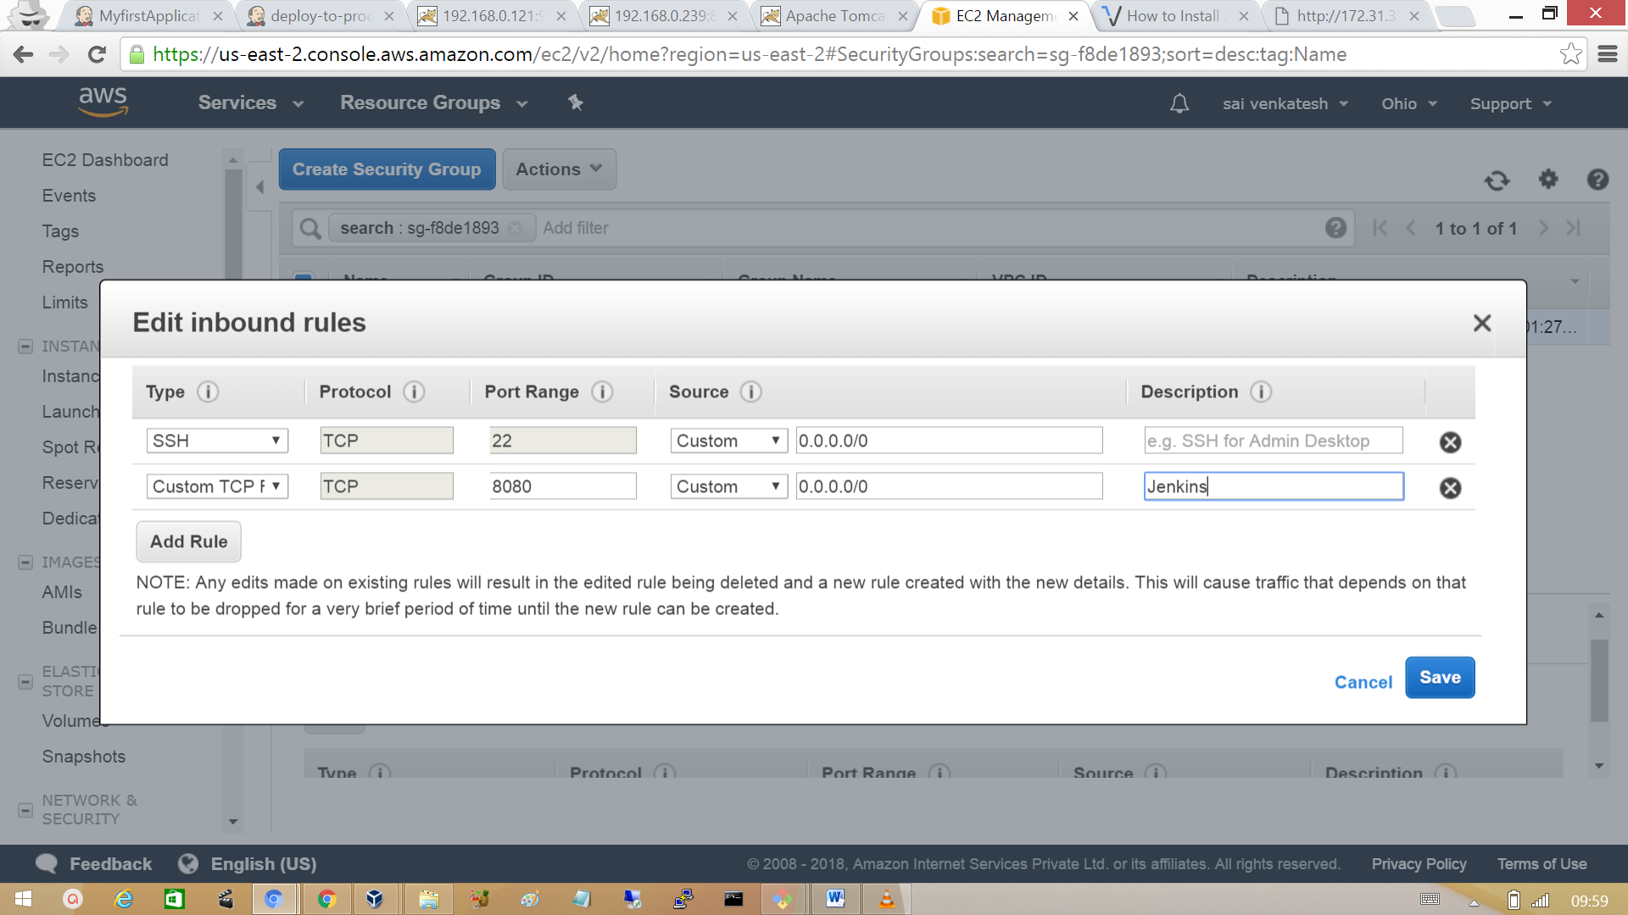

Go to the browser and hit the public IP of instances launched with port 8080

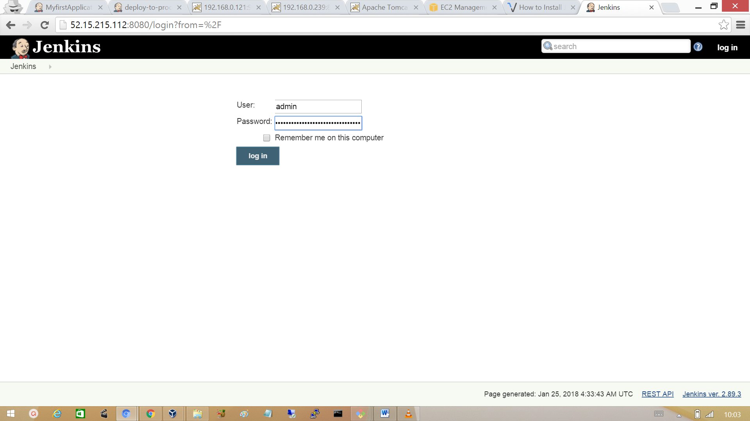

**Setting up Slave Agent**

Master node start the slave machine via SSH therefore automatic login from master node to slave node is needed, Jenkins user in the master node start the slaves agent. So, we need to setup a master-slave environment where Jenkins user can use SSH password less authentication using SSH keys.

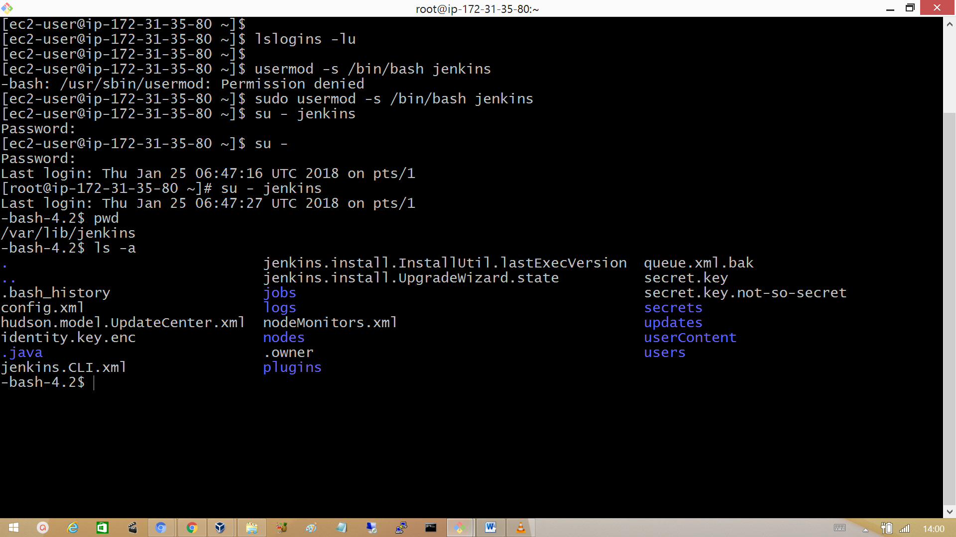

Login as user Jenkins in the master and generate SSH key pair with the command ‘ssh–keygen’. Keys generated will be stored in ‘/var/lib/Jenkins/.ssh’.

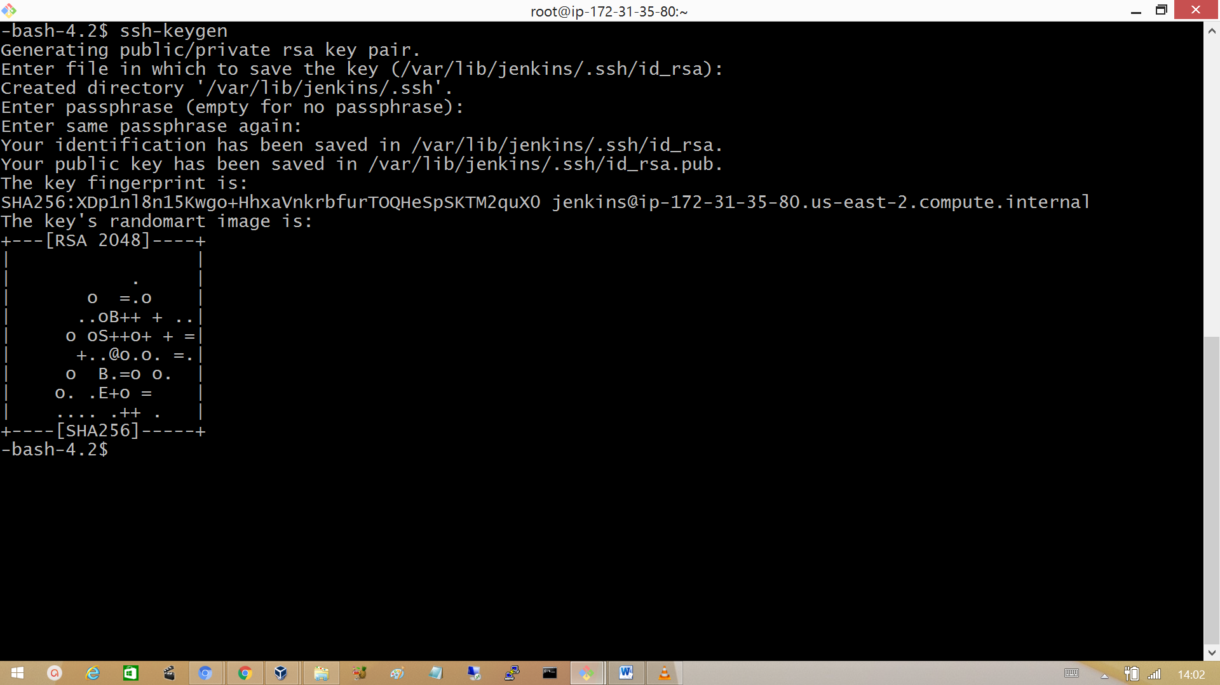

**Copy the keys generated to the root user account in slave machine.**

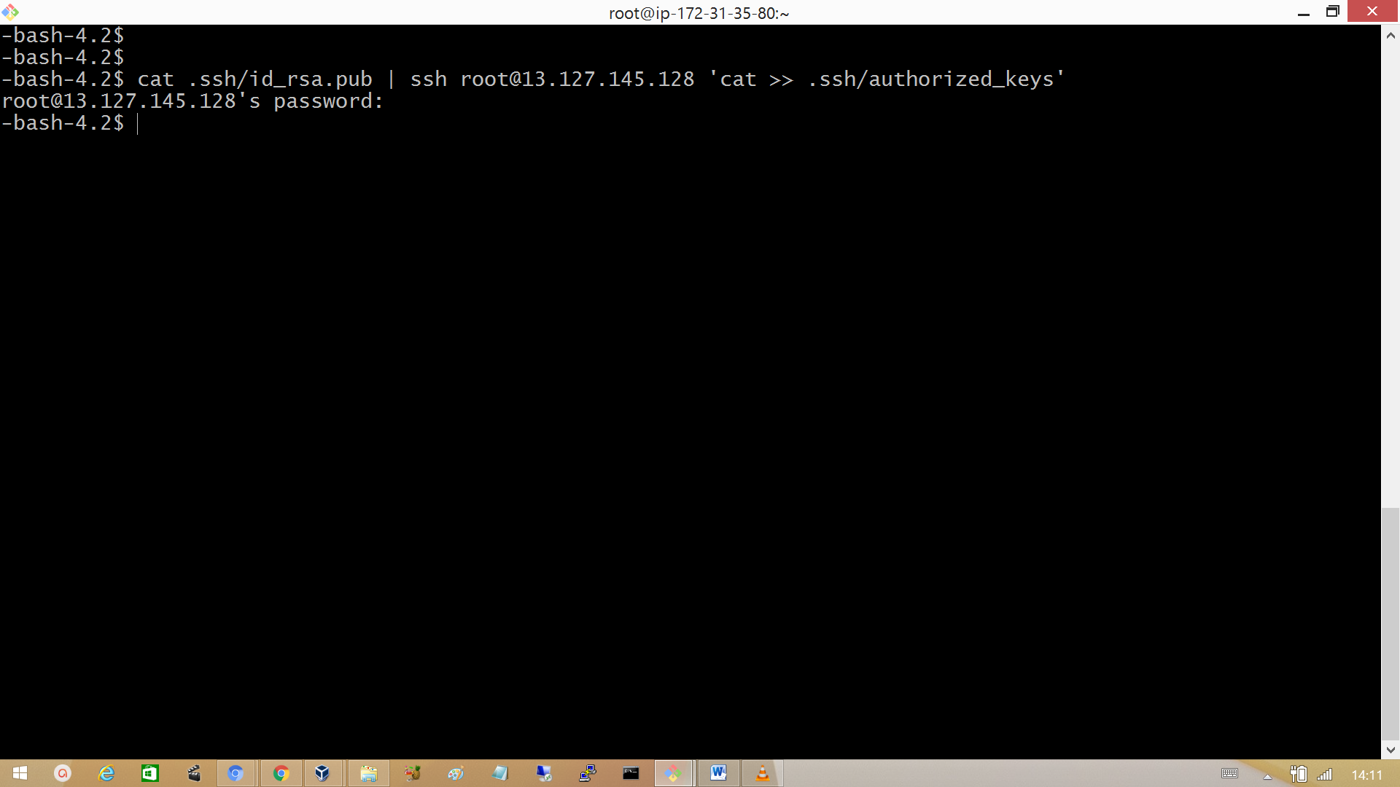

At the slave machine download the slave agent using wget from the master.

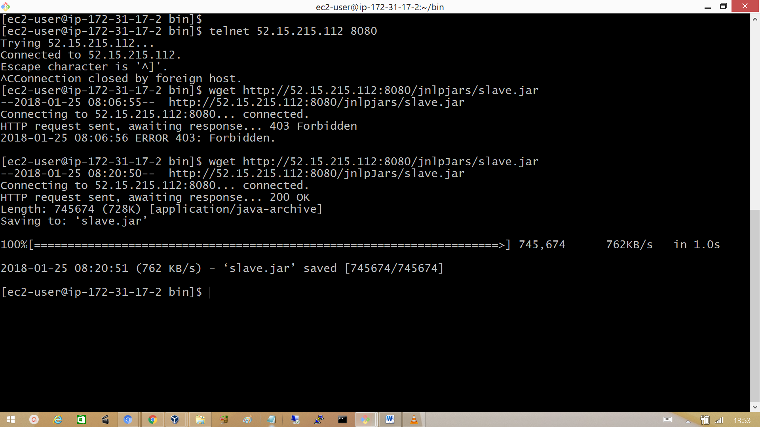

Now hook up the master with slave. Go to Manage Jenkins > Manage nodes > New Node. Provide the name for the slave, select permanent agent and click ok. Then click on Configure.

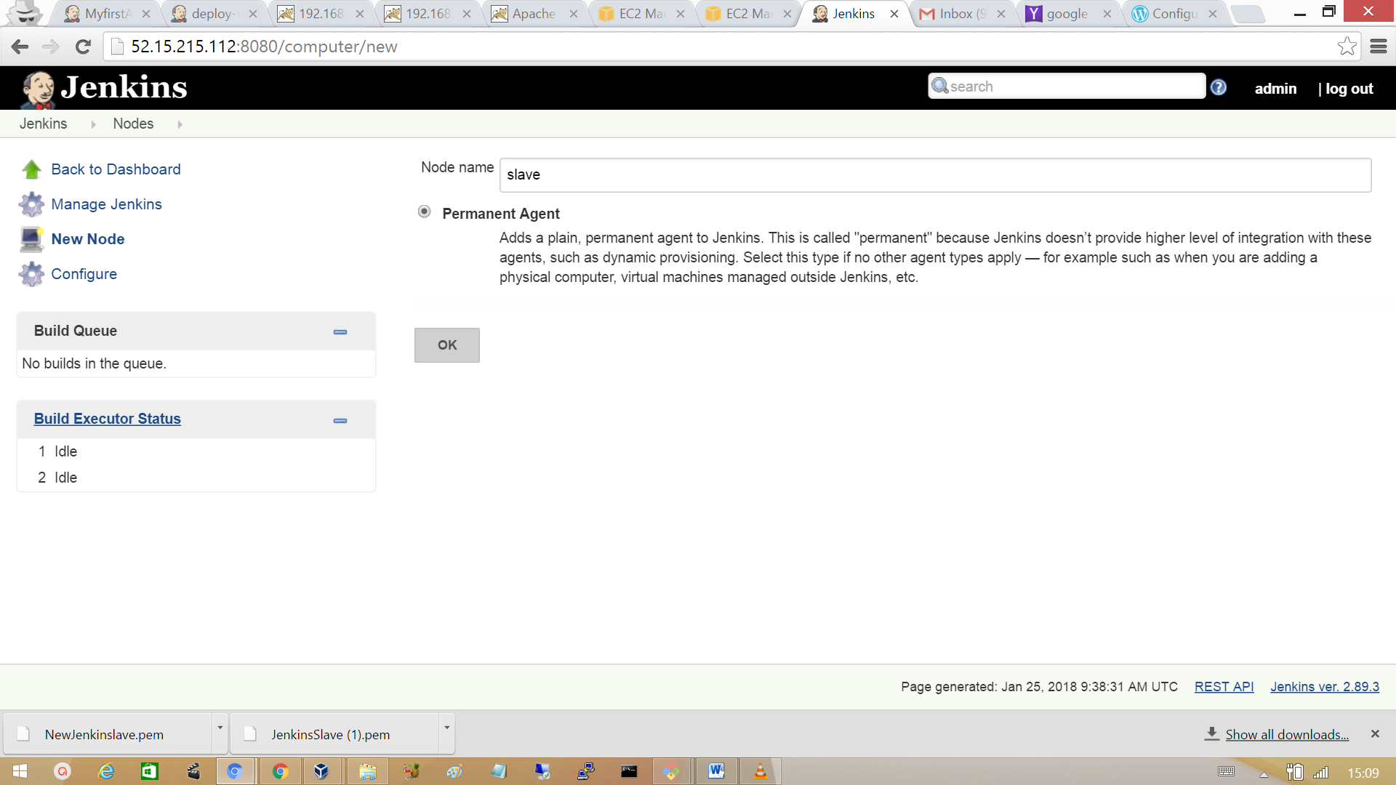

**Provide the following things in the configure section**

Remote root directory

An agent needs to have a directory dedicated to Jenkins. Specify the path to this directory on the agent. It is best to use an absolute path, such as /var/jenkins. This should be a path local to the agent machine. There is no need for this path to be visible from the master.

**Labels:** Labels can be used to setup a build to run on slave or master specifically.

**Usage**: Controls how Jenkins schedules builds on this node.

**Use this node as much as possible**

This is the default setting. In this mode, Jenkins uses this node freely. Whenever there is a build that can be done by using this node, Jenkins will use it.

**Only build jobs with label expressions matching this node**

In this mode, Jenkins will only build a project on this node when that project is restricted to certain nodes using a label expression, and that expression matches this node’s name and/or labels.

**Launch method**

This launch method relies on DCOM and is often associated with subtle problems. Consider using Launch slave agents using Java Web Start instead, which also permits installation as a Windows service but is generally considered more reliable.

Launch slave agents via Java Web Start  
Launch slave via execution of command on the Master

**Availability**

**Keep this agent online as much as possible**  
In this mode, Jenkins will keep this agent online as much as possible.

**Take this agent online and offline at specific times**  
In this mode, Jenkins will bring this agent online at the scheduled time(s), remaining online for a specified amount of time.

**Take this agent online when in demand, and offline when idle**  
In this mode, Jenkins will bring this agent online if there is demand, i.e. there are queued builds which meet the following criteria: They have been in the queue for at least the specified In demand delay time period.

**# of executors:** The maximum number of concurrent builds that Jenkins may perform on this agent. After entering the details click on ok.

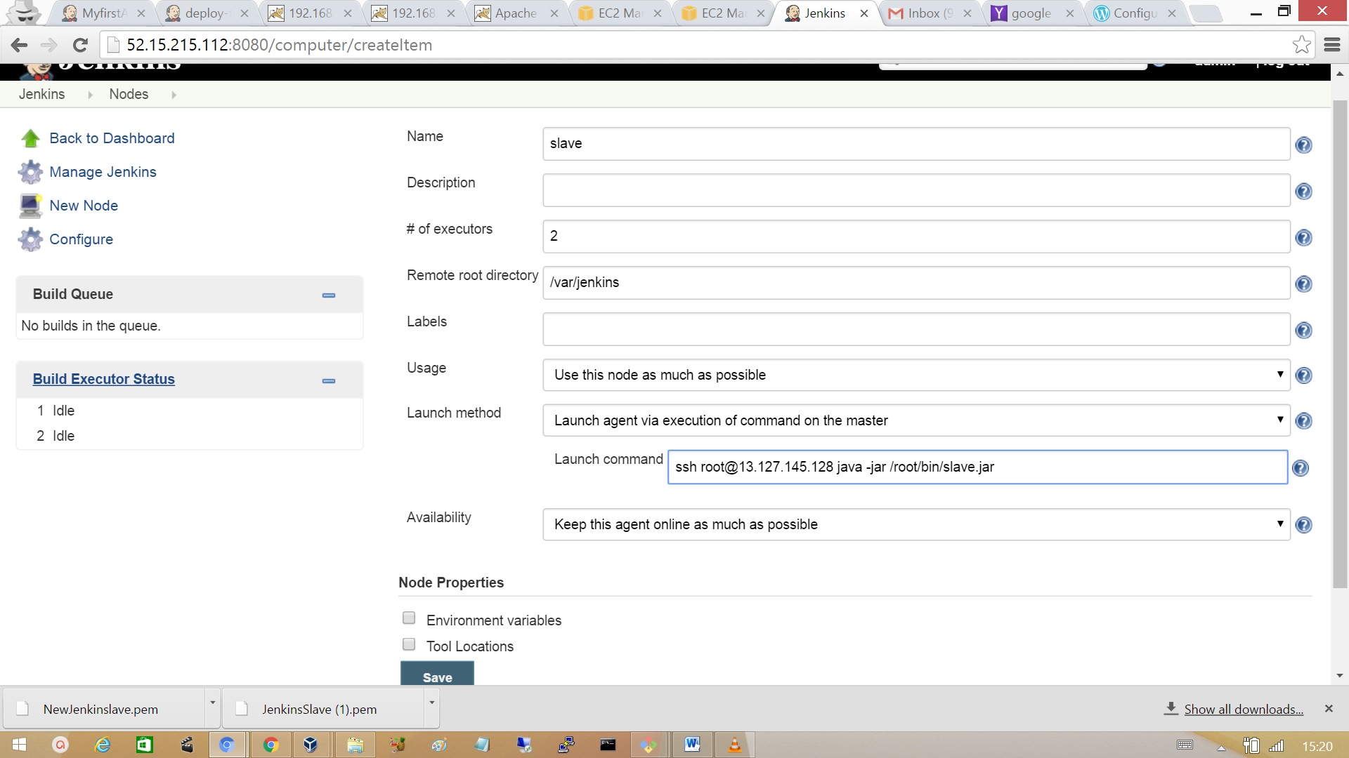

Go back to Manage nodes and verify slave node added or not.

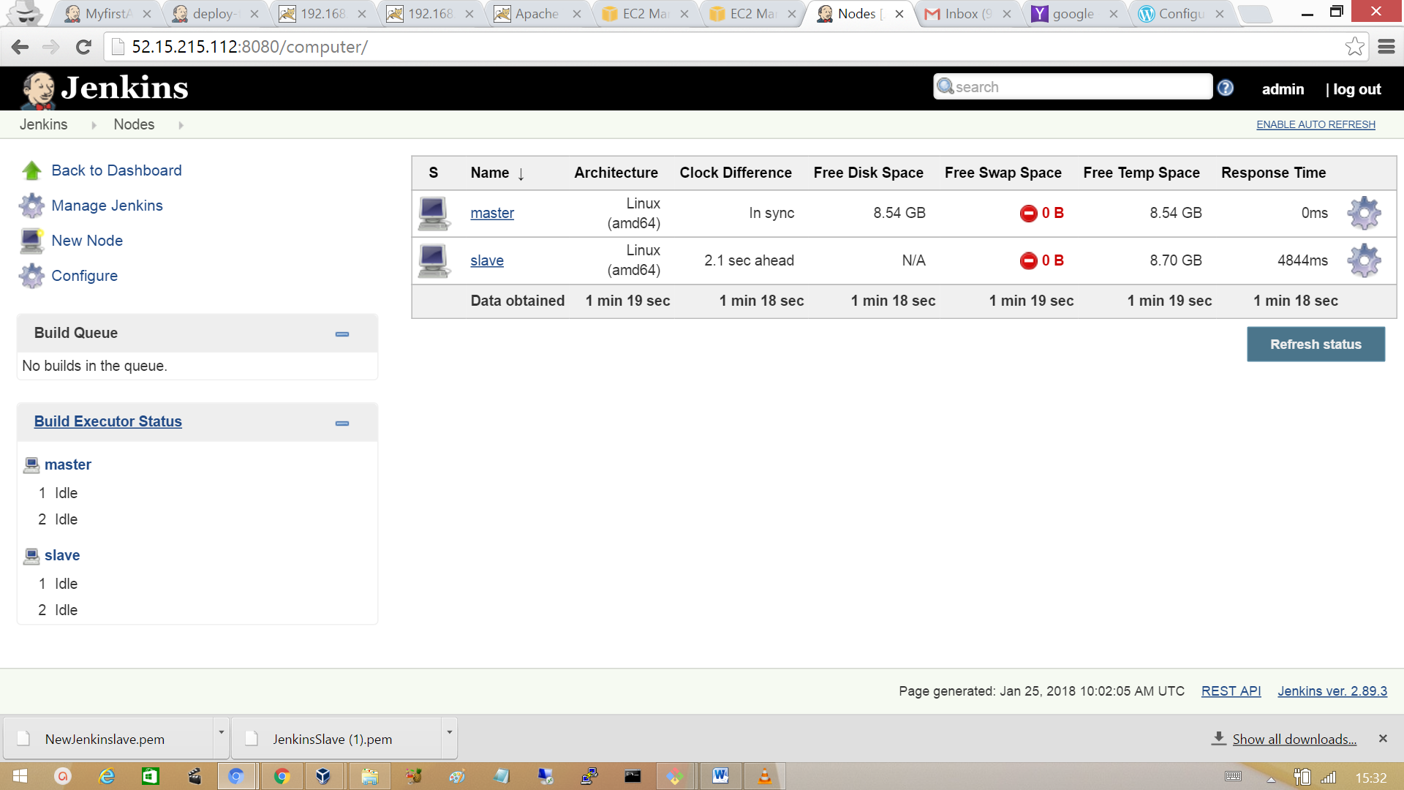

**Setting up simple jobs to run on master and slave.**

Click on New item and set a Freestyle project with a project name ‘job1’.

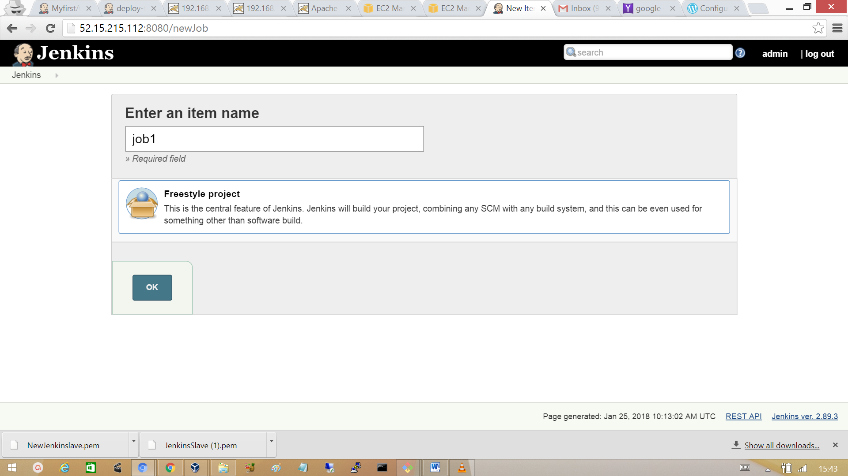

In Build section and a build step to execute a simple Linux sleep command. Add similar jobs to verify how master-slave setup is working**.**

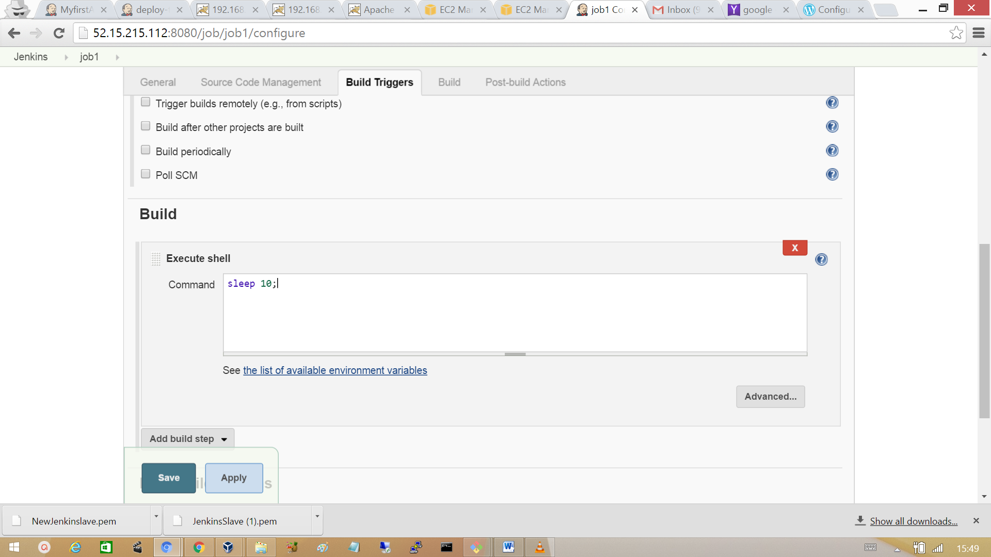

Schedule the Build manually for all the jobs at the same time**.**

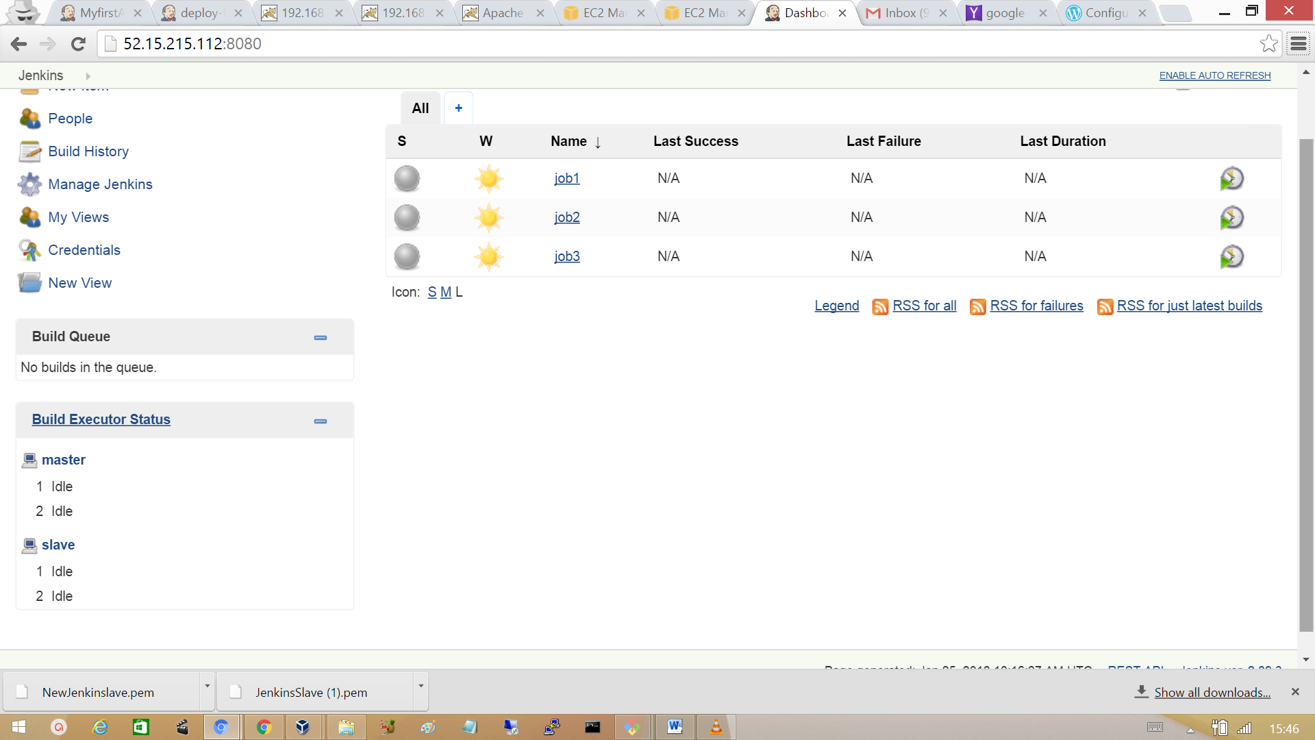

**Configure master and a slave to run specific jobs.**

We configure master or slaves to run specific jobs using the label which can be added to the nodes at configure section. Go to configure and add provide label and click on save.

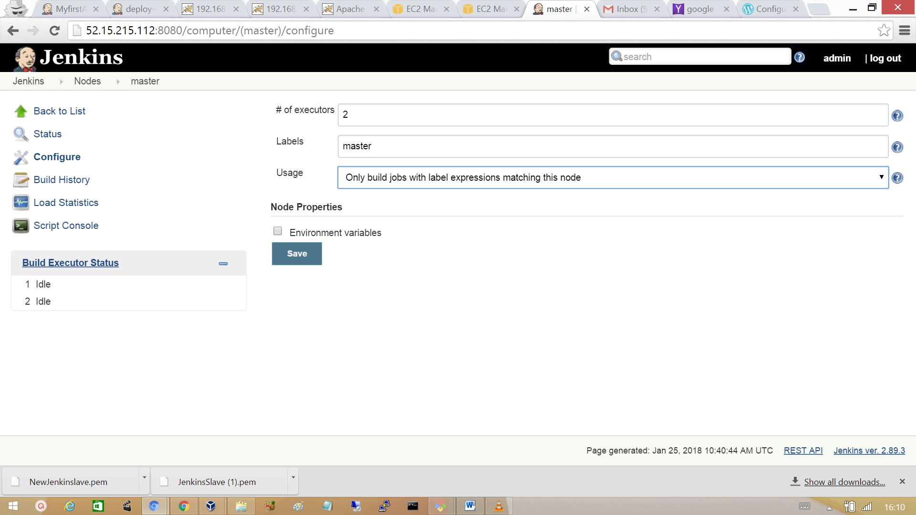

Add the label at the slave configuration.

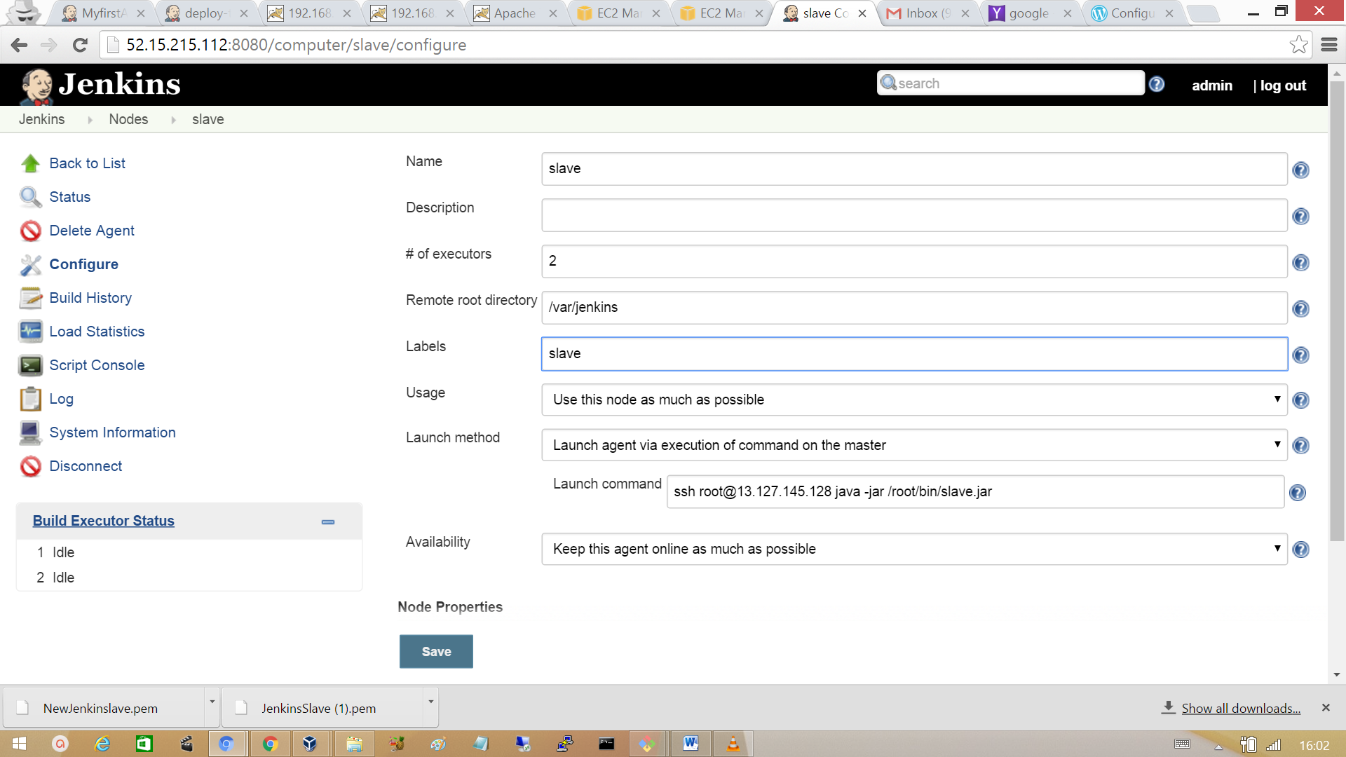

Now while setting up a job provides the label of the master or slave on which it has to run. For example for the job2, job3 add the label name of the slave and for the job1 add the label of the master.  
Select Restrict where this project can be run and provide the label name.

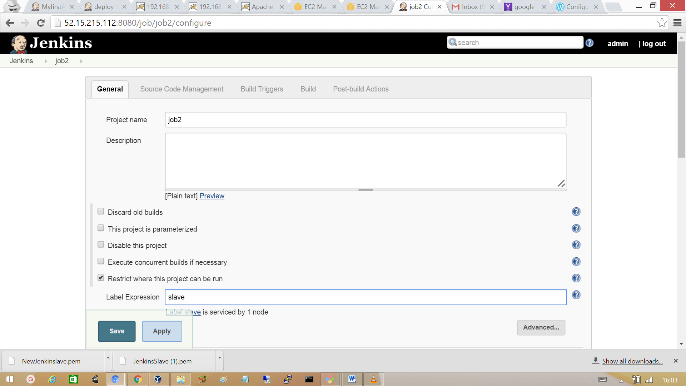

Go to the manage node and verify master and slave which jobs are allocated for it to run.

